



­DESTINATION MANAGEMENT

TRAINING GUIDE

*ILO - ASEAN Small Business Competitiveness*

A product of ­



Small Business Competitiveness by International Labour Organization (ILO – SBC) is licensed under a Creative Commons Attribution-Non Creative Commons Attribution‐NonCommercial‐ShareAlike 3.0 Unported License.



**Attribution** — You must give [appropriate credit](https://creativecommons.org/licenses/by-nc-sa/3.0/), provide a link to the license, and [indicate if changes were made](https://creativecommons.org/licenses/by-nc-sa/3.0/). You may do so in any reasonable manner, but not in any way that suggests the licensor endorses you or your use.



**NonCommercial** — You may not use the material for [commercial purposes](https://creativecommons.org/licenses/by-nc-sa/3.0/).



**ShareAlike** — If you remix, transform, or build upon the material, you must distribute your contributions under the [same license](https://creativecommons.org/licenses/by-nc-sa/3.0/) as the original.

****[*https://creativecommons.org/licenses/by-nc-sa/3.0/legalcode*](https://creativecommons.org/licenses/by-nc-sa/3.0/legalcode)

brought to you by:



**Table of Contents**

About C-BED vi

About the Destination Management Package: vi

Message to the Group vii

Session 1: Introductions 1

Activity 1A: Getting to Know Each Other 1

Session 2: Destination Management Players 5

Activity 2A: Overview of the GPG 5

Activity 2B: Destination Management Players 6

Activity 2C: Personal Action Plans 7

Session 3: Inventory Management of Tourism Subsectors 11

Activity 3A: Inventory of Tourism Subsectors 11

Activity 3B: Personal Action Plans 13

Session 4: The Planning Process 17

Activity 4A: PEST Analysis 17

Activity 4B: Personal Action Plans 19

Session 5: Infrastructure 21

Activity 5A: Infrastructure Elements 21

Activity 5B: Signposts 23

Activity 5C: Personal Action Plans 25

Session 6: Visitor Satisfaction 27

Activity 6A: Surveys 27

Activity 6B: Resolving Problems 29

Activity 6C: Personal Action Plans 30

Session 7: Destination Marketing 33

Activity 7A: Competition 33

Activity 7B: Competitive Comparison 34

Activity 7C: Measuring Visitor Satisfaction 36

Activity 7D: Market Research 37

Activity 7E: Personal Action Plans 39

Session 8: Crisis Management 41

Activity 8A: Crisis Management Standards 41

Activity 8B: Crisis Management Systems 43

Activity 8C: Crisis Management Preparedness 44

Activity 8D: Crisis Management Stakeholders 46

Activity 8E: Personal Action Plans 47

Session 9: Priority Action Plans 51

Activity 9A: Priority Action Plan 51

Annex 1: Flipcharts 55

Flipchart for Activity 3A 55

# About C-BED

Community-Based Enterprise Development (C-BED) is a low cost, innovative training programme designed by the International Labour Organization (ILO) to support skills development and empowerment in local communities for improvements in livelihoods, productivity and working conditions.

As an approach to training, C-BED is unique in that the programme is built around peer-to-peer, activity based learning methods with no role for teachers, experts, or external consultants specialised in the skill area. Instead, C-BED participants work together through a series of activities and discussions guided only by simple step-by-step instructions in the training manual. New knowledge, skills and competencies are developed through the interactions between participants and sharing of existing local knowledge and experience. In this way the programme is a low cost, sustainable option for any organization or community.

The C-BED programme is structured around two core training packages designed to develop competencies for business start-up and operation through a focus on marketing, financial management, and action planning. These are the C-BED for Aspiring Entrepreneurs and C-BED for Small Business Operators. Additionally, a growing suite of tools to strengthen business competencies and enhance skills for specific sectors is in continual development. These packages can be implemented as either stand-alone trainings or integrated in modular format into existing programmes.

## About the Destination Management Package:

**The training package:**

The Destination Management package should be used to help aspiring and current Destination Management entities improve their businesses. It focuses on key destination management principles to build on from what participants already know from managing their business and helps them to learn more. It can also build on from the learning in other C-BED tools namely SBO or AE. Participants bring experience to share and leave with a priority action plan (at least 3 actions to introduce improvements to their business). At the end of the training participants will have:

* Enhanced and advanced existing knowledge on destination management development
* Strengthened critical competences to analyse current conditions of work
* Decided on actions for the future

**The Good Practice Guide:**

During the training day participants will be introduced to and become familiar with the Good Practice Guide (GPG), which they will then be able to use to further their learning and to support them in setting up or improving their businesses. The GPG contains best practices, tools and extra activities that supplement those covered in the training to further support the participants in setting up or improving their businesses. The exercises may depend on the GPG but if the participants do not have this guide this should not prevent them from moving forward, if necessary skip that activity. Look out for this icon:



Here you should refer to the Good Practice Guide for more information.

## Message to the Group

At the end of this C-BED training you will have a clear plan for the practical steps you can take to start or improve your business. Your understanding of the basic principles of doing business will be much stronger and you will have begun relationships with others in your community that can potentially support or cooperate with you to achieve mutual success in the future.

The style of this training is different to traditional education approaches. There will be no teacher, trainer or expert to assist you. Instead, you will work together as a team to follow the simple step-by-step instructions for discussions and activities in your training guide. Because there is no group leader, all group members should take a turn reading the information and instructions out loud to the group, and all group members share responsibility for monitoring time. In this new style of training, we will learn from each other by sharing ideas and opinions, skills, knowledge and experience. For this to work, all group members must participate in discussions.

Before and after the training you will be asked to complete a survey to understand the impact of the training. This information will be kept confidential and is used to improve the training materials and organization of future programs. Some trainees may also be contacted in the future after 3, 6 or 12 months for another survey to learn about your business plans.

The instructions in the training guide are easy to follow and suggested timing for each step is provided. Look out for these signs:



When you see this sign, read aloud



When you see this sign, you are reading instructions and doing activities



When you see this sign, share with the group



This sign gives you the estimated time for the session



Use the flipchart as outlined in Appendix 1, if you don’t have a flipchart use extra paper or the Training Guide

Before you begin the training, follow the simple steps below to get organized.

* Fill out the pre-training survey. Ask the organizers if you don’t have a copy or have not already filled it in.
* Organize into small groups of 5-7. The organizers will guide you in how best to do this.
* Identify one group member to volunteer to start the training as ‘Group ‘Reader’. The ‘Group Reader’s’ role is to read the information and activity instructions out loud to the group. Any group member with basic literacy can be the ‘Group Reader’ and you should aim to share this role among group members throughout the training.

All group members are responsible for monitoring time but one group member should be nominated for each session to remind the group when the suggested time for a step has been reached. You do not strictly need to follow the suggested timing but you will need to manage your time for the total training. If one activity lasts longer than the suggested timing, try to save time in other activities to keep the balance.

All group members will receive the same training guide. Individual work can be completed in these guides as well as group work. Groups may also like to complete activities together on flipchart paper if available.

Enjoy the Training!

Session 1:

Introductions

# Session 1: Introductions



**Session Overview**

**20 Mins**



In this session you will get to know one another and the style of learning in this training. We learn without teachers. You help each other with your different experiences and ask questions if you don’t understand an activity. You will complete 1 activity. The objectives for this session are as follows:

* Identify the training sessions, timing for the day, expectations, and the workshop arrangements
* List the names of some of the trainees
* Understand the style of learning for this course, including activities and group work

## Activity 1A: Getting to Know Each Other



In Activity 1A, you will do some brief introductions so you can get to know one another.



**20 Mins**

1. Each person introduces themselves by providing their:

* Full name and any nickname you prefer to use during the session
* Destination
* Their purpose for attending this session and how you expect it to help your business

1. Each person shares a photo, business card or drawing of their destination for others to see. Place this on the wall or in the middle of the table or allow others to see it on your mobile phone.
2. Fill in this sheet below (if not now then during tea breaks and lunch time)

|  |  |  |
| --- | --- | --- |
| Table 1A: Participant Information | | |
| Participant Name | Destination | Phone number /  Email address |
|  |  |  |
|  |  |  |
|  |  |  |
|  |  |  |
|  |  |  |
|  |  |  |
|  |  |  |
|  |  |  |



In this session you have gotten to know who your peers are and a little about their destinations.

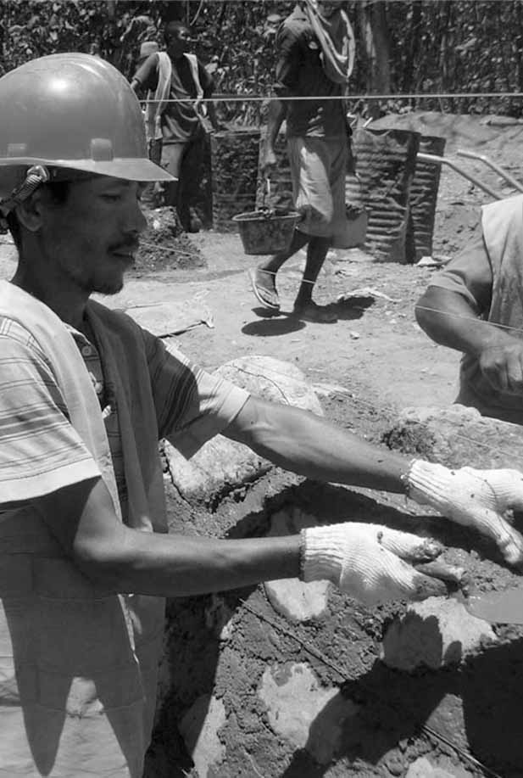

Session 2:

Destination Management Players

# Session 2: Destination Management Players





**25mins Part 1: Section 1.5**

**25 Mins**



**Session Overview**

In this session you will become familiar with the Destination Management Good Practice Guide (GPG) and identify the people, agencies, organisations, and businesses that are important for the management of your destination. You will complete 3 activities. The objectives of this session are as follows:

* Give a brief overview of the contents of the GPG
* List the players involved with the management of your destination
* Understand the collaborative nature of destination management
* Identify gaps in your destination management team/committee
* Create an action plan to invite additional players to the team to fill the gaps

## Activity 2A: Overview of the GPG

**[5 Mins]** In this activity you will get an overview of the GPG, some of which you will spend time on today. The Guide is also designed so that you can look further after the training.

Let’s take some time to become familiar with the GPGs. Open your GPG to the Table of Contents you’ll see that the GPG is divided into two parts.

Part 1 gives an overview of Destination Management and covers basic information about the topic for those of you who have less knowledge about it. Part 2 analyses the components of Destination Management. Take a moment to read the list of 10 topics covered in Part 2 (from Management Structure to Crisis Management). We won’t have time to cover every topic today, but now you know the kind of information included in the GPG.

Today, we will focus most of our attention on Part 2. Please take about 3 or 4 minutes to look over the first few pages of Part 1 to become familiar with the content. We’ll spend time on the Destination Management Players section together.

## Activity 2B: Destination Management Players

This activity is an individual activity that will help you get an overview of the players involved in the management of your destination in order to help you evaluate the effectiveness of your management team.

Part 1 Section 2.5 states that a public agency always takes the lead in managing a particular tourism destination. It also acknowledges that the management of a destination involves other public sector entities as well as private sector organisations and businesses. This group of entities is often called the Destination Management Team (or Committee). Sometimes it is called the Tourism Steering Committee. We know that Destination Management involves a combination of players. The list of players can change over time. To effectively manage a destination, it is important to have the right mix of players on the team and to update the team membership as needed.

Take a look at the list of public sector agencies/departments in the GPG starting with tourism, parks, and recreation. The names of these agencies/departments may vary from country to country and from region to region, but the list includes the primary public bodies engaged in destination management. The same is true with the list of private sector entities listed in the GPG.

**20 Mins**



1. Use Table 2B to list the public and private entities currently involved in managing your destinations.
2. Identify the current member of your team.
3. Also list those who should be added to the team.
4. Please note that this is an individual activity for destination managers. If you are not a destination manager (for example, if you are a government official), please participate by doing the exercise with one of your team members. Let the destination manager lead the exercise, but offer your thoughts and opinions where appropriate.

|  |
| --- |
| Table 2B: The members of My Management Team |
| Public sector agencies/departments/groups, etc., involved in the management of my destination include:    Private sector businesses/organisations/groups, etc., involved in the management of my destination include: |



In this activity you looked at the public and private sector organisations involved in the management of your destinations.

## Activity 2C: Personal Action Plans

In the final activity of this session you decide on some concrete actions to take with respect to your destination management teams. Keeping in mind all the things you’ve discussed so far, take a few minutes to record your thoughts.



**10 Mins**

1. Each of you uses Table 2C: Personal action plan to write 1-3 changes that you would make to improve your destination management team. Are there any improvements you would like to make based on what you have learned in the previous activities? If so, decide what you will implement or improve.
2. Record how you will make these changes.
3. Record by when will you make these changes.
4. Finally, state who will be responsible for this change.

|  |  |  |  |
| --- | --- | --- | --- |
| Table 2C: Personal Action Plan | | | |
| My changes | How will I make the changes? | When? | Who is responsible? |
|  |  |  |  |
|  |  |  |  |
|  |  |  |  |

In session 2 you focused on the destination management players present in your destination in order to get an overview of the entities involved. Part 1 Section 1.5 of your GPG has more information.

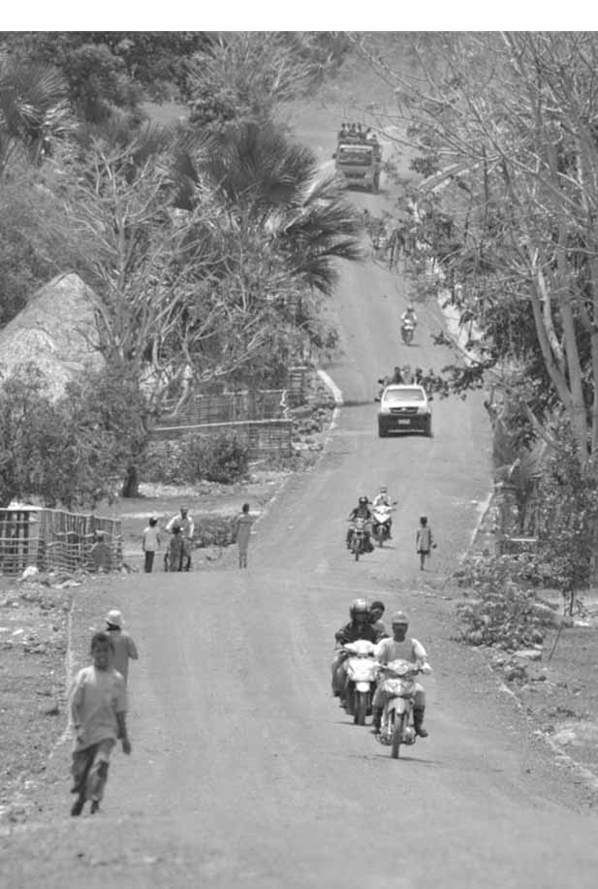

Session 3: Inventory Management of Tourism Subsectors

# Session 3: Inventory Management of Tourism Subsectors



**1**

**Part 1: Section 1.6**

**20 Mins**



**Session Overview**

In this session you will get a better understanding of the importance of measuring the components of tourism subsectors. You will complete 3 activities. The objectives for this session are as follows:

* Gain basic awareness of the primary tourism subsectors
* Identify ways to collect and maintain valuable inventories (i.e. number of beds for overnight visitors)
* Identify appropriate methods for collecting this data
* Develop a data-collecting plan for the specific destination
* Use brainstorming to develop cooperative, respectful relationships.

## Activity 3A: Inventory of Tourism Subsectors

In this activity you will use brainstorming to gather information from many different sources to discuss methods that can be used to take inventory of the different tourism subsectors. Brainstorming is a valuable tool because, when done correctly, it can help you establish cooperative, respectful relationships with the stakeholders at your destination. Some stakeholders will be more vocal than others, and it is up to you to make sure all the stakeholders are heard.

First, let’s take a look at and read Part 1 section 1.6 labelled Tourism Subsectors in the GPG. There are 4 charts in the GPG asking you to take inventory of the tourism subsectors accommodations, transport, activities, and attractions. You might not have this data available now, but this kind of information is important to include in a comprehensive Destination Management Plan. The more you know about these 4 subsectors, the better you can manage your destination and visitor satisfaction.

**10 Mins**



1. Discuss and compare methods you can use to measure inventories within these four subsectors: accommodations, transport, activities and attractions
2. Try to identify at least 2 or 3 good methods for gathering information for each subsector.
3. Follow the rules of brainstorming

* Encourage everyone to contribute ideas.
* Make everyone feel safe and comfortable contributing ideas.
* Seek as many ideas as possible, even unusual ones.

1. List suggested methods for data collection below for each subsector.

|  |
| --- |
| Table 3A: Identify Methods for Collecting Subsector Data |
| Accommodations:  Transport:  Activities:  Attractions: |



In this activity, you used brainstorming to identify methods to collect data for subsectors

## Activity 3B: Personal Action Plans

In the final activity of this session you decide on some concrete actions to take with respect to your destination management teams. Keeping in mind all the things you’ve discussed so far, take a few minutes to record your thoughts.

**10 Mins**



1. Each of us uses Table 3B: Personal action plan to write 1-3 changes that you would make to your inventory management methods. Are there any improvements you would like to make based on what you have learned in the previous activities? If so, decide what you will implement or improve.
2. Record how you will make these changes
3. Record by when will you make these changes.
4. Finally, state who will be responsible for this change.

|  |  |  |  |
| --- | --- | --- | --- |
| Table 3B: Personal Action Plan | | | |
| My changes | How will I make the changes? | When? | Who is responsible? |
|  |  |  |  |
|  |  |  |  |
|  |  |  |  |

In this session you looked at how to collect data for the various tourism subsectors. Part 1 Section 1.6 of your GPG has more information

.

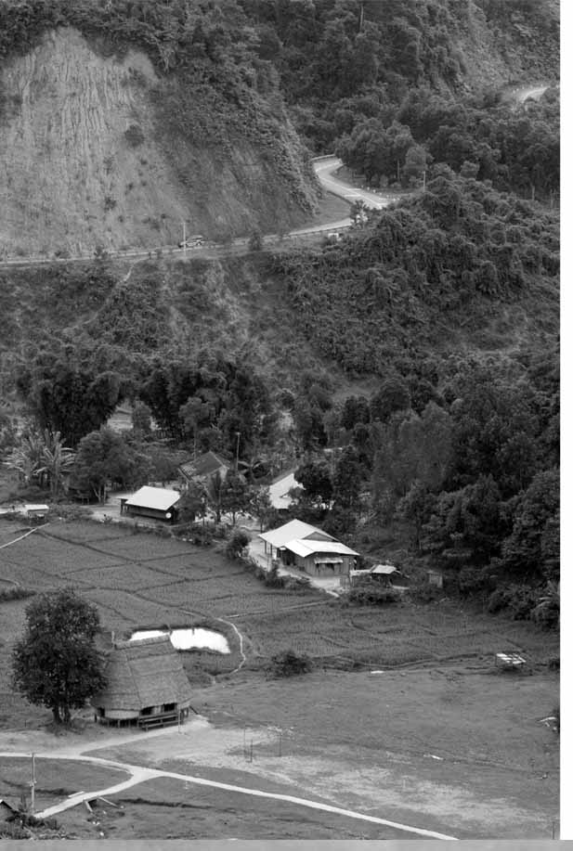

Session 4:

The Planning Process

# Session 4: The Planning Process



**Part 2: Section 2.1.**

**40 Mins**



**Session Overview**

In this session we will review proven models that can be helpful in the planning process of Destination Management, and to practice using the PEST analysis model. This will help us to identify potential strategic challenges and opportunities for your own destination. You will complete 2 activities. The objectives of this session are as follows:

* Learn to facilitate PEST and SWOT analysis sessions
* Understand the types of issues that might be included in a PEST analysis
* Identify potential strategic challenges and opportunities for your own destination.

## Activity 4A: PEST Analysis



In this activity you will complete a PEST analysis

.

**[10 Mins]** Please turn to Part 2 Section 2.1: Components of Destination Management in your GPG. This section talks about the planning process. On this page, you see a chart that asks you to assess the value chain for key components of an existing tourism destination. This is a tool that you can use later with your staff to assess the value chain in your destination. On the next couple of pages in the GPG, you see two proven models (PEST and SWOT) to help you with the planning process. Both models are explained in the GPG. For today’s workshop, we’re going to practice using the PEST model. The PEST analysis measures the Political, Economic, Socio-Cultural, and Technological factors associated with your destination. Please turn to the sample PEST analysis in the GPG, and take a moment to review it. After today’s workshop, you can do a PEST analysis and a SWOT analysis with your staff and various stakeholders in your destination



**20 Mins**

1. Practice doing a PEST analysis with your groups.
2. Take a couple of minutes to select a destination that someone on your team represents. Try to choose one that everyone has some knowledge of.
3. Please write the name of your selected destination below.
4. Brainstorm ideas about the Political, Economic, Socio-Cultural, and Technical factors that influence that destination.
5. Follow the rules of brainstorming:

* Encourage everyone to contribute ideas.
* Make everyone feel safe and comfortable contributing ideas.
* Seek as many ideas as possible, even unusual ones.

|  |  |
| --- | --- |
| Table 4A: PEST Analysis | |
| Destination Name: | |
| Political Factors | Economic Factors |
|  |  |
| Socio-cultural Factors | Technological Factors |
|  |  |



In Activity 4A you used brainstorming to complete a PEST analysis

## Activity 4B: Personal Action Plans

In the final activity of this session you decide on some concrete actions to take with respect to what we learnt in the session, keeping in mind all the things you’ve discussed so far, take a few minutes to record your thoughts.



**10 Mins**

1. Each of you uses Table 4B: Personal action plan to write 1-3 changes that you would make to your destination based on the PEST analysis. Are there any improvements you would like to make based on what you have learned in the previous activities? If so, decide what you will implement or improve.
2. Record how you will make these changes.
3. Record by when will you make these changes.
4. Finally, state who will be responsible for this change

|  |  |  |  |
| --- | --- | --- | --- |
| Table 4B: Personal Action Plan | | | |
| My changes | How will I make the changes? | When? | Who is responsible? |
|  |  |  |  |
|  |  |  |  |
|  |  |  |  |



Session 4 showed you how to do a PEST analysis that can be used in planning processes and gave you an overview of the planning process. Part 2 Section 2.1 of the GPG has more information.

Session 5: Infrastructure

# Session 5: Infrastructure



**Part 2: Section 2.2**

**40 Mins**



**Session Overview**

In session 5 you will look at the process of prioritizing infrastructure investment choices based on cost-value consideration. You will complete 3 activities. The objectives of this session are as follows:

* Understand the range of elements included in managing infrastructure
* Identify and prioritize infrastructure elements that need improvement
* Encourage local destination team to consider development of signposts for visitors.

## Activity 5A: Infrastructure Elements

In this activity, you will review infrastructure elements



**[5 Mins]** In the GPG Part 2 Section 2.2 you will see a short checklist to help you assess your community’s attitude toward tourism. Please take a moment to review the checklist, and see if you would check “Yes”, “No”, or “Unsure” in the columns to the right. If you answered “No” or “Unsure” to any of the statements, you’ll want to be sure to review this section on Community Engagement after today’s workshop.

There’s a strong possibility that budget limitations will not allow you to immediately work on all the infrastructure elements that need attention. That’s normal. Still, it’s good to be aware of them, to prioritize them and to take action when you can. To help us with the next activity, let’s go to Part 2 Section 2.4 in the GPG and look at the Sample Strategic Infrastructure Goals Planning Table.



**5 Mins**

1. This is an individual activity
2. Drawing from that list, and using the table below in this workbook, create a list of infrastructure elements in your destination that need attention.
3. After you complete your list, prioritize it by assigning a rank to each element (assigning number 1 to the most important element on your list).

|  |  |
| --- | --- |
| Table 5A: Infrastructure Elements | |
| Rank | Infrastructure Elements |
|  |  |



In this activity you looked at infrastructure elements that could be implemented or improved to support tourism in your destination. You also ranked these in order of importance.

## Activity 5B: Signposts

In this activity, you will review signposts discussing what worked well and what hasn’t worked well so that we can learn from each other.



One very important infrastructure element that frequently needs attention is signposts. This is an element that is absolutely crucial for a good quality visitor experience. It is also one that can often be significantly improved with low-cost investments.

**20 Mins**



1. Review signposts with your group using the discussion points listed below.
2. Share ideas about what has worked well for you and what has not worked well.
3. To compare ideas about how to improve and maintain signposts.

|  |
| --- |
| Table 5B: Signpost Improvements |
| 1. Best / worst interpretive signposts (signposts at roadside turnoffs; provide information on local history, geology, flora and fauna, etc.):  2. Best / worst directional signposts (point out services and points of interest):  3. Best/worst materials to use for signposts (consider costs and durability):  4. Other observations/comments about signpost improvements: |

## Activity 5C: Personal Action Plans

In the final activity of this session you decide on some concrete actions to take with respect to what you learnt in the session keeping in mind all the things you’ve discussed so far, take a few minutes to record your thoughts.



**10 Mins**

1. Each of you uses Table 5C: Personal action plan to write 1-3 changes that you would make to your destination based on the discussion about signposts. Are there any improvements you would like to make based on what you have learned in the previous activities? If so, decide what you will implement or improve.
2. Record how you will make these changes.
3. Record by when will you make these changes.
4. Finally, state who will be responsible for this change.

|  |  |  |  |
| --- | --- | --- | --- |
| Table 5C Personal Action Plan | | | |
| My changes | How will I make the changes? | When? | Who is responsible? |
|  |  |  |  |
|  |  |  |  |
|  |  |  |  |

In session 5 you looked at infrastructure elements that could improve your destinations. Part 2 Section 2.2 of the GPG has more information for you to refer to at a later stage.

Session 6:

Visitor

Satisfaction

# Session 6: Visitor Satisfaction



**Part 2: Section 2.5**

**55 Mins**



**Session Overview**

In this session, you will discuss effective ways to develop, distribute, and analyse visitor satisfaction surveys. You will complete 3 activities. The objectives for this session are as follows:

* Identify how and where to distribute and gather visitor survey data
* Understand the need to properly analyse the data
* Understand the essential differences and similarities between visitor satisfaction data and visitor market research data.

## Activity 6A: Surveys



In this activity you will brainstorm ideas about visitor satisfaction. You can also look at the section on visitor satisfaction in the GPG in Part 2 Section 2.5.



**20 Mins**

1. Discuss the statements about visitor satisfaction below
2. Compare how ideas about visitor satisfaction surveys should be designed and distributed.

|  |
| --- |
| Table 6A: Visitor Satisfaction Surveys (VSS) |
| Do you currently use VSS? If so, how effective have they been for you?  Have you experienced any problems related to VSS? If so, what kind?  List at least 5 questions that would be appropriate for a VSS.  Do you ask visitors to give you suggestions for improvement on your VSS? If so, has that been valuable? If not, why not?  Give examples of places where it is appropriate to ask tourists to fill out a VSS.  Who should analyse the completed surveys? How should the information be shared?  Any more comments or observations about VSS? |



In this activity you looked at visitor satisfaction and how to go about collecting information about visitor satisfaction.

## Activity 6B: Resolving Problems



In this activity you’ll do another activity related to Visitor Satisfaction. You will share success stories about resolving visitor satisfaction or discuss possible solution to visitor satisfaction problems.



**45 Mins**

1. For this activity, please think of a problem related to visitor satisfaction at your destination. Has there been a particular issue that prompted complaints from visitors? If so, have you resolved the problem? Are you still working on the problem? Would you like suggestions from your group members about how to resolve your problem?
2. Discuss either (1) how the problem was resolved or (2) ideas from fellow group members for resolving the problem in the future.

|  |
| --- |
| Table 6B: Visitor Satisfaction Problems |
| Each group member will take a few minutes to share the following:  1. A problem related to visitor satisfaction:  2. Steps taken to resolve the problem:  Or  3. An invitation to fellow group members to offer suggestions for resolving the problem. |



In this activity, you shared some ideas on how to resolve visitor satisfaction problems.

## Activity 6C: Personal Action Plans



In the final activity of this session you decide on some concrete actions to take with respect to what we learnt in the session keeping in mind all the things you’ve discussed so far, take a few minutes to record your thoughts.

**10 Mins**



1. Each of you uses Table 6C: Personal action plan to write 1-3 changes that you would make to your destination based on the discussion about visitor satisfaction. Are there any improvements you would like to make based on what you have learned in the previous activities? If so, decide what you will implement or improve.
2. Record how you will make these changes.
3. Record by when will you make these changes.
4. Finally, state who will be responsible for this change

|  |  |  |  |
| --- | --- | --- | --- |
| Table 6C: Personal Action Plan | | | |
| My changes | How will I make the changes? | When? | Who is responsible? |
|  |  |  |  |
|  |  |  |  |
|  |  |  |  |

In session 6 you looked at how to gather information about visitor satisfaction and how to resolve any problems that leave visitors dissatisfied. Part 2 Section 2.5 of the GPG has more information.

Session 7: Destination Marketing

# Session 7: Destination Marketing



**65 Mins**

**Part 2: Section 2.6.**



**Session Overview**

In this session you will gain a deeper understanding of how and why to gather data for the purpose of destination marketing. You will complete 5 activities. The objectives for the session are as follows:

* Consider competitive factors among similar destinations
* Understand that some nations are more valuable than others as source markets for tourism in your region
* Understand the importance of encouraging visitors to visit again in the future (repeats) and to recommend the destination to their friends and family (referrals)

## Activity 7A: Competition

In this activity, you will take a look at your competitors and also turn to the GPG to get a better understanding of why repeat customers are so important.

You’ll see that the Part 2 Section 2.6 is important to understanding the concepts of “Repeat Customers” and “Referral Customers.” Let’s take a couple of minutes to scan the first few pages of this section, including the description of Repeats and Referrals and the review of the 4 Ps of Marketing. Please stop when you reach the Activity, which you’ll work on together.

Please look at the graph in the GPG that shows how a number of tourism destinations in ASEAN countries compare in terms of perceived price and quantity of visitors. This is a brand positioning activity that can help you evaluate how your destination compares to your top competitors.

**10 Mins**



1. This is an individual activity
2. Identify 5 destinations that you think are your destination’s top competitors
3. Fill these in, in the spaces below

|  |
| --- |
| My destination’s Top 5 Competitors |
| 1.  2.  3.  4.  5. |



In this activity you looked at who your competitors are in order to help you positively position your destinations among its top competitors.

## Activity 7B: Competitive Comparison

In this activity, you will position your destination among its top competitors to get a better idea of how to you fair in comparison to your competitors.

**5 Mins**



1. Place your destination among its top 5 competitors on the chart.
2. Do this based on prices and popularity
3. Read the 6 questions following the graph – you can complete these at a later stage with your staff to help your analyse your destination and its competitors

Price

Quantity of visitors

* Is our destination’s placement on the chart similar to what it was five years ago?
* Where do we wish to be five years from now? Where do we expect to be?
* What are our top competitors doing successfully today? Can we learn from them? How can we react to their successes without simply copying them?
* Imagine that you are a foreign tourist. Considering the options you see on the chart, which destination would you choose when deciding how to spend your family’s time and money?
* How do we make this kind of competitive analysis a regular part of our planning process in the future?
* How will we train our stakeholders and service providers to be aware of our destination’s competitive pressures in order to motivate the community to maintain high levels of service quality?

In this activity, you positioned your destination among its competitors and took a look at some questions that we could answer together with your staff.

## Activity 7C: Measuring Visitor Satisfaction

In this activity you will look at survey questions aimed at measuring visitor satisfaction. You will identify demographic information about your visitors.

Let’s turn again to the Destination Marketing section in the GPG Section 2.6, where you see that there is a lot of good learning material, and more activities that you can do later with your staff. For now, let’s go to the sample survey entitled *“*Essential Questions to Include in Market Research Surveys.” This is a sample survey that has been used effectively in other destinations. If you decide to use it, of course, feel free to modify it to better suit your specific destination.

**5 Mins**



1. This is an individual activity
2. Answer questions the questions in Table 7C
3. Use the space provided below to record your answers, and if you don’t know the answer, guess to the best of your ability.

|  |
| --- |
| Table 7C: Visitor Demographics and Spending Habits |
| List the top 5 nationalities of visitors to your destination:  1.  2.  3.  4.  5.  Which age bracket do you think best describes the majority of your visitors?   □< 25 □26 – 39 　 □40 – 59 □> 60  Please estimate how much you think a typical visitor would spend on each of the following during his or her stay at your destination:  Hotel/guest house (per night) ___________  Food and Beverage (per day) ___________  Shopping (total during the visit) ___________  Activities and entertainment (total during the visit) ___________  Other ___________ |

## Activity 7D: Market Research

In this activity, you will discuss market research and the benefits of collecting this data.



**35 Mins**

1. Answer the questions below
2. Share ideas about how to use market research data to better your destinations

|  |
| --- |
| Table 7D: Market Research |
| What are the benefits of collecting market research data? How can you use the information?  What are the challenges in trying to collect this information?  Do you have any suggestions to share with your group about how to collect market research data? |

In this activity you looked at the benefits and challenges of collecting market research data as well as how to go about collecting this information.

## Activity 7E: Personal Action Plans

In the final activity of this session you decide on some concrete actions to take with respect to what you learnt in the session keeping in mind all the things you’ve discussed so far, take a few minutes to record your thoughts.



**10 Mins**

1. Each of you uses Table 7E: Personal action plan to write 1-3 changes that you would make to your destination based on the discussion about destination marketing. Are there any improvements you would like to make based on what you have learned in the previous activities? If so, decide what you will implement or improve.
2. Record how you will make these changes.
3. Record by when will you make these changes.
4. Finally, state who will be responsible for this change.

|  |  |  |  |
| --- | --- | --- | --- |
| Table 7E: Personal Action Plan | | | |
| My changes | How will I make the changes? | When? | Who is responsible? |
|  |  |  |  |
|  |  |  |  |
|  |  |  |  |

1. 

In session 7, you looked at the importance of destination marketing and conducting market research in order to position your destinations favourably and attract visitors. Remember to refer to Part 2 Section 2.6 of your GPG for more information.

Session 8:

Crisis Management

# Session 8: Crisis Management



**Part 2: Section 2.10.**

**90 Mins**



**Session Overview**

In this activity, you will look at the importance of developing crisis management plans to ensure visitor safety and to prevent negative external reports regarding the handling of crises. You will complete 5 activities. The objectives for this session are as follows:

* To gain awareness of the concept of standards for service levels
* Identify types of natural and human-caused crises that may disrupt visitor experiences
* Understand the necessity of effective planning for crises, including clear and effective communications to the community and to outside media
* Understand the basic requirements for a good crisis management plan and documentation.

## Activity 8A: Crisis Management Standards

In this activity you will become familiar with information about standards. Moving beyond the information about Visitor Data in the GPG, you will see that there are several pages devoted to Standards. You won’t do an activity related to Standards today, but we will take a few minutes to look over that material.



**5 Mins**

1. This is an individual activity
2. Read through the checklist and place and X in the “Yes” or “No”

|  |  |  |
| --- | --- | --- |
| Table 8A: Crisis Management | | |
| Destination Security Analysis  Source: World Tourism Organisation | Yes | No |
| Do you have a Safety and Security Policy that clearly sets out your goals and objectives? |  |  |
| Do you have a Safety and Security Plan based on an analysis of the risks to tourists at your destination? |  |  |
| Does your Safety and Security Plan include clear instructions for lines of authority relating to communications with visitors? |  |  |
| Do you include local businesspeople in discussions of your safety and security policy and plan? |  |  |
| Do you have a multilingual brochure for visitors with the most pertinent safety and security tips? |  |  |
| To what extent is your destination handicapped accessible?  (Rate as very good, needs improvement, or poor) |  |  |
| Is your water supply adequate and of good quality? |  |  |
| Are restaurants and catering facilities regularly checked for sanitation and good hygiene? |  |  |
| Are restaurants and catering facilities regularly checked for sanitation and good hygiene? |  |  |
| Do all hotels and other accommodation facilities meet local fire standards? Are hotels regularly checked for fire safety plans? |  |  |
| Are there up-to-date contingency plans for natural disasters? |  |  |
| Do you hold regular Safety and Security meetings with representatives from government and the community? |  |  |



In this activity, you looked at different elements of good crisis management.

## Activity 8B: Crisis Management Systems



In this activity you will look at what crisis management systems you do and don’t have in place.



**5 Mins**

1. This is an individual activity
2. Read through the checklist and place and X in the “Yes” or “No”

|  |  |  |
| --- | --- | --- |
| Table 8B: Crisis Management Systems | | |
| Our Crisis Management Preparedness | Yes | No |
| A Command and Control Centre has been selected and all key decision-makers know to gather there to manage the crisis |  |  |
| An evacuation route with clear signposts exists |  |  |
| We have done training for first-responders to assist visitors in need |  |  |
| We have an internal communication system to coordinate activities |  |  |
| We have a designated hierarchy of spokespersons known to all stakeholders and all stakeholders know how important it is to respect this hierarchy |  |  |



In this activity you reviewed the extent of your crisis management systems by reviewing whether or not you have different, necessary aspects of crisis management systems in place.

## Activity 8C: Crisis Management Preparedness



In this activity, you will look at crisis management preparedness

.



**30 Mins**

1. Discuss with your group members the five components included in the chart below
2. Share ideas on crisis management preparedness

|  |
| --- |
| Table 8C: Crisis Management Preparedness |
| Please share suggestions for creating and using a Crisis Command and Control Centre:  Please share suggestions for developing an evacuation route with signposts:  Please share suggestions for training first responders to assist visitors in need:  Please share suggestions for creating an internal communication system for coordinating activities during a crisis:  Please share suggestions about creating a hierarchy of spokespersons…how will you ensure all stakeholders respect this hierarchy? |



In this activity, you looked at how prepared your destination is for a crisis by discussing and sharing your insight about crisis management preparedness.

## Activity 8D: Crisis Management Stakeholders

In this activity, you will get an understanding of what crises could occur and which stakeholder should be involved in the management of these crises.



**40 Mins**

Using the chart below to guide you, list some of the potential crises. Please consider both natural and human-caused crises.

1. From this list, identify which stakeholders should be involved and what their responsibilities should be

|  |  |  |
| --- | --- | --- |
| Table 8D: Crisis Management Stakeholders | | |
| Crisis management players and responsibilities | | |
| Crisis  (flood, strike, etc.) | Stakeholders  (agencies, officers, departments, etc.) | What are each stakeholder’s responsibilities? |
|  |  |  |
|  |  |  |
|  |  |  |
|  |  |  |
|  |  |  |



By completing this activity you have looked at the different stakeholders that are involved in crisis management in your destination and also reviewed the types of crises that might be possible.

## Activity 8E: Personal Action Plans



In the final activity of this session you decide on some concrete actions to take with respect to what you learnt in the session keeping in mind all the things you’ve discussed so far, take a few minutes to record your thoughts.



**10 Mins**

1. Each of you uses Table 8E: Personal action plan to write 1-3 changes that you would make to your destination based on the discussion about crisis management. Are there any improvements you would like to make based on what you have learned in the previous activities? If so, decide what you will implement or improve.
2. Record how you will make these changes.
3. Record by when will you make these changes.
4. Finally, state who will be responsible for this change?

|  |  |  |  |
| --- | --- | --- | --- |
| Table 8E: Personal Action Plan | | | |
| My changes | How will I make the changes? | When? | Who is responsible? |
|  |  |  |  |
|  |  |  |  |
|  |  |  |  |



In session 8 you looked at how to ensure your destination is prepared for crises, how to manage crises and who should be involved in managing crises. Part 2 Section 2.10 of the GPG has more information on crisis management.

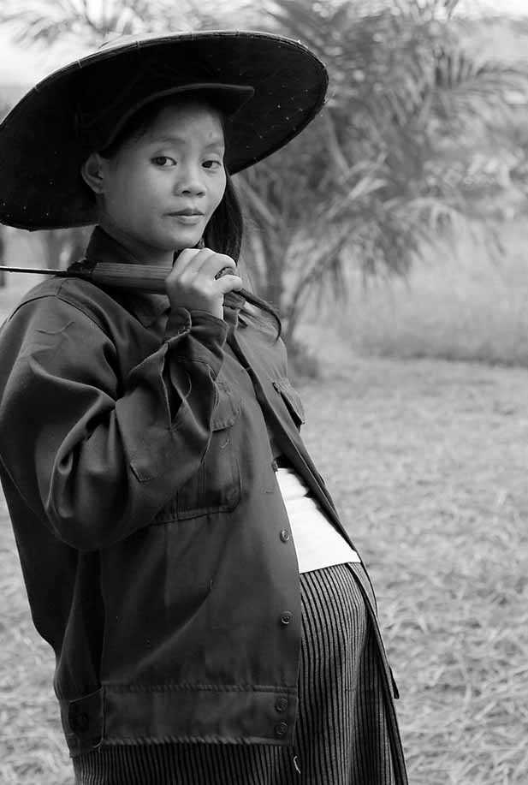

Session 9:

Priority Action Plans

# Session 9: Priority Action Plans



**40 Mins**



With the workload that comes with managing a destination, it’s not always easy to actually implement the changes you would like. In this session you will look at the work you completed during this training and create a simple action plan to improve your destinations. You complete a single activity

## Activity 9A: Priority Action Plan



You will work step-by-step, session-by-session to reflect on the activities and action plans that you have drawn up.



**40 Mins**

1. You talk in a group. Everyone says what he or she learned from in each of the activities. We start from the first activity.
2. For the next step you use Table 9A: Priority action plan. Individually you look at the action plans you completed for each session and choose which of the changes you will introduce first and when, in a week, in a month, in two months? List at least 3 actions [15mins]
3. Each of you presents your Priority action plan and the group shares their ideas of whether the priority of actions should be changed or if they are good the way they are. it. Each participant has 5 minutes. [25mins]
4. As a group, you can use additional time to decide whether you will meet again, after the training to practice some of the activities, like costing or anything else. You can also plan to meet on a regular basis and talk about how you are doing with the changes you are introducing

|  |  |  |  |
| --- | --- | --- | --- |
| Table 9A: Priority Action Plan | | | |
| My priority changes | How will I make the changes? | When? | Who is responsible? |
|  |  |  |  |
|  |  |  |  |
|  |  |  |  |
|  |  |  |  |
|  |  |  |  |
|  |  |  |  |



Prioritizing actions, the activity you completed at the end of the training, is a very important step. It pushes you to decide how to apply what you have learned in this training into your work and lives. You can use it together with the Training Guide to do revisions and motivate yourselves to take actions.

This is the end of the training. You can now complete the evaluation. In few months there will be some follow up evaluations too.

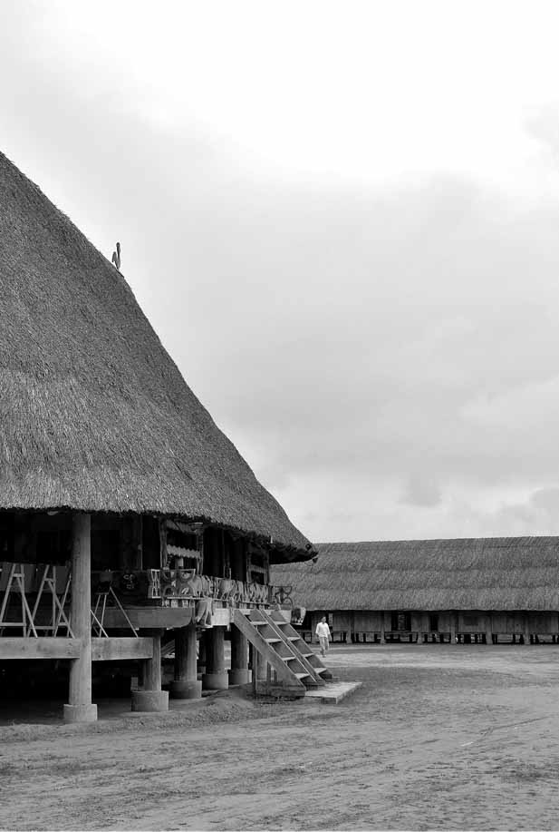

Annex 1:

Flipcharts

# Annex 1: Flipcharts

Write this information on the Flipcharts before the training begins.

## Flipchart for Activity 3A



1

**Flipchart 1: Guidelines for Effective Brainstorming**

* Encourage everyone to contribute ideas.
* Make everyone feel safe and comfortable contributing ideas.
* Seek as many ideas as possible, even unusual ones.



www.sme-tools.org