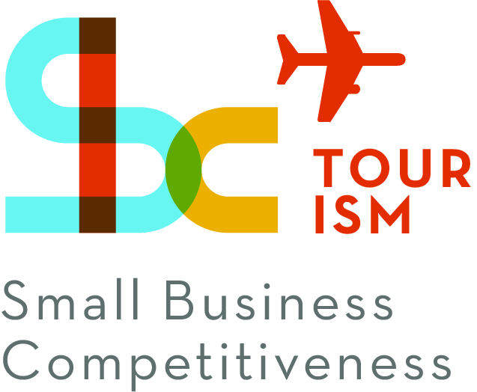

HANDICRAFT MANUFACTURERS GOOD PRACTICE GUIDE
ILO - ASEAN Small Business Competitiveness
A product of

Small Business Competitiveness by International Labour Organization (ILO – SBC) is licensed under a Creative Commons Attribution-Non Creative Commons Attribution‐NonCommercial‐ShareAlike 3.0 Unported License.
brought to you by:

Attribution — You must give appropriate credit, provide a link to the license, and indicate if changes were made. You may do so in any reasonable manner, but not in any way that suggests the licensor endorses you or your use.

NonCommercial — You may not use the material for commercial purposes.

ShareAlike — If you remix, transform, or build upon the material, you must distribute your contributions under the same license as the original.

https://creativecommons.org/licenses/by-nc-sa/3.0/legalcode
Table of Contents
Introduction 1
About C-BED 1
Handicraft Manufacturing 1
The Handicraft Package 1
How to Use The Good Practice Guide 2
1. Creating Systems 5
2. Your Product 7
2.1. Assessing Who You Are and What You Can Make 7
2.2. The Product From the Final Owner’s Point of View 10
3. Your Target Market 15
3.1. Types of Retail Markets and The Consumers Who Shop in Them 16
3.2. How Different Markets Usually Pay Their Suppliers 17
4. Customer Service 19
4.1. Reliability, Consistent Quality, Exceptional Communications 19
4.2. Market Research 20
5. Product Development 25
5.1. Market-led Product Development 25
5.2. Adapting to Your Market 26
5.3. Adapting to Changes in Your Business 26
5.4. Perceived Value 27
5.5. Increasing value 27
5.6. Developing New Products 28
6. Purchase Orders 33
6.1. Steps for Receiving and Confirming a Purchase Order: 33
7. Improving Production 37
7.1. Safety First 37
7.2. Evaluating The Current Production System 38
7.3. Planning and Scheduling Production: 39
7.4. Tracking Production 41
7.5. Raw Materials Management 41
7.6. Adequate Skilled Labour 43
7.7. Machinery and Tools 43
7.8. Work and Storage Space 44
7.9. Just-in-time Production 45
7.10. Dealing with Bottlenecks and Disasters 46
8. Quality Control 49
8.1. Raw Materials 50
8.2. Production Process 50
8.3. Training Workers 50
8.4. Working Conditions 50
8.5. Protective Packaging and Packing 51
8.6. Duplicate Samples 51
8.7. Effective quality control – Review 51
9. Costing and Pricing 55
9.1. The Difference Between Pricing and Costing 55
9.2. Costing 55
9.3. Recordkeeping 56
9.4. Cash Flow 57
9.5. Profit 57
9.6. Pricing 58
9.7. Reducing Cost 58
9.8. Increasing Price 59
9.9. Wholesale and Retail Prices 59
10. Turning Down an Order 63
11. Competitive Advantage 65

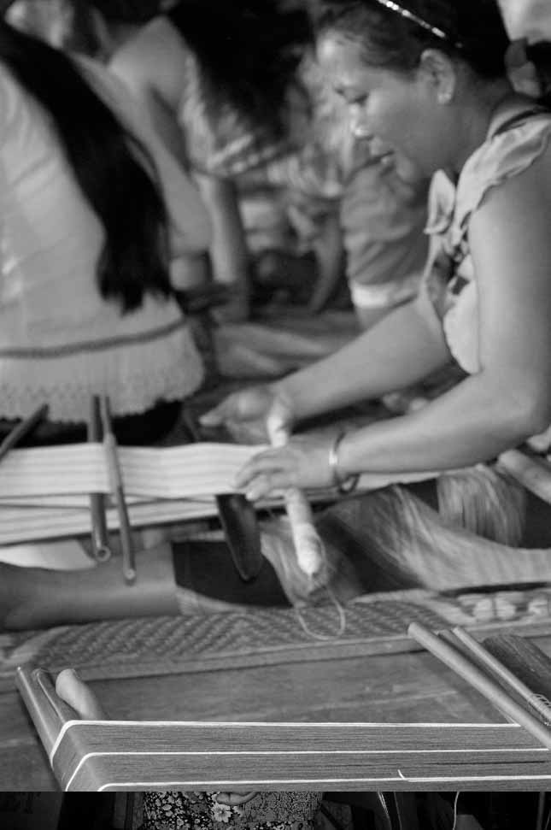

Introductions

Introduction

About C-BED

Community-Based Enterprise Development (C-BED) is a low cost, innovative training programme designed by the International Labour Organization (ILO) to support skills development and empowerment in local communities for improvements in livelihoods, productivity and working conditions.

As an approach to training, C-BED is unique in that the programme is built around peer-to-peer, activity based learning methods with no role for teachers, experts, or external consultants specialised in the skill area. Instead, C-BED participants work together through a series of activities and discussions guided only by simple step-by-step instructions in the training manual. New knowledge, skills and competencies are developed through the interactions between participants and sharing of existing local knowledge and experience. In this way the programme is a low cost, sustainable option for any organization or community.

The C-BED programme is structured around two core training packages designed to develop competencies for business start-up and operation through a focus on marketing, financial management, and action planning. These are the C-BED for Aspiring Entrepreneurs and C-BED for Small Business Operators. Additionally, a growing suite of tools to strengthen business competencies and enhance skills for specific sectors is in continual development. These packages can be implemented as either stand-alone trainings or integrated in modular format into existing programmes.

Handicraft Manufacturing

Handicrafts are products made by artisans. There are wide ranges of products that can be manufactured as handicrafts ranging from decorative to functional items. As part of the tourism industry, they are often locally made products that tourists can purchase from their destinations. Handicrafts markets and shops are an important source of entertainment for tourists and purchasing good quality handicrafts can contribute to the tourist experience.

The Handicraft Package

The Handicraft package should be used to help aspiring and current handicraft manufacturers start and improve their businesses. It focuses on key business principles to build on from what participants already know from managing their handicraft businesses and helps them to learn more. It can also build on from the learning in other C-BED tools namely SBO or AE. Participants bring experience to share and leave with a priority action plan (at least 3 actions to introduce improvements to their business). At the end of the training participants will have:
- Enhanced and advanced existing knowledge on handicraft manufacturing development
- Strengthened critical competences to analyse job prospects or current conditions of work
- Affirmed the potential of enterprise development
- Identified steps and actions to improve a business or launch a business idea
- Decided on actions for the future
- Started planning effective collaborations and associations

The Good Practice Guide:
This Good Practice Guide (GPG) is designed to help all handicraft manufacturers start and improve their businesses. Those who take part in the training day will be introduced to and become familiar with the GPG on the day. However, those who have not attended the training can also use the GPG. The GPG contains a number of practical tools, tips and exercises to help business or aspiring handicraft manufacturers.

How to Use The Good Practice Guide

Tips
Extra information for you to take note of
Definitions
Case studies
Exercise

Good practice tools
Creating
Systems

1. Creating Systems

OBJECTIVES:
- Helps you to know what a system is
- Helps you to know where systems can help you

TRAINING GUIDE:
- We cover this in session 2

What is a system?
A system is a set of organized, detailed procedures created to accomplish a task, do a specific activity, perform a duty or solve a problem efficiently with consistent quality.

A good system does not have to be complicated, the easier it is to follow the better. A system often starts with a checklist of clear, step-by-step things to do. A good system will help you run your business and achieve your goals in a logical, repeatable, and efficient way with the least amount of disruptions.

Where can systems help you?
Some areas where can systems help artisans succeed are:
- Assessing who you are and what you can make
- How to determine the best market and customer match for you
- How to learn about and understand your market and customer
- How to do market-led product development
- Improving production and quality control
- Record keeping
- Calculating your costs and setting your prices
- Efficient and reliable Customer Service
- Deciding whether to accept or turn down an order.

Your Product

2. Your Product
OBJECTIVES:
- Takes into account your strengths and resources when looking at what you can make
- Helps you to see the product from the final owners perspective

TRAINING GUIDE:
- We cover this in session 3 and 4

2.1. Assessing Who You Are and What You Can Make

What you can make depends on what you have available to you. What can you make for sale, what materials do you have access to, how much time do you have? Complete this exercise to learn more about who you are and what you are able to make.

- Fill out Table 2.1, answering the questions provided there.
- Once you have completed the table highlight in one colour your key strengths or anything that makes you unique from your competition
- In another colour, highlight any weaknesses or gaps (anything that will make it difficult for you to succeed) that you see
- Finally summarise what you find in the table in a sentence. For example, “I am the most technically skilled wood carver in my district, but there’s a shortage of good wood, and it often warps and cracks.”
- Here are some things to think about while you fill in the table:
- Who are you and who works with you?
- Do you work alone, with your spouse or do you have employees? Do other family members help?
- What do you make?
- Do you make clothing, jewelry, pottery?
- Is it strictly functional, decorative, or museum-quality? Do you produce high volume, limited production, one-of-a-kind products?
- What are your skills?
- If you make textiles for example, can you machine-sew, hand-sew, embroider, applique?
- Can you make complex pattern pieces?
- Can you tailor and custom fit garments?
- Can you weave and dye your own fabric? Can you install pockets and zippers?
- List as many skills as you can think of. There may be opportunities to earn from skills you hadn’t thought using of once you see them all.
- What materials do you use?
- Make a list of all the raw materials that go into your products.
- Your workspace:
- Do you work in your home or in a dedicated workspace?
- List your equipment and tools. Don’t forget your worktables, shelving, and other storage. List the utilities you use. Do you have a vehicle to bring your products to market?
- When do you work, and how much?
- Do you work year-round, or seasonally, full- or part-time?
- Do you have other sources of income?

Table 2.1 (1): Who Are You and What Can You Make
Who are you and who works with you? | What do you make? | What are your skills? | What materials do you use? | Your workspace:  Equipment, tools, utilities do you have and use? | Do you work year round, or seasonally? Full- or part-time? | Do you have other sources of income?

Strengths and weaknesses
By analyzing your strengths and weaknesses, you can learn where you have a competitive advantage that you can use to gain market share where your competitor is weak, or to promote your business. And, you can see where you are comparatively weaker and need to either improve, or decide it’s not worth to produce anymore.

If you have a significant advantage over your competition, you won’t have to compete on lower price, you will be the best source for that business. Similarly, if your closest competitor is much stronger than you in a particular area, say she/he has a high volume workshop that makes low cost products, you may decide against going head to head with her/him and to take your business in a different direction where you can excel. Later we’ll look at turning a disadvantage into an advantage.

You can use this system and change the headings to analyze your strengths and weaknesses in other areas, such as:
- Where is my money going, and am I making a profit?
- What are all my costs and expenses that go into making an item?
- What do I sell it for?
- How many do I sell, how often, when and where?
- Do I have cash on hand to buy what I need when I need it?
- How much have I saved for new equipment?
- What are my biggest production bottlenecks?

- In this exercise you will summarise you strengths and weaknesses
- Use the space below to record your strengths and weaknesses, those you observed above and others

Table 2.1 (2): Strengths and Weaknesses Summary
Strengths | Weaknesses

Tips

- Fill out this form for your competition too
- Come back to this form whenever you make changes to your business. Make a new copy, filling in your progress and setbacks, to help you build on your strengths and surmount your weaknesses.

2.2. The Product From the Final Owner’s Point of View

You can have the most magnificent product in the world, but unless someone needs or wants it enough to pay money for it, you won’t make a sale. That’s why you must know as much as possible about who you sell your products to, and who the final person is who owns and uses your products.

You need to be able to answer questions such as:
- Why do people buy?
- What do your customer and the final owner need and want?
- What are some common needs, and what need does your product fill?
- How will the consumer use it?
- What product features will meet these needs and wants?
- How is your product different (better!) than the competition?
- What can you do to improve your product and its desirability?

Why do people buy what they do?
This answer is: people don’t buy products they buy solutions to their problems. Problems include what they think or feel they need, or what they want.

For example, they may have a need to hang something on the wall. The need isn’t to buy nails, glue or tape, but to have the best solution that will attach the object to the wall with the least amount of damage.

Take one of your products, and analyze it from the user’s perspective. Let’s use a beaded necklace as an example. Below is a table that shows three possible reasons to buy a necklace, and what features it needs to meet for each use. It also compares the features of the producer’s product to see if it’s a good match.

Table 2.2: Example: A Beaded Necklace
What need does it fill | How will it be used | What features does it need | My product | Match?
Beauty, fashion | Worn at a wedding | To make the owner feel beautiful | It is the latest style and Colour | Yes
 |  | Won’t to break when if a child grabs it! | Has strong twine, with each bead individually knotted
Religious significance | Worn at a ceremony | Correct symbols and colours | Is fashion fashionable | No
Gift giving | As a present for someone special | Must be appropriate for the receiver | Looks expensive  Comes in a pretty gift box | Yes

Who might buy this necklace if they saw it in a shop?
Someone who knows what the latest style is, who recognizes high quality manufacturing, and who can afford it. It might be someone buying it for herself, or it could be a man or woman buying it to give as a special gift to someone special.

Who could be the final owner?
Probably someone with great taste who understands high quality, and cares about the latest fashion trends: most likely a mature woman and not a teenager. It would not be appropriate for someone who needs a necklace to wear to a religious ceremony. Note that a man could be the buyer of my necklace, but he would not necessarily be the final owner. We’d need to understand both the buyer and eventual owner: how a man makes jewelry buying decisions, and what will make the woman he gives it to want it to own it.
We have one more buyer to think about. This is the shopkeeper we sell to, who will be reselling the necklace to the man, and who will be giving it to the woman Let’s talk about that in the next segment.

We need to know as much as possible about all the different people who will have temporary and permanent ownership of the product. We need to know their problems and how we can solve them. We need to understand their needs and wants.

Tips

- You can also do the same of analysis of your competitors products
- You should continually think about what you can do to improve your product and its desirability for the final owner

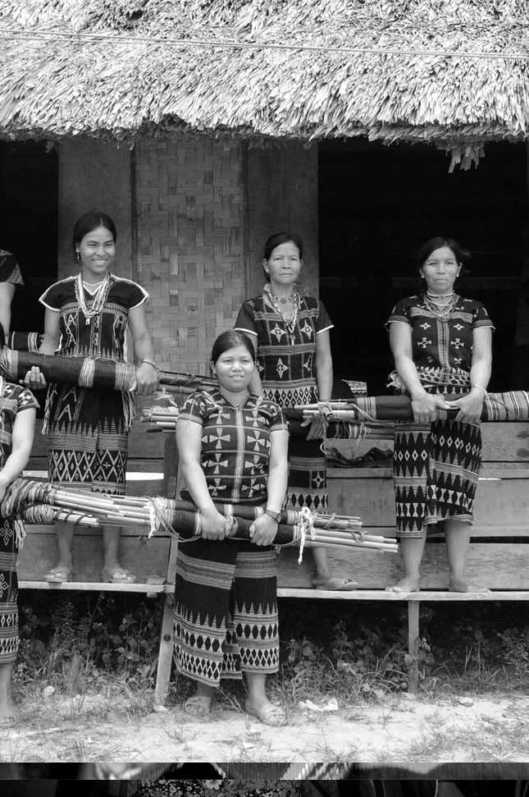

Your Target Market

3. Your Target Market
OBJECTIVES:
- Defines target market and looks at the difference between your customer and the final owner
- Gives and overview of types of different markets

TRAINING GUIDE:
- We cover this in session 4

Unless you retail yourself and sell directly to the final owner, you probably wholesale to a shopkeeper, who in turn sells to the end consumer or to someone who buys something to give as a gift. They have different needs and wants, and we have to understand both our customer and their customer to be successful.

Note

If the shopkeeper and final consumer are both buyers, how are their needs different? Your end consumer buys products they like that they need or want. A retailer buys products she can sell at a profit. The retail shop owner is running a business just like you, and has the same kinds of business concerns. Like you, the shopkeeper is in business to make a profit, and needs access to the right merchandise, or products, that their target market will buy. This the end customer we just talked about. Think of your products as the retailers’ raw materials. They need the right kind, quality, price, consistency and availability.

Note

You may be surprised to hear that retailers may not necessarily like the products they sell or want to own them themselves. They just need the right products for their buyers who are their market, just like you do, so their business will be a success.

DEFINITION: Target Market

Your target market is whom you sell directly to. Choosing the right market to sell to is just as important as making the right products.

3.1. Types of Retail Markets and The Consumers Who Shop in Them

The local daily or weekly marketplace sells everything from food to tools to household goods to basic clothing, where families purchase their routine necessities, including simple utilitarian crafts at modest prices. This is where functional, durable, and reasonably priced items like baskets for carrying rice and other produce, fabrics for making clothing, and cooking pots would be sold.

Local gift and housewares shops in your village sell things that are useful, pretty and that can be given as a gift. These crafts will be higher quality and more decorative, they will still tend to be primarily utilitarian and affordable. Vases for flowers, serving bowls and trays, picture frames, and religious artifacts can all be found in the village gift shop.

Retail shops in larger or more affluent cities are another outlet. These stores sell to people with more disposable income, cosmopolitan tastes, who are interested in international trends and in high quality authentic design. Stores specializing in this kind of merchandise can be freestanding independent retailers, and they can also be a department within trendy department stores.

Tourists and affluent natives will also shop in hotel shops, galleries and museum stores. Crafts must be of the highest quality and artistic design to be displayed in such prestigious settings. Here you will sell fewer, but higher priced, products. If your production is a one-of-a-kind, or a limited edition product this could be the perfect outlet. Hand painted or embroidered wall hangings, high fashion clothing and jewelry, and very authentic traditional artifacts will find a home and a buyer in these exclusive outlets.

Cultural festivals and other special events are wonderful domestic outlets for crafts. People often buy souvenirs, ranging from cheap trinkets to high quality original art. The crafts that sell best will be impulse buys, which are decorative, fun, or special, including clothing and personal accessories, musical instruments, holiday and religious goods, and things that relate to the theme of the event. It helps if the merchandise is easy to pack and carry home.

3.2. How Different Markets Usually Pay Their Suppliers

Each type of marketplace has a fairly common standard payment method for its suppliers. You may of course agree with your buyer on different terms of payment. Just don’t assume you will be paid a particular way, your buyer may have a different assumption. Make sure you are clear on the terms of payment and that you understand all the implications.

It would be best to have everything in writing, so if there is ever a question or dispute you can refer to your contract or purchase order. The more comprehensive your agreement is, the less likely you are to have a dispute and to lose money on the sale.

When you sell outright you will typically be paid cash in exchange for your goods, though some customers may ask for credit.

Shopkeepers may buy your products for cash on delivery, or may only pay once your item has sold. You will need to agree on the terms before you do business. For instance, how long after something has sold will you are paid, and the amount. Some things to think about include:
- How long can the shop keep your item if it hasn’t sold before you can take it back?
- What happens if the shopkeeper sells your item at a discount?
- Will your payment be reduced or will the shop take the entire cut?

Galleries and other high-end outlets may sell on consignment. This means you own your products and don’t get paid until the work sells. You also get a percentage of the sale price, rather than a fixed price, depending on for how much the gallery sells your work. Consignment is tricky and you should get competent legal advice before selling this way.

Tips

- It is vital to understand how and when you will be paid, and to have protection if you will be paid only after something sells, or if something is damaged while in the store.
- Make sure you remain the owner of your work and can get it back if the shop closes or goes out of business.

Customer
Service

4. Customer Service

OBJECTIVES:
- Defines what good customer service is
- Gives an overview of how to conduct market research

TRAINING GUIDE:
- We cover this in session 4

4.1. Reliability, Consistent Quality, Exceptional Communications

At the top of every company’s list is the need to work with reliable suppliers. Shopkeepers often work very hard for not enough money, and have intense competition they must stay ahead of. How reliable a supplier you are is just as critical to them as it is to you, and can even be more important than having the latest designs.

Tips

- Anything you can do to make your customers life easier will give you an advantage over your competition. Be a good business partner and people will want to do business with you instead of someone else.
- Always do as you say you will. Deliver correctly, and on time. Without the right product, no one will look at what you have to sell. Without reliable delivery, no one will go to the trouble of buying from you no matter how great your product, or won’t buy again.
- Communicate all issues and unforeseen events immediately to your buyer. Do not make a change on your own without your customer’s consent.
- If you’re not sure about something, ask. Do not guess.
- No one will buy from you because you need the sale. They will buy from you if your product is good; you’re a reliable supplier and a good business partner. Make sure it’s easier to do business with you than someone else. Above all be professional.

- Use the table below to help you identify what the best market and customer match is for you
- Fill out the table to help you identify your target market

Table 4.1: Best Market and Customer Match
Who buys my products?
Who uses my products? (the end consumer)
My target market: what kind of shop?
Where is my target market located?
What is my competitive advantage?
What can I do now to improve my business?

4.2. Market Research

It is important to get information about your target market and their customers. One of the best ways to learn what products your market will buy is to ask. If you are a reliable producer and a good business partner, the wholesaler or buyer you sell to will be very happy to give you information to improve your products, for when your products sells more, they sells more, and you both make more money. They will also be impressed with your professionalism and desire to learn and will consider you a good business partner.

Once you’ve developed a successful and trusting relationship, your buyer will be more willing to give you accurate information about their customers, the competition, and industry trends, to help you provide better products for their customers. Some of the things you might want to ask about include:
- Who will want to buy what you can make and why? What is their lifestyle, where do they live?
- What are the typical things they buy the most? Why?
- What changes are needed so your product is more desirable?
- Will enough people want to buy what you make so it worth your while to produce it?
- What are your major competitors making? What can you make that’s different and better?
- What is the typical price range for your type of products? How much sells in a set amount of time?
- What are the typical sales and payment terms?

Note

We talked about customer service before market research because the better your customer service, the stronger your business partnership, and the more your buyer will want to help you with good market information.

- Brainstorm some other ideas about how you can get information about your market and final buyer
- What other kinds of information would be helpful to you and where could you get it?
- Record your ideas in the space below

Table 4.2 (1): Market Research

- Use this table for each product that you want to sell to help you learn more about your market and decide what the market wants and to decide if it is right for you
- Answer the questions in column 1 and repeat this for your different products.

Table 4.2. (2): Which Market is Right For Your Product
Product:
 | Buyer 1 | Buyer 2 | Buyer 3 | Buyer 4 | Yes/no
Which end-buyer would buy this?
What changes do I need to make to sell more?
Is the market big enough to be worthwhile?
What price will this sell for?
How much profit will I make?
How much of my product sells in a set amount of time?
What’s the closest competitive product?
Who’s my competition?
What else can the shop sell that it doesn’t have and that I can make?
Other

Other
Other

Other

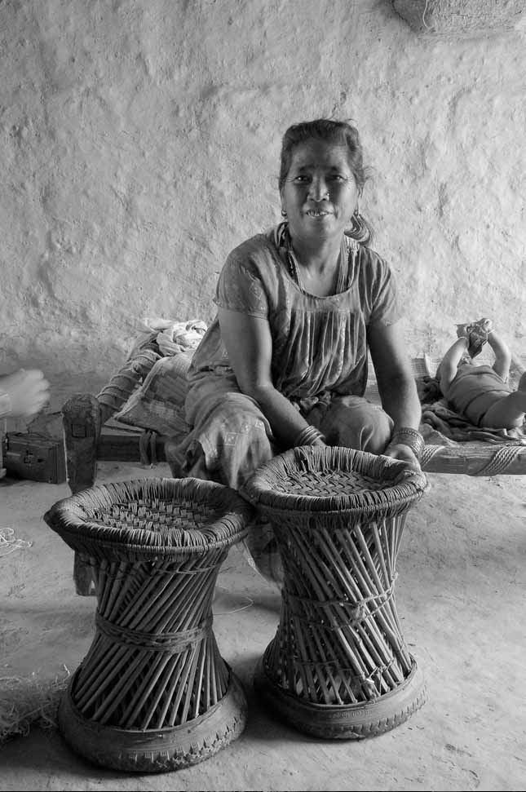
Product Development

5. Product Development
OBJECTIVES:
- Helps you to gain an understanding of how to develop new products
- Provides an overview of how to increase the value of products without increasing cost

TRAINING GUIDE:
- We cover this in session 5

5.1. Market-led Product Development

Market-led product development vs. product-led product development:
Market-led product development involves choosing and understanding your market first, then designing for it where as product-led product development involves making products first, then looking for a market that might buy it. Market-led product development is about being market focused.

- Based on what you have learned in the GPG so far, which approach do you think is better and why?
- Record your thought in Table 5.1

Table 5.1: Market-led Product Development

5.2. Adapting to Your Market

Markets and consumer wants and needs are not static. They change over time.
- Tastes and trends change all the time. What’s fashionable today might be outdated tomorrow.
- Economic situations change and customers can afford to spend more or less.
- They need something for a specific event, like a birthday present or the holidays.
- People get older and need different things.
- People want something new or different

Remember: people don’t buy products; they buy solutions to their problems.

5.3. Adapting to Changes in Your Business

You may also need to develop new products because of changes in your business. For example:
- Some raw materials are no longer available; they have gotten more expensive, or have changed
- Your workforce has gotten smaller or bigger, and people have more or fewer skills
- You need to differentiate from the competition
- You need to offset sales seasonality (something only sells at a certain time of year)

Table 5.3: Adapting your products
 | Y/N | Why? | Solutions
Is my product still selling well?
Am I making enough profit from it?
Are there raw material supply or quality issues?
Other
Other
Other

5.4. Perceived Value

Perceived value is what something is understood to be valued at, what it seems to be worth, and what people generally are willing to pay for it. It may have no relation to its real value based on costs.

Perceived value can be higher or lower than the real value. For example, perfume has a high-perceived value, yet the ingredients are only about 2% of the selling price. Perfume manufacturers have convinced the market that perfume is worth more, and people expect to pay and are willing to pay high prices. In fact, if you saw perfume for sale at a really low price you would probably be suspicious and think it was bad or fake.

Handmade baskets on the other hand typically have a low-perceived value. Even though they require great skill and a lot of time to make, most people do not value them highly and will not pay what they are actually worth.

Unique items are perceived as worth more. When there is a lot of the same thing, it’s no longer special. It’s perceived as worth less and as being cheaper. It is key to differentiate yourself from your competition and make your products unique.

5.5. Increasing value

To improve the value of your products in the eyes of your consumer, you can improve the quality of your products and do other things that make them seem worth more, but that will only increase your costs by a small amount. Value-added is when the perceived value of something is increased by more than the extra cost incurred. If we increase our costs by as much as we increase the value, we don’t gain anything.

Tips

Some things that add value, or increase perceived value without greatly increasing our costs are:
- Updating the design and style, making your products as fashionable as possible may not cost you much but the latest designs are worth more.
- Make products functional in addition to being decorative. A pillowcase is functional and decorative. A pretty box is also useful and it can hold things. Reusable things also have higher perceived value.
- Use several materials or patterns, more than one production technique, or moving parts, in one product.
- Make different things from other producers. When everyone makes the same thing, it becomes common and appears to be worth less. Unique things are worth more.
- Make sure your products look like they are carefully handmade. Quality and finish are most important, even for inexpensive items. It shows when things are made with care. They look better and are perceived as more valuable.
- Promotional materials that explain your product inform the consumer and get them interested in buying it. Use hangtags to describe the cultural importance of your design, to explain how it is made and its traditional uses. Explain how to use your product. Make hangtags as well designed as your products.
- Boxed sets and appealing packaging increase perceived value, yet don’t add a lot to the cost.
- Sets of matching things may also be perceived as more valuable.
- How things are displayed also effects how valuable they appear. Make your presentation and display as nice as possible.

5.6. Developing New Products

After you’ve done your market research and you know what your customers need and want, you need to develop new products or adapt your current ones to make them more desirable and saleable. One way to do this is to base the new designs on your existing ones:
- Old products can be improved and/or updated.
- Expand your product line into a collection, a set, or a line extension.
- Improve quality of existing products.
- Add new colours, shapes and sizes.
- Make things that coordinate (go together, not match) with each other.

Coming up with new designs
Sometimes you may want to develop entirely new products. Work with what you already have that makes you unique from your competition. These could include:
- Design, artistic, traditional, and cultural resources
- Raw materials
- Skills and human resources
- Machinery and technology
- Can you turn a disadvantage into an advantage?

To look for new ideas, look outside your business and get help from outside resources:
- Look at trends in magazines, catalogues, shops, trade shows, TV, and on the street
- Get input from buyers, customers, consumers, and friends
- Brainstorm with other artisans
- Hire outside consultants and designers

Development and testing
Once you have a good idea, you need to develop and test market it:
- Make sketches of your ideas
- Make prototypes
- Ask for feedback from buyers, friends, and colleagues
- Assess if production is feasible. This would include having raw material available, skilled labour, and good production capacity
- Test market a limited number to see if it is successful before you invest in the resources you’d need for production. Make sure it’s worth it.

Costing new items
You will need to know what the cost of each new item is to your business. For each new product, you will need:
- To stock new kinds of materials that you will have to buy and pay for in advance.
- Get training in new production techniques, such as in new painting styles, in how to work with new materials, or in how to use new machinery (which you may also need to purchase).
- New packaging that needs to be designed, bought, inventoried and stored.
- Keep track of each additional product. This increases the amount of record- and bookkeeping you will have to do.

These all increase the cost of making the new product. Make sure it is worth the extra cost and effort:
- Cost the product to see if it will be profitable
- Forecast sales volume and market potential
- Forecast cash flow, budget, production and delivery lead times
- Assess the risk. Every change you make affects your business, both for good and bad.

Can you turn a disadvantage into an advantage?
A much more profitable and enjoyable way of doing business is to figure out what it is that you do best and to specialize in that area. This would mean using the skills, materials, or resources you have that are unique to you, or that you can do better than anyone else.

For example, a large production shop is very different situation to a family business. The large shop may have many people with basic skills that need to be kept fully employed. It may also have a line of credit and the ability to buy and store supplies. This business will do best with large, steady orders of simple, related items.

On the other hand, the family business may have rare artistic skills handed down through the generations, or unique traditional designs that are very intricate and labour-intensive. They may also only produce handcrafts part-time. This business will thrive with small orders of very high quality pieces that may take a long time to make but sell for a higher price, and that have longer lead times.

You can see from this example how these two businesses each have their own strengths and weaknesses and each will excel by making very different products to the other. Even though they may both make handcrafts in the same materials and even the same styles, they have different markets and customers and aren’t competing against each other.

Tips

Product development:
- Everything you do should be aimed at increasing sales of your products. You have no reason for undertaking it if it is not going to help you make more money, either directly or indirectly.
- Make products people want to buy. The product must be desirable on its own.
- Make what you’re good at and what you know, inspired by your culture. Make everything as perfect as you can, especially the finishing.
- The more rough and less unique your product, the more you will be expected to lower your price, since it could be made by any factory worker for cheaper. The better your workmanship, the less you will have to negotiate on pricing.
- Don’t copy other artisans. If you try to make art objects you won’t make them as well as the owners of the artistic tradition.
- Show your buyers your dedication to making quality products you are proud of, and your willingness to adapt your merchandise to suit the needs of your buyer. The buyer knows what s/he can sell, and will be happy to give you design and colour information when you’ve established a trusting working relationship.
- Always make the best possible quality you can, even for inexpensive items. Constantly strive to improve your quality.
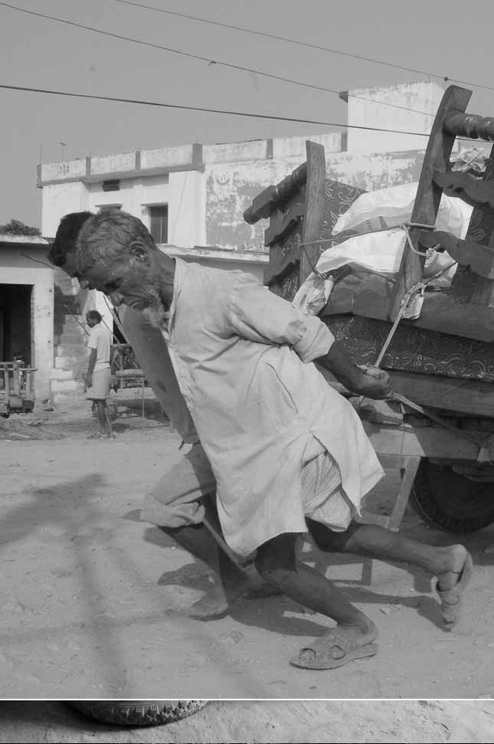

Purchase
Orders

6. Purchase Orders

OBJECTIVES:
- Gives you an understanding of what a purchase order is
- Covers what a purchase order should contain and how to receive and confirm it

TRAINING GUIDE:
- This is additional information, not covered in the Training Guide

A purchase order (PO) is a written contract issued by a buyer to a seller. It details the products what the buyer wants to purchase and contains product description, quantities, payment terms, delivery dates and shipping or delivery details.

A PO is a legal offer to buy products. However, no contract exists until the seller confirms acceptance of the PO. Once the seller accepts, they will be expected to deliver the products exactly as specified in the PO by the date specified and for the price listed in the PO. This is why before confirming acceptance of a PO, it is important to review it carefully to make sure all of the conditions of the order are acceptable and that you will be able to make and deliver the product as specified. If there are any questions or concerns about the PO, or something needs to be amended, it is vital to communicate this clearly to the buyer beforehand. It is better to be clear in the beginning than to have disputes later on.

6.1. Steps for Receiving and Confirming a Purchase Order:

1. Carefully review the PO:
- Are the prices correct?
- Are there any doubts or concerns about what products are being ordered, have any changes been requested?
- Can you produce the order in time for the delivery date? Do you have all the materials and labour needed to fill the order on time?
- Are the payment terms and payment method acceptable?
- Are there any special instructions regarding labeling, packaging or shipping that you need to be aware of or that may add to your costs or the time needed to produce the order?

2. Communicate any concerns, questions or difficulties:
If there is anything that you are concerned about in the PO, talk with the buyer immediately. If you need to make any changes to the PO, discuss it now, explaining the change. Don’t send a confirmed PO with something altered on it. You must ensure that the buyer understands and accepts the change you need. The buyer will then issue a new, acceptable PO.

3. Confirm the purchase order:
Once you have seen that everything in the PO is acceptable, and you are certain that you can meet the order deadline and specifications, confirm in writing your acceptance of the order. Include the PO number in your acceptance of the order.

POs can vary in format, but they should always include the following information:
- Buyer’s name, address, and complete contact information
- Where the order is to be delivered or shipped to, and the due date
- Who and where the order is to be billed to: where the invoice is to be sent
- PO number
- Date PO issued
- Seller’s name and address, and complete contact information
- For each item, the product name, buyer’s and seller’s product codes, and a detailed description:
- Materials
- Product /description
- Style code
- Colour/s
- Size/weight/dimensions/measurements
- A photograph, if available
- Quantity ordered, price per unit, and total cost per item
- Total amount of all items on the PO
- Additional charges, such as delivery, special packaging, etc.
- Total price for the order
- Method and details of delivery
- Method of payment and payment terms
- Special instructions for labeling, packaging, packing, documents, insurance (if needed)
- Buyer’s signature

While POs have a lot of information, they don’t need to be complicated. The easier they are to understand the better.

Tips

Ask for a written PO, and if the buyer doesn’t have one, you provide one.
A written PO that can be consulted and reviewed is your only insurance against disagreements.
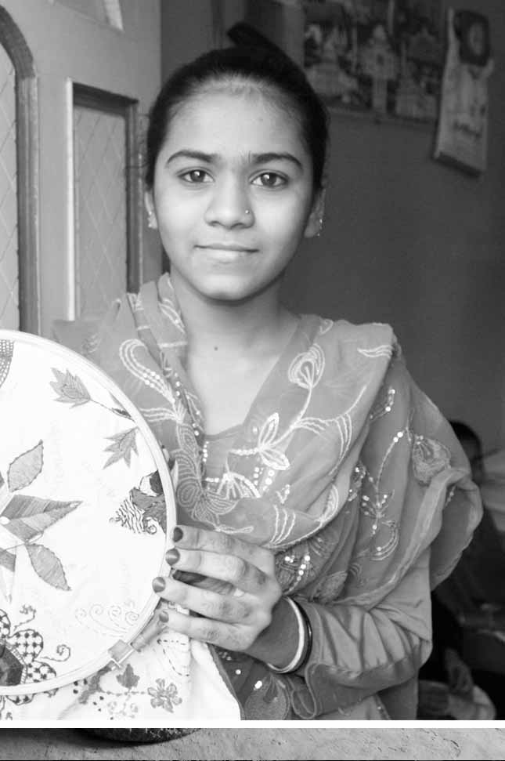

Improving Production

7. Improving Production

OBJECTIVES:
- Gives safety and health tips
- Shows you how to evaluate your current production system and how to improve it through better scheduling, tracking and management of production

TRAINING GUIDE:
- We cover this in session 6

All manufacturing businesses, including small handicrafts businesses, need to deliver high quality products, bring their products to market in a timely manner, reduce costs, manage change emergencies, and be profitable. Production refers to all the steps involved in making a product, from the first contact with the raw materials to the finished product ready for packing and shipping.

Efficient production will help you compete better. When your physical workspace and your workflow are organized for maximum efficiency, you will produce the most amount of uniform, quality-controlled product, in the least amount of time, for the least cost. Thereby, increasing your profit.

7.1. Safety First

You safety and health and that of everyone working with you should always be your first concern and priority. Never compromise the safety of your people and customers, products, workshop, or the environment for a sale. The short-term gain is never worth the long-term consequences.

Tips

- Have detailed, accurate, step by step procedures for every process. Make sure everyone knows and understands them and follows them.
- Always heed safety warnings on all equipment, chemicals, etc.
- Ensure only trained, qualified workers operate machinery or handle anything potentially hazardous or dangerous. Make sure they have proper protection.
- Store and dispose of materials properly.
- Always have first aid available, and have step-by-step procedures for getting medical help.
- Maintain a clean, uncluttered, healthy workshop. Have good lighting, ventilation, etc.
- Ensure workers are in good shape for their jobs and are well rested and not sick.
- Keep children far away from anything potentially dangerous. Better yet, keep them out of the workshop altogether.

7.2. Evaluating The Current Production System

In addition to scheduling and tracking the manufacturing of your product, you need to know and keep track of all the information about each order.

To improve production, a business needs to first evaluate its current production system before it can practice an optimum one. You instinctively know what goes into making your product, but listing every step ensures you won’t forget to allow for any time and materials you’ll need.

- For each product, identify each step required to make it, no matter how small or minor; the order they need to be performed in; and how long each takes.
- Identify everything that goes into making the product: raw materials, equipment, tools, space, (rooms, tables, shelves, etc.), training, labour, time, utilities, packaging, packing materials, etc.
- Identify quality control issues, bottlenecks, where the product needs improvement, and anything else that could be troublesome or can be improved.
- Evaluate the efficiency of your current production system.

Table 7.2: Evaluating Production
Raw materials | Tools | Equipment | Space | Labour/need training y/n | Utilities | Packaging | Packing | Other | Other | Need to improve

Once you have a clear understanding of your current system, you can see areas that need improvement and development and put into practice an optimum production system for each product.

7.3. Planning and Scheduling Production:

Most businesses use charts and timelines to help them plan and visualize how they will fill an order. By starting with the customer’s delivery date and working backwards to the very first step in producing the order, map out all the steps that need to be completed, the order they need to be performed in, and how much time each takes.

- Make a calendar.
First mark off any days that are not available to fill the order, such as weekends, holidays, and time for other orders and commitments you’ve made.

- Make a list of every step and everything needed to produce the order. Don’t leave anything out, no matter how simple or quick. This includes but is not limited to:
- Raw materials: what do you have on hand and what do you need to order? Is it all usable?
- Adequate skilled labour: is everyone available and trained, or do you need time to find workers?
- Equipment: is everything in good working order? Do you need any parts?
- Work & storage space: is there space available to make the order?
- Set up time: what do you need to do to be ready for production?
- Cash: do you need to pay in advance for any raw materials? What about extra salaries?
- Labeling, packaging and packing: do you have everything you need?
- Time for proper setup and cleanup of each production step
- Time for packing and delivery of the order
- Time for recordkeeping and filling out paperwork.

- Estimate how long each step will take to make the full order.
You need to estimate how much time it will take to make the order. Where it makes sense you may generally complete each step of the process for all quantity of the same item, and then move on to the next step, instead of making one piece from start to finish, and then the next piece. Some activities like ordering supplies and waiting for deliveries, still take the same amount of time whether you make one piece or many. While other steps will take longer the more pieces you have to make. Start at the delivery due date and work backwards to find the date you must start the order.

- Make a Gantt chart.
You can create a chart to visualize the steps required to make the product, the order they need to be performed in, and how long each takes. The Gantt chart is a bar chart or line chart with time shown along the horizontal, and tasks along the vertical. It is useful for planning and visualizing how production will proceed. Here’s a sample chart that plots what needs to be done to fill a particular order.

Gantt Chart

Table 7.3. Gantt Chart
Number of days | Activity | Wk 1 | Wk 2 | Wk 3 | Wk 4 |  |  |  | Wk 5 | Wk 6 | Wk 7 | Wk 8 |  | Due date
14 | - Order, receive unpack supplies
6 | 2.
2 | 3.
5 | 4.
3 | 5.
6 | 6.
8 | 7.
3 | 8. Packing
2 | 9. Delivery

This chart allows you to see that:
- Tasks take different amounts of time. Some are active where some are passive, such as waiting for supplies to be delivered.
- Some tasks overlap.
- It takes two weeks to get supplies. You don’t actually start production until week 3.
- Week 5 is blocked out. No activity on this order will occur. There could be a holiday or scheduled vacation, or it could be time that was already designated for working on something else.
- Week 4 is a very busy week with three different activities going on at once, starting and ending at different times. This is a potentially troublesome week and you have to be extra prepared and attentive.
- The order is finished at the end of week 7 and packed at the beginning of week 8, but is not scheduled for delivery until three days later in week 9. This is a cushion the producer has factored in, to budget extra time in case something goes wrong or takes longer than anticipated.

7.4. Tracking Production

Tracking production involves keeping all the details of an order and its production progress together. This involves tracking the order through all stages of production, from the purchase order to delivery, invoicing, and finality once full payment is received. It also provides a complete record of the production experience, which you can use to pinpoint bottlenecks and problem areas in the current production system. This way it can be improved in the future and be more profitable for your business.

All papers, invoices, receipts and communications for the order all need to be kept together in one place. With all this information, you should have a complete record of the order’s history, and can calculate what your total costs were to fill the order (and see if it is profitable), and see how to improve your production systems in the future. With organized tracking systems you also have every detail at hand and don’t have to hunt down any information if a question arises about the order.

There are different ways of collecting and organizing all this information, and it will take thought and time to figure out which tracking systems will work best in your situation. Systems range from simple wall charts to complex computer programs:
- Production of simple orders is sometimes tracked directly on the calendars and charts that are created to plan production. This is easier if these charts are created on large chalk or marker boards that hang on the wall where everyone who needs to has access to add or review information. You still need a space for the PO and other communications.
- Graphic arts and printing businesses use a job ticket (also called a production envelope) to keep all details of the order in one place. A loose-leaf notebook would work similarly.
- Large-scale factories use customized software on networked computers.

7.5. Raw Materials Management

Raw materials are the basic ingredients that make up your product, including unseen ones like glue and nails. Never use banned, stolen, or illegally harvested materials in your products. Try to substitute safer materials for dangerous, toxic, or environmentally damaging ones wherever possible.

Just as your buyers are dependent on having reliable supplies of products, your business is highly dependent on having a reliable supply of consistent-quality raw materials. You cannot accurately produce orders or deliver them on time if your raw materials are unavailable or substandard. Defective raw materials can cost you your business, and not just from their cost.

Tips

- Buy from a few good suppliers. If you procure from 2 or 3 good, reliable suppliers, you will build solid relationships and become one of their good, reliable customers. This way you can usually get the best prices, while still having a solid backup source in case one supplier has a problem. If you consistently order and pay on time, they are more likely to accommodate you when you have a sudden emergency.

Good suppliers
What qualities are important in your suppliers? Remember, the same customer service your buyer demands of you, you have a right to expect in your suppliers.

Good supplier | Bad supplier
- Delivers on time in the correct quantity  - Supplies materials of consistent quality  - Sets fair prices and terms  - Cooperates to solve problems | - Delivers late or early and in wrong quantity  - Supplies defective or inconsistent materials  - Charges high prices or has bad terms  - Is unwilling to help solve problems.

How and when you order raw materials depends on the state of your business and your current production. The ideal amount of raw materials to keep in inventory is a balance between enough to meet current orders plus some extra for damages and waste, but not so much to adversely affect your cash flow and create storage problems. There will rarely be a perfect time or way to procure materials. However, there are several factors to consider:

- Order lead-time
- How far in advance do you need to order raw materials before they are delivered?
- Materials processing
- Do you need to process any of your raw materials before you can use them in your products? (For example, do you need to dye or wash fabric?)
- How long does it take?
- Seasonal availability
- If materials are only available on a seasonal basis, you must anticipate your future needs and order enough to last until they will be available again.
- Useful life-span (obsolescence and spoilage)
- Do any of your materials have a shelf life and become unusable over time? Do any become outdated? If so, order only what you can use during their useful life span.
- Storage facilities
- Do you have adequate storage facilities, including space and proper conditions, to keep raw materials in good condition until you need them?
- Financing of raw materials
- You need to have available cash flow to pay for materials until you are paid for your order. Ordering in bulk will cost more up front, but you may get a volume discount. Consider pooling your orders with other artisans.
- Wastage:
- Finally, when you are ready to order, calculate the amount of raw materials needed including wastage, and add extra to cover damages and defects, both in raw materials supply and in production.

7.6. Adequate Skilled Labour

Whether your products are made by you alone, your family, or with trained help, everyone needs to have the right skills to make your product, be available when needed, and be reliable.

Analyse your workforce:
- What skills are needed to produce your products?
- Who is involved in the production process?
- Are your artisans adequately trained or do they need additional training in some areas?
- How are production steps divided up among workers?
- Can the same workers perform more than one task?
- Are they flexible and able to quickly “switch gears” and perform another job if needed?
- How much supervision do your workers need?
- Who decides how to solve a sudden problem? Are other people capable of making decisions?
- Is someone trained to fix machinery? Are they always available?
- When do you need workers for each step? Full-time, part-time, seasonally?
- Does your workforce meet your current needs or are you understaffed? Can you expand production with your current workforce or would you need to hire and train more artisans?

7.7. Machinery and Tools

Having the right machinery and tools is vital to smooth production. Analyse your equipment:
- What machinery and tools are needed to produce your products?
- Are your artisans adequately trained to use machinery and tools correctly?
- Is all your equipment in good working order?
- Do you have regularly scheduled maintenance checks and servicing to prevent breakdowns?
- Do you have enough spare parts and replacement tools in stock to avoid interrupting production?
- Who fixes and maintains your equipment?
- How much oversight does your equipment need?
- Can any equipment perform more than one task?
- How is each piece used? All the time, sometimes, seasonally? Are you getting the best use?
- Do you have enough fuel and supplies to keep your equipment running? Do you have emergency backups?
- Do you have proper safety equipment? Safety shutoffs? Easily accessible emergency equipment? Does everyone know how to use them and what to do if there is an emergency?
- Does your equipment meet your current needs? Can you expand production with your current machinery?

7.8. Work and Storage Space

Arranging and organizing your workshop for optimum workflow will speed up production, improve quality control, and cut down on breakage and damaged products. Always consider the safety and health of your workers first, and never spare on proper training, safety equipment, light, ventilation, and protection from hazardous materials. No matter the size or layout of your workshop, always practice good housekeeping by keeping it clean and free of garbage, excess raw materials, parts, tools, personal items, defective materials, and people not involved in production; and keep the workshop organized with things returned to their proper place after use.

Workstations should flow in the same order as the production sequence. It is much easier to track production when it progresses in one direction, without backtracking. The most common workshop layouts are linear, where raw materials enter at one end and finished goods exit at the other, or if there is one common entry and exit, a “racetrack” layout where production moves around the workshop. Many workshops, in an effort to maximize space and equipment usage, use space and equipment for more than one task. If you do this, you must be extra careful, as “double duty” usage can cause mistakes in production, and even stop the next step from being performed until the area or equipment needed is free and cleaned, slowing down production.

While no work site will ever be ideal, try to incorporate as many of the following as you can:
- Separate storage and work areas for raw materials, each stage of production, finished products, and packing materials
- Duplicates of tools that are used in more than one production stage, like scissors, hammers, measures, etc. so they don’t have to travel back and forth through the workshop, and be in use at one station when needed at another; or getting lost
- Wide enough isles so workers don’t bump into each other or equipment, especially when carrying things
- Sufficient, un-crowded, logically arranged, and well-labeled storage spaces so it is easy to find everything
- Storage space for raw materials near their entry point, and orders packed near where they exit
- Optimum climate control (temperature, moisture, light, dirt, etc.) to maximize useful life-span of materials
- Well lit, well ventilated, climate controlled space for comfort and safety of workers
- A workshop that is easy to clean and keep clean.

7.9. Just-in-time Production

Just-In-Time (JIT) production, is a management philosophy that strives to make production more efficient by only producing the right product when it is needed. JIT systems increase profits by reducing both finished product and raw material inventory levels and costs, improving product quality, reducing production and delivery lead times, and reducing other costs.

JIT can help a craft workshops operate more efficiently and increase profits. The main principles of JIT are to:
- Produce products only when they are needed (vs. producing in advance in anticipation of orders)
- Minimize costs by minimizing waste and increasing quality.

A JIT, or pull, system, requires:
- Fast, flexible production so that you can respond quickly to changes in demand for product
- Excellent communications so you know the demand as soon as possible.

Tips

- These are excellent capabilities for any business to have, regardless of the production system
- Take advantage of a slow order season and keep workers employed
- Get a head start on a repeat, large order you regularly get from one of your customers
- Produce for an upcoming event
- Replenish your retail shop, if you have one.

There are risks to producing for inventory without an order, including the products that may never sell, and your cash flow is tied up until they do. On the other hand, for times when you need to temporarily increase production capacity, or if you accept an unusually large order, try using scheduled overtime, adding temporary staff, and subcontracting to help get you through the crunch.

Dealing with Bottlenecks and Disasters

Bottlenecks are conditions or situations that slow or stop movement or progress. Production bottlenecks mostly come from the production process, people, and uncontrollable externals like weather or natural disasters. Production will come to a standstill if:
- You don’t have all your raw materials available in sufficient quantity when you need them.
- You don’t have the artisans or they don’t have the skills your product requires
- You don’t have available cash flow or financing to pay for materials or workers
- There is a natural disaster or political situation that prevents your workshop from operating.

Production will slow down if:
- Your workspace is not laid out for optimal movement of people and products
- Your tools and equipment are not up to the task at hand or need maintenance
- Management or supervisors are unavailable and no one else can make decisions
- The calendar is filled with holidays or other non-work days
- Workers have other pressing responsibilities, including agricultural tasks
- Workers are worried about their safety so are more cautious and move slower.

Even the best production system will need to adapt to the unexpected and to disasters. You may have had a flood, or some of your raw materials may have arrived unusable or be unavailable, from any supplier. While you can’t think of every possible scenario, try to have backup plans for every key step. You should have:
- Several raw material suppliers
- Slightly more materials in stock than required, even above wastage (but not so much that you tie up too much cash flow in excess raw material inventory)
- Extra trained artisans, and artisans trained in more than one task
- Spare parts for machinery
- Backup power sources
- Sources for potential financing
- Regular communications with buyers

Disaster affects both you and your customer. Whatever the issue, immediately notify your buyer. Often a solution can be found and the order saved. Your buyer will respect your professionalism, honesty and promptness in communicating, so even if this order can't be saved, you will maintain the relationship and probably get another in the future.

If a buyer's request is difficult for you to meet or you have another suggestion, contact your buyer and ask. Don’t make a decision or change on behalf of your buyer as you may not know the reason for the request, or how important it is. Perhaps the two of you can work out another option acceptable to you both. If not, turn down the order now, before you invest time and money in something unworkable, and while your buyer has time to procure another product.

If something unexpected happens that prevents you from making a delivery date, you may be able to save the order. Evaluate if the cost you will incur is worth it to you, bearing in mind that preserving goodwill and your reputation for being reliable and professional are paramount and will affect future business. These are more important than any extra short-term costs. Again, immediately contact your buyer, and offer to do something to make it worthwhile for the buyer to keep the order, such as:
- Delivering by a faster but more expensive method, at your expense
- Giving a discount in exchange for accepting late delivery
- Splitting the order into two or three shipments.

Quality
Control

8. Quality Control

OBJECTIVES:
- Gives an overview of quality control through the production process
- Outlines some key elements to ensuring consistent quality

TRAINING GUIDE:
- We cover this in session 6

Quality control is how you ensure that products are uniform (of consistent quality) and meet or exceed the standards that have been set by your customers. These include all specifications, such as price, craftsmanship, materials, design, colour, size, style, texture, weight, finish, labeling, packaging, packing, and shipping method.

Efficient production and accurate quality control systems will enable you to meet buyers’ expectations and needs and increase your business. It is imperative to establish specific quality standards and systems for ensuring you meet them, especially if you subcontract work to outside producers. Production quality must also match the quality of the sample the order is based on. A defective or substandard product is a waste of materials, time, money and effort because it cannot be sold, or if it is sold it produces complaints or demands for replacements, and may discourage your buyer from ordering from you again. Buyers have the right to return anything, at your expense, that does not match the PO or the sample you showed them.

Quality control should take place at every stage of production, starting with your raw materials. The earlier you catch a problem, the sooner you can solve it and prevent it from becoming bigger or from ruining production. If you have a quality issue that can’t be fixed, catching it sooner enables you to stop production right away instead of continuing to invest in something that can’t be sold. Continuous quality control will also prevent you from ruining good work at the final stages of production. Quality control also helps ensure production proceeds smoothly.

To ensure quality, you need a workable system with designated people who are responsible for quality at each step of the production process. The Gantt chart you made earlier can help you determine where quality control checks should occur, and these can be scheduled on your production calendar, and tracked on the job ticket.

8.1. Raw Materials

The first step in maintaining quality is careful selection of the materials to be used. Materials should be of the same quality as the sample that was sent to the buyer. If the same materials are unavailable or need to be substituted, the buyer must be notified. All materials should also be examined for quality. For example. wood should be properly dried or final products will crack, textiles should be checked for colour fastness and shrinking, and fittings and fasteners should function properly and withstand use. All materials used should be consistent in quality and colour. In general, it is not a good idea to compromise quality for cost by using inexpensive, but poorly made materials. Paying a little more for good quality materials will pay off in the long run by building buyers’ confidence in your products.

8.2. Production Process

Some buyers may request that a production sample (photo or actual product) be sent to them for their approval before the order is shipped to ensure that it matches their specifications. Quality control throughout production can help identify mistakes and correct them before they result in costly errors. Use a thorough quality control check list for monitoring consistency and quality of your production. See creating a duplicate sample (section 8.6) for more information.

8.3. Training Workers

Handcrafts are often made in small workshops, and large orders may be filled by a number of different producers. In this case, extra care must be taken to make sure that the final products are all alike and are the same as the sample. Training and good communication with the artisans is essential. Artisans should understand what is involved in and how to meet quality requirements. All artisans should be trained in how to check for quality issues as they make the products and be provided with a checklist of what to look for when monitoring the quality of their production.

8.4. Working Conditions

Good quality is also a factor of the working conditions of the artisans. Working conditions include things like fair wages, proper work areas and equipment, and worker incentives. The price paid to the artisan can impact the quality of production, as does the time they have to fulfill an order. If artisans have to produce a large order in a short amount of time, this could result in quality being compromised. If artisans are paid a low wage, they have little incentive to invest time into making a good quality item.

Finally, good quality production also depends on workshop conditions. Work areas should be kept clean and artisans should have all appropriate tools needed. Sometimes something as simple as making sure the artisans have tape measurers can make a big difference.

8.5. Protective Packaging and Packing

Quality can also be compromised if products are not properly packed for shipping. A product may have been made well, but be damaged during shipping, resulting in losses. Entire boxes of products can arrive damaged because they were packed when still wet, were packed too tightly or without adequate protection. Quality control also includes packing products so that they are protected from damages until they reach the buyer. Proper packing is the responsibility of the producer.

8.6. Duplicate Samples

Whenever you make a sample you need to make two. One can get sent out to potential customers, while you keep the other as a control, a record, along with detailed notes on how you made it. This way you can always refer to it and compare your product to the sample at every stage, to make sure you are matching the specifications your buyer expects. This is critical to quality control. Even when you have to make and send a sample in a hurry, make two at the same time, labeling your copy with the buyer’s information. With your copy of the sample in hand, you can more easily discuss changes with your buyer, and make them correctly. For example, if you are asked to use a darker shade of green, you can see the original shade you sent the buyer. Remember, the buyer has a sample, so if an order is not made to match, they have proof. You must have proof that you followed the approved sample, by keeping a copy of the actual approved sample.

8.7. Effective quality control – Review

Some key elements of quality control include:
- Checking quality control at multiple points throughout production process.
- Using a thorough quality control checklist for monitoring consistency and quality of your production.
- Providing a checklist for all stages of production and make sure all artisans know how to check for quality issues as they make the products.
- Making and keeping an exact duplicate samples of the ones sent to buyer.
- Tracking and controlling quality of:
- Raw materials
- Production process
- Training workers
- Working conditions
- Protective packaging and packing
Checklist

Table 6C: Sample Quality Control Checklist |  | Y/N
Colours | Do the colours match the colours requested in the order?  Do they match the sample?  Is the colour consistent in all products? Do the dyes crack, rub off or fade?
Materials | Is the quality of the materials identical to the sample?  Is the quality consistent in all the products produced for the purchase order?
Odours | Does your product smell of stain, paint, fumigants, textile ink, soil, repellents, mould or cigarette smoke? Chances are your buyers will notice these orders and complain. Be sure to air products adequately before packing for delivery.
Size and dimensions | Are the products the same size as the original sample or order request?  Are the dimensions accurately duplicated in production?  Is the weight of the finished product the same as the original sample?
Finishes | Have the requested finishes and embellishments been added?  Are they exactly like those on the control sample and purchase order?
Construction | Are you using trained, skilled artisans and appropriate tools and technology to deliver a quality product?
Storage | Is the climate in the storage area controlled? Is there mould? Insects? Is the moisture level adequate?
Packaging | Is the quality of the label, tags, and wrapping or bag as requested?
Packing | Are the packing materials in good condition? Are the boxes strong enough to withstand rough handling? Are the contents safe from the effects of water?
Rush orders | If you are working against a deadline, has the rush compromised the quality of the quality of the product?
Other
Other
Other

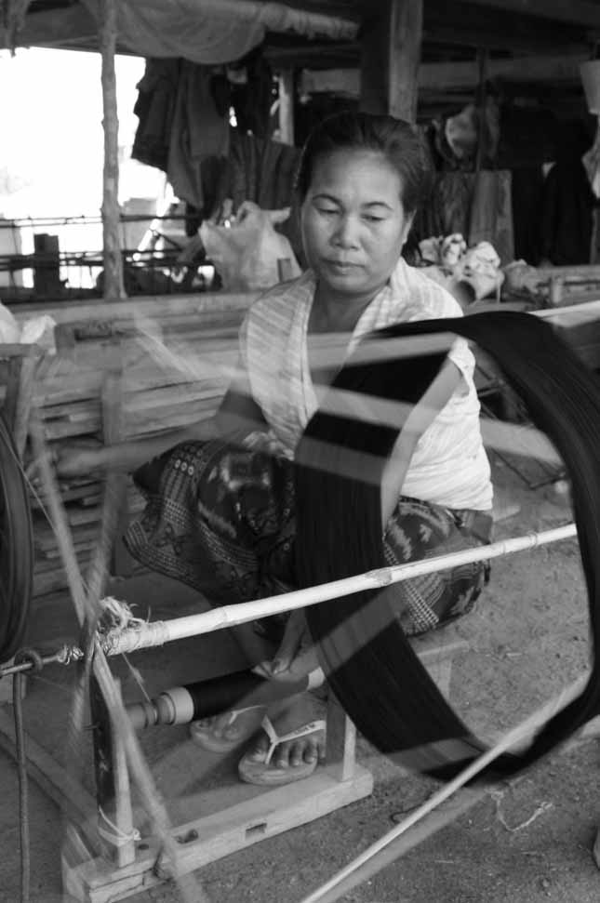
Costing
and
Pricing

9. Costing and Pricing
OBJECTIVES:
- Gives an overview of the different types of costs involved
- Looks at how to price you products
- Gives an overview of managing financial flows through good recordkeeping

TRAINING GUIDE:
- We cover this in session 7

9.1. The Difference Between Pricing and Costing

Cost is mathematical. Cost is what it actually costs you to make a product. Price is more of an art. Price is what you can sell your product for, how much money the market is willing to pay. It is also in comparison to what your competitors charge. In order to be able to price a product to ensure you are covering your costs and making a profit you need to know what it costs to make your product. It is important that you know the costs of your products.

9.2. Costing

Costing is the process of adding up all of the expenses involved in producing and selling a product. Your costs are everything that goes into making your product and running your business.

Direct vs. indirect costs
Direct costs are the physical materials that make up your product, plus the labour and utility costs to make it. Such as:
- Raw materials, including things like paint, glue, and thread that you buy once for many products
- Equipment, machinery, and tools directly used to make your product
- Your labour or time, and your employees’ wages if you have any
- Wastage: things you paid for but throw away or can’t use
- Promotional materials: packaging, labels, hang tags, etc.

Indirect costs are all the expenses you have to operate your business that you wouldn’t have if you were working for someone else or not working at all. Most, but not all of your indirect costs are overheads. For example, some of your water and electricity is used to produce your products and some to run your business. These could include:
- Overhead: rent, utilities, taxes and fees, licenses, insurance, etc.
- Machinery maintenance and repairs
- Administrative expenses, like bookkeeping, shipping and postage
- Office supplies: paper, pens, computers, fax machines
- Transportation and fuel used to pick up materials and deliver your products
- New product development expenses (raw materials, labour, overhead)
- Selling and distribution costs: marketing and promotion costs, including attending fairs and shows shipping or delivery costs to get your product to the market or buyer
- Housekeeping costs
- Social security costs
- If you cover your workers’ transportation costs to your workshop
- Costs associated with attending crafts fairs and other sales and promotional events.

Fixed vs. variable costs
Fixed costs are things that are the same each time regardless of changes to production, like rent, fixed salaries, and insurance premiums. The same fixed amount will be entered each time into your records.

Variable costs are costs that change with changes to production: your raw materials, hourly or daily wages paid only for the amount of time worked, and utilities like electricity that may go up or down. These need to be calculated each time you do your recordkeeping.

9.3. Recordkeeping

Without proper records you will not know if you are recovering all your costs when you sell your products. You can only recover all of your business expenses by accounting for them in the prices for which you sell your products. If for example, you don’t factor in the cost of electricity into your selling price, you may not have the money to pay the electricity bill. You must account for all your costs, and a consistent and accurate record keeping system will enable you and your accountant or bookkeeper to do that.

There are two methods for allocating the monthly electricity bill to each product:
- Adding a set amount to the sales price of each item, or
- Adding a percentage of indirect costs to each item.

9.4. Cash Flow

Cash flow is the movement of money into and out of your business.

- Cash is coming in from customers who are buying your products. If customers don't pay at time of purchase, some of your cash flow is coming from collections of past accounts receivable.
- Cash is going out in the form of payments for expenses, like raw materials, rent, salaries, monthly loan payments, and other accounts payable.

If more money is coming in than is going out, you have a positive cash flow and have enough cash on hand to pay your bills. If more cash is going out than coming in, you are in danger of being overdrawn. Even if your business is profitable, you will have a negative cash flow if you are waiting for payments. A simple method to perform a cash flow analysis is to compare the total unpaid purchases to the total sales due at the end of each month. If the total unpaid purchases are greater than the total sales due, you will need to spend more cash than you receive in the next month, indicating a potential cash flow problem.

9.5. Profit

Profit arises when total sales exceed total cost for a specific time period. Profit is not the same as the business owner’s salary. Salary is a direct cost when associated with making products, and an indirect cost when paid for running the business.

Profit is the money earned from selling products after all costs are covered. Once a profit has been made, the owners of the business have a choice:

- Take the profit out of the business, or
- Keep the profit in the business. Either in cash or by investing the profit into new assets.

Most entrepreneurs reinvest or retain profits in a business. Profit is the most important source of finance for a business because it is entirely within the control of the business, as outsiders do not provide it. You have it whenever you need it, without being dependent on a bank or someone willing to lend you cash. Another reason is that profits are a relatively cheap source of business cash because you do not pay interest on a bank loan or overdraft.

Profit can be used as a cash cushion to cover sudden unforeseen expenses or emergencies, like repairing broken equipment or damage from a flood. Profit can also be reinvested in anything that helps the business grow. Such as:
- Buying bulk stocks of raw materials and tools for future use, especially at a volume discount
- Creating additional production capacity
- Making major purchases like a new truck for delivery
- Furthering your business training or education.

9.6. Pricing

Pricing is the process of figuring out how much you can sell your product for, how much money you can get for it. It is an art. To pick your selling price, you take all the costs of producing and marketing your product, add in your profit margin, and try to find a middle ground between what you want to charge, what the market will typically pay, and what your competitors charge for comparable things.

Pricing is the costs of producing and marketing your product balanced against what the market will pay and in comparison to what your competitors charge.

Remember, perceived value may have no relation to the real cost! You may find that for you to make money, you need to get a higher price than the market is willing to pay you. This means the market does not value your product enough to pay you what you need. This is very common, and you should not take this personally, it happens all the time, to artisans and to all businesses. Everyone wants a bargain, to pay as little as possible and to get as much as possible, and of course you want the opposite - to get as much money for as little work as possible! So how can you increase the price the market will pay for your products? First try to reduce costs, without compromising quality or safety.

9.7. Reducing Cost

Reducing costs can help you to save money can earn more profit. These are some ways to reduce costs:
- Reduce indirect costs that don’t affect quality, like office supplies (buy them in bulk if you can).
- Reduce raw materials costs by using free materials, buying from less expensive suppliers, buying in bulk, or buying together with other artisans to get a better volume discount.
- Reduce labour costs with training to work faster and smarter, to improve efficiency and productivity but never at the expense of safety.
- Find ways to streamline production. Don’t make products one at a time, make the same part for many products, like blouse sleeves, together; then make another part like all the fronts; then assemble all the blouses at the same time.
- Lower your profit margin if you have to.

Many artisans think they are saving money by making or doing everything themselves. However, your time also has value, and you should spend it doing the parts of your business that make you the most money. For example, perhaps you should buy processed raw materials so you have more time to make finished products. Cost it both ways. Of course in the beginning you may not be able to afford to that, you may have to do everything but later on when you can, see if it is more profitable to outsource some things.

9.8. Increasing Price

You can also try increasing your prices to increase profit. You could do this through:
- Increasing your product’s perceived value
- Increasing your quality while minimally increasing costs

Appropriate price vs. cheapest price
Appropriate price doesn’t mean making things cheaply, it means a fair or agreeable price, what the item is worth or its perceived value. Best price means the lowest price among producers, all other things (quality level, sale and delivery terms, etc.) being equal.

The goal of increasing the value of your products is to be able to increase your price and the amount of money you make. If you can’t raise prices no matter what, go back and see if you can lower your costs without jeopardizing safety or hurting your product’s quality or selling price. The end result will still be that you make more profit.

9.9. Wholesale and Retail Prices

Wholesale prices are what businesses charge when they sell to another business. Wholesalers sell in volume, which helps lower their costs. After paying wholesale, the retailer needs to add the costs of their expenses and salary on top of what they paid the supplier, plus their profit margin, so they can cover their costs and make money too. The price the shopkeeper sells his/her wares to the public is the retail price.

The retailer typically sells only one or two items at a time, which increases her costs. Usually the retail price will be double the wholesale price. The retailer may not have production costs like the producer, but their expenses include the costs of the products they sells, which are equivalent to the producer’s raw materials, and overhead like store rent, salaries for sales staff, marketing, advertising, and promotion costs, all of which can be quite high.

If you sell both to wholesale and retail, your retail prices should be comparable to other retailers. This is to protect both you and your main market. If the public can buy products from you at wholesale prices they won’t shop at the retailer. You will have driven your main customer who buys the bulk of your production out of business, reducing your market. Selling retail and whole can mean that you are running two separate businesses with separate sets of expenses and employees.

Tips

Successful costing and pricing:
- Accurately calculate your costs.
- Cover all your costs and make a profit.
- Be seen as reasonable or good value to your target customer.
- Compete effectively with prices of other similar products in the market.
- Use loans to invest for future growth and profit, not for immediate expenses.
- Keep personal and business money separate.
- And remember: your salary and your profit are not the same thing.

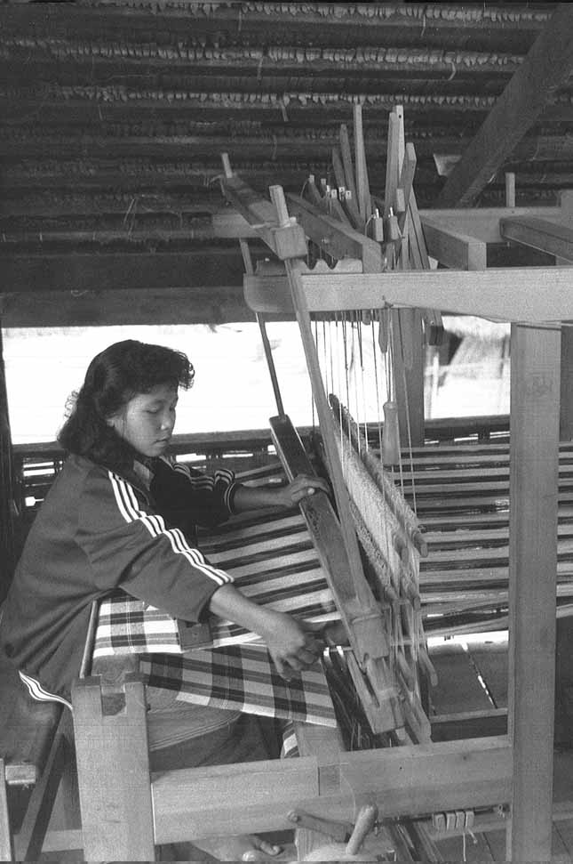
Turnng Down
an Order

10. Turning Down an Order

OBJECTIVES:
- Gives an overview of when to turn down and order
- Helps you to understand that this may be in the best interest of your business

TRAINING GUIDE:
- We cover this in session 8

There will be times when you should turn down a sale. Here are some good reasons to turn down an order:
- There is no profit. An exception might be to keep your factory producing and not shut down and keep your trained staff when a new, profitable order is soon coming. It would cost more to find and train new people, and start up again.
- The buyer owes you money. It’s not your job to finance your customer’s cash flow, just as your suppliers will not continue to supply you with more and more raw materials if you haven’t paid for the ones before. All past due payments for previous orders must be paid in full before you deliver anything else.
- It’s too big for you to handle: It’s too big and complicated for your expertise and there’s a good chance you’ll get it wrong.
- It’s a one-time huge order: You’ll have to hire people and invest in training and equipment that you won’t need again.
- It’s the wrong buyer/market segment for you.
- The payment terms are not good for you.
- The terms and price are too good to be true: could this be a warning?
- You don’t have the ability to finance production and will have to go into debt.
- You don’t have time in the production schedule to deliver it on time.
- It conflicts with other orders you already have.
- It violates an exclusive agreement you have with another buyer.
- It’s not what you make. You don’t have the expertise.
- You are discontinuing the item.
- The customer will be impossible to satisfy.

Competitive
Advantage

11. Competitive Advantage

OBJECTIVES:
- Provide an overview of competitive advantage
- Provide some tips on how to achieve it
- Gives a checklist for running a successful business

TRAINING GUIDE:
- This is additional information, not covered on the training day

Your competitive advantage is the key factor that will enable you to sell for higher prices and not compete for the lowest price. It is what you have and offer that is special, valuable, and unique in the marketplace over all other similar products and producers. It could be:
- Good products or unique design that can’t be produced by someone else
- Superior quality
- Price/value: superior value for the price
- Unique raw materials or skills that no one else has.

It should always be:
- Excellent customer service including professionalism, exceptional communication, consistent quality and reliable, on-time delivery

Checklist to Run a Successful Business

Checklist for Running a Successful Business
Product: who are you and what do you produce? |  | Done
 | Who are you and who works with you?
 | Do you work alone, with your spouse, do you have employees? Do your children help?
 | What do you make?
 | What are your skills?
 | What materials do you use?
 | Is your workspace adequate?
 | Do you have all the materials and tools you need, and access to more?
 | Do you have a vehicle to bring your products to market?
 | When do you work, and how much?
 | Do you work year-round, or seasonally? Full- or part-time?
 | Do you have other sources of income?
 | Your Product from the final owner’s point of view
 | What do your customer and the final owner need and want?
 | What are some common needs, and what need does your product fill?
 | How will the consumer use it?
 | What product features will meet these needs and wants?
 | How is your product different (better!) than the competition?
 | What can you do to improve your product and its desirability?
Place: Your Target Market: What is the best market and customer match for you?
 | Who buys your products, what do I know about their needs?
 | Who uses your products, what do I know about their needs and wants?
 | Where is your target market located
 | Do you know how your market typically pays?
 | What is your competitive advantage?
Product Development
 | Are you practicing market-led product development?
 | Do you need to change your products for your market? How?
 | Do you need to change your products for your business? How?
 | Can you increase the perceived value of your products? How?
 | New designs: what do you already have that is unique or better than what your competition has?
 | Can you turn a disadvantage into an advantage?
 | Have you prototyped and tested your product, and gotten feedback?
 | Have you analyzed the impact of making the product on your business?
Production
 | Safety first. Do you have the safest setup possible?
 | Have you analyzed and improved your production system for maximum efficiency?
 | Have you analyzed the order to make sure it is right for your business?
 | Is the purchase order complete, accurate, and correct?
 | Have you worked backwards to plan and schedule production? Did you build in extra time?
 | Do you have the right systems to track production?
 | Do you have the raw materials you need or can you get them when you need them?
 | Do you have adequate skilled labour?
 | Do you have the machinery and tools you need, are they in good working order?
 | Do you have sufficient work and storage space that’s clean, organized, and safe?
 | Do you have adequate cash flow to buy supplies and finance production?
 | Do you have accurate complete and up to date record systems from start to finish?
 | Are you following the principles of Just-In-Time production?
 | Can you deal with any bottlenecks and disasters?
 | Are you carefully controlling quality?
 | Are raw materials properly stored, and are they defect-free?
 | Do you have quality checks throughout the production process?
 | Are your workers thoroughly trained?
 | Are your working conditions as good as they can be?
 | Do you have the needed protective packaging and packing while in transit?
 | Did you make and keep an exact duplicate sample?
Price: How much can you sell it for and make a profit?
 | Have you accurately calculated the actual costs of making and selling your product?
 | Direct and indirect costs?
 | Fixed and variable costs?
 | Have you researched what your competition charges for similar products?
 | Have you studied whether there are ways to reduce your costs?
 | Do you have a profit margin built into your price?
 | Can you increase your price by increasing you perceived worth or value?
Promotion: How do you persuade customers to buy your product?
 | Do you have nice packaging that shows off your product?
 | Advertising and promotion: hang tags, packaging, mailings, brochures, catalogs, website
 | How you or the retailer display your products for sale: showroom, stands, props, lighting
 | Product information: easy to read and attractive signage, pricing
 | Professional demeanor and dress
 | Demonstrating how to use your product
People: Who do you work with, how do you interact?
 | Do you have great relations with your business partners: your suppliers, your workers, your retailers?
 | Customer service: are you
 | Reliable?
 | Do you always deliver your best and consistent quality?
 | Do you have exceptional communications?
What else?

www.sme-tools.org

