



HOMESTAY TRAINING GUIDE

*ILO - ASEAN Small Business Competitiveness*

A product of ­



Small Business Competitiveness by International Labour Organization (ILO – SBC) is licensed under a Creative Commons Attribution-Non Creative Commons Attribution‐NonCommercial‐ShareAlike 3.0 Unported License.



**Attribution** — You must give [appropriate credit](https://creativecommons.org/licenses/by-nc-sa/3.0/), provide a link to the license, and [indicate if changes were made](https://creativecommons.org/licenses/by-nc-sa/3.0/). You may do so in any reasonable manner, but not in any way that suggests the licensor endorses you or your use.



**NonCommercial** — You may not use the material for [commercial purposes](https://creativecommons.org/licenses/by-nc-sa/3.0/).



**ShareAlike** — If you remix, transform, or build upon the material, you must distribute your contributions under the [same license](https://creativecommons.org/licenses/by-nc-sa/3.0/) as the original.

****[*https://creativecommons.org/licenses/by-nc-sa/3.0/legalcode*](https://creativecommons.org/licenses/by-nc-sa/3.0/legalcode)

brought to you by:



Table of Contents

About C-BED vi

About the Homestay Package: vi

Message to the Group vii

Session 1: Introductions 1

Activity 1A: Getting to Know Each Other 1

Session 2: Creating Systems 5

Activity 2A: Examples 5

Activity 2B: Creating Systems 7

Activity 2C: Homestay Systems 8

Activity 2D: Systems and Customer Perception 11

Activity 2E: Personal Action Plans 13

Session 3: Marketing Your Homestay 17

Activity 3A: Homestay activities 17

Activity 3B: Personal Action Plans 19

Session 4: Budgeting and Pricing 23

Activity 4A: Estimating Costs 23

Activity 4B: Estimating Hosting Costs 26

Activity 4C: Estimating Maintenance Cost 28

Activity 4D: Pricing 29

Activity 4E: Personal Action Plans 30

Session 5: Joint Problem Solving and Developing Your Staff 33

Activity 5A: Problems 33

Activity 5B: Solving Problems 35

Activity 5C: Evaluating Solutions 36

Activity 5D: Staff contribution 37

Activity 5E: Personal Action Plans 39

Session 6: Improving Service 41

Activity 6A: Continual Improvement 42

Activity 6B: Personal Action Plans 44

Session 7: Safety and Health 47

Activity 7A: Safety and Health Standards 47

Activity 7B: Personal Action Plans 49

Session 8: Priority Action Plans 53

Activity 8A: Prioritized Actions 53

Optional session: Creating a community-based tourism (CBT) homestay 57

Activity A: Effect of Tourism on Communities 58

Activity B: Advantages of CBT 60

Activity C: Ensuring positive effects 62

Activity D: Personal action plans 63

Annex 1: Flipcharts 65

Flipcharts for Activity 2B 65

# About C-BED

Community-Based Enterprise Development (C-BED) is a low cost, innovative training programme designed by the International Labour Organization (ILO) to support skills development and empowerment in local communities for improvements in livelihoods, productivity and working conditions.

As an approach to training, C-BED is unique in that the programme is built around peer-to-peer, activity based learning methods with no role for teachers, experts, or external consultants specialised in the skill area. Instead, C-BED participants work together through a series of activities and discussions guided only by simple step-by-step instructions in the training manual. New knowledge, skills and competencies are developed through the interactions between participants and sharing of existing local knowledge and experience. In this way the programme is a low cost, sustainable option for any organization or community.

The C-BED programme is structured around two core training packages designed to develop competencies for business start-up and operation through a focus on marketing, financial management, and action planning. These are the C-BED for Aspiring Entrepreneurs and C-BED for Small Business Operators. Additionally, a growing suite of tools to strengthen business competencies and enhance skills for specific sectors is in continual development. These packages can be implemented as either stand-alone trainings or integrated in modular format into existing programmes.

## About the Homestay Package:

**The training package:**

The Homestay package should be used to help aspiring and current homestay owners start and improve their businesses. It focuses on key business principles to build on from what participants already know from managing their homestays and helps them to learn more. It can also build on from the learning in other C-BED tools namely SBO or AE. Participants bring experience to share and leave with a priority action plan (at least 3 actions to introduce improvements to their business). At the end of the training participants will have:

* Enhanced and advanced existing knowledge on homestay development
* Strengthened critical competences to analyse job prospects or current conditions of work
* Affirmed the potential of enterprise development
* Identified steps and actions to improve a business or launch a business idea
* Decided on actions for the future
* Started planning effective collaborations and associations

**The Good Practice Guide:**

During the training day participants will be introduced to and become familiar with the Good Practice Guide (GPG), which they will then be able to use to further their learning and to support them in setting up or improving their businesses. The GPG contains best practices, tools and extra activities that supplement those covered in the training to further support the participants in setting up or improving their businesses. The exercises may depend on the GPG but if the participants do not have this guide this should not prevent them from moving forward, if necessary skip that activity. Look out for this icon:



Here you should refer to the Good Practice Guide for more information.

## Message to the Group

At the end of this C-BED training you will have a clear plan for the practical steps you can take to start or improve your business. Your understanding of the basic principles of doing business will be much stronger and you will have begun relationships with others in your community that can potentially support or cooperate with you to achieve mutual success in the future.

The style of this training is different to traditional education approaches. There will be no teacher, trainer or expert to assist you. Instead, you will work together as a team to follow the simple step-by-step instructions for discussions and activities in your training guide. Because there is no group leader, all group members should take a turn reading the information and instructions out loud to the group, and all group members share responsibility for monitoring time. In this new style of training, we will learn from each other by sharing ideas and opinions, skills, knowledge and experience. For this to work, all group members must participate in discussions.

Before and after the training you will be asked to complete a survey to understand the impact of the training. This information will be kept confidential and is used to improve the training materials and organization of future programs. Some trainees may also be contacted in the future after 3, 6 or 12 months for another survey to learn about your business plans.

The instructions in the training guide are easy to follow and suggested timing for each step is provided. Look out for these signs:



When you see this sign, read aloud

When you see this sign, you are reading instructions and doing activities

This sign gives you the estimated time for the session

When you see this sign, share with the group

Use the flipchart as outlined in Appendix 1, if you don’t have a flipchart use extra paper or the Training Guide

Before you begin the training, follow the simple steps below to get organized.

* Fill out the pre-training survey. Ask the organizers if you don’t have a copy or have not already filled it in.
* Organize into small groups of 5-7. The organizers will guide you in how best to do this.
* Identify one group member to volunteer to start the training as ‘Group ‘Reader’. The ‘Group Reader’s’ role is to read the information and activity instructions out loud to the group. Any group member with basic literacy can be the ‘Group Reader’ and you should aim to share this role among group members throughout the training.

All group members are responsible for monitoring time but one group member should be nominated for each session to remind the group when the suggested time for a step has been reached. You do not strictly need to follow the suggested timing but you will need to manage your time for the total training. If one activity lasts longer than the suggested timing, try to save time in other activities to keep the balance.

All group members will receive the same training guide. Individual work can be completed in these guides as well as group work. Groups may also like to complete activities together on flipchart paper if available.

Enjoy the Training!

Session 1:

Introductions

# Session 1: Introductions



**20 Mins**



**Session overview:**

In this session you will get to know one another and the style of learning in this training. We learn without teachers. You help each other by sharing your different experiences and ask questions if you don’t understand an activity. You will complete one activity. The objectives of this session are to:

* List the names of some of the trainees
* Understand the style of learning for this course, including activities and group work
* Understand the importance of contributing ideas and suggestions

## Activity 1A: Getting to Know Each Other



In Activity 1A, you will do some brief introductions so you can get to know one another.



**20 Mins**

1. Each person introduces themselves by providing:

* Full name and any nickname you prefer to use during the session
* Homestay address
* How long your homestay has existed (if applicable)
* Your purpose for attending this session and how you expect it to help your business

1. Each person shares a photo, business card or drawing of their homestay for others to see. Place this on the wall or in the middle of the table, or allow others to see it on your mobile phone.
2. Fill in this sheet below (if not now, then during tea breaks and lunch time)

|  |  |  |
| --- | --- | --- |
| Table 1A: Participant Information | | |
| Participant Name | Homestay Address | Phone number /  Email address |
|  |  |  |
|  |  |  |
|  |  |  |
|  |  |  |
|  |  |  |
|  |  |  |
|  |  |  |
|  |  |  |



In this activity you have gotten to know who your peers are and a little about their businesses

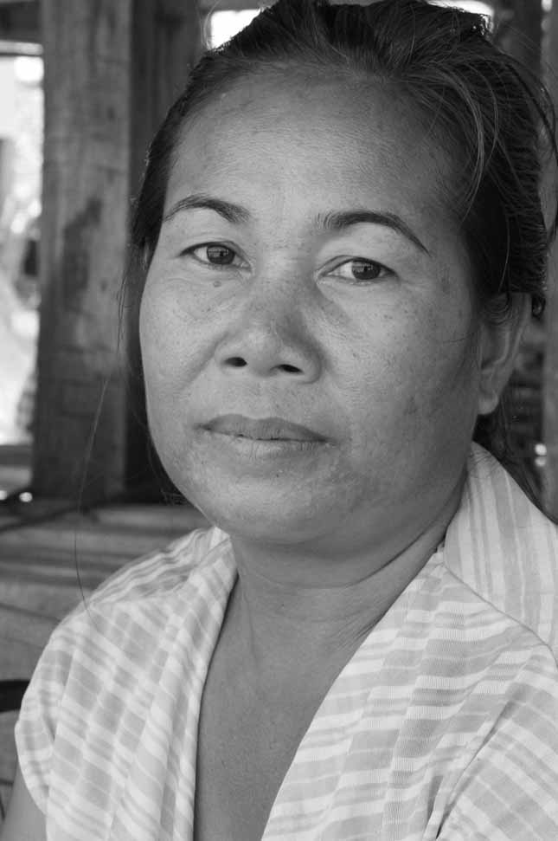

Session 2:

Creating

System

# Session 2: Creating Systems



**2**

**1, 2, & 3**

**45 Mins**



**Session overview**

In this session you will read two stories that show you the value of using systems to make sure you have a well-run homestay and that guests are happy. You will complete 5 activities. The objectives of this session are to:

* Identify the benefits of a systems-based approach to management
* Understand the shortcomings associated with businesses that do not use a systems-based approach
* Become familiar with the Good Practices Guide (GPG)
* Learn that the GPG will help you create systems to improve your businesses

## Activity 2A: Examples

In Activity 2A you will hear the stories of two homestays as told by some recent guests. You should listen carefully to their experience to help you complete the next activities. Is there someone who would like to read us the first story?



The Story of Homestay no 1:

**[5 Mins]** Mr and Ms Kim, a couple in their mid-30s from Seoul, South Korea, went on vacation in Indonesia and homestays seemed like the perfect way for them to travel and experience the country. They arrive at the homestay tired from their journey and are greeted by the receptionist. Unfortunately the receptionist was not very helpful, leaving them uncertain of where their room was and without much information about the surrounding area.

They arrived in their room only to find that it was dirty. They decide to go out sightseeing but on their way out Mr Kim is injured when he falls on the broken stairs. They are surprised that no one is able to help them with any first aid. After cleaning his hand and going out sightseeing, they return hungry and ready for dinner. Uncertain of when and where dinner would be served, they knock on a door to find dinner preparation underway. Mr and Ms Kim are worried that some potatoes, that are probably going to be served with their dinner, are on the floor. The family communicates that dinner will only be in an hour. There are no snacks for Mr and Ms Kim to purchase and they remain hungry until dinnertime.

After dinner, when they return to their room ready to sleep, they discover that the bed is dirty. Unwilling to disturb their unfriendly hosts, they sleep on the dirty bed. The next morning they also discover that not only is there no toilet paper in the bathroom, but their hosts don’t have any extra in stock. They did not know how to cancel their stay and were miserable for the rest of their time at the homestay. They even considered cancelling their reservation at the second homestay.



Would someone else like to read us the next story?



**The Story of Homestay no 2:**

[5mins] Mr and Ms Kim arrived at their second homestay and were so relieved to find a friendly receptionist and a clean place. Feeling very welcome, they were shown around the place and given information about where they could find snacks, bicycles to rent and when dinner would be served. The receptionist also gave them a list of nice places to visit in the town.

The receptionist let them know that they would share the bathroom with the family but assured them that they wanted Mr and Ms Kim to be comfortable and would give them priority for using the bathroom. They both immediately noticed how clean the bathroom was. Mr and Ms Kim were introduced to the rest of the family and warmly welcomed. They were even presented with some flowers for their room.

That evening, some of the family joined Mr and Ms Kim for dinner. They really enjoyed learning new words in each other’s languages and hearing from the family about places they should visit and activities that the homestay offered. The activities ended up being the best part about Mr and Ms Kim’s holiday. They took part in a cooking demonstration and helped the family to prepare a delicious meal. They also went fishing and took a two-hour guided walk with one the family members. It was a wonderful way for them to learn about life in the village and the culture. They were very glad that they hadn’t cancelled their second homestay visit because of their first bad experience. The second family clearly enjoyed having people to stay and also have systems for the staff to follow to keep everything clean and well organized.

In this activity you have heard about the two, very different experiences of Mr and Ms Kim. These stories will help you to understand more about systems in the next few activities.

## Activity 2B: Creating Systems

In Activity 2B you will review the terms staff and systems. You heard these terms referenced in the examples. You will also take a look at the GPG.



[10mins] We can refer to Flipchart 1, if available. It says staff are all the people who work at your homestay, including your family members, friends, hired helpers, or outsourced staff shared with other homestays.

On Flipchart 2 it says: a good system often starts with a clear, easy-to-follow, written checklist. It does not have to be complicated. But a simple checklist will clearly let your staff know exactly what you expect of them. Do systems have to be complicated? No.

Systems can help your homestays to run efficiently. Even if your staff includes only your family members, it is best to have systems in place so your homestays run smoothly and efficiently. You can look to the GPG for help on implementing systems, specifically Section 2. You can take 2 or 3mins to look through it now. It will help you create systems to improve your managerial skills, to train your staff, and to keep your guests happy.



In Activity 2B we reviewed what is meant by staff and systems and what they can do for your homestay.

## Activity 2C: Homestay Systems

In Activity 2C you will discuss together in small groups what systems you already have, what systems need to be improved and what systems you need to create. Of course, if you have not started your homestay yet, you will have to create all of these systems.



**30 mins**

1. Each fill in Table 2C with information about your homestay according to the information below:

* In column 1 list of some of the most important systems needed to operate a homestay
* In column 2 rate each of the systems (1, 2, or 3).
  + 1 = A good system already exists
  + 2 = The current system needs improvement
  + 3 = There is no system yet
* In column 3 identify who will primarily be responsible for this system (you, your spouse, one of your children, your brother, your sister, an aunt, an uncle, a friend, etc.). Then list the names of people who will help with this system.
* In column 4 describe actions you will take to improve or create these systems.
* In column 5 select a target date to have each system clearly organized and in place.

1. Discuss your table with the group

|  |  |  |  |  |
| --- | --- | --- | --- | --- |
| Table 2C: Homestay Systems | | | | |
| Column 1 | Column 2 | Column 3 | Column 4 | Column 5 |
| Homestay systems | Rate  1, 2, or 3 | Who is responsible? Who will help? | Action plan | Date |
| Reservations - taking telephone and online reservations; working with travel agencies. |  |  |  |  |
| Guest check-in and checkout - including taking payment from guests. |  |  |  |  |
| Housekeeping - cleaning guest rooms, bathrooms, and common areas. |  |  |  |  |
| Accounting and finance - tracking earnings, expenses, and savings for repairs. |  |  |  |  |
| Problem solving - handling problems that occur with guests or among staff. |  |  |  |  |
| Improving service - this must be done continuously in a successful homestay. |  |  |  |  |
| Meals for guests - shopping, cooking, serving, cleaning and preparing the kitchen and dining area. |  |  |  |  |
| Supplies - buying or making supplies and keeping them stocked. |  |  |  |  |
| Maintenance - repairing and improving buildings, grounds, and equipment. |  |  |  |  |
| Other areas - caring for praying rooms, gardens, etc. |  |  |  |  |
| Marketing - promoting the homestay (Internet, travel agencies, tourism bureaus, etc.). Finding and working with marketing partners. |  |  |  |  |



In this activity you looked at what systems you have, what systems you need to improve and what new systems you need.

## Activity 2D: Systems and Customer Perception

In Activity 2D you will build on from the stories of Homestay 1 and 2 to discuss what systems were used in these homestays. You will discuss in your groups the systems that contribute to running a homestay and how the customer would perceive it.



**30 mins**

1. In Table 2D, you see that Column 1 is there for you to create a list of systems typically used in homestays. Two examples (housekeeping and customer service) are already listed.
2. With your group, try to identify 3 or 4 other systems that were referenced in the stories of Homestays 1 and 2. Finally, try to identify one more system that was not referenced in the stories.
3. In Column 2, discuss how the absence of these systems in Homestay 1 led to things that the guests do not like. In Column 3, discuss how the presence of these systems in Homestay 2 led to things that guests do like.

|  |  |  |  |
| --- | --- | --- | --- |
| Table 2D: Group Discussions – Systems and Values | | | |
| Column 1 | Column 2 | Column 3 | |
| Systems | Rate on how customer perceives.  (See it from the customer’s point of view.) | | |
| Homestay 1 | | Homestay 2 |
| Example 1:  Housekeeping | Spider webs: the place is not cleaned regularly.  Bathroom wastebasket not emptied, hair around shower. | | Simple and clean bathroom |
| Example 2:  Customer Service | No one carried luggage to their room, no one showed them their room or dining area | | Smiling, giving information needed |
| Other (Fill in yourself) |  | |  |
| Other |  | |  |
| Other |  | |  |
| Other |  | |  |
| Please think of another system that is not referenced in the stories. |  | |  |

In this activity you looked at different systems in homestays and how customers perceive the homestay based on what systems were used. To do this you referenced the stories of Homestay 1 and 2.

## Activity 2E: Personal Action Plans

In the final activity of this session you will decide on some concrete actions to improve or create systems in your homestays. Keeping in mind all the things you’ve discussed so far about creating systems, take a few minutes to record your thoughts.



**10 Mins**

1. Each of you uses Table 2E: Personal action plan to write 1-3 changes that you would make to improve systems in your businesses. Are there any improvements you would like to make based on what you have learned in the previous activities? If so, decide what systems you will implement or improve.
2. Record how you will make these changes.
3. Record by when will you make these changes.
4. Finally, state who will be responsible for this change.

|  |  |  |  |
| --- | --- | --- | --- |
| Table 2E: Personal Action Plan | | | |
| My changes | How will I make the changes? | When? | Who is responsible? |
|  |  |  |  |
|  |  |  |  |
|  |  |  |  |

You have completed the final activity of session 2. In this session you looked at what systems you need in a homestay and the important role that they play in guest experience. For more information refer to Section 2 of your GPG.

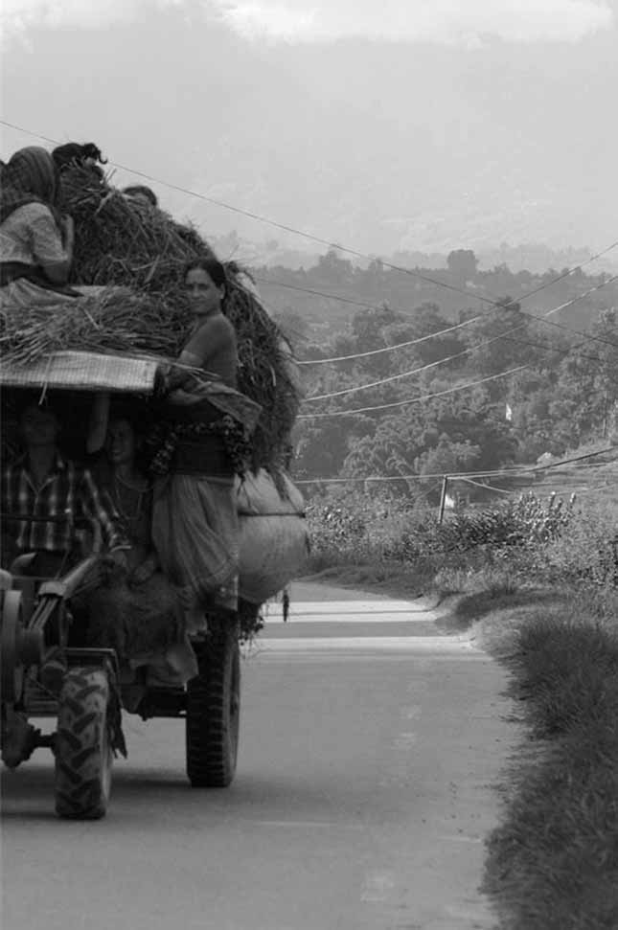

Session 3:

Marketing Your Homestay

# Session 3: Marketing Your Homestay





**3**

**45 Mins**



**Session overview:**

In session 3, you will get to understand the importance of the marketing your homestay and how to identify things that make your homestay special or unique and help you promote it to potential guests. You will complete 2 activities. The objectives of the session are to:

* Understand the purpose of a marketing plan
* Highlight the importance of knowing your customer
* Look at what activities you could offer to enhance guest experience

## Activity 3A: Homestay activities

In Activity 3A you will discuss creating activities for customers that will help to sell or promote your homestay. You will also try to understand what makes your homestay unique



All businesses must find customers. Without customers, your homestay will not survive. How will you find guests for your homestay? It is important to create a plan to spread the word about your homestay to potential guests. We call this a marketing plan. In Section 3 of your GPG you will find a section on marketing your homestay with some useful suggestions for creating a marketing plan. To be successful you have to compete against other homestays, hostels, guesthouses, hotels, etc. What can you do to ensure your homestay is special enough to persuade people to stay with you?



First, it is important to know the kind of traveller who would be attracted to a homestay. Often, these travellers want to have a special experience that they could not get by staying in an ordinary hotel. They typically want to learn about, and experience your culture and lifestyle firsthand - just like the young Korean couple in the stories.

One way to make your homestay more attractive to these travellers is to offer them activities that will teach them about your culture and lifestyle. Travelers will pay extra for these activities. These activities not only help you preserve and share your culture, but they also help you earn extra income. Below, you see a list of some activities to consider. For our next activity, you will review this list, and see if you can add to it.



**30 Mins**

1. Review this list of activities:

* Cooking demonstration (prepare a traditional dish with guests)
* Weaving demonstration
* Other handicraft demonstration (wood carving, painting, etc.)
* Traditional agricultural demonstration
* Traditional clothing demonstration
* Traditional wedding ceremony discussion and demonstration
* Fishing
* Hiking or trekking (maybe include a packed lunch)
* Discussion about a special holiday or festival and how it is celebrated in your culture
* How a traditional game is played
* Musical and/or dance demonstration

1. See if you can add to the list
2. Discuss with the group what activities would be appropriate for your homestay and how you would organize them
3. Remember that guests would pay extra for these activities and they should be well organized
4. Write your ideas in the space in Table 3A.

|  |
| --- |
| Table 3A: Homestay Activity Ideas |
| In this activity you listed some ideas for activities that might be suitable for your homestay and your homestay guests. |

## Activity 3B: Personal Action Plans

In the final activity of this session you decide on some concrete actions to market your homestay. Keeping in mind all the things you’ve discussed so far about marketing and activities, take a few minutes to record your thoughts.





**10 Mins**

1. Each of you uses Table 3B: Personal action plan to write 1-3 changes that you would make to market your businesses better. Are there any improvements you would like to make based on what you have learned in the previous activities? If so, decide what marketing changes you will implement or improve.
2. Record how you will make these changes.
3. Record by when will you make these changes.
4. Finally, state who will be responsible for this change?

|  |  |  |  |
| --- | --- | --- | --- |
| Table 3B: Personal Action Plan | | | |
| My changes | How will I make the changes? | When? | Who is responsible? |
|  |  |  |  |
|  |  |  |  |
|  |  |  |  |



In this session, you learned about marketing your homestay and activities that could make your homestay special or unique. For more information refer to Section 3 of your GPG.

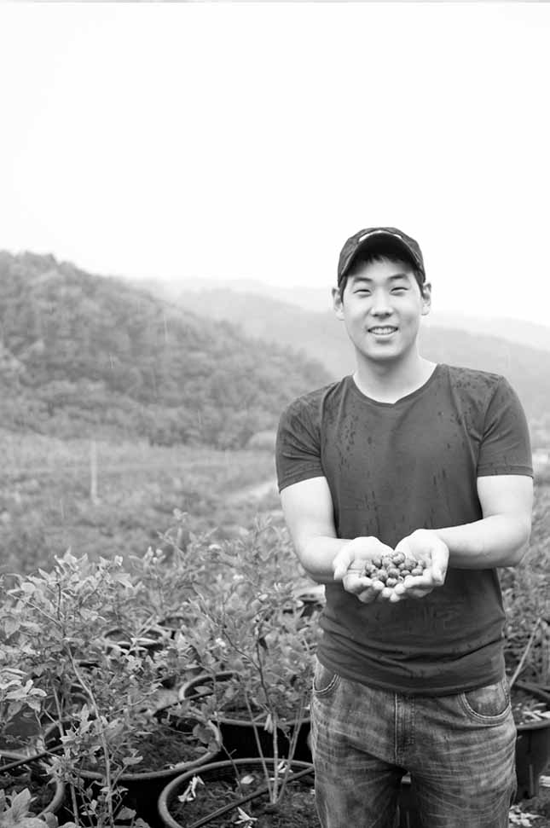

Session 4:

Budgeting and Pricing

# Session 4: Budgeting and Pricing



**70 Mins**



**4**



**Session Overview**

In this session, you will consider the cost of running a homestay. These will include the start up costs, the ongoing costs and pricing of your homestay. You will also understand the basic costs involved in starting and maintaining a homestay. You wil complete 5 activities. The objectives of the session are to:

* Develop an awareness of the complexity of starting a homestay
* Understand the basic costs involved in starting and maintaining a homestay
* Start thinking about pricing

## Activity 4A: Estimating Costs



In this activity, we will discuss what you need for your homestay, what you already have and how much these items might cost for you to get or to improve. This will give you an idea of how much it will cost to start or ready your homestay.

Please open your GPG to Section 2. On the first page of this section, you will see 4 lists. Before we begin, please take a moment to look through Section 2 of your GPG. If you have not started your homestay yet, this section is very important for you. After today’s workshop, we encourage you to go through this entire section with your family to help you start thinking about how much you will have to spend to start your homestay.

Some of you might decide that it would cost you more than you are prepared to spend, and that this is not the right time for you to start a homestay. Others might decide that you already have almost everything you need to start a homestay, and that it will not be too costly for you. This is a personal decision that only you and your family can make.



**30 Mins**

1. Estimate the costs for the items in Table 4A using these 4 definitions of costs:

* Nothing ($0): this applies if you already have the item and it is in good enough condition to use now.
* Estimated price of improvement: this applies if you have the item but must improve it before you can use it.
* The estimated price of buying the item either new or used: this applies if it is something you must buy.
* The estimated price of materials and labour to make the item: this applies if you have to hire someone to help you make, build, or install it.

1. Share your ideas about how much each of these items might cost to buy, improve, or make with your group
2. When you finish filling in the costs, spend a few minutes identifying other things you might eventually need for your homestay.

|  |  |  |  |
| --- | --- | --- | --- |
| Table 4A: Estimating Cost | | | |
| Guestroom(s) | Estimated  Cost | Guestroom(s) | Estimated  Cost |
| One or two guest bedrooms |  | Ceiling or wall light |  |
| Beds with mattresses |  | Reading lamps by bed(s) |  |
| Pillows |  | Shelves |  |
| Blankets |  | Hooks on walls for coats |  |
| Sheets and pillowcases |  | Window curtains |  |
| Mosquito nets |  | Floor rug by the door |  |
| Small table |  | Wastebasket |  |
| Chairs |  | Decorations (art, flowers) |  |
| Electric wall outlets |  | Lock for the door |  |
| Bathroom | Estimated  Cost | Dining Area | Estimated  Cost |
| Sit-down flush toilet |  | Table |  |
| Shower with hot & cold water |  | Chairs and/or benches |  |
| Sink |  | Tablecloth(s) |  |
| Ceiling or wall light |  | Plates |  |
| Guest towels |  | Bowls |  |
| Floor mat by the shower |  | Cups |  |
| Wall shelves and hooks |  | Glasses |  |
| Mirror above the sink |  | Forks, knives, spoons |  |
| Electric wall outlet |  | Chopsticks |  |
| Toilet paper |  | Salt and pepper shakers |  |
| Soap |  | Hot water dispenser |  |
| Wastebasket |  | Tea, sugar, cream |  |
| Curtains for windows |  | Napkins (cloth or paper) |  |
| Lock for the door |  | Decorations (art, flowers) |  |
| List other items you might want to have (eventually) for your homestay: |  |  |  |



In this activity you discussed some of the costs involved in starting up or making your homestay ready for guests.

## Activity 4B: Estimating Hosting Costs



In Activity 4B, you will look at the on-going cost of running your homestay. That is how much it would cost you to have a guest for one night.

**10 Mins**



1. In your groups decide on how much it would cost for each of the items in Table 4B.
2. Think about how much these items would be for one guest for one night. These are your on-going costs.

|  |  |
| --- | --- |
| Table 4B: Estimate the Cost of Hosting One Guest for One Night | |
| Additional guest expenses (for one guest / for one night) | Estimated cost |
| Extra electricity (for lights in guestroom, etc.) |  |
| Extra gas (for cooking guest meals, etc.) |  |
| Extra water (for cleaning, cooking, guest showers, etc.) |  |
| Food for guest meals (including salt, pepper, spices, etc.) |  |
| Bottled water for guests |  |
| Other beverages (tea, coffee, cream, etc.) |  |
| Toilet paper |  |
| Soap |  |
| Laundry soap |  |
| Cleaning supplies (cleansers, toilet brush, etc.) |  |
| Other |  |
| Other |  |
| Total Additional Guest Expenses |  |

In this activity you looked at the on-going costs that you would have when you have guests to stay.



## Activity 4C: Estimating Maintenance Cost

Now let’s think about a different kind of on-going cost. For example, things that need to be repaired or ongoing maintenance. You will look at these costs in this activity.





**10 Mins**

1. In your groups decide on how much it would cost for each of the items listed in Table 4C
2. Think about how much these items would be for one guest for one night. These are your ongoing costs.

|  |  |
| --- | --- |
| Table 4C: Estimate Costs for Maintenance and Repairs | |
| Additional on-going maintenance expenses | Estimated cost |
| Light bulbs |  |
| Batteries |  |
| Paint for buildings |  |
| Wood for repairs |  |
| Hardware (nails, screws, etc.) for repairs |  |
| Materials for roof repairs |  |
| Other |  |
| Other |  |
| Total ongoing maintenance expenses |  |



This activity helped you to look at and estimate the different ongoing costs involved in running a homestay.

## Activity 4D: Pricing



Now that you’ve had a chance to start thinking about the cost of starting and maintaining a homestay, let’s start thinking about how much you should charge each guest per night. In Activity 4D you will explore how to go about setting a price for your rooms.

**10 Mins**



1. Work in groups and keep the costs you have just discussed in mind.
2. Estimate how much it would cost to host one guest for a night. Record this in Table 4D.
3. Estimate how much other homestays, guesthouses or small hotels charge. Share information that you have about this with each other. Record this in the table.
4. Estimate how much you could charge, based on how much it would cost, what the others charge and what you would offer your guests inclusive in the price, such as meals.

|  |  |
| --- | --- |
| Table 4D: How Much to Charge | |
| Estimate the following | Amount |
| Cost for hosting one guest for one night |  |
| Amount other homestays, guesthouses, small hotels charge (for 1 night) |  |
| The price I could charge for 1 person for 1 night |  |



In this activity you estimated how much you could charge for your homestay based on the costs involved in hosting guests and what other accommodations charge.

## Activity 4E: Personal Action Plans

In the final activity of this session you will decide on some concrete actions related to the budgeting and pricing of your homestay. Keeping in mind all the things you’ve discussed so far about costs and pricing, take a few minutes to record your thoughts.



**10 Mins**



1. Each of you uses Table 4E: Personal action plan to write 1-3 changes that you would make to your budgeting and pricing. Are there any improvements you would like to make based on what you have learned in the previous activities? If so, decide what changes you need to make.
2. Record how you will make these changes.
3. Record by when will you make these changes.
4. Finally, state who will be responsible for this change.

|  |  |  |  |
| --- | --- | --- | --- |
| Table 4E: Personal Action Plan | | | |
| My changes | How will I make the changes? | When? | Who is responsible? |
|  |  |  |  |
|  |  |  |  |
|  |  |  |  |



In session 4 you learned about the costs involved in starting and running a homestay as well as looked at how much you could charge for your homestay. You can look at Section 4 of your GPG for more information.



Session 5:

Joint Problem Solving and Developing Staff

# Session 5: Joint Problem Solving and Developing Your Staff



**5**

**55 Mins**



**Session Overview**

In this session, you will look at brainstorming and problem solving. This will help you to involve your staff in problem solving in your homestay. You will also look at how to treat your staff in order to make your homestay better. Happy well-trained staff means happy customers. You will complete 5 activities. The objectives of this session are to:

* List the principles of effective brainstorming
* Conduct brainstorming sessions
* Understand the value in involving staff in solving work-related problems
* Assess how staff are currently treated
* Identify specific actions to take to treat staff well and to strengthen professionalism

## Activity 5A: Problems



In Activity 5A you will brainstorm some problems that could occur in a homestay. These can be regular or unusual problems.

Every business has problems. So when you operate a homestay business, it is very important to know how to solve problems. In Section 5 of the GPG you will find some good ideas about brainstorming with your staff to find solutions to problems. Please take a minute or two to look through this section.

As the manager of your homestay, it is important for you to understand the benefits of including your staff in problem solving. One great way to develop your staff is to ask for their input when solving problems related to your homestay. After all, if they are working at your homestay, they know a lot about it. They might even know more than you do about certain aspects of your homestay.



**10 Mins**

1. In your group create a list of problems that could occur in a homestay.
2. Try to think of some unusual problems too.
3. Follow the 3 rules of brainstorming:

* Encourage everyone to contribute ideas.
* Seek as many ideas as possible, even unusual ones.
* Make everyone feel safe and comfortable contributing ideas.

1. Record the list in the Table 5A. At this stage just focus on the problems.

|  |
| --- |
| Table 5A: Brainstorm Homestay Problems |
|  |



In this activity you brainstormed about potential homestay problems. In the next activity you will look further at these.

## Activity 5B: Solving Problems



**10 Mins**

In Activity 5B, you will take the list of problems and choose one problem to solve. Here you will learn about solving problems jointly.

1. Imagine that your group works at the same homestay
2. Even if you do not have anyone else working in your homestay, remember you can also ask neighbours and friends for help with finding solutions.
3. Select one problem to work on.
4. Brainstorm ideas to solve the selected problem and record them here. Come up with as many solutions as possible.
5. Remember to follow the 3 rules of brainstorming



In this activity together you identified a number of solutions to a single problem. Now you will evaluate these solutions.

|  |
| --- |
| Table 5B: Problem Sollving |
| Choose one problem from your list, and write it here: |
| Write the ideas for solving the problem here: |

## Activity 5C: Evaluating Solutions

In this activity you will evaluate the solutions that you have come up with in the previous activity.



**10 Mins**

1. Select 3 options from the list you have just created.
2. Together identify pros and cons for the solutions on this list.
3. Record this information in Table 5C.
4. Once you have done this for all 3 options, select what you think is the best solution.

|  |  |  |
| --- | --- | --- |
| Table 5C: Evaluating Solutions | | |
|  | Pros | Cons |
| Option 1 |  |  |
| Option 2 |  |  |
| Option 3 |  |  |
| Choose the best option and write it here: | | |



In this activity, you focused on choosing a solution based on the previous activity’s brainstorming.

## Activity 5D: Staff contribution



In Activity 5D you will focus on the contribution of staff to the homestay. Having positive, happy staff leads to more satisfied guests.

Promoting a positive atmosphere is one of the keys to your homestay’s success. In Section 5 of the GPG, there is a checklist calledA Successful Homestay is a Happy Homestay. We’ve copied that checklist below. Please think about how you treat the people who work with you. Ask yourself if you could do anything to make your homestay a more positive place to work.

**15 Mins**



1. Ask yourself the questions listed below.
2. Place an “X” in the “Yes” or “No” column.
3. Brainstorm with your group what you could do to create a positive workplace to keep everyone who works at your homestay (including yourself) positive and happy.
4. Follow the 3 rules of brainstorming.
5. Try to come up with has many ideas as possible.

|  |  |  |
| --- | --- | --- |
| Table 5D: Successful Homestay is a Happy Homestay | | |
| Self-evaluation | Yes | No |
| Do all my staff members clearly understand what I expect them to do? |  |  |
| If they do not understand, do I explain it to them in a friendly way? |  |  |
| Do I compliment each of them every day? |  |  |
| Do I get angry with them if they make a mistake? |  |  |
| Do I turn mistakes into opportunities for learning in a positive way? |  |  |
| Do I treat everyone fairly? |  |  |
| Do I treat everyone with respect? |  |  |
| Do I invite their ideas and suggestions and really listen to them? |  |  |
| Do we take enough time to relax and enjoy each other’s company? |  |  |
| Is there any reason one of them is unhappy? |  |  |
| If so, can I do something to help? |  |  |
| Am I ever cruel or unfair to them? |  |  |
| Do I yell at them or make fun of them? |  |  |
| List things you can do to make sure your staff feels positive and happy about working at your homestay:    In this activity you focused on what you can do to keep a happy and positive atmosphere amongst the people working in your homestay in order to improve customer service. | | |

## Activity 5E: Personal Action Plans

In the final activity of this session you will decide on some concrete actions related to problem solving in your homestay and developing your staff. Keeping in mind all the things you’ve discussed so far about problem solving, take a few minutes to record your thoughts.



**10 Mins**



1. Each of you uses Table 5E: Personal action plan to write 1-3 changes that you would make to your problem solving. Are there any improvements you would like to make based on what you have learned in the previous activities? If so, decide what changes you need to make.
2. Record how you will make these changes.
3. Record by when will you make these changes.
4. Finally, state who will be responsible for this change.

|  |  |  |  |
| --- | --- | --- | --- |
| Table 5E: Personal Action Plan | | | |
| My changes | How will I make the changes? | When? | Who is responsible? |
|  |  |  |  |
|  |  |  |  |
|  |  |  |  |



In this session, you learned about the power of joint problem solving and developing your staff. Look at Section 5 of your GPG for more information.

Session 6:

Improving

Service

# Session 6: Improving Service



**30 Mins**

**6**



**Session Overview**

The purpose of this session is to see the importance of continuous improvement and learn how to decide what needs improvement. After this session you will understand the value of staff interacting with guests, determine what guests like and dislike, and how to use guest comment cards. You will complete 2 activities. The objectives of this session are to:

* Understand the value in having staff members interact with guests
* Be able to determine what guests like and dislike
* Learn how to use guest comment forms
* Understand that the checklists and forms in the GPG can be customized

Continually thinking of ways to improve your service will make your business more successful. Customers expect good service, and if they feel that they did not receive it, they might post negative comments about your homestay through various forums.

It is important to always know what your guests like and dislike. If a few guests dislike something, it could simply be that their preferences are different but if there is an on-going pattern of guests disliking something about your homestay, it is important for you to know, so you can make changes.

How do you find out what your guests like and dislike? If your staff are friendly, your guests will want to communicate with them. Even if they do not speak the same language, guests will find ways to show your staff what they like and dislike. Getting that information from your staff will help you improve your service because it will tell you exactly what your guests like and dislike.

Please open your GPG to Section 6. Take a brief look through this section. This includes a sample of guest comment forms. This is just a sample and that you can change to suit your own needs. You can adapt all the checklists and forms in the GPG to suit your own homestay. Section 6 is one of the most important sections in the GPG.

## Activity 6A: Continual Improvement



In this activity, you will learn about how to use lists for continual improvement in your homestay



**20 Mins**

1. You will make two lists.
2. The first list should look at what guest will dislike about a poorly managed homestay.
3. The second list will look at what guests will like about a well-managed homestay.
4. Be creative with your lists.

|  |
| --- |
| Table 6A: Small Group Discussions |
| List 1: make a list of the kinds of things guests would probably dislike about a poorly managed homestay. |
| List 2: make a list of the kinds of things guests would probably like about a well-managed homestay. |

In Activity 6A we looked at what guests are likely to like and dislike about a homestay.



## Activity 6B: Personal Action Plans

In the final activity of this session you will decide on some concrete actions related to improving service. Keeping in mind all the things you’ve discussed so far about improving service, take a few minutes to record your thoughts.



**10 Mins**



1. Each of you uses Table 6B: Personal action plan to write 1-3 changes that you would make to your service. Are there any improvements you would like to make based on what you have learned in the previous activity? If so, decide what changes you need to make.
2. Record how you will make these changes.
3. Record by when will you make these changes.
4. Finally, state who will be responsible for this change.

|  |  |  |  |
| --- | --- | --- | --- |
| Table 6B: Personal Action Plan | | | |
| My changes | How will I make the changes? | When? | Who is responsible? |
|  |  |  |  |
|  |  |  |  |
|  |  |  |  |



In this session you learned about service improvement and how you can use lists to ensure consistent service. Remember Section 6 of your GPG has more information.



Session 7:

Safety and

Health

# Session 7: Safety and Health



**45 Mins**

**7**



**Session Overview**

In this session you will learn about creating a safe working environment, how to prevent accidents and what to do in case of an accident. This will give your guests and staff confidence in the safety and health standards in your homestay. You will complete 2 activities. The objectives of the session are to:

* Maintain good safety and health standards
* Identify systemic failures that lead to accidents
* Promote basic hygiene, fire safety, and pest control
* Administer first aid and ensure staff are able to follow basic techniques to give first aid
* Respond to fire and train staff to ensure safety of all guests during an emergency

## Activity 7A: Safety and Health Standards

In this activity you will look safety and health in your homestay. This activity is divided into three parts.



Please open your GPG to Section 7: Safety and Health. When you operate a homestay, you are responsible for the safety and health of your guests and staff. Maintaining good safety and health standards in your homestay will help you attract guests, grow your business, and give you peace of mind. Please take a few minutes to look through Section 7 in your GPG.

**35 Mins**



1. This activity is divided into three parts. You will:

* Discuss safety and health problems that could occur in a homestay (part 1a)
* Choose 2 of the problems and brainstorm about how to prevent them (part 1b)
* Review and discuss the OSH Tool 1 in the GPG (part 2)

1. You will have 3 group discussions on this topic.
2. Part 1a: brainstorm about the safety and health problems that could occur in a homestay. Follow the 3 rules for effective brainstorming. [10mins]
3. Part1b: select 2 problems and brainstorm how to solve these problems. If you would like help from your group in selecting them that’s okay. Write your ideas in the space below in Table 7A Part 2. [10mins]
4. Part 2: Review Section 7: Safety and Health in your GPGs. Discuss the various OSH do’s and don’ts that you find in this section together. If there is something you want to add to the lists, please do. If there is something you think should be changed, please bring it up for discussion and make changes in your GPG if you wish. (15mins)

|  |
| --- |
| Table 7A: Part 1a: List of Safety and Health Problems |
| Write your list here. |

|  |
| --- |
| Table 7A: Part 1b: Ideas About How to Prevent the Problems. |
| Write your ideas here. |



In this activity you used brainstorming and problem solving to help you come up with solutions to safety and health challenges in homestays.

## Activity 7B: Personal Action Plans



In the final activity of this session you will decide on some concrete actions related to safety and health. Keeping in mind all the things you’ve discussed so far about safety and health, take a few minutes to record your thoughts.

**10 Mins**



1. Each of you uses Table 7B: Personal action plan to write 1-3 changes that you would make to your safety and health standards. Are there any improvements you would like to make based on what you have learned in the previous activities? If so, decide what changes you need to make.
2. Record how you will make these changes.
3. Record by when will you make these changes.
4. Finally, state who will be responsible for this change.

|  |  |  |  |
| --- | --- | --- | --- |
| Table 7B: Personal Action Plan | | | |
| My changes | How will I make the changes? | When? | Who is responsible? |
|  |  |  |  |
|  |  |  |  |
|  |  |  |  |



In this session, you learned about safety and health and looked at some tools to help you to improve your safety and health standards. Refer to Section 7 of your GPG if you want more information.

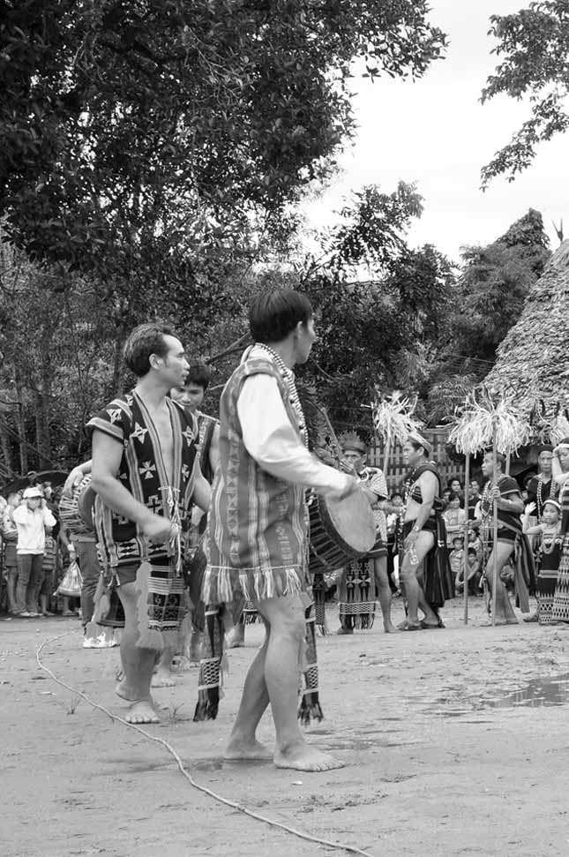

Session 8:

Priority Action Plans

# Session 8: Priority Action Plans



**40 Mins**



**Session overview:**

With the workload that comes with running a small business, it’s not always easy to actually implement the changes you would like. In this session you look at the work you completed during this training and create a simple action plan to improve your businesses. You complete a single activity

## Activity 8A: Prioritized Actions

You will work step-by-step, session-by-session to prioritize the actions you have listed in the previous sessions.





**40 Mins**

1. You talk in a group. Everyone says what he or she found in each of the activities. You start from the first activity.
2. For the next step you use Table 8A: Priority action plan. Individually you look at the action plans you completed for each session and choose which of the changes you will introduce first and when, in a week, in a month, in two months? List at least 3 actions [15mins]
3. Each of us present their Priority Action Plan and the group shares their ideas of whether the priority of actions should be changed or if they are good the way they have been set. Each participant has 5 minutes. [25mins]
4. As a group, you can use additional time to decide whether you will meet again, after the training to practice some of the activities, such as costing. You can also plan to meet on a regular basis and talk about how are you doing with the changes you are introducing

|  |  |  |  |
| --- | --- | --- | --- |
| Table 8A: Priority Action Plan | | | |
| My priority changes | How will I make the changes? | When? | Who is responsible? |
|  |  |  |  |
|  |  |  |  |
|  |  |  |  |
|  |  |  |  |
|  |  |  |  |
|  |  |  |  |



Prioritizing actions, the activity you completed at the end of the training, is a very important step. It pushes you to decide how to apply what you have learned in this training into your work and lives. You can use it together with the Training Guide and GPG to do revisions and motivate yourselves to take actions.

This is the end of the training. You can now complete the evaluation. In few months there will be some follow up too.

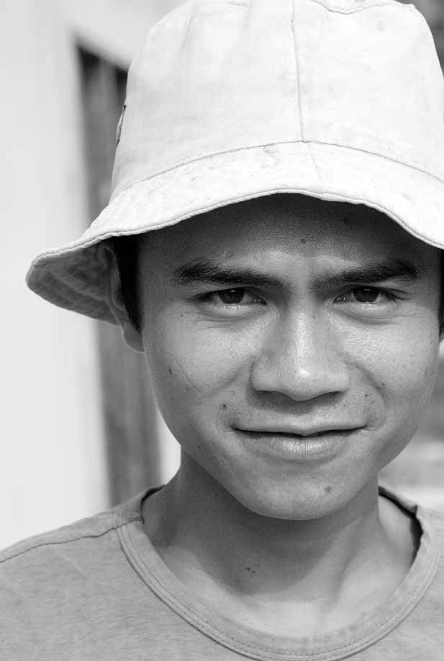

Optional Session:

Creating a Community-Based Tourism (CBT) Homestay

# Optional session: Creating a community-based tourism (CBT) homestay



**90 Mins**

**8**



**Session Overview**

In this session, you will learn about the pros and cons of creating a CBT homestay programme. You will consider the usefulness of associations or cooperatives, and learn how to reduce management efforts and eliminate unhealthy competition. You will complete 4 activities. The objectives of session are to:

* Consider the usefulness of making associations or cooperatives between homestay owners, that is beneficial to reducing costs (e.g., buying food in bulk or paying for Internet service together);
* Learn how to reduce management efforts (e.g., assign one key person to do the marketing for all the households in the CBT homestay, assign one person to handle payments, assign one person to allocate tourists);
* Eliminate unhealthy competition between homestay owners.

## Activity A: Effect of Tourism on Communities



In Activity A you will read some stories that illustrate different forms of tourism in communities and the effect on the community.

**The Story of Ida’s Village**



**[5 Mins]** Ida is a 37-year-old Indonesian woman, who lives with her husband and three children in a village that is near a beautiful temple that attracts many visitors. Ida remembers that when she was younger, everyone in the village helped one another a lot, and it was a wonderful place to grow up. Now she is sad about how things have changed in her village.

Ten years ago, eight village families decided they wanted to open their homes to tourists and to create what they called homestays. It was a way for them to earn money from tourists who came to visit the temple. These families were all related, and they decided to create an association that would include all eight households. They were able to find a donor to give them money to improve their homes. They built modern bathrooms and bought bedroom furniture, paint, roofing materials, etc. with the money.

These eight families worked very hard and created a successful CBT. Now some of their children are going to universities in the city, and the families are buying more and more things that no one else in the village can afford.

Two years ago, other families tried to join the CBT Homestay, but the original eight family members would not let them. Often, every home in the CBT is full with tourists, and tourists who would like to stay in the village are forced to go elsewhere to stay and still the CBT will not accept new members.

One of the elders in the village tried to persuade the eight families to share their good fortune with their neighbours, but they refused. Now, there is much unhappiness in the village. Families that used to be friends no longer speak to each other. Children from one family are not allowed to play with children from another family. The sense of community that once existed in the village is gone.

As tourists come to the village, more and more of them are learning about the sadness in the village. Some have written about it on the Internet. Now, tourists are starting to go elsewhere to stay because they have heard about the unfortunate situation in the village, and they think it is not a good place to stay. They say: “who wants to stay in a village where the villagers do not get along and help one another? We will go somewhere else to stay.”

Ida is sad that the tourists are starting to go elsewhere, and she wishes the village could be a happy place like it was when she was younger.

**The Story of Suri’s Village**

Suri is very happy. Today, her village will celebrate the 5th anniversary of its CBT homestay programme. Five years ago, 8 families from the village started the CBT homestay programme, and today 14 families belong. Suri’s family does not belong to the CBT homestay programme - she and her husband are much too shy to have strangers staying in their home - but they benefit from the programme in many ways.

Suri is hired by the families to go shopping for supplies in the city. Every week she and two of her friends go to buy food and other supplies that are needed (soap, toilet paper, paint, nails, etc.). She buys supplies for all 14 families so she can buy items in large quantities, which saves money for the CBT. It is a good way for Suri and her two friends to earn extra money. Suri’s husband works as a fishing guide for the CBT homestay programme. He loves to fish, and he knows all the best places to catch fish all year-round. He enjoys this work very much. Even Suri’s two teenagers earn money from the CBT homestay programme by helping out in the CBT community garden.

Today, Suri carries a big plate of fried rice to the community centre (built for the village by the CBT homestay programme). All the villagers are there, and they are all laughing and smiling. Suri is so happy to live here! She notices several strangers in the community centre, and she smiles at each of them warmly. They seem to be having a wonderful time, and she is happy about that. She is proud that her village can share its special ways with people from all over the world.

Then Suri goes to sit next to Uncle Praba, one of the elders of the community who helped create the CBT homestay programme 5 years ago. She thanks him for all that the CBT homestay programme has done for her village and asks him why they have been so generous. Uncle Praba takes a moment to think before he responds, then he says, “When we started, some of the families wanted to keep all the profits for themselves, but some of us said that we must think of the entire community if we wanted our village to stay happy. In the end, we created a contract, and all the CBT family members had to sign the contract. The contract states that we must share a percentage of our profits (through salaries or donations) with the rest of the community - in fact, our donations paid for the new roof on the school. It was the right thing to do, and it has made our village stronger as a result.” He continued, “not only that, we stated in the contract that every 6 months we would meet to discuss whether or not we had enough visitors to add other households to the CBT. We’ve grown slowly but steadily over the past 5 years, and as you know, we now have 14 families hosting visitors.”

Uncle Praba looked around the room at all the happy faces and he smiled again. “I am glad we started a CBT that thinks about the whole community. I know that when I am gone, my village will remain unified and strong, and that makes me very happy.”

Then Uncle Praba said, “Excuse me dear Suri. I see young Ari and Lia over there. Ari is very good at managing the sales and marketing for our CBT, and Lia handles all the accounting and budgeting by herself. She even takes payments from all the guests. Those two are a real asset to our community, and I want to thank them.”

Suri smiled and said, “Please thank them for me, too, Uncle Praba!” And then she went to join in on one of the traditional dances that the women were performing.

In this activity you heard the stories of two communities and their different experiences of CBT homestay programmes.



## Activity B: Advantages of CBT



In Activity B you will look at the advantages and disadvantages of community-based tourism.



**30 Mins**

1. Together discuss how a CBT homestay programme can offer advantages over just having several unconnected, individual homestays in a village or town.
2. Record your discussion in Table B.

|  |
| --- |
| Table B: Benefits of creating a CBT Homestay Programme |
|  |



In this activity you listed some advantages to creating CBT homestay programmes.

## Activity C: Ensuring positive effects



Here you will look at how to ensure that CBT homestay programmes have a positive effect on the community.



**30 Mins**

1. Work in groups to discuss what needs to be in place so that CBT homestays have a positive effect on communities.
2. Keep the stories of Ida’s Village and Suri’s Village in mind
3. Discuss the things that must be considered to ensure a CBT homestay programme has a positive effect on a village or town.

|  |
| --- |
| Table C: Creating a positive CBT homestay programme |
|  |

This activity highlighted what can be done to ensure that CBT positively affects communities



## Activity D: Personal action plans



In the final activity of this session you will decide on some concrete actions related to CBT. Keeping in mind all the things you’ve discussed so far about CBT, take a few minutes to record your thoughts.



**10 Mins**

1. Each of you uses Table D: Personal action plan to write 1-3 changes that you would make to ensure positive CBT. Are there any improvements you would like to make based on what you have learned in the previous activities? If so, decide what changes you need to make.
2. Record how you will make these changes.
3. Record by when will you make these changes.
4. Finally, state who will be responsible for this change.

|  |  |  |  |
| --- | --- | --- | --- |
| Table D: Personal Action Plan | | | |
| My changes | How will I make the changes? | When? | Who is responsible? |
|  |  |  |  |
|  |  |  |  |
|  |  |  |  |

In this session, you learned about CBT and looked at what factors would ensure that it positively affects communities. Refer to Section 8 of your GPG for more information or to review CBT’s further.



Annex 1: Flipcharts

# Annex 1: Flipcharts

**On the flipcharts write the following:**

## Flipcharts for Activity 2B



**Flipchart 1: Staff and Systems**

* **Staff** = All the people who work at your homestay, including your family members, friends, hired helpers, or outsourced staff shared with other homestays.
* **System** = A set of detailed procedures created to:
  + Do a specific activity
  + Perform a duty
  + Solve a problem efficiently and with consistent quality



**Flipchart 2: Systems and Checklists**

A good system often starts with a CHECKLIST that is:

* Clear
* Easy-to-follow
* Written



www.sme-tools.org