



MARKET VENDORS TRAINING GUIDE

*ILO - ASEAN Small Business Competitiveness*

A product of ­



Small Business Competitiveness by International Labour Organization (ILO – SBC) is licensed under a Creative Commons Attribution-Non Creative Commons Attribution‐NonCommercial‐ShareAlike 3.0 Unported License.

brought to you by:





**Attribution** — You must give [appropriate credit](https://creativecommons.org/licenses/by-nc-sa/3.0/), provide a link to the license, and [indicate if changes were made](https://creativecommons.org/licenses/by-nc-sa/3.0/). You may do so in any reasonable manner, but not in any way that suggests the licensor endorses you or your use.



**NonCommercial** — You may not use the material for [commercial purposes](https://creativecommons.org/licenses/by-nc-sa/3.0/).



**ShareAlike** — If you remix, transform, or build upon the material, you must distribute your contributions under the [same license](https://creativecommons.org/licenses/by-nc-sa/3.0/) as the original.

****[*https://creativecommons.org/licenses/by-nc-sa/3.0/legalcode*](https://creativecommons.org/licenses/by-nc-sa/3.0/legalcode)

**Table of Contents**

About C-BED v

About the Market Vendor Package: v

Message to the Group vi

Session 1: Introductions 1

Activity 1A: Getting to Know Each Other 1

Session 2: Assessing Your Business 5

Activity 2A: What Makes a Business Succeed 5

Activity 2B: SWOT Analysis 8

Activity 2C: Personal Action Plans 10

Session 3: Marketing Your Business 13

Activity 3A: Describe Your Business 13

Activity 3B: Market Analysis 17

Activity 3C: Product, Place, Promotion 19

Activity 3D: Personal Action Plans 24

Session 4: Budgeting and Pricing 27

Activity 4A: Know Your Costs, Prices and Profits 27

Activity 4B: Know Your Costs (Variable/Fixed) 28

Activity 4C: Personal Action Plans 34

Session 5: Systems for Improvement 37

Activity 5A: Solving Common Business Problems 37

Activity 5B: Personal action plans 39

Session 6: Priority Action Plans 43

Activity 6A: Priority action plan 43

Flipcharts: 47

Flipcharts for Activity 4A: 47

Flipcharts for Activity 5A 48

# About C-BED

Community-Based Enterprise Development (C-BED) is a low cost, innovative training programme designed by the International Labour Organization (ILO) to support skills development and empowerment in local communities for improvements in livelihoods, productivity and working conditions.

As an approach to training, C-BED is unique in that the programme is built around peer-to-peer, activity based learning methods with no role for teachers, experts, or external consultants specialised in the skill area. Instead, C-BED participants work together through a series of activities and discussions guided only by simple step-by-step instructions in the training manual. New knowledge, skills and competencies are developed through the interactions between participants and sharing of existing local knowledge and experience. In this way the programme is a low cost, sustainable option for any organization or community.

The C-BED programme is structured around two core training packages designed to develop competencies for business start-up and operation through a focus on marketing, financial management, and action planning. These are the C-BED for Aspiring Entrepreneurs and C-BED for Small Business Operators. Additionally, a growing suite of tools to strengthen business competencies and enhance skills for specific sectors is in continual development. These packages can be implemented as either stand-alone trainings or integrated in modular format into existing programmes.

.

## About the Market Vendor Package:

**The training package:**

The Market Vendor package should be used to help aspiring and current market vendors start and improve their businesses. It focuses on key business principles to build on from what participants already know from managing their stores and helps them to learn more. It can also build on from the learning in other C-BED tools namely SBO or AE. Participants bring experience to share and leave with a priority action plan (at least 3 actions to introduce improvements to their business). At the end of the training participants will have:

* Enhanced and advanced existing knowledge on market vending
* Strengthened critical competences to analyse job prospects or current conditions of work
* Affirmed the potential of enterprise development
* Identified steps and actions to improve a business or launch a business idea
* Decided on actions for the future
* Started planning effective collaborations and associations

**The Good Practice Guide:**

During the training day participants will be introduced to and become familiar with the Good Practice Guide (GPG), which they will then be able to use to further their learning and to support them in setting up or improving their businesses. The GPG contains best practices, tools and extra activities that supplement those covered in the training to further support the participants in setting up or improving their businesses. The exercises may depend on the GPG but if the participants do not have this guide this should not prevent them from moving forward, if necessary skip that activity. Look out for this icon:

Here you should refer to the Good Practice Guide for more information.



## Message to the Group

At the end of this C-BED training you will have a clear plan for the practical steps you can take to start or improve your business. Your understanding of the basic principles of doing business will be much stronger and you will have begun relationships with others in your community that can potentially support or cooperate with you to achieve mutual success in the future.

The style of this training is different to traditional education approaches. There will be no teacher, trainer or expert to assist you. Instead, you will work together as a team to follow the simple step-by-step instructions for discussions and activities in your training guide. Because there is no group leader, all group members should take a turn reading the information and instructions out loud to the group, and all group members share responsibility for monitoring time. In this new style of training, we will learn from each other by sharing ideas and opinions, skills, knowledge and experience. For this to work, all group members must participate in discussions.

Before and after the training you will be asked to complete a survey to understand the impact of the training. This information will be kept confidential and is used to improve the training materials and organization of future programs. Some trainees may also be contacted in the future after 3, 6 or 12 months for another survey to learn about your business plans.

The instructions in the training guide are easy to follow and suggested timing for each step is provided. Look out for these signs:



When you see this sign, read aloud

When you see this sign, share with the group

When you see this sign, you are reading instructions and doing activities

This sign gives you the estimated time for the session

Use the flipchart as outlined in Appendix 1, if you don’t have a flipchart use extra paper or the Training Guide







Before you begin the training, follow the simple steps below to get organized.

* Fill out the pre-training survey. Ask the organizers if you don’t have a copy or have not already filled it in.
* Organize into small groups of 5-7. The organizers will guide you in how best to do this.
* Identify one group member to volunteer to start the training as ‘Group ‘Reader’. The ‘Group Reader’s’ role is to read the information and activity instructions out loud to the group. Any group member with basic literacy can be the ‘Group Reader’ and you should aim to share this role among group members throughout the training.

All group members are responsible for monitoring time but one group member should be nominated for each session to remind the group when the suggested time for a step has been reached. You do not strictly need to follow the suggested timing but you will need to manage your time for the total training. If one activity lasts longer than the suggested timing, try to save time in other activities to keep the balance.

All group members will receive the same training guide. Individual work can be completed in these guides as well as group work. Groups may also like to complete activities together on flipchart paper if available.

Enjoy the Training!

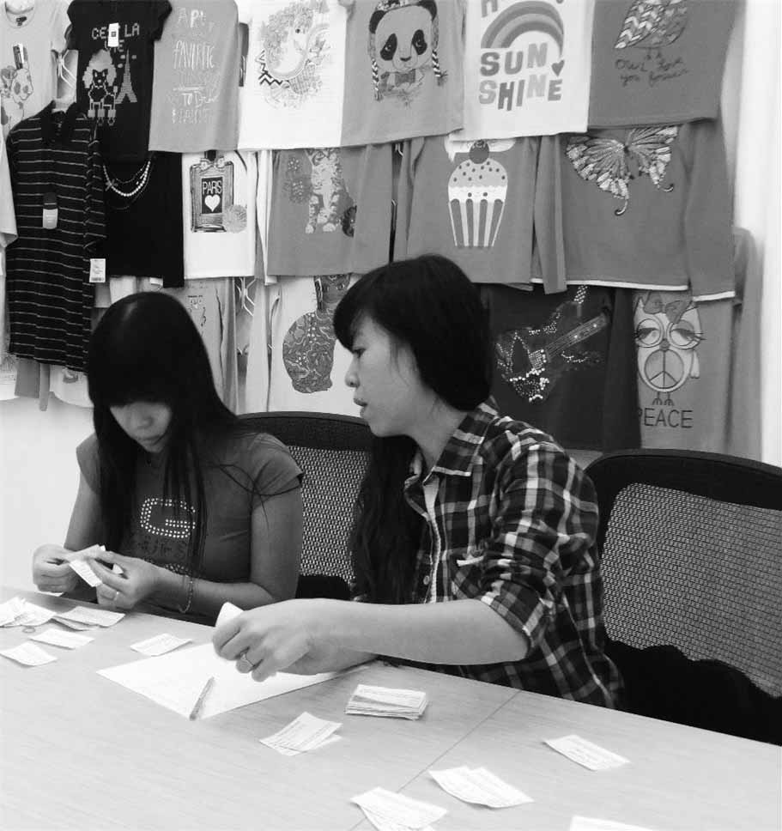

Session 1:

Introductions

# Session 1: Introductions



**20 Mins**



**Session Overview**

In this session you will get to know one another and the style of learning in this training. We learn without teachers. You help each other with your different experiences and ask questions if you don’t understand an activity. You will complete a single activity. The objectives for this session are as follows:

* Identify the training sessions, timing for the day, expectations, and the workshop arrangements
* List the names of some of the trainees
* Understand the style of learning for this course, including activities and group work

## Activity 1A: Getting to Know Each Other



In Activity 1A, you will do some brief introductions so you can get to know one another.



**20 Mins**

1. Each person introduces themselves by providing their:

* Full name and any nickname you prefer to use during the session
* Store or market address
* How long your business has existed (if applicable)
* Their purpose for attending this session and how you expect it to help your business

1. Each person shares a drawing or picture of his or her best-selling item for others to see. Place this on the wall or in the middle of the table or allow others to see it on your mobile phone.
2. Fill in this sheet below (if not now then during tea breaks and lunch time)

|  |  |  |
| --- | --- | --- |
| Table 1A: Participant Information | | |
| Participant name | Store or market address | Phone number /  Email address |
|  |  |  |
|  |  |  |
|  |  |  |
|  |  |  |
|  |  |  |
|  |  |  |
|  |  |  |
|  |  |  |



In this session you have gotten to know who your peers are and a little about their businesses.

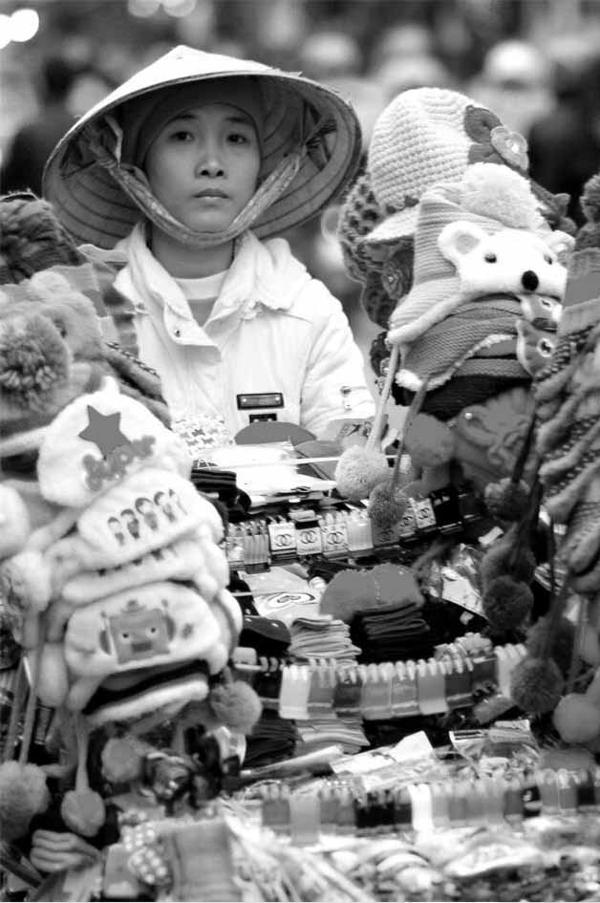

Session 2: Assessing Your Business

# Session 2: Assessing Your Business



**1**

**90 Mins**



**Session Overview**

In this session you will undertake some activities to help you to assess your business. You will complete 3 activities. The objectives for this session are as follows:

* Understand what factors impact your business
* Understand what factors make your business succeed
* Use SWOT as a tool for understanding the internal success factors and external opportunities or threats facing your business

## Activity 2A: What Makes a Business Succeed

In Activity 2A you will look at some important factors that make a business succeed. Discussion amongst yourselves will help you to identify factors that influence your business.



**45 Mins**

1. In your groups discuss the words in the Word Cloud in Table 2A below. List the five most important ones for your whole group. Negotiate the order of words until everyone agrees. [5 minutes]
2. Each group presents their top five characteristics on a flip chart or large sheet of paper. [5 minutes]
3. Ask the following questions: [10 minutes]

* What are the similarities between the groups?
* Which ones created most discussion, and why?
* Were there any particularly related to women only, why do you think this is?

1. Once you have completed this, use it assess your business and yourself as a businessperson.
2. Discuss your assessments within your groups and reflect on the following points:

* Can you group some of them together? For example, the ones related to finance, marketing, staff etc.?
* Can you think about ordering them according to how easy or how difficult it will be to address them?
* Can you think about how you will make changes, do you know what to do? For example, be more organized yourself, seek advice from others, or search for learning materials like books, magazines, internet

|  |
| --- |
| Table 2A: What Makes a Successful Business |
| |  | | --- | | Word Cloud | | Place of business/sales Know customers’ needs Good sale price  Know my business costs Cost of products Family support  Good quality products Staff/workers busy Good marketing techniques  Attracting customers Products available Skilled workers  Good storage No waste of products Availability of loans  Know your daily tasks Good working conditions Good bookkeeping  Clean workspace Sufficient customers Tracking your money  Organized workspace Know your types of costs Good business person/s  Satisfied with your business Product in good condition Knowing what you earn  Equipment in good condition Know the tasks of your workers  Knowing what you are owed Customers come back to you | |  |  |  |  |  | | --- | --- | --- | | Top 5 Business Success Factors | | | | Our 5 top business success criteria | Our reasons for selecting this criteria | Do you do this well - score individually using:  ☺ Good  😐 Okay  ☹ Needs improving | | 1. |  |  | | 2. |  |  | | 3. |  |  | | 4. |  |  | | 5. |  |  | |
| |  |  |  |  |  |  | | --- | --- | --- | --- | --- | --- | | Your Own Business Assessment | | | | | | |  | Success criteria | ☺ Good | 😐 Okay | ☹ Not good | What I can do | | 1. | Place of business/sales |  |  |  |  | | 2. | Know my business costs |  |  |  |  | | 3. | Quality of products |  |  |  |  | | 4. | Customers |  |  |  |  | | 5. | Storage of products |  |  |  |  | | 6. | Daily tasks and routines |  |  |  |  | | 7. | Clean workspace |  |  |  |  | | 8. | Organized workplace |  |  |  |  | | 9. | Satisfied with business |  |  |  |  | | 10. | Equipment condition |  |  |  |  | | 11. | Know what you are owed |  |  |  |  | | 12. | Know customer needs |  |  |  |  | | 13. | Cost of products |  |  |  |  | | 14. | Sale price |  |  |  |  | | 15. | Products available |  |  |  |  | | 16. | Waste of products |  |  |  |  | | 17. | Productivity of staff |  |  |  |  | | 18. | Staff work conditions |  |  |  |  | | 19. | Sufficient customers |  |  |  |  | | 20. | All costs included |  |  |  |  | | 21. | Product in good condition |  |  |  |  | | 22. | Know staff tasks |  |  |  |  | | 23. | Customers come back |  |  |  |  | | 24. | Sale price |  |  |  |  | | 25. | Family supports you |  |  |  |  | | 26. | Marketing techniques |  |  |  |  | | 27. | Skilled & reliable staff |  |  |  |  | | 28. | Availability of loans |  |  |  |  | | 29. | Bookkeeping |  |  |  |  | | 30. | Tracking your money |  |  |  |  | | 31. | Good business person |  |  |  |  | | 32 | Know what you earn |  |  |  |  | |

In this activity you looked at a number of factors that could impact your business and highlight a few important ones. You also assessed yourself as a businessperson and your business against these factors. There are many factors which will have an impact on your business and if you can find the ones that are having a negative impact on your business, and then change them, your business should improve.

## Activity 2B: SWOT Analysis

In Activity 2B you will complete a SWOT analysis. The SWOT analysis tool is used to explore issues in a business, including its strengths, its weaknesses and outside factors that will enhance the business or risks that might damage the business.

**SWOT:**

* Strengths: inside the business
* Weaknesses: inside the business
* Opportunities: outside the business
* Threats: outside the business

**Strengths** will give your business an advantage over similar businesses. For example, having quality products, or a good location for sales.

**Weaknesses** are those aspects that you and your business are not good at. For example, a supplier is inconsistent or there are high costs involved for transporting products.

**Opportunities** are things that happen outside your business that can help you. For example, a new guest houses in the area or tourists using the bus station.

**Threats** are things outside the business that may harm your business and reduce your profit. For example, your business idea is popular and people copy the idea or there are fewer tourists for you to sell to.

When strengths and opportunities are greater than weaknesses and threats, you are in control of your business and can take calculated risks. When weaknesses and threats are greater then the strengths and opportunities, you will need to take serious action to save your business.

This is an example of a SWOT analysis.

|  |  |
| --- | --- |
| Strengths | Weaknesses |
| Prime location in local market  Will sell a variety of products  Knows several handicraft producers  Has the skills to source products and negotiate good product prices | Inconsistent financial management  No marketing or development plans |
| Opportunities | **Threats** |
| Many visitors coming to the area  More hotels and guest houses  Has good relationships with many of the local residents and businesses | Competitors can easily start a similar business which might lead to a decrease in sales |
| Are there more strengths than weaknesses? Yes  No  Are there more opportunities than threats? Yes  No  How will I handle weaknesses and threats?  I will improve my business by paying more attention to the finances and marketing.  I will provide a good service to my producers and customers so that I keep ahead in my business.  I will use my friends, family and other contacts to support and promote my business. | |



**25 Mins**

1. Thinking about your own business, write down as many points as possible under strengths, weaknesses, opportunities and threats. [5 minutes]
2. Work in pairs within your groups. Using the criteria in Activity 2A (top 5 success factors) check that most are covered, discuss these in your pairs. [10 minutes]
3. Ask the following questions to highlight similarities and problem solve as a group [10 minutes]:

* Did any of the pairs have similar statements, which ones?
* Does anyone have a challenge that they don’t know how to resolve? If yes, how do others in the group manage this challenge?
* Are you starting to get an idea of some of your own business challenges?

|  |  |
| --- | --- |
| Table 2B: SWOT Analysis | |
| Strengths | **Weaknesses** |
|  |  |
| Opportunities | **Threats** |
|  |  |
| Are there more strengths than weaknesses? Yes  No  Are there more opportunities than threats? Yes  No  How will I handle weaknesses and threats?  I will  I will  I will | |

In this activity, you have now used a second tool to help you identify the internal and external factors that are having a positive or negative effect on your business. There are many factors which will have an impact on your business and if you can find them, and then change them, your business should improve.

## Activity 2C: Personal Action Plans

In the final activity of this session you decide on some concrete actions to take with respect to your business. Keeping in mind all the things you’ve discussed so far, take a few minutes to record your thoughts.



**10 Mins**

1. Each of you uses Table 2C: Personal action plan to write 1-3 changes that you would make to improve your business. Are there any improvements you would like to make based on what you have learned in the previous activities? If so, decide what you will implement or improve.
2. Record how you will make these changes.
3. Record by when will you make these changes.
4. Finally, state who will be responsible for this change.

|  |  |  |  |
| --- | --- | --- | --- |
| Table 2C: Personal Action Plan | | | |
| My changes | How will I make the changes? | When? | Who is responsible? |
|  |  |  |  |
|  |  |  |  |
|  |  |  |  |

In session 2 you focused on assessing your business. This helps you to determine factors that will help your business to be successful as well as to identify internal strengths and weaknesses, and external opportunities and threats. Look at Section1 of your GPG for more information.

Session 3: Marketing Your Business

# Session 3: Marketing Your Business



**95 Mins**

**2**



**Sessions Overview**

This session addresses the need for a marketing plan and it provides activities to develop one for your own business. A marketing plan is developed from an analysis of customers and an analysis of the market and includes what is known as the 4 Ps’ - Product, Place, Promotion and Price. Every effective business needs a marketing plan to guide the business to reaching as many customers as possible. A marketing plan is necessary if you have to write a business plan. A business plan is a document that fully describes and explains your business. Writing a business plan is a useful exercise for you as it helps to order your thoughts, your ideas and make a plan for the business to develop. You will complete 4 activities. The objectives of the session are as follows:

* Describe your own business using key terms to help others understand what you do and how you do it
* Take a look at important aspects of a business plan
* Get an overview of a marketing plan and some key marketing concepts

## Activity 3A: Describe Your Business

In this activity you will learn how to effectively describe your business. First we will read through the case study and the example, before completing a description of our business using the template. A business description helps you answer questions such as:

* Which customer needs the products will satisfy
* What products are sold
* Who they are sold to
* How the products are sold



**Case Study**

[5mins] Pom Sittuwe lives in a small town with her two teenage children. She has been buying locally produced handicrafts and selling them in the Saturday Walking Street Market. Business has been good for the past two years. Pom has managed to get enough handicrafts from surrounding villages and she has a good turnover of stock. She is thinking about trying to expand her business by including other options for sales as she has noticed there are more visitors to the area using guesthouses and homestays. Pom has assessed her current business and wants to improve on her marketing and financial management. She is even thinking of taking out a loan from her uncle, who has offered her good repayment terms, including a very low interest rate. Before he invests he would like to know that his money is safe and that Pom will be able to make the monthly repayments to him and so he has asked her for a simple business plan with some projections.

|  |  |
| --- | --- |
| Pom Sittuwe’s Business Description | |
| Name of business: | Ethnics 4 All |
| Type of business | ❑ Manufacturer ❑ Service operator  🗹 Retailer ❑ Wholesaler |
| What need will the products satisfy? | Handicrafts for local people, visitors and tourists to support local craft workers (i.e. social responsibility), presents for festivals and special events (i.e. Mother’s day & graduation day cards), and souvenirs from their holiday/visit. |
| What products will the business produce? | None, the products are purchased from rural handicraft producers. |
| Who will the products be sold to? | To people who live, work or visit the town. |
| How will the products be sold? | In the market, in guesthouses, bus stations, coffee shops and in special ‘event’ markets (e.g. for graduation - outside the school on graduation day). |

Some definitions:

* **Manufacturer:** makes products.
* **Wholesaler:** sources bulk products and sells them on to the retailer. They don’t usually sell direct to the public. If the retailer can cut out the need for the wholesaler (i.e. they get products from the person who makes them) they don’t have to pay the costs of the wholesaler - so the products are usually cheaper. A wholesaler would be used if the seller cannot access the producer.
* Service provider: does not sell products but sells a service (e.g. repairing sewing machine, hair cutting).



**30 Mins**

1. Talk through the headings of a business plan. See the business plan checklist below and in your GPG section 1.
2. Read out the explanation below from the business plan checklist. You do not need to read all the information under each heading as most are covered later in the module. You should pay most attention to the marker analysis and market plan section.
3. We have read Pom Sittuwe case study, now complete a description of your own business in Table 3A. Work in pairs. [10 minutes]
4. Share your descriptions with the group. [10 minutes]
5. Discuss in your group the following questions. [5 minutes]

* What differences did you have in your 3 pairs, what similarities?
* What do you think this activity helps you to do

|  |  |
| --- | --- |
| Business Plan Checklist* | |
| Executive summary:   * Name of business * Name of owner * The vision (where you would like to in 5 years time) * The structure of the business, who is involved, where is it * Describe the products, how they are made etc. * What are the market opportunities for sales * What sales goals will you achieve over 1, 2 and 3 years * Applying for a loan: include the amount, how it will be used and how you will guarantee repayments based on the success of your business |  |
| Description of the business:   * Product characteristics particularly in comparison to competitors * Overview of the business including prices and marketing |  |
| Market analysis:   * Specific product descriptions including size, material, weight * Description of clients and why they will buy from you * Assessment of market potential (e.g. more tourists or new hotels) * Competitive sales market, why you will be better than others * Unique selling point (e.g. locally sourced, organic, sustainable) |  |
| Management plan:   * Structure of the business, who is responsible, who supports the business |  |
| Marketing plan:   * Price the customer will pay, what competitors charge * Distribution, where will you be selling, mail order etc. * Advertising and promotions |  |
| Financial plan:   * Money required for loan to develop (or start) a business * Future financing when loan expired based on increased profits * Projected performance, estimated figures to show growth * Financial statement, estimate of total income, total expenditure and your total investment (including assets) * Income statement showing estimated performance over 3+ years, total revenues and expenditure * Break even analysis showing that income from sales is higher than expenditure (business costs and outgoing funds) * Projected cash flow to show financial resources needed * Capital equipment (assets) i.e. business items, materials, equipment owned by you |  |

|  |  |
| --- | --- |
| Table 3A: Business Description | |
| Name of business: |  |
| Type of business: | ❑ Manufacturer ❑ Service operator  ❑ Retailer ❑ Wholesaler  ❑ Other |
| What needs will the products satisfy? |  |
| What products will the business produce? |  |
| Who will the products be sold to? |  |
| How will the products be sold? |  |

Using a template like the one in Activity 3A will provide you with a framework to include all the relevant information needed to describe your business in detail. Many of the activities in this module will help you to build up the skills to write a detailed plans for your business.

## Activity 3B: Market Analysis



In activity 3B you will take the next steps in writing a marketing plan



[5mins] The next step to writing a marketing plan is to analyse your market. This means understanding your customers and competitors. How do you do this?

1. Talk to potential/future customers.

* What products do they want to buy?
* What do they think about other people selling similar products?

1. Observe your competitors’ businesses.

* What sort of quality, range, sizes etc. do they sell?
* How much do they charge?
* How do they attract customers? What offers, discounts do they use?

1. Ask friends, family and other business people.

* What goods sell well?
* What do they honestly feel about your business?
* What do they think about your competitors’ products?
* How do they attract customers?



**25 Mins**

1. Discuss the chart for Pom Sittuwe’s handicraft business. Who are the likely customers and what are their needs and preferences? [5 mins]
2. In pairs, complete a similar blank chart for your own business [10 minutes].
3. Ask the following questions to stimulate discussion [10 minutes]

* Have you got any unusual potential customers, those that are not either individuals or other vendors?
* What about the needs (e.g. type of handicraft) and preferences (e.g. size, shape, colour, gender specific, seasonal events such as Mothers’ Day and special events like graduation or Songkran)? What special events, festivals could you supply?

|  |  |  |  |
| --- | --- | --- | --- |
| Pom Sittuwe’s Potential Customers | | | |
| Market segment | Potential customers | Needs and preferences of customers | Analysis of competitors |
| 1. | Individuals (own market stalls) | Light and easy to pack when travelling  Easy to post overseas  Reminder of their visit | Few handicraft traders in market/or other business outlets  Higher cost of transported goods from other countries (keep it local)  Limited time to purchase - time spent on main business (e.g. guesthouse) |
| 2. | Other businesses (e.g. guesthouses, bus station, local craft shops, galleries, and cafes) | Currently source products themselves (time consuming as it is not their main business and they cannot leave their shop)  They usually don’t know where to find the products |
| 3. | Schools, universities (students, teachers, parents waiting for their children) | Students only have specific times available to buy the products, and have a limited budget. | Very few competitors exists in the schools’ compound |

|  |  |  |  |
| --- | --- | --- | --- |
| Table 3B: Market Analysis | | | |
| Market segment | Potential customers | Needs and preferences of customers | Analysis of competitors |
| 1. |  |  |  |
| 2. |  |  |  |
| 3. |  |  |  |

In this activity you looked at a market analysis for your business. Analysing who your potential customers are can help you to explore new business opportunities and increase your customer base. There can be many market segments - explore all new possibiities. They include where/how you sell now. For example, just from your stall in the walking street market. Although you could leave products with other businesses to sell or you could explore the mail order/online market. This means selling from a brochure or website. Next you analyze and describe the their needs and preferences. You have to ask them, do some fact finding to get the answers. Finally, you really need to know and analyze your competitiors to position your business better.

## Activity 3C: Product, Place, Promotion

In activity 3C, you will explore 3 of the 4 P’s of marketing. We will read through the product, place, promotion, and price table below and refer to some completed templates before completing an exercise.

|  |
| --- |
| PRODUCT: What products are you selling to your customers?   * The range = bags, hats, scarves, socks, wallets etc. * The size = large bags, small bags, wallets, S/M/L etc. * The style = rucksack, over the shoulder, clasp etc. * The ‘gender or age’ = suitable for babies, children, older people, men and/or women. * Quality = cheap and low cost, medium range, expensive and high cost). * Colour = dark, light, mixed, modern, traditional. * Packaging = re-used supermarket bag, specially printed brown paper bag, organza gift bag for expensive products like jewellery. |
| PLACE: Where and how will you reach your customers?   * Customer comes to you at your market staff or event stall. * You sell to other businesses that are likely to interact with visitors and tourists. * What about mail order (i.e. for customers on holiday who have returned home)? * Have you thought of selling via the Internet or Facebook (mail order)? * What location is best for my customers? * Where are my customers likely to ‘hang out’? * Can I carry my products to the stall? * Are there any services available - e.g. water, electricity, toilet, changing room (for trying on clothes)? * Do I need to consider my suppliers when choosing a location? * Can I still make a profit if I am far from my producers? * Can I sell through somebody else’s place (e.g. kiosk in the bus station, wall display in a guest house, stall in the municipality office)? * How much is the rent? |
| PROMOTION: How will you let your customers know about your products and how will you encourage them to buy?   * Signs at your main staff (e.g. opening and closing hours, contact telephone, your name, business name, email address). * Do you explain on a business card, leaflet or sticker, where your products come from and how you are supporting local producers, encouraging ethnic culture and crafts? What is your Unique Selling Point (USP)? * Do you have notices or leaflets offering discounts for 10 or more purchases of the same product or incentives like ‘Three for the Price of Two!’ * What about a guarantee for quality? |
| PRICE: What price you are going to charge? The price is very important - too high and you might not sell enough, too low and you won’t make enough money. We cover pricing in the Session 3. |

|  |  |  |
| --- | --- | --- |
| Example | | |
| Product | | |
|  | Example: Carry on Bag | Example: Rice Sack Wallets |
| Quality | Naturally dyed cotton, hand stitched | Re used, washed sacks, double edge sewing for strength, water proof |
| Colour | Black/red | Varies, depends on the sacks used at time of production |
| Size | 14” x 9” x 22” | 6” x 3” |
| Packaging | Cellophane | Business label (logo) |
| USP  (what is unique) | Locally designed, hand made | Very low cost for product material, recycled rice sacks, sustainable source |
| Place | | |
| Premises: 🗹 Rented ❑ Own ❑ Sublet Space ❑ Sale/Return ❑ Other | | |
| Location | Main bus station (cabinet) | Lucky’s Guest House |
| Why here? | Lots of visitors and tourists come by bus, I don’t have to sell - just supply, collect money every week | Friend works here, busy guest house, don’t have to sell - just supply, collect money once a month, will call for more stock |
| Disadvantages? | Sign goes missing, some products lost/stolen | None |
| Rent | None, commission paid (5% of all goods sold) | No charge, they support local businesses |
| Promotion | | |
| ADVERTISING | | |
| Type | Details | Cost |
| Sign for market stall | Sign writer to make with business name, business owner, telephone number | $30 |
| Business cards | As above, but includes USP (e.g. sustainable, locally, hand made etc.) | $12 |
| Product labels (as above or just logo) | Small sticky tear off labels to put on all packaging, name and telephone only | $5 |
| PROMOTION | | |
| Type | Details | Cost |
| Seasonal discounts | 10% off for Mother’s Day, Winter Clearance 20% off | 10% of daily income for same period last year |
| Bulk buy | 20% off for 5 or more of the same product; free mailing for order over $100 | Mailing cost approximately $2 per 100; 1/5 |
| Buy 2 get 1 free (anytime of year) | Various time of the year including low season, rainy season, Chinese New Year | 1/3 |
| Example | | |
| Product | | |
|  | Example: Carry on Bag | Example: Rice Sack Wallets |
| Quality | Naturally dyed cotton, hand stitched | Re used, washed sacks, double edge sewing for strength, water proof |
| Colour | Black/red | Varies, depends on the sacks used at time of production |
| Size | 14” x 9” x 22” | 6” x 3” |
| Packaging | Cellophane | Business label (logo) |
| USP  (what is unique) | Locally designed, hand made | Very low cost for product material, recycled rice sacks, sustainable source |
| Place | | |
| Premises: 🗹 Rented ❑ Own ❑ Sublet Space ❑ Sale/Return ❑ Other | | |
| Location | Main bus station (cabinet) | Lucky’s Guest House |
| Why here? | Lots of visitors and tourists come by bus, I don’t have to sell - just supply, collect money every week | Friend works here, busy guest house, don’t have to sell - just supply, collect money once a month, will call for more stock |
| Disadvantages? | Sign goes missing, some products lost/stolen | None |
| Rent | None, commission paid (5% of all goods sold) | No charge, they support local businesses |
| Promotion | | |
| ADVERTISING | | |
| Type | Details | Cost |
| Sign for market stall | Sign writer to make with business name, business owner, telephone number | $30 |
| Business cards | As above, but includes USP (e.g. sustainable, locally, hand made etc.) | $12 |
| Product labels (as above or just logo) | Small sticky tear off labels to put on all packaging, name and telephone only | $5 |
| PROMOTION | | |
| Type | Details | Cost |
| Seasonal discounts | 10% off for Mother’s Day, Winter Clearance 20% off | 10% of daily income for same period last year |
| Bulk buy | 20% off for 5 or more of the same product; free mailing for order over $100 | Mailing cost approximately $2 per 100; 1/5 |
| Buy 2 get 1 free (anytime of year) | Various time of the year including low season, rainy season, Chinese New Year | 1/3 |



**30 Mins**

1. In groups complete a sample product and place template in Table 3C
2. Then work on some ideas for your promotions, including advertising.
3. Individually prepare an A4 poster to advertise for your own business. It could be information about the business or it could be promotional offers. Remember the poster has to be read from a distance (e.g. say from the other side of the street) so make your drawings, writing etc. easy to read, well laid out, spelt correctly, dark and clear. When you have finished hang your poster on the wall.

|  |  |  |
| --- | --- | --- |
| Table 3C: Product, place, promotion | | |
| Product | | |
|  | Product 1 | Product 2 |
| Quality |  |  |
| Colour |  |  |
| Size |  |  |
| Packaging |  |  |
| USP  (What is unique) |  |  |
| Place | | |
| Premises: ❑ Rented ❑ Own ❑ Sublet Space ❑ Sale/Return ❑ Other | | |
|  | Location 1 | Location 2 (optional) |
| Why here? |  |  |
| Disadvantages? |  |  |
| Rent |  |  |

This activity has shown how to write up information relating to your Product, Place and Promotions and you have had the opportunity to design some promotional material for your business. The 4 P’s are the key components of a marketing plan. In the GPG Section 2.3, you can find blank templates (with an example) for the 4P analysis. Please use these templates to assess better your business in the future.

## Activity 3D: Personal Action Plans

In the final activity of this session you decide on some concrete actions to take with respect to your business. Keeping in mind all the things you’ve discussed so far, take a few minutes to record your thoughts.



**10 Mins**

1. Each of you uses Table 3D: Personal action plan to write 1-3 changes that you would make to improve your business. Are there any improvements you would like to make based on what you have learned in the previous activities? If so, decide what you will implement or improve.
2. Record how you will make these changes.
3. Record by when will you make these changes.
4. Finally, state who will be responsible for this change.

|  |  |  |  |
| --- | --- | --- | --- |
| Table 3D: Personal Action Plan | | | |
| My changes | How will I make the changes? | When? | Who is responsible? |
|  |  |  |  |
|  |  |  |  |
|  |  |  |  |

In this session, you explored and described your customers and analyzed your markets, that is, how and where you could sell. Overall this session helped you to think about constructing a marketing plan for your business. Section 2 of your GPG has more information.

Session 4: Budgeting and Pricing

# Session 4: Budgeting and Pricing



**3**

**1**

**60 Mins**



**Session Overview**

The purpose of this session is to understand the different types of business costs in relation to the sale price of your products in order to make a profit.The session covers costs and calculating profits. You will complete 3 activities. The objectives of the session are as follows:

1. Understanding variable and fixed costs
2. Using total costs to determine price
3. Calculating business profit

## Activity 4A: Know Your Costs, Prices and Profits

In Activity 4A you will get an idea of how to manage your finances. This includes business costs and pricing your products. To get these figures we need to start with an estimate of how much we can sell per month.

Each of these sections corresponds to an example displayed on a flipchart (or a piece of paper on your tables). We will now read through this and look at the flipchart.



**1. ESTIMATING PRODUCT PRICES:**

[10mins] How much you will charge your customers for your products? In order to make a profit, the price customers will pay must be higher than your costs to provide the product and inline with your competitors’ prices. To set your prices you have to know:

* How much your potential customers are willing to pay
* Your competitors’ prices - the highest and the lowest prices in the market for the same type of products
* Your costs to bring the products to a selling point such as a market

Work from the Flipchart 1 to show the example

**2. ESTIMATING MONTHLY SALES:**

When you have your estimate you can work out your monthly sales. You can do this in several ways:

* Comparison with sales figures for the same period the previous year
* Comparison with other handicraft traders
* Conduct a survey with potential customers
* Field testing by having a very small range of products to experiment with - what sells quicker, how many etc. (This is not a good method if there is a high investment cost involved.)
* Advanced orders: a written agreement is usually better than a verbal agreement.

Work from Flipchart 1 to show the example [5 minutes].

In this activity you looked at how to estimate what you can charge for a product and how many products you might sell per month. Once you have these two figures you can focus on working out your costs.

## Activity 4B: Know Your Costs (Variable/Fixed)

[10mins] You now have an idea of how many products you hope to sell and an estimate of what price to sell them for, but you cannot confirm these numbers until you have worked out what it is going to cost you to sell the products. There are a number of different types of costs involved. In Activity 4B we will read through the definitions of different types of costs.

This table contains the definitions of the various types of costs. Let’s read through it now to help you complete the next activity. In brief, you should remember:

* Variable: these increase and decrease depending on how much work you do or how much you sell
* Fixed: these stay the same no matter what you do and what you sell

|  |  |
| --- | --- |
| Term used | Definition |
| Variable costs | Variable costs change with the amount of products you sell. They include raw materials and labour costs. A handicraft trader would include costs like transport and postage of products to the customer etc. For example, telephone calls are a variable cost, but not the telephone itself, as the cost changes depending on how often and how long you talk on the telephone. |
| Raw materials | These are the basic materials used to make the final product. For example, the packaging for jewellery or the logo labels for the products. Raw materials come under variable costs because the cost changes depending on how many of the products are sold. |
| Labour Costs | Labour costs are the amount of wages you pay yourself, your employees or the commission you give to people selling for you (e.g. the bus station kiosk manager). Labour costs come under variable costs because the amount changes according to what you sell (e.g. kiosk manager - she does not get a regular wages, just a percentage of what she sells). Likewise your wage should depend on how productive you are. |
| Fixed Costs | Fixed costs are the same regardless of the amount of products you sell. For example, the cost of your Saturday Night Market stall, your telephone etc. |



**10 Mins**

1. Now we will complete a short quiz.
2. If the participants are all able to stand up (i.e. nobody is in a wheelchair or has difficulty walking or standing for a short period) start the quiz with everyone standing.
3. The group reader will read out the statements and check for the correct the answers. If you think the cost described is a fixed cost then sit down. If you think it is a variable cost, stay standing.
4. Those who get an answer wrong should move away from the main group as they are out of the quiz.
5. The winners are the ones left standing after the last question.
6. Take a look at the answer sheet below when you have completed the quiz to see where you went wrong.
7. Once you have completed the quiz the group reader will read through an example of budgeting and costing for you.

|  |  |  |
| --- | --- | --- |
| Item | Variable | Fixed |
| Monthly rent for your stall |  |  |
| Commission for the bus station kiosk |  |  |
| Loan repayment for the motorbike |  |  |
| Staff coffee |  |  |
| Electricity for the stall |  |  |
| Telephone credit |  |  |
| Cleaning products |  |  |
| Post and packing of products to be sent overseas |  |  |
| Business owner’s social security payments |  |  |
| Loan repayment to Uncle |  |  |
| Holiday pay for the business owner |  |  |
| Transport costs to collect products from the villages |  |  |
| Accommodation costs to observe handicraft trade fair in the City |  |  |
| New cloth for market stall table |  |  |
| Scissors |  |  |
| New signs for display cabinets |  |  |
| Business cards with logo |  |  |
| Plastic boxes with lids to transport the products to market |  |  |
| Product packaging |  |  |

|  |  |  |
| --- | --- | --- |
| Answer sheet  Item | Variable | Fixed |
| Monthly rent for your stall |  |  |
| Commission for the bus station kiosk |  |  |
| Loan repayment for the motorbike |  |  |
| Staff coffee |  |  |
| Electricity for the stall |  |  |
| Telephone credit |  |  |
| Cleaning products |  |  |
| Post and packing of products to be sent overseas |  |  |
| Business owner’s social security payments |  |  |
| Loan repayment to Uncle |  |  |
| Holiday pay for the business owner |  |  |
| Transport costs to collect products from the villages |  |  |
| Accommodation costs to observe handicraft trade fair in the City |  |  |
| New cloth for market stall table |  |  |
| Scissors |  |  |
| New signs for display cabinets |  |  |
| Business cards with logo |  |  |
| Plastic boxes with lids to transport the products to market |  |  |
| Product packaging |  |  |

[20mins] Now we’ll look through some examples and templates that will help you to work out your price and profit based on your variable and fixed costs. If you are not breaking even - i.e. covering all your costs the business could fail. You then need to cut down your costs or put up your prices and sales. These examples costs are from Pom Sittuew’s business.

|  |  |  |  |
| --- | --- | --- | --- |
| Raw Material Costs (variable) | | | |
| Raw Material | How much? | Unit price? | Cost per product? |
| Logo printed brown bag | 1 | $10 for 100 | $0.10 |
| Logo sticky labels | 1 | $5 for 100 | $0.05 |
| Total cost per product | $0.15 | | |
| Total per month | 18.8 (taken from previous calculation) | | |
| COST PER MONTH | $2.28 for VARIABLE RAW MATERIALS | | |

|  |  |  |  |
| --- | --- | --- | --- |
| Labour costs (variable) | | | |
| Who? | Per month | Rate | Cost per month |
| Person: Me | 5 hours per day x 6 days per week x 4 weeks per month = 120 hours | $1 per hour | $120 |
| Person: Bus station kiosk | Estimate 10 sales per month of product costing $1.5 (taken from previous calculation) = $15 | 10% of goods sold | $1.50 |
| COST PER MONTH | **$121.50 for VARIABLE LABOUR COSTS** | | |
| The percentage for the bus station kiosk person could also be put into the ‘Raw Material Cost’ calculation, but it sits better with ‘labour costs’. | | | |

|  |  |  |  |
| --- | --- | --- | --- |
| Fixed costs (Includes Overheads) | | | |
| Item | Purchase price | Number of months used | Cost per month |
| Monthly rent for market staff | - | - | $4.00 |
| Monthly rent display case in coffee shop | - | - | $1.00 |
| Table for market stall | $10 | 24 | $0.4 |
| Business leaflets | $5 | 12 | $0.2 |
| Sign for market stall | $10 | 24 | $0.4 |
| Sign for coffee shop | $2 | 24 | $0.8 |
| Sign for bus station kiosk | $2 | 24 | $0.8 |
| Travel to producers (once per month) | - | - | $8.00 |
| COST PER MONTH | $15.6 per month for FIXED COSTS | | |

|  |  |
| --- | --- |
| Total Costs Per Month* | |
| Type of cost | Total cost per month |
| Raw Material (Variable) | $2.26 |
| Labour Costs (Variable) | $121.50 |
| Overhead (Fixed) | $15.6 |
| Total Costs (outgoings) Per Month | $139.36 |
| Price x Sales - Costs = Profit | |
| |  |  |  |  |  |  | | --- | --- | --- | --- | --- | --- | | Step 1 | My Price | X | My Sales | = | Monthly Sales | | $1.50 |  | 104 |  | $156.00 |      |  |  |  |  |  |  | | --- | --- | --- | --- | --- | --- | | Step 2 | Monthly Sales | _ | My Costs | = | PROFIT | | $156.00 |  | $139.36 |  | $17.00 |   We have only used your sales at the Saturday Night Market; you will need to do a similar calculation for the bus station kiosk and for the coffee shop display case. | |

We have talked through the costs for Pom Sittuew’s business using a pre-prepared sample. When you get home, you should complete the blank templates contained in your GPG in section 3.2. Conclude by working out your profit.

There is a lot more information on budgeting and pricing in your GPG. Work through section 3 thoroughly as it is an important section. In this activity we learned more about the different types of costs and reviewed an example of how to work out profit based on Pom Sittuew’s case study.

## Activity 4C: Personal Action Plans

In the final activity of this session you decide on some concrete actions to take with respect to your business. Keeping in mind all the things you’ve discussed so far, take a few minutes to record your thoughts.



**10 Mins**

1. Each of you uses Table 4C: Personal action plan to write 1-3 changes that you would make to improve your business. Are there any improvements you would like to make based on what you have learned in the previous activities? If so, decide what you will implement or improve.
2. Record how you will make these changes.
3. Record by when will you make these changes.
4. Finally, state who will be responsible for this change.

|  |  |  |  |
| --- | --- | --- | --- |
| Table 4C: Personal Action Plan | | | |
| My changes | How will I make the changes? | When? | Who is responsible? |
|  |  |  |  |
|  |  |  |  |
|  |  |  |  |

This has been a challenging session. Try to go over your notes and through your GPG in Section 3 if you need more practice on this subject. This session gave us an overview of the types of costs involved and looked at estimating prices and monthly sales.

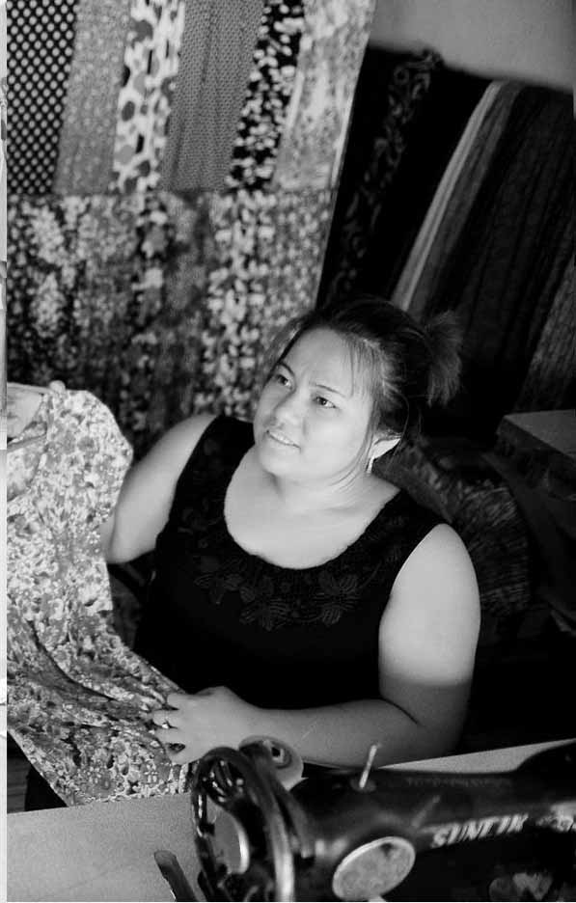

****Session 5: Systems for improvement****

# ****Session 5: Systems for Improvement****



**3**

**2**

**35 Mins**



**Session Overview**

In this session we will highlight the importance of basic business systems in order to keep control over products/stock and money. You will complete 2 activities. The objectives for this session are as follows:

* To get an overview of the types of systems you could use for tracking and recording money and product flows.
* Help you analyse some common business problems and point out systems that can be used to solve or improve these.

## Activity 5A: Solving Common Business Problems

In Activity 5A you will review some of the tools we have looked at so far and focus on how these can be used to help solve common business problems. We will read 4 scenarios and then complete the activity.



**Scenario 1:**

Your sister who also sells handicrafts on a market stall at one of the beach resorts has told you that she has met someone who would like to invest a little bit of money into her business. She would be able move from selling in an open-air market, to a small lock up, covered market. The investor has asked her to make some simple notes in the format of a business plan as she wants to make sure that your sister’s business is successful.

**Scenario 2:**

Your friend has told you that she thinks it is time to expand her business but she really does not know how or where to start. She knows that there is a lot of development going on in the area and some new businesses have started up. Her main problem is that she does not know whether she is making a profit now. Should she be thinking of expanding?

**Scenario 3:**

The woman who helps you to sell your products at the bus station kiosks asks you for some more wallets as she just sold the last one. When you deliver the wallets and ask for the money from the ones she has sold she gives you $12 (i.e. she sold 8 at @1.50). You are a bit confused as you usually give her 10 of each item, but she says you only gave her 8 wallets last time.

**Scenario 4:**

You have been asked to give a short talk to a local community group. They have asked you to talk about ‘Recording IN and OUT Business Transactions’.



**25 Mins**

1. On Flipchart 2 or on pieces of paper on your table you will see a number of templates that you have discussed today.
2. Identify the problem and answer the following questions for each scenario

* Which document would you use?
* Why this one?

1. Work in pairs to match the systems as seen on the flipchart or on the available handouts to the problem in Table 5A.
2. If you have differing opinions explain to one another why.
3. The templates you can find at GPG Section 3 as well as in Section 1

|  |  |  |
| --- | --- | --- |
| Table 5A: Systems for Improvement | | |
| Templates I have identified / page | I have it | I need it |
|  | □ Yes □ No | □ Yes □ No |
|  | □ Yes □ No | □ Yes □ No |
|  | □ Yes □ No | □ Yes □ No |
|  | □ Yes □ No | □ Yes □ No |
|  | □ Yes □ No | □ Yes □ No |
|  | □ Yes □ No | □ Yes □ No |
|  | □ Yes □ No | □ Yes □ No |
|  | □ Yes □ No | □ Yes □ No |

All successful and well managed businesses have to have some sort of paperwork, systems and records, in order for the owner to know what is going on: tracking products (stock) and recording financial transactions (money in and money out). It is even more important to have business paperwork if you want a loan, or some other financial support. This activity helped us to look at what systems you have available to you and what you could use them for[1].

## Activity 5B: Personal action plans

In the final activity of this session you decide on some concrete actions to take with respect to your business. Keeping in mind all the things you’ve discussed so far, take a few minutes to record your thoughts.



**10 Mins**

1. Each of you uses Table 5B: Personal action plan to write 1-3 changes that you would make to improve your business. Are there any improvements you would like to make based on what you have learned in the previous activities? If so, decide what you will implement or improve.
2. Record how you will make these changes.
3. Record by when will you make these changes.
4. Finally, state who will be responsible for this change.

|  |  |  |  |
| --- | --- | --- | --- |
| Table 5B: Personal Action Plan | | | |
| My changes | How will I make the changes? | When? | Who is responsible? |
|  |  |  |  |
|  |  |  |  |
|  |  |  |  |

In this activity, you reviewed some of the templates that you have and saw how they could make a difference to businesses. This session also helped you to identify what templates you could use from the GPG to apply to your business after the training. The templates are also available in Section 3.3 of your GPG.

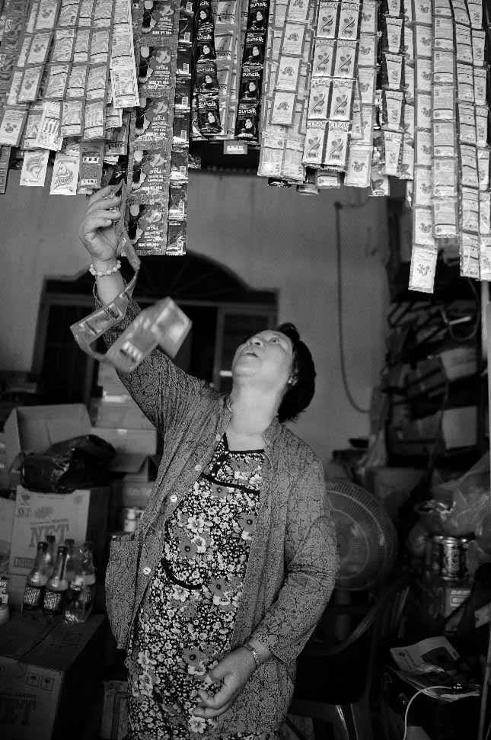

Session 6:

Priority Action Plans

# Session 6: Priority Action Plans



**40 Mins**

With the workload that comes with managing a handicraft business, it’s not always easy to actually implement the changes you would like. In this session you will look at the work you completed during this training and create a simple action plan to improve your destinations. You complete a single activity

## Activity 6A: Priority action plan



You will work step-by-step, session-by-session to reflect on the activities and action plans that you have drawn up.



**40 Mins**

1. You talk in a group. Everyone says what he or she found in each of the activities. You start from the first activity.
2. For the next step you use Table 8A: Priority action plan. Individually you look at the action plans you completed for each session and choose which of the changes you will introduce first and when, in a week, in a month, in two months? List at least 3 actions [15mins]
3. Each of us present their Priority Action Plan and the group shares their ideas of whether the priority of actions should be changed or if they are good the way they have been set. Each participant has 5 minutes. [25mins]
4. As a group, you can use additional time to decide whether you will meet again, after the training to practice some of the activities, such as costing. You can also plan to meet on a regular basis and talk about how are you doing with the changes you are introducing

|  |  |  |  |
| --- | --- | --- | --- |
| Table 6A: Priority Action Plan | | | |
| My priority changes | How will I make the changes? | When? | Who is responsible? |
|  |  |  |  |
|  |  |  |  |
|  |  |  |  |
|  |  |  |  |
|  |  |  |  |
|  |  |  |  |

Prioritizing actions, the activity you completed at the end of the training, is a very important step. It pushes you to decide how to apply what you have learned in this training into your work and lives. You can use it together with the Training Guide to do revisions and motivate yourselves to take actions.

This is the end of the training. You can now complete the evaluation. In few months there will be some follow up evaluations too.

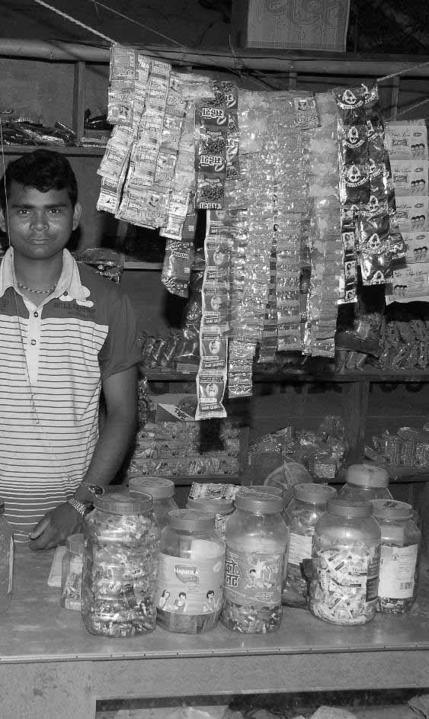

Flipcharts

# Flipcharts:

## Flipcharts for Activity 4A:



**1**

|  |  |  |  |
| --- | --- | --- | --- |
| Estimating Product Prices* | | | |
|  | 1: Rice bag Wallet | 2: | 3: |
| What customers will pay | $1.50 |  |  |
| Competitor highest  Competitor lowest | $2.25 (sold in city shop)  $1.25 (sold from home) |  |  |
| My price (before discount offers) | $1.50 |  |  |

|  |  |  |  |  |  |
| --- | --- | --- | --- | --- | --- |
| Estimating Monthly Sales | | | | | |
| Months | Product 1 | Product 2 | Product 3 | Product 4 | Product 5 |
| 1 | 80 |  |  |  |  |
| 2 | 90 |  |  |  |  |
| 3 | 100 |  |  |  |  |
| 4 | 150 |  |  |  |  |
| 5 | 100 |  |  |  |  |
| 6 | 100 |  |  |  |  |
| Total (over 6 month period) | 620 |  |  |  |  |
| Monthly average | 104 |  |  |  |  |

## Flipcharts for Activity 5A



**2**

Note: these may require more than one flipchart but are to be used when you see the above symbol and number.

Template 1: My own business assessment

|  |  |  |  |  |  |
| --- | --- | --- | --- | --- | --- |
|  | Success criteria | ☺ Good | 😐 OK | ☹ Not good | What I can do? |
| 1. | Place of business/sales |  |  |  |  |
| 2. | Know my business costs |  |  |  |  |
| 3. | Quality of products |  |  |  |  |
| 4. | Customers |  |  |  |  |
| 5. | Storage of products |  |  |  |  |
| 6. | Daily tasks and routines |  |  |  |  |
| 7. | Clean workspace |  |  |  |  |
| 8. | Organized workplace |  |  |  |  |
| 9. | Satisfied with business |  |  |  |  |
| 10. | Equipment condition |  |  |  |  |
| 11. | Know what you are owed |  |  |  |  |
| 12. | Know customer needs |  |  |  |  |
| 13. | Cost of products |  |  |  |  |
| 14. | Sale price |  |  |  |  |
| 15. | Products available |  |  |  |  |
| 16. | Waste of products |  |  |  |  |
| 17. | Productivity of staff |  |  |  |  |
| 18. | Staff work conditions |  |  |  |  |
| 19. | Sufficient customers |  |  |  |  |
| 20. | All costs included |  |  |  |  |
| 21. | Product in good condition |  |  |  |  |
| 22. | Know staff tasks |  |  |  |  |
| 23. | Customers come back |  |  |  |  |
| 24. | Sale price |  |  |  |  |
| 25. | Family supports you |  |  |  |  |
| 26. | Marketing techniques |  |  |  |  |
| 27. | Skilled & reliable staff |  |  |  |  |
| 28. | Availability of loans |  |  |  |  |
| 29. | Bookkeeping |  |  |  |  |
| 30. | Tracking your money |  |  |  |  |
| 31. | Good business person |  |  |  |  |
| 32 | Know what you earn |  |  |  |  |

Template 2: Business description

|  |  |
| --- | --- |
| Business description | |
| Name of business: |  |
| Type of business: | ❑ Manufacturer ❑ Service operator  ❑ Retailer ❑ Wholesaler  ❑ Other |
| Which needs will the products satisfy? |  |
| What products will the business produce? |  |
| Who will the products be sold to? |  |
| How will the products be sold? |  |

Template 3: Business plan checklist

|  |  |
| --- | --- |
| Business Plan Checklist |  |
| 1. Executive Summary (summary of 1 - 5 below)   * Name of business * Name of owner * The vision, where you would like to in 5 years time * The structure of the business, who is involved, where is it * Describe the products, how they are made etc. * What are the market opportunities for sales * What sales goals will you achieve over 1, 2 and 3 years * Applying for a loan: Include amount, how it will be used and how you will guarantee repayments based on the success of your business |  |
| 2. Description of the business:   * Product characteristics particularly in comparison to competitors * Overview of the business including prices and marketing |  |
| 3. Market analysis:   * Specific product descriptions including size, material, weight * Description of clients and why they will buy from you * Assessment of market potential (i.e. more tourists, new hotels) * Competitive sales market, why you will be better than others * Unique selling point (e.g. locally sourced, organic, sustainable) |  |
| 4. Management plan:   * Structure of the business, who is responsible, who supports the business |  |
| 5. Marketing plan:   * Price the customer will pay, what competitors charge * Distribution, where will you be selling, mail order etc * Advertising and promotions |  |
| 6. Financial plan:   * Money required for loan to develop (or start) a business * Future financing when loan expired based on increased profits * Projected performance, estimated figures to show growth * Financial statement, estimate of total income, total expenditure and your total investment (including assets) * Income statement showing estimated performance over 3+ years, total revenues and expenditure * Break even analysis showing that income from sales is higher than expenditure (business costs, outgoings) * Projected cash flow to show financial resources needed * Capital equipment (assets) i.e. business items, materials, equipment owned by you |  |

Template 4: Estimating product prices

|  |  |  |  |
| --- | --- | --- | --- |
| Estimating Product Prices* | | | |
|  | 1: Rice bag Wallet | 2: | 3: |
| What customers will pay |  |  |  |
| Competitor highest  Competitor lowest |  |  |  |
| My price (before discount offers) |  |  |  |

**Template 5: Estimating monthly sales**

|  |  |  |  |  |  |
| --- | --- | --- | --- | --- | --- |
| Estimating Monthly Sales | | | | | |
| Months | Product 1 | Product 2 | Product 3 | Product 4 | Product 5 |
| 1 |  |  |  |  |  |
| 2 |  |  |  |  |  |
| 3 |  |  |  |  |  |
| 4 |  |  |  |  |  |
| 5 |  |  |  |  |  |
| 6 |  |  |  |  |  |
| Total (over 6 month period) |  |  |  |  |  |
| Monthly average |  |  |  |  |  |

Template 6: Total costs per month

|  |  |
| --- | --- |
| Total Costs Per Month | |
| Type of cost | Total cost per month |
| Raw Material (Variable) |  |
| Labour Costs (Variable) |  |
| Overheard (Fixed) |  |
| Total Costs (outgoings) Per Month |  |
| Price x Sales - Costs = Profit | |
| |  |  |  |  |  |  | | --- | --- | --- | --- | --- | --- | | Step 1 | My Price | X | My Sales | = | Monthly Sales | |  |  |  |  |  |      |  |  |  |  |  |  | | --- | --- | --- | --- | --- | --- | | Step 2 | Monthly Sales | _ | My Costs | = | PROFIT | |  |  |  |  |  | | |

Template 7: Product stock card

|  |  |  |  |  |
| --- | --- | --- | --- | --- |
| Product Stock Card | | | | |
| Product name:  Product code: | | | | |
| Supplier/producer contact: | | | | |
| Description: | | Value & Mark Up | | Comments: |
|  | |  | |  |
| Date | IN (B/F) | OUT | Balance | Comments |
|  |  |  |  |  |
|  |  |  |  |  |
|  |  |  |  |  |
| Totals |  |  |  |  |

Template 8: Simple bookkeeping

|  |  |  |  |  |  |
| --- | --- | --- | --- | --- | --- |
| Managing the Money | | | | | |
| Bookkeeping Made Simple: Cash Book | | | | | |
| Month  Year | Description | Money  in business | Money  out  business | Money  out  personal | Balance |
| 01st |  |  |  |  |  |
| 2nd |  |  |  |  |  |
| 3rd |  |  |  |  |  |
| 4th |  |  |  |  |  |
| 5th |  |  |  |  |  |
| 6th |  |  |  |  |  |
| 7th |  |  |  |  |  |
| 8th |  |  |  |  |  |
| 9th |  |  |  |  |  |
| 10th |  |  |  |  |  |
| 11th |  |  |  |  |  |
| 12th |  |  |  |  |  |
| 13th |  |  |  |  |  |
| 14th |  |  |  |  |  |
| 15th |  |  |  |  |  |
| 16th |  |  |  |  |  |
| 17th |  |  |  |  |  |
| 18th |  |  |  |  |  |
| 19th |  |  |  |  |  |
| 20th |  |  |  |  |  |
| 21st |  |  |  |  |  |
| 22nd |  |  |  |  |  |
| 23rd |  |  |  |  |  |
| 24th |  |  |  |  |  |
| 25th |  |  |  |  |  |
| 26th |  |  |  |  |  |
| 27th |  |  |  |  |  |
| 28th |  |  |  |  |  |
| 29th |  |  |  |  |  |
| 30th |  |  |  |  |  |
| 31st |  |  |  |  |  |
| Totals |  |  |  |  |  |



www.sme-tools.org

1. The correct answers for this activity were: Scenario 1: Business Plan Template, Scenario 2: Total Costs per Month, Scenario 3: Product Stock Card, Scenario 4: Simple Bookkeeping