Community-Based Enterprise Development

(C-BED)

For Aspiring Entrepreneurs in the Tourism Sector
ILO - ASEAN Small Business Competitiveness
A product of

Small Business Competitiveness by International Labour Organization (ILO – SBC) is licensed under a Creative Commons Attribution-Non Creative Commons Attribution‐NonCommercial‐ShareAlike 3.0 Unported License.

Attribution — You must give appropriate credit, provide a link to the license, and indicate if changes were made. You may do so in any reasonable manner, but not in any way that suggests the licensor endorses you or your use.

NonCommercial — You may not use the material for commercial purposes.

ShareAlike — If you remix, transform, or build upon the material, you must distribute your contributions under the same license as the original.

https://creativecommons.org/licenses/by-nc-sa/3.0/legalcode
brought to you by:
brought to you by:
Table of Contents
About C-BED vi
About the Tourism AE package vi
Message to the Group vii
Session 1: Introductions 1
Activity 1A: Getting to Know Each Other 1
Activity 1B: Assessing My Influences 2
Session 2: Selecting a Business Idea 5
Activity 2A: Business Idea Brainstorming 5
Activity 2B: Selection Criteria for a Business Idea 7
Activity 2C: SWOT Analysis 10
Session 2.5: The Life Cycle of People 15
Activity 2.5A: Lifecycles 15
Session 3: Defining a Business Idea and Potential Customers 19
Activity 3A: Describing Your Business Idea 19
Activity 3B: Market Research 22
Session 4: Marketing 27
Activity 4A: Define the Characteristics of Your Product 28
Activity 4B: Where to Sell Your Product 29
Activity 4C: Promoting Your Business 32
Session 5: Setting Your Price 37
Activity 5A: Competition and Customers 37
Activity 5B: Estimating Monthly Sales and Production Needs 39
Activity 5C: Costs 42
Activity 5D: Making a Profit 47
Session 6: What Makes a Successful Business? 51
Activity 6A: Characteristics of a Successful Business 51
Session 7: Action Plan 55
Activity 7A: Taking Action 55

About C-BED

Community-Based Enterprise Development (C-BED) is a low cost, innovative training programme designed by the International Labour Organization (ILO) to support skills development and empowerment in local communities for improvements in livelihoods, productivity and working conditions.

As an approach to training, C-BED is unique in that the programme is built around peer-to-peer, activity based learning methods with no role for teachers, experts, or external consultants specialised in the skill area. Instead, C-BED participants work together through a series of activities and discussions guided only by simple step-by-step instructions in the training manual. New knowledge, skills and competencies are developed through the interactions between participants and sharing of existing local knowledge and experience. In this way the programme is a low cost, sustainable option for any organization or community.

The C-BED programme is structured around two core training packages designed to develop competencies for business start-up and operation through a focus on marketing, financial management, and action planning. These are the C-BED for Aspiring Entrepreneurs and C-BED for Small Business Operators. Additionally, a growing suite of tools to strengthen business competencies and enhance skills for specific sectors is in continual development. These packages can be implemented as either stand-alone trainings or integrated in modular format into existing programmes

About the Tourism AE package

C-BED for Aspiring Entrepreneurs is an introductory training that is suitable also for audiences with very limited literacy and useful to everyone who wants to gain basic familiarity with business development and operation. Participants arrive seeking opportunities to make change in their lives, wanting to find or change a vocation or improve their working conditions. They leave with basic competencies in business operation and critical learning. For criteria to select the participants refer to the C-BED curriculum Outline. At the end of the training participants will have:
- Gained new knowledge on enterprise development
- Acquired critical competences to weigh job prospective or current conditions for work
- Raised awareness about enterprise development
- Learned about different steps to start-up or improve a business
- Strengthened confidence to make decisions, plan and take action for the future
- Recognized the potential of association and collaborations
Potential for Tourism Business in Indonesia

The potential for tapping into the tourism industry in Indonesia has never been better.
Indonesia’s abundance of natural-beauty, wildlife, expansive coastline and islands, resorts, recreational and adventure activities, cosmopolitan cities and cuisine are attracting an increasing number of tourists from both Asean and abroad. The country saw an all-time high of 8.8 million visitors last year, a number that has steadily increased over the past several years, according to the central statistics agency (BPS). Last year’s tourism revenue totalled $10 billion in foreign exchange earnings, up one billion from 2012.

This record number of visitors today presents opportunity for entrepreneurs to target business toward tourism, and with a successful business plan, to receive high return. This package is intended to assist you as entrepreneurs to develop a solid business plan, an essential part of success that will help to obtain financing, to manage a business, and to help you work effectively toward a target. It will generate ideas to inspire you to take advantage of the opportunities in the booming tourism industry and reduce the chances of failure.

Message to the Group

At the end of this C-BED training you will have a clear plan for the practical steps you can take to start or improve your business. Your understanding of the basic principles of doing business will be much stronger and you will have begun relationships with others in your community that can potentially support or cooperate with you to achieve mutual success in the future.

The style of this training is different to traditional education approaches. There will be no teacher, trainer or expert to assist you. Instead, you will work together as a team to follow the simple step-by-step instructions for discussions and activities in your training guide. Because there is no group leader, all group members should take a turn reading the information and instructions out loud to the group, and all group members share responsibility for monitoring time. In this new style of training, we will learn from each other by sharing ideas and opinions, skills, knowledge and experience. For this to work, all group members must participate in discussions.

Before and after the training you will be asked to complete a survey to understand the impact of the training. This information will be kept confidential and is used to improve the training materials and organization of future programs. Some trainees may also be contacted in the future after 3, 6 or 12 months for another survey to learn about your business plans.

The instructions in the training guide are easy to follow and suggested timing for each step is provided. Look out for these signs:
When you see this sign, share with the group
When you see this sign, you are reading instructions and doing activities

When you see this sign, read aloud
This sign gives you the estimated time for the session
Use the flipchart as outlined in Appendix 1, if you don’t have a flipchart use extra paper or the Training Guide

Before you begin the training, follow the simple steps below to get organized.
- Fill out the pre-training survey. Ask the organizers if you don’t have a copy or have not already filled it in.
- Organize into small groups of 5-7. The organizers will guide you in how best to do this.
- Identify one group member to volunteer to start the training as ‘Group ‘Reader’. The ‘Group Reader’s’ role is to read the information and activity instructions out loud to the group. Any group member with basic literacy can be the ‘Group Reader’ and you should aim to share this role among group members throughout the training.

All group members are responsible for monitoring time but one group member should be nominated for each session to remind the group when the suggested time for a step has been reached. You do not strictly need to follow the suggested timing but you will need to manage your time for the total training. If one activity lasts longer than the suggested timing, try to save time in other activities to keep the balance.

All group members will receive the same training guide. Individual work can be completed in these guides as well as group work. Groups may also like to complete activities together on flipchart paper if available.

Enjoy the Training!

Session 1:
Introductions

Session 1: Introductions
Session Overview
50 Mins

In this session we will complete two activities to get to know one another and become familiar with the style of C-BED training. In C-BED our goal is to learn from each other as we complete the activities in each of the seven sessions. There will be no teacher so we should help each other by sharing our different ideas and experiences, and ask questions to the group if we don’t understand a concept or activity.

Activity 1A: Getting to Know Each Other

In Activity 1A we will get to know each other as a group and learn about our individual business interests. We will need pens and loose paper for this activity.

First we will read through all the instructions before starting the activity at Step 1. When the time runs out for each step, the group reader will notify the group so everyone can move on to the next step and so on until we complete the activity.

15 Mins

- Draw a picture of our current business or new business idea [5 minutes]
- One-by-one each group member should introduce themselves to the group. Please give your name, birthplace, and then display the picture and explain what it shows. Each person has one minute for introductions [5 minutes]
- Display the drawings on a wall nearby or put them at the centre of the table [5 minutes]

In this first activity we got to know more about one another; we shared our drawings and talked about our business aspirations. Now we can move to the next activity.

Activity 1B: Assessing My Influences

In Activity 1B, we will assess the different influences that contribute to our motivation to do business. The things we are curious about, the past experiences we have, and the important people in our lives all have an influence on us. Recognising these influences can help us gain a better understanding of our priorities how they affect our business choices.

First we will read through all the instructions before starting the activity at Step 1. The group reader will monitor our timing and remind us when to move on to the next step. We can now begin Activity 1B

35 Mins

- Each person should complete the self-assessment sheet on his or her own. The group should support non-literate group members. [5 minutes]
- Each group member uses the self-assessment sheet to present their influences to the group. [10 minutes]
- As a group, discuss how these different influences are related to your business idea and motivation. [15 minutes]

Table 1B: Assessing My Influences
My interests: Work I am curious about and like doing (paid or non-paid)

_________________________________________________________________

_________________________________________________________________

_________________________________________________________________

My experiences: I have the following work experience (including training and education):

_________________________________________________________________

_________________________________________________________________

_________________________________________________________________

My role models: I admire the following people I know (family, friends, teachers, business people, community leaders, etc)

_________________________________________________________________

_________________________________________________________________

_________________________________________________________________

In Session 1 you have learned more about the members of your group and explored the different influences on your motivation to do business. You have a better understanding of your interests and how they are related to the business ideas you identify.

Session 2: Selecting a Business Idea

Session 2: Selecting a Business Idea

120 Mins

Session Overview

In Session 2 we will complete 3 activities to help us to generate and assess different business ideas and to identify those with the strongest potential. At the end of this session, group members will choose to continue working together on a shared business idea or to support each other to develop plans for personal business interests. By working together through the different sessions, each group member will develop important skills for developing plans for any type of business.

Activity 2A: Business Idea Brainstorming

In this activity we will work as a group to brainstorm as many new and creative business ideas as possible. We should aim to identify a variety of different ideas that are new to the community. It can be hard to make a business successful if too many people run the same business in the same place.

When brainstorming ideas, it can be helpful to think about the different types of businesses and activities. During the brainstorming process, you should think about which aspects of tourism are most relevant to your communities. Think about what the demand is and what you can most easily and affordably supply?

Much of this depends on location. There are many more tourism service providers around well-known landmarks than there are in urban areas. For example, there may be more opportunity for hotels and small stores in urban areas. You need to reflect upon what needs you can fill with what you can offer based on the resources in your communities. Business ideas can come from a variety of different areas in tourism, including the following:
- Restaurants
- Guesthouses
- Service provision
- Tour organization
- Transportation

25 Mins

- As a group, develop a list of business ideas and record them on a piece of paper. Remember to try and identify new and creative business ideas. The ideas should be written down or illustrated on a piece of flip chart paper, if available. Otherwise a piece of A4 paper can be used. Each group member should contribute at least three ideas and give a brief explanation of each before it is recorded. [10 minutes]
- After brainstorming business ideas in this way, your next step is to make quick, intuitive assessments of each idea and its potential for success. Record a + for those ideas the group feels have high potential. Record or a – for those ideas with lower potential. It is important to discuss why an idea has high or low potential before the group makes a decision. [15 minutes]
- The final step is to display the list somewhere that the group can see it easily.

In this activity we generated different business ideas and performed an intuitive assessment of their potential. Our personal interests and our confidence with ideas often influence intuitive assessments. This type of assessment though may not take into consideration practical conditions needed for a business to succeed. In the next activity we will learn about the criteria that should be used to select high potential business ideas.

Activity 2B: Selection Criteria for a Business Idea

A successful business is one that sells something customers need or want at a price they are willing to pay. But a successful business should also generate more than a subsistence income and provide you with satisfaction. For these reasons it is important that the business ideas you select are carefully assessed.

In this activity we will learn about three important criteria for selecting good business ideas.

- Skills
A variety of skills in different areas may be needed to operate a business successfully. These skills may inclide practical knowledge or abilities to do specific tasks, or they may be more general skills to interact with others and manage activities. Knowing how to cook, to cut hair or repair a machine are examples of practical skills. Being able to effectively manage time, organize things, speak different languages, or work well with others are examples of general skills that may benefit a business. You may have use these skills at home, at school, at work, or in the community.

- Resources
You cannot operate a successful business without access to the raw materials, land, equipment, money, staff, and other things needed. When planning a new business you may not at first have possession of all the resources needed, but it is important that you do have access to these resources in and around your community.

- Demand
All businesses need demand for the goods or services they produce. While entrepreneurs may create demand by introducing a product that has never been available before, other businesses will aim to meet existing demand in a community. Either way it is important that customers need or want what the business produces.

The Group reader will now read through the steps for Activity 2B.

55 Mins

- Look at the example table listing skills, resources and demand identified by a group from past C-BED training. One-by-one the group reader will read the items listed and the group will discuss the similarities or differences to what is available in your community. [10 minutes].
- Make groups of 2 or 3 and work together to complete the next steps.
- Use Table 2B(1) to list the skills each of you have. Include the skills you have that may not be directly related to your personal business interest. [5 minutes]
- Next, list the resources each of you has access to. Include resources that may not be directly related to your own personal business interest. [5 minutes]
- Next, list in the demand column any goods and services that are needed or wanted in your community. Include goods and services that may not be directly related to your own personal business interest. [5 minutes]
- Get back into one group and record the high potential business ideas from Activity 2A into Table 2B (2). (5 minutes)
- Working together as a group, now compare the skills you have each identified what would be needed by the business ideas listed. Each group member should participate in the discussion. If many of the skills available in your group match the business idea, record in the skills column. If only one of the skills match the idea, record a single . If none of the skills match, record a × [10 minutes].
- Continue working as a group and repeat this process for resources and demand identified by group members. [10 minutes]
- As a group, discuss the following questions:
- Which business ideas now have the most potential based on the assesment of skills, resources, and demand identified?
- Are these the same businesses identified as high potential in Activity 2A? [5 minutes]

Example: Criteria for selecting a business idea
Skills | Resources | Demand
Sewing  Cooking fish  Making shrimp paste  Growing vegetables  Speak two languages  Motorcycle repair  Accounting skills | Fruit and vegetables  Forest products  Technical school graduates  Microfinance loans from nearby bank  Land for rent near local market place | Traditional medicine  Fresh meat  Organic vegetables  Website designers  Tour guides  Bicycle repair

Table 2B (1): Criteria for Selecting a Business Idea
Skills | Resources | Demand

Table 2B (2): Matching Business Criteria to Your skills, Resources and Demand
(Matches all 2 or more of the skills, resources or demand you listed) |  | (Matches 1of the skills, resources or demand you listed) |  | (Does not match any of skills, resources or demand you listed)
Tourism business idea | Skills |  | Resources |  | Demand

In this activity you assessed your different business ideas by considering three important criteria for a successful business – the skills, the resources, and the demand available. This type of assessment is useful to ensure the business ideas you are interested in are realistic and to get better insight into which ideas have the highest potential. In the next activity we will look at the final step to assess a business idea.

Activity 2C: SWOT Analysis

A SWOT analysis is a simple but effective way to assess the strengths and weaknesses of your potential business, as well as the opportunities and threats you could face. SWOT analysis can be used for all types of decision-making.

SWOT stands for:
- Strengths
- Weaknesses
- Opportunities
- Threats

Strengths are the characteristics of you or inside your business that will give it an advantage over competitors and make it attractive to customers. Some examples are: producing good quality products, ability to serve customers in English or the local language, or having no local competitors.

Weaknesses are those characteristics of you or inside your business that are not good and could be improved. Some examples are: business location is far from suppliers which increases the cost of getting raw materials, staff have not been trained in customer service, or your weak financial skills make managing the business accounts difficult.

Opportunities are things that happen outside your business that you can take advantage of to succeed. Some examples are: a new highway has increases the number of tourists visiting your village, or a local NGO has begun to offer microfinance loans to entrepreneurs.

Threats are things that happen outside your business that could prevent your success and reduce profits. Some examples are: your business could be very popular so others may start similar businesses and there will be more competition, or your family members may not expect to pay for goods and services they take from your business.

When Strengths and Opportunities are greater than your Weaknesses and Threats, you can be more confident that your business idea has the potential for success and you will be more aware of the risks you take. In some cases though some of your Weaknesses and Threats may be serious enough that you need to consider another business idea.

Next we will read through all the instructions before starting the activity at Step 1. The group reader will monitor our timing and remind us when to move on to the next step. We can now begin Activity 2C.

45 Mins

- Review the example SWOT analysis for a handicraft vendor business. The group reader will read each of the items to the group. [3 minutes]
- As a group, read, discuss and answer the questions at the bottom of the SWOT:
- Are there more strengths than weaknesses?
- Are there more opportunities than threats?
- How can we address the weaknesses and threats? [7 minutes]
- Complete Table 2C either in your training guide or on flipchart paper, if available. [3 minutes]
- As a group, look back at Activity 2B and select two business ideas that have the most potential. [2 minutes]
- Working as a group, complete a SWOT analysis for each of the business ideas selected. The information you idenfitied in Activitity 2A and 2B can help you. After you complete each of the tables, discuss and answer the assessment questions:
- Are there more strengths than weaknesses?
- Are there more opportunities than threats?
- How can we address the weaknesses and threats? [20 minutes]
- After finishing the SWOT analysis and assessment questions, the group needs to decide which business idea has the highest potential and should be developed in the next activities. [10 minutes]

Example: Handicraft Vendor
Strengths | Weaknesses
Prime location in tourist night market  Will sell a variety of wooden carvings  Know good producer to buy quality carvings from nearby | No experience in selling handicrafts
Opportunities | Threats
Lack of handicraft vendors with a variety of local products from nearby tribal village  Holiday in near future will increase sales | Competitors can easily start a similar business, which might lead to a decrease in sales
Are there more strengths than weaknesses? Yes No

Are there more opportunities than threats? Yes No

How will I handle weaknesses and threats?

I will offer more variety in fruit to be more competitive.

I will speak to friends and family to learn how to sell at the market.

Table 2C: Your SWOT Analysis
Strengths | Weaknesses
Opportunities | Threats
Are there more strengths than weaknesses? Yes No
Are there more opportunities than threats? Yes No
How will I handle weaknesses and threats?

In Session 2 you learned the process to assess new business ideas against your interests, and the skills, resources, and demand that you have available. If the business idea has more strengths and opportunities than weaknesses or threats, it could be a good idea. In the next session we will develop our business ideas further and begin to plan in more detail.

Session 2.5:
The Life Cycle
of People

Session 2.5: The Life Cycle of People

40 Mins

Session Overview

Woman entrepreneurs face unique challenges from men in starting and managing their own business. Often, women have additional responsibilities of running a household and taking care of children. They may find it difficult to have enough free time to dedicate to starting a business. The goal of this session is to identify and discuss these specific challenges and brainstorm ways women can manage their family and business.

Activity 2.5A: Lifecycles

Activity 2.5A will focus on the life cycle of people and the differences between men and women in each stage of life. Participants should discuss the differences in workload, responsibilities, income and decision-making.

40 Mins

- As a group, identify stages in the life cycle of people. Write these stages on a flipchart, if available or record them below in Table 2.5A. [10 minutes]
- *Note: As a guide, the overall stages that can be identified are: birth, childhood, teenager, adulthood, middle age, retirement, death
- Divide into pairs. Each pair should be assigned a life stage. In pairs, write down the similarities and differences between men and woman in your assigned stage. [15 minutes]
- As a group, discuss the similarities and differences that each pair identified. Share ideas on how to manage these differences. Brainstorm ways in which women can take care of their family and children as well as have time to run a business. [15 minutes]

Table 2.5A: Lifecycles
Only Women
Only Men
Similarities

In this session we looked at the lifecycles of men and women as well as some of the challenges women face in running a business and how these can be solved.

Session 3: Defining a Business Idea and Potential Customers

Session 3: Defining a Business Idea and Potential Customers

40 Mins

Session Overview

Now that a business idea has been selected, your next step is to begin a business plan. This will help you to organize your ideas and get a better understanding of how to build your business. If group members share a common business idea they can complete the remaining sessions by developing that idea further. It is also possible for group members to complete the remaining sessions by working on their personal business ideas with the group.
By the end of this session you will be able to describe your business idea in more detail, understand ways to do basic market research, and clearly identify who your potential customers will be.

Activity 3A: Describing Your Business Idea

In the next activity you will create a simple outline of your business plan. This should describe the business in enough details so that a stranger can understand clearly what your business does and who your potential customers are.

Have a clear business idea
It is a good idea to have a very well thought out description of your tourism-related business. Having a clear vision will help you to convey the true message of what your business really is to others, help you to grasp the full meaning of your idea and keep you focused on goals and objectives. When developing a plan, try to be as descriptive as possible- opening a gift shop could be defined more specifically as opening a gift shop that caters to families on vacation by the beach, selling beach-related products.

25 Mins
- The group reader will first read Ms Koodo’s story to the group. [5 minutes]
- As a group, review the business plan outline for Ms K’s Delicious Breads and check that the details are correct. [5 minutes]
- Using Table 3A, work together to support each other to complete a business plan outline for the high potential business idea that was selected after Activity 2C. [15 minutes]

Ms Koodo’s story:
Ms Koodo lives in a village not far from the capital city. After finishing school, she has decided to start a business selling bread at a stall in the local market. There is no bakery in the village, so Ms Koodo thinks her bread will be in high demand. She would also like to sell her bread to other market vendors who could use her bread as ingredients in dishes they sell.

Ms.Koodo’s mother is famous for her baking and will help by teaching Ms.Koodo some baking secrets and allow Ms Koodo to user her kitchen and equipment for baking. Ms.Koodo is also lucky because her aunty has a successful stall in the market selling fruit. She offers to let Ms.Koodo rent a part of the space for her bakey sales. Ms.Koodo will name her business, “Ms. K’s Delicious Breads.” Although Ms.Koodo does not have any previous business experience, she is confident she can learn quickly from her mother and aunty.

Example: Ms Koodo’s Business Idea Template
Name of Business: | Ms. K’s Delicious Breads
Type of Business: | Manufacturer Service operator  Retailer Wholesaler
Which needs the goods/services will satisfy: | Need for baked goods in the village
What goods/services business will produce: | Bread
Who will sell goods/services to: | Village residents, market vendors
How will sell goods/services: | In local market

Table 3A: Describing Your Business
Name of Business:
Type of Business: | Retailer  Wholesaler  Manufacturer  Service provider  Agriculture
What goods will the business produce:
What services will the business produce:
What customers will be targeted:
Where will the business be located:

In this activity you have developed a basic outline of the high potential business idea identified earlier. This outline is useful to share the basic idea of your business with others and as a guide to the different aspects of your business that will need to be expanded on in a business plan.

Activity 3B: Market Research

After your business idea has been outlined, the next step is to develop your plans on how to sell your goods or services. To be successful in these plans businesses must be able to identify who the potential customers are, what they need or want, and how much they are willing to pay. Everything a business does to find this information is called market research.

Market research can be simple. You can:
- Talk to potential customers.
- What goods or services do they want to buy?
- What special needs or expectations about these goods and services attract them?
- What do they think about other businesses that already provide these goods and services?
- Observe competitors’ businesses.
- Are their goods or services of good quality?
- How much do they charge?
- What are the differences between the most and least successful businesses?
- How do they attract customers?
- Ask friends, family, and other peers:
- What do they think of your business idea?
- What goods and services sell well in their business?
- What they think about your competitors’ products?

The information collected through market research should then be recorded in a market analysis table. You should also consider:
What need is your product or service filling?
Why would tourists want to buy from your business? How can your product benefit the customer?
Is your product/service in demand year round, seasonally or sporadically?
Will there be seasonal peaks and valleys in number of visitors and therefore revenue?
Who are your competitors, and how are they appealing to tourists? Is your product available elsewhere in your market area?
What makes your product different (convenience, quality, service, price)?
How do customers pay (will you need a credit card machine or an accountant?)
Is the number of customers likely to increase?

Knowing whom your customer is and defining your target market is also crucial to delivering your product/service. You must know who will buy your product and what they want to determine how to attract them. Things to consider:
Who will buy your products or services?
Where are your customers located, where are they coming from and why, how far are they travelling and how much time and dollars will they likely spend in your area?
-Are tourists in your area here for leisure, study, group vacations, or business?
Will customers come from general tourism business in your area, or will they be drawn specifically to your business by special events or promotions? Is your area a tourist destination or pass-through area?
Who normally makes the decision to buy your product (a parent), and who influences the decision to buy (a child)?

45 Mins

- Before the activity starts, the group reader will read Ms. Koodo’s market research to the group. As a group, discuss how Ms Koodo can use this information in planning her business. The information she has collected on what prices customers will pay and the prices her competition is charging has been recorded in another table that you will review later. [10 minutes]
- Working with one or two other members in the group, discuss your own business idea and complete the market research information in Table 3B of your Training Guide.
- In column 1: describe the potential customers to target
- In column 2: identify where your market information has come from
- In column 3: list the type of goods and services in demand by these potential customers
- In column 4: list the needs and preferences of these customers. Think about their motivations, and where, how, and how often they want to buy
- In column 5: list any information that is known about competitors. [15 minutes]
- As a group, share together the results of your market research to identify if there are any differences. Each person should participate in the discussion and update your own with new information learned from the group. [15 minutes]

Example: Ms Koodo’s Market Research
Potential customers | Sources of market information | Goods and services in demand | Customer needs and preferences | Analysis of competitors
Members of the local community, particularly those with young families. | Observation of competitors and discussion with potential customers. | Bread for sandwiches. | Prefer to buy fresh bread daily. | The nearest bakery is in the capital 30 km away.  In the village bread can only be bought from the local 711 but it is not freshly baked. The 711 also sells a variety of baked products like cakes and biscuits.
Market vendors in the village and my Aunty. | Observation of competitors and discussion with local business people. | Bread to use in making local deserts.  Stale bread sold at the temple for feeding fish. | Want the cheapest supplies available. | Local market vendors’ work together to buy large orders of bread from a bakery in the capital. A local trader makes the delivery for a small fee once a week.

Table 3B: Market Research Information
Potential customers | Sources of market information | Goods and services in demand | Customer needs and preferences | Analysis of competitors

Market research is something that successful businesses will need to do on a regular basis. Customers’ needs and preferences are always changing and your competition will always be trying to meet the demand. Session 3 has helped you develop the skills to create a business plan outline and to do market research. In the next session you will use this information to develop a marketing plan.

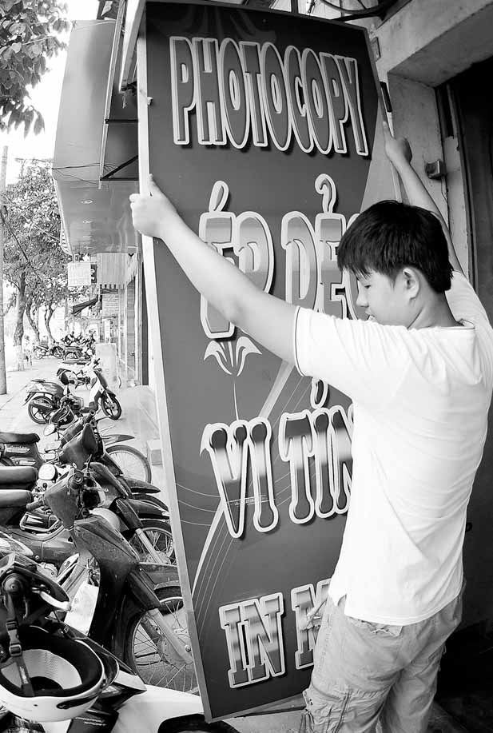
Session 4:
The Planning Process

Session 4: Marketing

120 Mins

Session Overview

A marketing plan sets out your business strategy to make the goods and services attractive to potential customers. You develop a marketing plan one step at a time by making decisions about the strategies you will adopt in different areas of your business. These decision areas are known as the 4 P’s:
- Product: what goods or services you are going to sell to your customers
- Place: how and where you are going to reach your customers
- Promotion: how you inform your customers about your goods or services and how you attract your customers
- Price: how much you will charge your customers for your goods or services.

The marketing section of your business plan should be one of the strongest. You need to be able to communicate your idea clearly and concisely to customers. An idea without an effective sales pitch and attractive presentation will not succeed. You need to build an image, reputation and customer base.
Things for you to consider:
- How do you want your business to be portrayed in the market? (Image as cheap but good, customer-oriented, high quality, convenient, exclusive)
- What will be your company name and logo? Will you have a building and what will it look like? Will you wear a uniform?
- What special features will you emphasize to customers?
- Keep in mind the age, sex, income, education level and marital status of your customers
- Identify forces that might affect your business’ ability to generate sales (weather, changes in legal or environmental regulations, physical infrastructure, changes in technology)
- How will you attract, retain and increase customers?
- How will you price, advertise and promote your product, service or attraction?
- Who will be an advertising partner? Does a local visitors bureau have funding for advertising?
- Where should ads be placed (billboards, radio, newspaper, road signs, brochures, Internet ads)? What are the costs for each? What is the most visible in your community?

In this session we will learn about Product, Place, and Promotion. We will learn about Price in another session.

Activity 4A: Define the Characteristics of Your Product

We will start our marketing plan by defining the specific features of our goods or services and describing what makes them special, or different from the competition.

25 Mins

- Listen to the group reader read Ms. Koodo’s product plan and discuss how the plan would be different if Ms Koodo’s business provided a service instead of a good. [5 minutes]
- Recreate Table 4A: Product Marketing Plan Template on a piece of flipchart paper. If flipchart paper is not available, group members can work in the Training manual. [3 minutes]
- As a group, complete a product marketing plan for your goods or services. You can describe 1 – 3 different products but each should be described in a separate planning table that you will need to recreate in a separate piece of paper. [15 minutes]

Example: Ms Koodo’s Marketing Plan
Product  (Goods or Service) | Bread loaves
Quality | Fresh home-made bread with a crunchy crust.
Color | White bread with a dark crust
Size | Medium sized loaf (12 slices)
Packaging | Clear plastic bag.
How product will differ from competition? | My bread is home-made and will be freshly baked each day.

Table 4A: Product Marketing Plan
Product
(Goods or Service)
Quality
Color
Size
Packaging
How product will differ from competition?

In this activity you looked at defining the characteristics of your product and the importance for marketing.

Activity 4B: Where to Sell Your Product

The next step of your marketing plan is to decide where your business will be located. Having the right location, or Place, can be the difference between success and failure but how important location is really depends on the type of business you plan, the equipment, supplies, and resources you need, as well as where your customers are.

The location of your business should be considered carefully. You should consider convenience and ease of access (how easily and quickly available the product will be for the buyer), visibility of your business (will it be on a main road used by tourists?), traffic flow, parking, facilities, and other businesses surrounding your proposed location (will your business benefit by being close to other tourism businesses? Will it benefit from traffic flow and share in advertising costs and promotion?).
It is also important to consider operational questions:
- Who will manage your business? Will you hire other staff, and if so, who would you trust to work for you?
- What are the license, fees and permits I will need to obtain to register your business?
- Will you need a phone number, office space, or website?
25 Mins

- As a group read through the location plan for Ms. Koodo’s location. As you review the plan discuss together if group members agree with her choice and anything you would do differently if you were Ms Koodo. [5 minutes]
- Next, work in pairs to complete a location plan for your own businesses. [10 minutes]
- Reform into a group and take turns sharing your location plan with the group. Group members should offer helpful comments and suggestions on each plan presented before moving on to the next step. [10 minutes]
- Before moving on to the next section, have a brief discussion in your group about the different location types entrepreneurs can choose from and which are more common in your community. What are the strengths and opportunities of these different types and how are they related to workplace safety? [5 minutes]

Table 4B: Marketing Plan for Ms. Koodo’s Business Place
Location of business:
Type of location:
Status: | rented owned by me  to be constructed other (please specify)
I chose this location because:
Location advantages:
Location disadvantages:
Workplace safety – Potential threats or hazards:
Monthly cost of this location are:
These costs include:

Example: Location Plan for Ms. Koodo’s Business Place
Location of business: | I will rent out a portion of my aunt’s food stall at the local market.
Type of location: | Retail/commercial space (a market stall)
Status: | rented owned by me  to be constructed other (please specify)
I chose this location because: | It is conveniently located where all of my customers go to buy food.
Location advantages: | Location will be cheaper because I am renting space from my aunt.
Location disadvantages: | My food stall is at the back of the market; not may customers walking by
Workplace safety – Potential threats or hazards: | No fire extinguishers or equipment provided.  Crowded space with poor air ventilation.  Gets very hot.
Monthly cost of this location are: | USD $30 rent
These costs include: | Rent only

We learned what are some of the important elements to consider when choosing a place for your business. We can now move to the next P—promotion.

Activity 4C: Promoting Your Business

In this activity you will learn how to develop a plan to attract customers by promoting your business and products. Many of you will already have some ideas about advertising but it is important to remember that advertising is just one way you can promote our business.

Advertising is giving information to your customers to make them more interested in buying your goods or services. It often focuses on features of your product that are different or better than your competitions.

Sales strategy is more concerned with the things you can do to encourage customers to buy, or buy more of, your product when they come to your business.

When brainstorming ideas for your promotion plan it is important to consider your costs and to remember that you do not have to do both or either. The most important thing is to decide on a plan that will result in increased profit or sales. These plans may be short term, such as a few hours or days, or long term lasting for weeks, months or even years.

25 Mins

- As a group read through the promotion plan for Ms. Koodo’s business. As you review the plan, discuss if you agree with her choices and anything you would do differently if you were Ms Koodo. [5 minutes]
- Work together to complete Table 4C with different methods for advertising and sales promotion that group members know about and have experienced. The examples from Ms Koodo’s business have already been included. As you capture these ideas try to include both methods that are common in your community as well as new and creative ideas. [5 minutes]
- Next, work in pairs to create a promotion plan for your own business. You can use Table 5C to capture your plan. [15 minutes]
- Reform into a group and take turns sharing your promotion plan with the group. Group members should offer helpful comments and suggestions on each plan presented before moving on to the next step. [10 minutes]
Example: Ms Koodo’s Promotion Plan
Advertising Plan
Method | Details |  | Timeframe
Sign in front of market stall | Put up sign in front of market stall advertising the business name and different breads sold. |  | Permanent
Business card | Create a business card with my name and contact information on it to hand to customers when they are interested in the bakery or when they purchase an item. |  | Always have business cards available
Contact information on product label | Print my phone number on product label of bread. |  | Always have labels on products
Sales Plan
Strategy | Details |  | Timeframe
Buy 3 loaves and get the 4th at 50% off | If customers buy 3 loaves of bread, they will receive the 4th loaf at 50% of the price. |  | Once a week
Examples of advertising and sales promotion
Advertising methods |  | Sales Promotion
Signs  Business cards  Product labels |  | Buy one get one free

Table 4C: Promotion Plan
Advertising Plan
Method | Details |  | Timeframe
 | .
Sales Plan
Examples of advertising and sales promotion
Advertising methods |  | Sales Promotion
Signs  Business cards  Product labels |  | Buy one get one free

We completed the final activity of session 4. In this session we have learned how to develop a business’s Product, Place, and Promotion plans. The final part of a marketing plan will be to develop the business’s Pricing plan. This is one of the most important parts of a business plan and involves calculating the costs of your business.

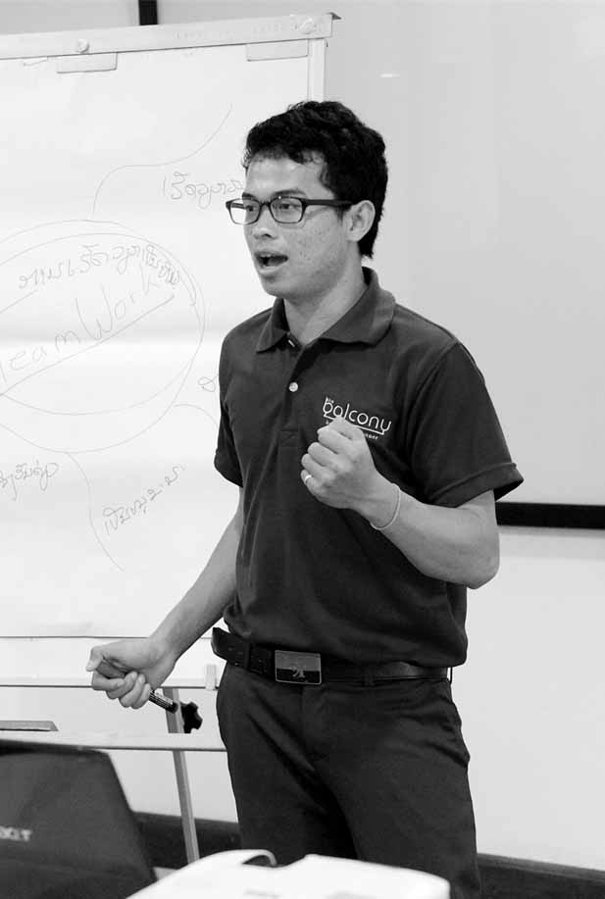

Session 5:
Setting Your
Price

Session 5: Setting Your Price

120 Mins

Session Overview

Price means how much you will charge your customers for your goods or services. A successful business is one that sells something customers need or want at a price they are willing to pay while ensuring that this price is higher than your costs to provide the product.

To set your prices you have to:
- Know how much your potential customers are willing to pay
- Know your competitors’ prices
- Know your costs

This next session of the training will demonstrate how to calculate whether your business will make a profit or a loss. The group will work through different activities to estimate a competitive price, predict monthly sales and production, and break down the different business costs.

It is important to keep in mind how any tourism seasons will affect incoming cash flow, and how you can compensate in the off-season (by hiring less staff, or providing other products, for example). Let us start with the activities.

Activity 5A: Competition and Customers

In the first activity you will learn what factors are important to consider when setting the price of a product/service.

Next we will read through all the instructions before starting the activity at Step 1. The group reader will monitor our timing and remind us when to move on to the next step. We can now begin Activity 5A.
35 Mins
- As a group review Ms. Koodo’s product pricing research of how much customers are willing to pay and what prices competitors offer. Discuss how she may have collected this information and what you can do to collect this type of information when planning your own business. [5 minutes]
- Next, support each other to complete a product pricing research table for your own business ideas in Table 5A. It is important to be realistic about these prices. If you do not know what price your customers are willing to pay, ask other members of the group what they would pay. [15 minutes]
- Take turns presenting your product pricing research table to the group. Group members will provide feedback and helpful comments to strengthen these tables before moving on to the next activity. [10 minutes]

Example: Ms Koodo’s Pricing Strategy
Product Range  (Goods or Services) | Average Market Price | Competitor Highest Price | Competitor Lowest Price | My Price
Bread loaves | $3.50 /loaf | $4 /loaf from bakery in neighbouring village | $2 / loaf from local 7/11 | $3.00 /loaf

Table 5A: Your Pricing Strategy
Product Range  (Goods or Services) | Average Market Price | Competitor Highest Price | Competitor Lowest Price | My Price

Once a competitive price has been identified, the next step towards setting your price is to estimate how much you can sell each month and how much you should be producing to meet this demand. This information will allow you to determine how much you can expect to earn based on your proposed price.

Activity 5B: Estimating Monthly Sales and Production Needs

In this activity you will learn about a way to calculate monthly production and sales. To do this you must have a realistic idea about how much you can sell as a new business. In this training, group members will help each other to predict realistic sales figures but those entrepreneurs who are serious about launching their business should redo this activity using information collected in one or more of the following ways:
- Compare with similar businesses through observation or asking business owners.
- Conduct market research by surveying potential customers about what products, how much they would pay, and how much and how often they would buy your product.
- Experiment with your sales by starting your business on a very small scale to assess what your customer will pay and how much you can sell.
- Advance orders are a method to get commitments from future customers to purchase your products before they are produced. Remember that a written commitment to buy is usually better than a verbal agreement.

Next, the group reader will read through all the following instructions before the group starts the activity at Step 1.
35 Mins

- As a group read through the estimated production and sales table for Ms. Koodo’s business. Because her business is a start-up she has only made estimates for 6 months. Discuss how she has calculated her monthly average and what she could do with her excess production if there are no damaged products or higher demand. [10 minutes]
- Work together in pairs to complete an estimated monthly sales and production plan for your businesses in Table 5B: [15 minutes]
- As a group, present the estimates for each business and discuss the percentage used for predicting damaged products or higher demand. Did everyone use the 20% figure like the example? What can you do to be sure you have used an appropriate percentage for your business? [10 minutes].

Example: Ms Koodo’s Estimated Monthly Sales and Production Plan
Products  (Goods/Services) |  | Month of Sales/Production |  |  |  |  |  | TOTAL  produced | AVERAGE per month  (TOTAL of Months / Number of months)
 |  | 1 | 2 | 3 | 4 | 5 | 6
Predicted bread loaves that can be sold to individuals through the market stall | Estimated sales | 100 | 150 | 150 | 200 | 200 | 250 | 1,050 | 175 loaves per month
To account for damaged products or higher demand, produce 20% more than estimated sales*
Bread loaves that will be produced to sell to individuals through the market stall | Quantity to be produced | 120 | 180 | 180 | 240 | 240 | 300 | 1.260 | 210 loaves per month

*Note: this percentage can be changed to one you believe is more reasonable for your business

Table 5B: Your Estimated Monthly Sales and Production Plan
Products  (Goods / Services) |  | Month of Sales/Production |  |  |  |  |  | TOTAL  produced | AVERAGE per month  (TOTAL of Months / Number of months)
 |  | 1 | 2 | 3 | 4 | 5 | 6
 | Estimated sales
 | Estimated sales
 | Estimated sales
To account for damaged products or higher demand, produce ?% more than estimated sales*
 | Quantity to be produced
 | Quantity to be produced
 | Quantity to be produced

We have now identified a competitive price for our products, estimated how much we can sell, and calculated how much we should produce to meet this demand. Already you may have some idea about the income your business can generate from sales but to understand how much of this will be profit you first need to calculate your business costs.

Activity 5C: Costs
In this activity you will learn about the key components of your costs and know how to estimate them.
Let us read together the types of cost that you can expect to have in your business:

Variable costs
Variable costs change with the amount of goods/services produced and usually fall under the raw materials or labour column. Using the haircutting example, variable costs would be shampoo or hair gel and labour costs are cutting and washing hair.

Raw materials
The basic materials used to make the final product or service. For hairdressing, it is the shampoo or conditioner needed to wash hair. This is a variable cost because it changes based on the amount of goods/services produced.

Labour costs
These costs are the amount of wages you pay your employees, as well as the amount of money you earn from your business. These are variable costs because the amount of money you pay your employees and yourself changes with the amount of goods/services produced.

Fixed costs
Fixed costs are the same regardless of the amount of goods and services produced. For the hairdressing example, the cost of rent, scissors and chairs are all fixed costs.

Now that we went over the types of costs, let us try and estimate what they may be for our businesses. Next we will read through all the instructions before starting the activity at Step 1.

50 Mins
- Read through the sample table of raw materials for Ms. Koodo’s business and discuss how each calculation has been made. [15 minutes]
- Support each other to complete a raw materials cost breakdown for one good or service to be produced in each business idea - Table 5C (1) [10 minutes]
- Read through the sample table of labour materials for Ms. Koodo’s business and discuss what an appropriate salary or income for business owners should be - Table 5C (2) [5 minutes]
- Support each other to complete a labour cost breakdown for one good or service produced in each business idea - Table 5C (3). [5 minutes]

Example: Ms Koodo’s Variable Costs: Raw Materials
Raw materials | Quantity needed per product (loaf) | Unit price | Cost per product (loaf) ($)
Yeast | 0.1 kg | 1 dollar per kg | 0.10
Salt | 0.5 kg | 2 dollar per kg | 0.01
Oil | 0.5 ounces | 10 cents per ounce | 0.05
Eggs | 3 eggs | 10 cents per egg | 0.30
Flour | 0.5 kg | 1 dollar per kg | 0.50
Total Cost for a Loaf | $0.96 dollars / loaf
Total Production Per Month* | 210 loaves/month
Total Cost Per Month** | $201.60/ month

* This value is from the Sample Table in Activity 5B.
**To calculate total cost per month, multiply total cost for a loaf by production per month

Table 5C (1): Your Variable Costs: Raw Materials for One Product (Good or Service)
Raw materials | Quantity needed per product (loaf) | Unit price | Cost per product (loaf)
Total cost for a product
Total production per month*
Total cost per month**

Example: Ms. Koodo’s Variable Labour Costs to Make a Loaf of Bread
Person | Time (in hours) per month | Cost per hour | Cost per month
Ms. Koodo | 120 hours | $2 | $240
Total cost per month | $240/month

Table 5C (2): Your Variable Labour Costs Per Product (Good or Service)
Person | Time (in hours) per month | Cost per hour | Cost per month
Total cost per month | $240/month

Example: Ms. Koodo’s Fixed Costs to Make Bread
Equipment | Purchasing price | Number of months it can be used | Cost per month (purchasing price/ number of months)
Knife | $18 | 12 months | $1.50
Bowl | $12 | 24 months | $0.50
Mixer | $36 | 24 months | $1.50
Wooden spoon | $3 | 12 months | $0.25
Rent/month* |  |  | $60
Transportation/month* |  |  | $15
Total cost per month |  |  | $78.75 / month

*These two are also called “overhead costs”

Table 5C (3): Your Fixed Costs for One Product (good or service)
Equipment | Purchasing price | Number of months it can be used | Cost per month (purchasing price/ number of months)
Total cost per month

Example: Ms.Koodo’s Total Costs to Make a Loaf of Bread
Type of cost | Total cost per month
Variable raw materials costs | $201.60
Variable labour costs | $240
Fixed costs: Equipment + “Overhead” | $78.75
Total cost per month | $520.35

Table 5C (4): Your Total Costs for One Product (Good or Service)
Type of cost | Total cost per month
Variable raw materials costs
Variable labour costs
Fixed costs: Equipment + Overhead
Total cost per month | $520.35

In this activity of this session, you learned how to estimate your monthly costs for a business producing one good or service by calculating for raw materials, labour, equipment, and location. Before entrepreneurs put their business plans into action, it is important that these calculations have been made for each good or service and the totals clearly identified.

Activity 5D: Making a Profit

The final step in setting the price of your product is to determine if you will make a profit or a loss given your estimated price, sales, production, and costs.

You make a profit when income from sales is greater than costs.
You make a loss when costs are greater than income from sales.

If you find out that you are making a loss, you will need to take another look at one of the following to see if you can change it:
- Price: Can you charge a higher price?
- Sales: Can you sell more? Are there promotions that will help you to sell more?
- Costs: Is there a way to reduce your costs?

If you are unable to make changes, or you do and you are still making a loss, it may be a good idea to consider another business idea.

To calculate your profit, you will need to compare what the customer will pay and with the sales and cost for the business. This next activity will show you how to do this using what you learned in Activity 5A, 5B and 5C.

35 Mins

- As a group, read aloud the sample profit sheet for Ms. Koodo’s business and discuss how the calculation has been made. [10 minutes]
- Work in pairs to complete profit sheets for each group member’s business idea using the calculations developed in the previous activities. [15 minutes]
- Reform as a group and share each group member’s profit or loss calculation. Discuss what each individual has learned from this session and what changes might be made to the business plan with this new knowledge? [10 minutes]

Example: Profit Sheet for Ms. Koodo’s Breads
Step 1 | Ms. Koodos Price  (From Activity 5A) | X | Ms.Koodo’s Sales  (Monthly average from Activity 5B) | = | Monthly Sales
 | $3.50 / Loaf |  | 175 Loaves |  | $612.50
Step 2 | Monthly sales |  | Ms Koodo’s Costs  (From Activity 5C) |  | Profit
 | $612.50 |  | $520.35 |  | $92.15

Table 5D: Profit Sheet for Ms. Koodo’s Breads
Step 1 | Your price  (From Activity 5A) | X | Your sales  (Monthly average from Activity 5B) | = | Monthly sales
Step 2 | Monthly sales |  | Your costs  (From Activity 5C) |  | Profit/loss?

The Setting Your Price session has presented the different tools and strategies entrepreneurs can use to set an appropriate price for their products. It is important to remember that your business costs and what your competition is offering will influence how much you can charge your customer. Before launching a new business, entrepreneurs should take the time to gather information and calculate the costs of each good or service they will offer. Making a profit though is not the only indicator of business success.

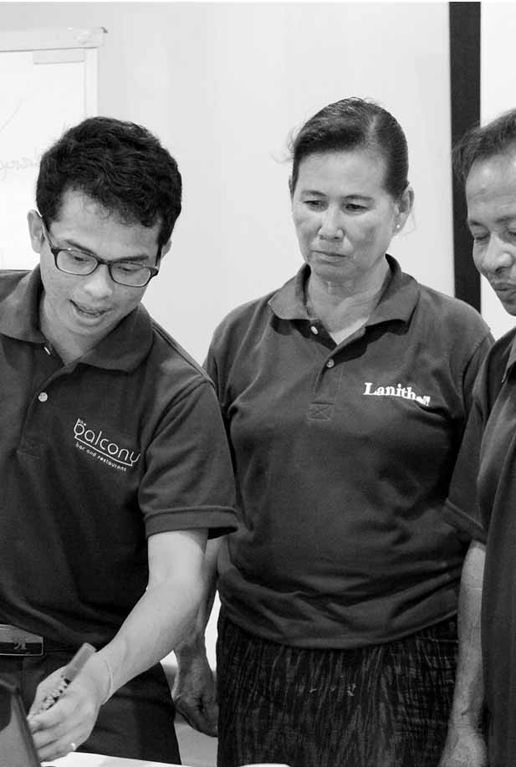
Session 6:
What Makes a Successful Business?

Session 6: What Makes a Successful Business?

35 Mins

Session Overview

Session 6 will allow you to think about the successful businesses you know and identify important characteristics that make those businesses successful. Some examples are:
- Clear business plan
- Management has good attitude to staff and customers
- Management has an ability to take risks
- Product is in high demand
- Creative marketing strategies
- Good product design
- Strategic business location

These are among the basic principles of successful business that you may want to consider for your own business. There are many more. Next we will read through all the instructions before starting the activity at Step 1.

Activity 6A: Characteristics of a Successful Business

In this activity you will identify characteristics that contribute to the success of a business and you will consider which can be useful for your own business

30 Mins

- As a first step you work as a group and we will use a flipchart or a piece of paper. Each of you shares with your group an example of a successful business. Tell the group why you think that business is successful. Write them down on the flipchart or a white paper [10 minutes]
- Discuss as a group if the success criteria each of you named can be achieved with some of the sessions and activities of the training. If not what other ways are there? [10 minutes]
- Now you will take the time and choose three of these criteria that we would like to achieve in our business. Write them down in Table 6A. Write also what you need to introduce these criteria. We will work together for support. [10 minutes]

Table 6A: My Criteria of a Successful Business
My chosen criteria | How can I implement these criteria in my business?

In Activity 6A we considered some criteria that contribute to the success of a business. We thought about successful businesses of people we know.

You can combine these criteria with the skills that we learned so far. Since the first session we learned:
- How to select and assess a good business idea
- How to conduct a market research and analyze customers
- How to define details of your business: product, place, promotion, and price
- How to set prices to make a business a profit.

In the final session we will go through the skills we learned and decide what actions we can take about our business ideas after the training

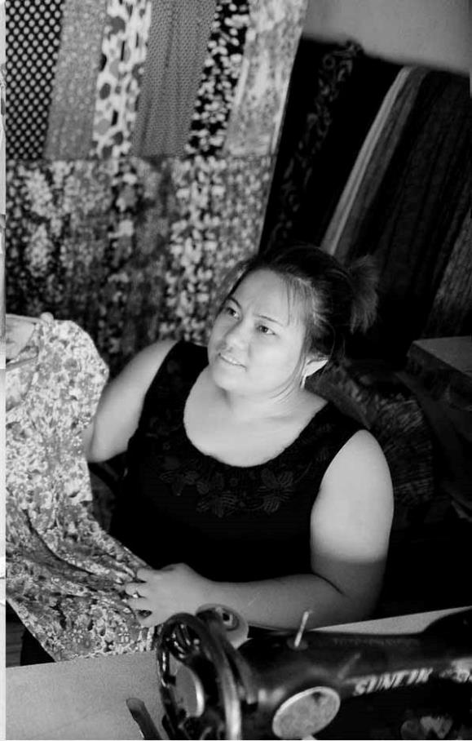
Session 7: Action Plan

Session 7: Action Plan

40 Mins

Session Overview

This final session will review all the skills that have been developed in the training to identify what your next steps should be. Each session in this training matches a step you can take if you decide to start a business.

Activity 7A: Taking Action

In this final activity we will go through each of the steps and decide if we are ready to take action or we need to do some more work after the training.
30 Mins

- As a group, listen to the group reader read each step in the action-planning worksheet. As you listen, mark the first column with a YES or NO to show if the action has been completed or not. [5 minutes]
- Work individually or in pairs to go back over the work you have completed in this training and record any important details related to the different steps that you will need to reflect on later. This may be something new that was learned, a decision that was made, or some additional information that may be needed. [15 minutes]
- As a group, help each other to define next steps that can be taken to put the plans into action. Each group member should share their Action Plan with the group. [15 minutes]

If everyone in the group is interested, we can plan to meet on a regular basis to talk what we have done to complete the actions.
Table 7A: Action Planning
Steps to starting a business |  |  | Completed? (Yes/No) | Details | Next steps
Select your business idea
Define your business idea
Know who your customers are
Decide on your product characteristics (color, size, quality)
Pick a location
Select your Advertising and Sales promotion strategies
Know what price your clients are selling competing products at
Know what price your customers are willing to pay
Estimate your raw materials, equipment, labor and overhead costs
Decide which qualities of a successful business you want your business to have

Action planning, the activity we completed at the end of the training, is a very important step. It pushes us to decide how to apply what we have learned in this training into our work and lives. We can use it together with the training guide to do revisions and motivate ourselves to take actions.

This is the end of the training. We can now complete the evaluation. In few months there will be some follow up as well.

www.sme-tools.org

