



HANDICRAFT TRAINING GUIDE

*ILO - ASEAN Small Business Competitiveness*

A product of ­



Small Business Competitiveness by International Labour Organization (ILO – SBC) is licensed under a Creative Commons Attribution-Non Creative Commons Attribution‐NonCommercial‐ShareAlike 3.0 Unported License.



**Attribution** — You must give [appropriate credit](https://creativecommons.org/licenses/by-nc-sa/3.0/), provide a link to the license, and [indicate if changes were made](https://creativecommons.org/licenses/by-nc-sa/3.0/). You may do so in any reasonable manner, but not in any way that suggests the licensor endorses you or your use.



**NonCommercial** — You may not use the material for [commercial purposes](https://creativecommons.org/licenses/by-nc-sa/3.0/).



**ShareAlike** — If you remix, transform, or build upon the material, you must distribute your contributions under the [same license](https://creativecommons.org/licenses/by-nc-sa/3.0/) as the original.

****[*https://creativecommons.org/licenses/by-nc-sa/3.0/legalcode*](https://creativecommons.org/licenses/by-nc-sa/3.0/legalcode)

brought to you by:



Table of Contents

About C-BED vi

About The Handicraft Package: vi

Message to The Group vii

Session 1: Introductions 1

Activity 1A: Getting to Know Each Other 1

Session 2: Creating Systems 5

Activity 2A: Case Study 1 5

Activity 2B: Case Study 2 6

Activity 2C: Comparing Systems 7

Activity 2D: Using Systems 8

Activity 2E: Personal Action Plans 8

Session 3: You and Your Product 11

Activity 3A: Your Strengths and Skills 11

Activity 3B: Summary of Strengths and Weaknesses 12

Activity 3C: Discussing Strengths And Weaknesses 14

Activity 3D: Personal Action Plans 14

Session 4: Your Product From the Final Owner’s Point of View 17

Activity 4A: Final Owners 17

Activity 4B: End Consumer vs. Retailers 18

Activity 4C: Customer Service 20

Activity 4D: Target Market and Customer Match 22

Activity 4E: Market Research 23

Activity 4F: The Right Market for Your Product 24

Activity 4G: Personal Action Plans 26

Session 5: Market-led Product Development 29

Activity 5A: Market- vs Product-led Development 29

Activity 5B: Reassessing Your Products 30

Activity 5C: Perceived Value 32

Activity 5D: Coming up With New Designs 34

Activity 5E: Personal Action Plans 38

Session 6: Improving Production and Quality Control 41

Activity 6A: Scheduling Production and Using Gantt charts 42

Activity 6B: Dealing with Bottlenecks 44

Activity 6C: Quality Control 45

Activity 6D: Personal Action Plans 47

Session 7: Costing and Pricing 51

Activity 7A: Difference Between Cost and Price 51

Activity 7B: Costs 52

Activity 7C: Importance of Recordkeeping 53

Activity 7D: Pricing 54

Activity 7E: Personal action plans 54

Session 8: Reasons to turn Down an Order 57

Activity 8A: Turning Down and Order 57

Activity 8B: Personal Action Plans 59

Session 9: Priority Action Plans 61

Activity 9A: Prioritized Actions 61

Flipcharts: 63

Activity 2C 63

# About C-BED

Community-Based Enterprise Development (C-BED) is a low cost, innovative training programme designed by the International Labour Organization (ILO) to support skills development and empowerment in local communities for improvements in livelihoods, productivity and working conditions.

As an approach to training, C-BED is unique in that the programme is built around peer-to-peer, activity based learning methods with no role for teachers, experts, or external consultants specialised in the skill area. Instead, C-BED participants work together through a series of activities and discussions guided only by simple step-by-step instructions in the training manual. New knowledge, skills and competencies are developed through the interactions between participants and sharing of existing local knowledge and experience. In this way the programme is a low cost, sustainable option for any organization or community.

The C-BED programme is structured around two core training packages designed to develop competencies for business start-up and operation through a focus on marketing, financial management, and action planning. These are the C-BED for Aspiring Entrepreneurs and C-BED for Small Business Operators. Additionally, a growing suite of tools to strengthen business competencies and enhance skills for specific sectors is in continual development. These packages can be implemented as either stand-alone trainings or integrated in modular format into existing programmes.

## About The Handicraft Package:

**The training package:**

The Handicraft package should be used to help aspiring and current handicraft manufacturers start and improve their businesses. It focuses on key business principles to build on from what participants already know from managing their handicraft businesses and helps them to learn more. It can also build on from the learning in other C-BED tools namely SBO or AE. Participants bring experience to share and leave with a priority action plan (at least 3 actions to introduce improvements to their business). At the end of the training participants will have:

* Enhanced and advanced existing knowledge on handicraft manufacturing development
* Strengthened critical competences to analyse job prospects or current conditions of work
* Affirmed the potential of enterprise development
* Identified steps and actions to improve a business or launch a business idea
* Decided on actions for the future
* Started planning effective collaborations and associations

**The Good Practice Guide:**

During the training day participants will be introduced to and become familiar with the Good Practice Guide (GPG), which they will then be able to use to further their learning and to support them in setting up or improving their businesses. The GPG contains best practices, tools and extra activities that supplement those covered in the training to further support the participants in setting up or improving their businesses. The exercises may depend on the GPG but if the participants do not have this guide this should not prevent them from moving forward, if necessary skip that activity. Look out for this icon:



Here you should refer to the Good Practice Guide for more information

## Message to The Group

At the end of this C-BED training you will have a clear plan for the practical steps you can take to start or improve your business. Your understanding of the basic principles of doing business will be much stronger and you will have begun relationships with others in your community that can potentially support or cooperate with you to achieve mutual success in the future.

The style of this training is different to traditional education approaches. There will be no teacher, trainer or expert to assist you. Instead, you will work together as a team to follow the simple step-by-step instructions for discussions and activities in your training guide. Because there is no group leader, all group members should take a turn reading the information and instructions out loud to the group, and all group members share responsibility for monitoring time. In this new style of training, we will learn from each other by sharing ideas and opinions, skills, knowledge and experience. For this to work, all group members must participate in discussions.

Before and after the training you will be asked to complete a survey to understand the impact of the training. This information will be kept confidential and is used to improve the training materials and organization of future programs. Some trainees may also be contacted in the future after 3, 6 or 12 months for another survey to learn about your business plans.

The instructions in the training guide are easy to follow and suggested timing for each step is provided. Look out for these signs:



When you see this sign, share with the group

When you see this sign, you are reading instructions and doing activities

When you see this sign, read aloud

This sign gives you the estimated time for the session

Use the flipchart as outlined in Appendix 1, if you don’t have a flipchart use extra paper or the Training Guide









Before you begin the training, follow the simple steps below to get organized.

* Fill out the pre-training survey. Ask the organizers if you don’t have a copy or have not already filled it in.
* Organize into small groups of 5-7. The organizers will guide you in how best to do this.
* Identify one group member to volunteer to start the training as ‘Group ‘Reader’. The ‘Group Reader’s’ role is to read the information and activity instructions out loud to the group. Any group member with basic literacy can be the ‘Group Reader’ and you should aim to share this role among group members throughout the training.

All group members are responsible for monitoring time but one group member should be nominated for each session to remind the group when the suggested time for a step has been reached. You do not strictly need to follow the suggested timing but you will need to manage your time for the total training. If one activity lasts longer than the suggested timing, try to save time in other activities to keep the balance.

All group members will receive the same training guide. Individual work can be completed in these guides as well as group work. Groups may also like to complete activities together on flipchart paper if available.

Enjoy The Training!

Session 1:

Introductions

# Session 1: Introductions



**20 Mins**



**Session overview:**

In this session you will get to know one another and the style of learning in this training. We learn without teachers. You help each other by sharing your different experiences and ask questions if you don’t understand an activity. The objectives of this session are to:

* Identify the training sessions, timing for the day, expectations (e.g., action planning) and the workshop arrangements (e.g. breaks, water)
* List the names of some of the trainees
* Understand the style of learning for this course, including activities and group work
* Understand the importance of contributing ideas and suggestions
* Understand your unique competitive advantage and how you present that, and how that will help you succeed

## Activity 1A: Getting to Know Each Other



In Activity 1A, you will do some brief introductions so you can get to know one another.



**20 Mins**

1. Each person introduces themselves by providing:

* Full name and any nickname you prefer to use during the session
* Business address
* How long your business has existed (if applicable)
* Your purpose for attending this session and how you expect it to help your business

1. Each person shares a photo, handicraft item, business card or drawing of their best selling product for others to see. Place this on the wall or in the middle of the table, or allow others to see it on your mobile phone. Ideally, each person has brought two of his or her products to the training. Show these to the group too. We will use these later on in some exercises.
2. Fill in this sheet below (if not now, then during tea breaks and lunch time)

|  |  |  |
| --- | --- | --- |
| Table 1A: Participant Information | | |
| Participant Name | Business Address | Phone number /  Email address |
|  |  |  |
|  |  |  |
|  |  |  |
|  |  |  |
|  |  |  |
|  |  |  |
|  |  |  |
|  |  |  |



In this activity you have gotten to know who your peers are and a little about their businesses.

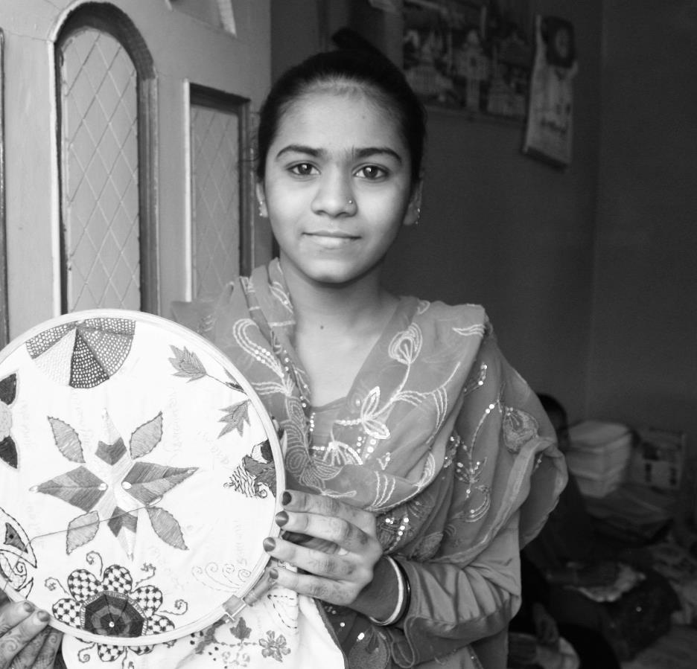

Session 2:

Creating

System

# Session 2: Creating Systems



**45 Mins**

**2**

**1, 2, & 3**



**Session overview**

In this session, we will hear two examples that show us the value of using systems to operate a successful handicrafts business. These will help us to discuss the benefits of using systems. We’ll compare the operations of two businesses, one using systems and one that doesn’t. The two stories will show the value of using systems to plan and operate a successful handcraft business, and lead into discussions about the benefits of using systems. You will complete 5 activities.

## Activity 2A: Case Study 1

[5mins] Dara, the owner of a handcraft production workshop with 4 employees, is exhausted. He works constantly but no matter how much he does, he’s falling further and further behind and more in debt. He keeps adding new products to his line, but can’t figure out why he always has to borrow money to pay his bills. He’s afraid to add up how much he owes and doesn’t even remember all the people he’s borrowed from. Now his best retailers are starting to drop him from their stores, and his suppliers are demanding all the back payments he owes before they’ll deliver any more raw materials. If he can’t get more wood he may have to cancel an order he has, and the retailer said if he did that one more time he’d never buy from him again.



While he doesn’t know about different woods or have advanced carving skills, Dara has beginner skills and hired experienced carvers. If they left he couldn’t produce any more. Last month he also started making beaded glass necklaces after he overheard some fashionable women talking about how much they’d paid for necklaces they’d bought in the capital city department store. His employees hate making them, complaining they can’t see the eye of the needle, and their fingers are too large to hold onto the beads while trying to thread them; and they keep dropping the expensive beads on the floor. He has no idea how many he’s lost, but thinks it’s a lot. Last week his young son came into the shop and slipped on one, luckily he wasn’t seriously hurt.

Yesterday he saw some great hand woven pillows in a shop and thought he’d cut his losses on the necklaces and make pillows. He doesn’t have a sewing machine and none of his carvers know how to sew, but he doesn’t think it will be hard, it’s only four straight seams!

Last week his best carver quit without warning, even though Dara owes him back wages. He heard he got a job at another workshop and is making a higher salary. Dara suspects his other workers want to leave too. They used to suggest new wood designs and help him properly dry the wood so it wouldn’t warp or crack, but they aren’t talking with him anymore. He thinks maybe he should delay paying them so they’ll have to stay if they want their money later.

## Activity 2B: Case Study 2



**Would someone else like to read the second example to us?**

[5mins] As a young child, Nui learned how to dye and block print fabric from her mother and grandmother. She studied painting and traditional design in school, and her family has a treasure trove of original designs from her great grandmother that everyone in the village loves. She opened a block-printing workshop with her mother and grandmother after consulting her uncle, a respected businessman. He offered to train her in his business, and after working under his guidance for six months, she’d learned the importance of having repeatable systems, how to keep records, and how to do market research. When they both felt she was ready to start her workshop, they drew up a contract detailing how she’d pay back the money her uncle lent her to buy her first supplies.

The three women agreed that Nui would be in charge of running the business while her mother would manage printing and her grandmother would be the chief designer. For the first year, Nui spent most of her time away from the workshop, meeting suppliers and retailers and building relationships, and studying what else is on the market and how it’s selling. The first six months were rough until sales picked up and payments started coming in regularly; but the women had planned and saved for that so they could pay their bills. They’re proud that they made a small profit their first year, and have never been late on a payment to Nui uncle.

Since all three women know how to design and print, her mother and grandmother can help each other, and Nui can help them both whenever there’s a big or rush order. So far they’ve had one large order, which they delivered two days ahead of the promised delivery date. The retailer said it was exactly as he ordered it, and his customers loved it. He wants to place a repeat order as soon as he’s made the final payment for this one. He also asked if she could also make handmade soaps, which are a hit with the teenage girls, but Nui politely explained that even though it’s a very profitable product, it’s not right for her, and gave the retailer the name of someone who makes them, which he appreciated.

She is however, interested in expanding into block printed clothing. Once she’s finished paying off the loan to her uncle she’s planning on taking out a loan from the bank to buy a sewing machine. Her uncle offered to cosign the loan and the banker said her loan repayment history shows she is a good credit risk. Meanwhile, she’s taking lessons from the most skilled seamstress in the area. The seamstress has said she’d like to come work for Nui when she is ready to hire a sewer.

## Activity 2C: Comparing Systems



In this activity we will discuss what we mean by systems and compare the two stories.



**10 Mins**

1. List as many things as possible that Dara is doing wrong in his business and list as many things as possible that Nui is doing right. Write these on the flipcharts.
2. After we have done this, we can turn to Section 2 of the Good Practice Guide to learn more about systems. The Group Reader will read us the information about systems below.

A system is a set of organized, detailed procedures created to accomplish a task: Do a specific activity, perform a duty, solve a problem efficiently and with consistent quality. A good system does not have to be complicated, the easier it is to follow the better. A system often starts with a checklist of clear, step-by-step things to do. A good system will help you run your business and achieve your goals in a logical, repeatable, and efficient way with the least amount of disruptions.

1. Discuss what systems Nui is using in her business and write these on the Flipchart 2.
2. Discuss what systems Dara could immediately start to implement in his business to improve it. Are there other systems that he would need to put in place over time? Record these on Flipchart 3

In this activity we have compared a business that uses systems to one that doesn’t and noted some of the systems that are being used and that could be used.

## Activity 2D: Using Systems

In this activity we will discuss some of the things that we can use systems for.





**10 Mins**

1. Continuing on the bottom half of the same page we just read, we see some areas where systems can help artisans succeed. Does anyone have any systems they’re using right now in any of these areas?
2. Discuss and record the discussion on the Flipchart
3. Be sure to discuss how the system has helped you too.

In this session we have looked at what systems are, how they are used and how they can help us.

## Activity 2E: Personal Action Plans

In the final activity of this session we decide on some concrete actions to improve or create systems in our businesses. Keeping in mind all the things we’ve discussed so far about creating systems, take a few minutes to record your thoughts.

**10 Mins**



1. Each of us uses Table 2E: Personal action plan to write 1-3 changes that we would make to improve systems in our businesses. Are there any improvements you would like to make based on what we have learned in the previous activities? If so, decide what systems you will implement or improve.
2. Record how you will make these changes
3. Record by when will you make these changes?
4. Finally, state who will be responsible for this change?

|  |  |  |  |
| --- | --- | --- | --- |
| Table 2E: Priority Action Plan | | | |
| My changes | How will I make the changes? | When? | Who is responsible? |
|  |  |  |  |
|  |  |  |  |
|  |  |  |  |

In this session you heard two case studies that illustrated the value of having systems in place for running your handicraft business. Systems should be simple and easy to follow. Refer to section 1 of your GPG for more information.

Session 3:

You and

Your Product

# Session 3: You and Your Product



**2**

**60mins**



**Session overview:**

In this session, we will begin to assess our business strengths and weaknesses in order to better assess these and our products. In the examples we saw that Nui maintained control of her business growth by carefully assessing her skills and resources before starting to expand her business. You will complete 4 activities.

## Activity 3A: Your Strengths and Skills



In this activity you will list your main strengths and skills.



**10 Mins**

1. For now, please list just one or two of your main skills and strengths in each column. You can refer to the page before the chart in the GPG for some ideas about what kind of information can go on the chart.

|  |  |  |  |  |  |  |
| --- | --- | --- | --- | --- | --- | --- |
| Table 3A: Strengths and Weaknesses | | | | | | |
| Who are you and who works with you? | What do you make? | What are your skills? | What materials do you use? | Your workspace:  equipment, tools, utilities do you have and use? | Do you work year round, or seasonally. full- or part-time? | Do you have other sources of income? |
|  |  |  |  |  |  |  |
|  |  |  |  |  |  |  |
|  |  |  |  |  |  |  |



In this activity we listed some of our skills and strengths.

## Activity 3B: Summary of Strengths and Weaknesses



In this activity we will look at our strengths and weaknesses.



**5 Mins**

1. In Table 3B (which you can also find in your GPG), please summarize on it what you just learned about your single most important capability and shortcoming. For example, I am the most technically skilled wood carver in my district, but there’s a shortage of good wood, and it often warps and cracks. Try to think of your own most important ones.

|  |  |
| --- | --- |
| Table 3B: Your strengths and weaknesses | |
| My strengths | My weaknesses |
|  |  |



In this activity, we looked at both our strengths and weaknesses.

## Activity 3C: Discussing Strengths And Weaknesses



In this activity you will discuss your strength and weaknesses together.



**30 Mins**

1. Show each other what you filled in the previous worksheets. Make sure you each have someone else’s completed activity.
2. Study the person’s strength and weaknesses
3. Brainstorm together what other major strengths you could use to your advantage that you might have overlooked.
4. Record the suggestions that you might get.
5. You can do this with a different people in the group to get as many ideas as possible. Work with a new person every 2 or 3 minutes.

In this activity we looked at what other strengths we might have and what we should work on. Did anyone get any new ideas for their business? It is important for artisans to share with one another for inspiration.

## Activity 3D: Personal Action Plans

In the final activity of this session we decide on some concrete actions to improve or create systems in our businesses. Keeping in mind all the things we’ve discussed so far about our businesses, and ourselves take a few minutes to record your thoughts.



**10 Mins**

1. Each of us uses Table 3D: Personal action plan to write 1-3 changes that we would make to improve systems in our businesses. Are there any improvements you would like to make based on what we have learned in the previous activities? If so, decide what systems you will implement or improve.
2. Record how you will make these changes
3. By when will you make these changes?
4. Who will be responsible for this change?

|  |  |  |  |
| --- | --- | --- | --- |
| Table 3D Priority Action Plan | | | |
| My changes | How will I make the changes? | When? | Who is responsible? |
|  |  |  |  |
|  |  |  |  |
|  |  |  |  |

In this session you focused on your strengths and weaknesses, and what you have at hand to help you to make a success of your business. You can find more information in Section 2.1 of your GPG.

Session 4:

Your Product From the Final Owner’s of View

# Session 4: Your Product From the Final Owner’s Point of View



**75 Mins**



**2, 3 & 4**



**Session overview**

The purpose of this session is to understand the real reasons people buy, by thinking about products from the final owner’s point of view. You will complete 7 activities. The objectives of this session are as follows:

* To think about the final owner’s needs and wants before product development
* Choose your target market, and know the difference between it and the final customer
* Understand the importance of exceptional customer service
* Know how to research your market.

## Activity 4A: Final Owners



In Activity 4A you will learn about your final owner, the person who will actually own and use your product.

Why do people buy what they do? This answer is: people don’t buy products; they buy solutions to their problems. Problems include what they think or feel they need, or what they want. For example, they may have a need to hang something on the wall. The need isn’t to buy nails, glue or tape, but to have the best solution that will attach the object to the wall with the least amount of damage.

You can have the most magnificent product in the world, but unless someone needs or wants it enough to pay money for it, you won’t make a sale. That’s why you must know as much as possible about who you sell your products to, and who the final person is who ultimately owns and uses your products. We need to know as much as possible about all the different people who will have temporary and permanent ownership of the product. We need to know their problems and how we can solve them. We need to understand their needs and wants.



**10 Mins**

1. In your groups, share your thoughts about this.
2. What experience do you have with why people buy what they do?
3. You can share from your experience as both a seller and a consumer.

In this activity you reflected on the needs and wants of your final customer but also understood that it is important to know the needs and wants of all your buyers whether they have temporary or final ownership of the product. Refer to Section 2.2. of your GPG for more information.

## Activity 4B: End Consumer vs. Retailers



In Activity 4B you will reflect on the different between your end consumer and a retailers.

Your end consumer buys products they like, want or need. A retailer buys products she can sell at a profit. Unless you retail yourselves and sell directly to the final owner, you probably wholesale to a shopkeeper, who in turn sells to the end consumer or to someone who buys something to give as a gift. They have different needs and wants, and you have to understand both your customer and the shop owner’s customer to be successful. The retail shop owner is running a business just like you, and has the same kinds of business concerns. Like you, the shopkeeper is in business to make a profit, and needs access to the right merchandise, or products, that their target market will buy - the end customer we just talked about. You can think of your products as the retail shop’s raw materials: they need to be the right kind, quality, price, consistency, and availability.

Your target market is whom you sell directly to. Choosing the right market to sell to is just as important as making the right products

.



**10mins**

1. Complete Table 4B to help you to think about your customers
2. Differentiate between the final owners and retailers
3. Think about what their interests are to complete the table
4. Try to keep in mind aspects that we have already discussed such as reliability, price and consistency
5. Define your target market based on the outcome this exercise

|  |  |  |
| --- | --- | --- |
| Table 4B: Target Market | | |
|  | Retailers | Final Owners |
| Do you have these customers ? | □ Yes □ No | □ Yes □ No |
| What do they like from your product ? |  |  |
| What do they like from your services ? |  |  |
| How can you answer to their needs (in terms of products)? |  |  |
| How can you answer to their needs (in terms of services)? |  |  |



In this activity you looked at who your target market is and who to understand them better. Your GPG has more information in Section 3.

## Activity 4C: Customer Service



In Activity 4C you will review the important of good customer service for a successful handicrafts business.

**[5mins]**

At the top of every company’s list is the need to work with reliable suppliers. Like you, shopkeepers work very hard for not enough money, and have intense competition they must outsmart. How reliable a supplier you are is just as critical to them as it is to you, and can even be more important than having the latest designs.

In this activity the group reader will read some more information about Nui and how she made her business successful before you complete the exercise.

Nui realizes that a good relationship her buyers is very important and want to ensure that she is a good supplier. She has one big client Mr Kunia who buys up to 70 per cent of products. Her key to success is that she understand that Mr Kunia is in a very competitive industry and when she designs new products she does so for the end buyer, helping Mr Kunia to stay ahead of his competitors.

It is not rare that Mr. Kurnia comes up with big order, sometimes almost doubling her average production rate. For these occasions, Nui has her system that she applies consistently. She has already agreed with Mr. Kurnia that he would give her notice at least 1 month in advance of the expected delivery date if he would like to order above her production rate, instead of 2 weeks notice as in normal times. She would in turn as well give him generous discount for bigger orders. In other times, she would offer him discount in payment terms: he can pay two weeks later instead of one week. With both parties agreeing to this term, she can be sure that she can deliver the correct items, and on time. She wants to deliver the right product and be reliable for delivery so as not to disappoint her buyers. When she is unable to attain her target, she makes sure that she gives notice to Mr. Kurnia or her other buyers much in advance explaining the unforeseen problems or event happening, so that the buyers can look for other suppliers in time. When she’s unsure about some of the buyers’ expectation, she does not hesitate to ask. She does not give false promise and would like to make her buyers’ life easier. Nui now has a good reputation for quality products and reliable delivery.

**60 Mins**



1. Discuss in your groups what would you advice yourself and fellow handicrafts producers to do to remain a reputable supplier.
2. Use the keywords below to construct your advice. The group reader will read these aloud.

|  |
| --- |
| Table 4C: Customer service |
| Keywords:   * Reliability * Trust * Innovation * Helpful/resourceful * Responsive * Quality * Communication * Reputation |
| Advice: |

1. Use at least 4 of the key words and record your ideas in Table 4C.



In this activity you reflected on what would make you a good supplier and how to provide good customer service and gain a good reputation.

## Activity 4D: Target Market and Customer Match



In this activity you will review your target market and customer match. Ensuring a good match will help to ensure good supply.



1. Use Table 4D below to help you identify what the best market and

customer match is for you

1. Fill out the table to help you identify your target market

|  |  |
| --- | --- |
| Table 4D: Best Market and Customer Match | |
| Who buys my products? |  |
| Who uses my products? (the end consumer) |  |
| My target market: what kind of shop? |  |
| Where is my target market located? |  |
| What is my competitive advantage? |  |
| What can I do now to improve my business? |  |

Together with the exercises you completed earlier you should have a better ideas of what makes your business unique and how you can deliver good service to your customers by knowing more about your market. Look at Section 4.1 of your GPG for more information.

## Activity 4E: Market Research



In this activity you will reflect on how you can learn more about your customers through market research.

One of the best ways to learn what products your market will buy from you is to ask. If you are a reliable producer and a good business partner, the wholesaler or buyer you sell to will be very happy to give you information to improve your products, for when your products sells more, he sells more, and you both make more money. He will also be impressed with your professionalism and desire to learn and will consider you a good business partner.

Once you’ve developed a successful and trusting relationship, your buyer will be more willing to give you accurate information about their customers, the competition, and industry trends, to help you provide better products for his customers. Some of the things you might want to ask about include:

* Who will want to buy what you can make and why? What is their lifestyle, where do they live?
* What are the typical things they buy the most? Why?
* What changes are needed so your product is more desirable?
* Will enough people want to buy what you make so it worth your while to produce it?
* What are your major competitors making? What can you make that’s different and better?
* What is the typical price range for your type of products? How much sells in a set amount of time?
* What are the typical sales and payment terms?



**10 Mins**

1. In your groups, brainstorm some other ideas about how you can get information about your market and final buyer
2. What other kinds of information would be helpful to you and where could you get it?
3. Record your ideas in the space below

|  |
| --- |
| Table 4E: Market research |
|  |

In this activity you looked at market research and how it can help you to learn more about your customer. You brainstormed some ideas about what to ask and how to go about this.

## Activity 4F: The Right Market for Your Product

Now you have reflected on your market, it is important that you carefully select the right market for your product. Activity 4F will give you an idea of the types of questions you should answer to understand which product is for which buyer.



**10 Mins**

1. Break into groups of 2 or 3.
2. Help each to complete this exercise
3. Use Table 4F for a product that you want to sell to help you learn more about your market and decide what it wants and to decide if it is right for you
4. Answer the questions in column 1. You can repeat this for your different products.

|  |  |  |  |  |  |
| --- | --- | --- | --- | --- | --- |
| Table 4F: Which Market is Right for Your Product | | | | | |
| Product: | | | | | |
|  | Buyer 1 | Buyer 2 | Buyer 3 | Buyer 4 | Yes/no |
| Which end-buyer would buy this? |  |  |  |  |  |
| What changes do I need to make to sell more? |  |  |  |  |  |
| Is the market big enough to be worthwhile? |  |  |  |  |  |
| What price will this sell for? |  |  |  |  |  |
| How much profit will I make? |  |  |  |  |  |
| How much of my product sells in a set amount of time? |  |  |  |  |  |
| What’s the closest competitive product? |  |  |  |  |  |
| Who’s my competition? |  |  |  |  |  |
| What else can the shop sell that it doesn’t have and that I can make? |  |  |  |  |  |
| Other |  |  |  |  |  |
| Other |  |  |  |  |  |
| Other |  |  |  |  |  |
| Other |  |  |  |  |  |



In this activity you reflected on ensuring the match between your market and your product is good.

## Activity 4G: Personal Action Plans

In the final activity of this session we decide on some concrete actions to improve customer service based on your improved understanding of you market. Keeping in mind all the things we’ve discussed so far, take a few minutes to record your thoughts.

**10 Mins**



1. Each of us uses Table 4G: Personal action plan to write 1-3 changes that we would make to customer service in our businesses. Are there any improvements you would like to make based on what we have learned in the previous activities? If so, decide what systems you will implement or improve.
2. Record how you will make these changes
3. Record by when will you make these changes?
4. Finally, state who will be responsible for this change

|  |  |  |  |
| --- | --- | --- | --- |
| Table 4G: Priority Action Plan | | | |
| My changes | How will I make the changes? | When? | Who is responsible? |
|  |  |  |  |
|  |  |  |  |
|  |  |  |  |

In this session you reflected on your target market and looked at what this meant for customer service. You can find more information about this in Section 3 and 4 of your GPG.

Session 5:

Market-led Product Development

# Session 5: Market-led Product Development



**5**

**120 Mins**



**Session overview:**

The purpose of this session is to understand the value of market-led product development and to begin to practice it. You will complete 8 activities. The objectives of this session are as follows:

* Understand the difference between market-directed and product-directed product development
* Be able to decide if you need to change your products, and how
* Understand what perceived value is and how to work with it
* Understand ways to increase the prices consumers are willing to pay

## Activity 5A: Market- vs Product-led Development



In this activity you will look at the difference between market- and product-led development

Market-led product development involves choosing and understanding your market first, then designing for it where as product-led product development involves making products first, then looking for a market that might buy it. Market-led product development is about being market focused.



**5 Mins**

1. Discuss in your groups some examples of market- and product- led product development
2. Think back to the case studies of Dara and Nui you heard in the beginning of training and think about how they developed their products



In this activity you reflected on the difference between market- and product-led product development.

## Activity 5B: Reassessing Your Products



In Activity 5B you will look at whether or not your need to change your products. There are a number of different reasons why you need to change your products. These could be market or business related.

**Markets and consumer wants and needs are not static. They change over time.**

* Tastes and trends change all the time. What’s fashionable today is outdated tomorrow.
* Their economic situation changes so they can afford to spend more or less.
* They need something for a specific event, like a birthday present or the holidays.
* People get older and need different things.
* People just want something new or different

**Adapting to changes in your business**

You may also need to develop new products because of changes in your business. For example:

* Some raw materials are no longer available, have gotten more expensive, or have changed.
* Your workforce has gotten smaller or bigger, and people have more or fewer skills.
* You need to differentiate from the competition.
* You need to offset sales seasonality (something only sells at a certain time of year).



**10 Mins**

1. In your groups, discuss each item in Table 5B.
2. Decide whether you need to change to products due to a change in the business or in the market.
3. Complete Table 5B by placing a tick in the market or business column

|  |  |  |
| --- | --- | --- |
| Table 5B: Adapting to Change | | |
| You need to change your products due to changes in: | Market | Business |
| Example: Tastes and trends change all the time. What’s fashionable today is outdated tomorrow. |  |  |
| You need to differentiate from the competition. |  |  |
| Their economic situation changes so they can afford to spend more or less. |  |  |
| They need something for a specific event, like a birthday present or the holidays. |  |  |
| Your workforce has gotten smaller or bigger, and people have more or fewer skills. |  |  |
| Tastes and trends change all the time. What’s fashionable today is outdated tomorrow. |  |  |
| People get older and need different things. |  |  |
| Some raw materials are no longer available, have gotten more expensive, or have changed. |  |  |
| People just want something new or different. |  |  |
| You need to offset sales seasonality (something only sells at a certain time of year). |  |  |

In this activity you reflected on changes in your business or market and how they drive the need for product changes. You should reflect over this question at home to decide whether or not you need to make changes to your products.

## Activity 5C: Perceived Value

In this activity you will get to understand more about perceived value and what you can do to increase the perceived value of your products. This can be done with little additional expense.

Perceived value is what something is understood to be valued at, what it seems to be worth, and what people generally are willing to pay for it. It may have no relation to its real value based on costs.

How can you make your products more valuable in the eyes of the consumer and charge higher prices? You can improve the quality of your products and do other things that make them seem worth more, but that will only increase your costs a little. Value-added is more than the extra cost incurred increases the perceived value of something. If we increase our costs by as much as we increase the value, we don’t gain anything. Some of the things you can do without greatly increasing costs include:

* Updating the design and style,
* Make products functional in addition to being decorative
* Use several materials or patterns, more than one production technique
* Make different things from other producers
* Make sure your products look like they are lovingly handmade. Quality and finish are most important.
* Promotional materials that explain your product inform the consumer and get them interested in buying it. Use hangtags to describe the cultural importance of your design; to explain how it is made and its traditional uses.
* Boxed sets and beautiful packaging increase perceived value, yet don’t add a lot to the cost.
* Sets of matching things
* Display can also affect perceived value



**15 Mins**

1. In your groups, discuss how you have increased the perceived value of any products
2. Share with the groups what you did and what it was that the customers liked about this
3. Take notes in order to reflect back on this discussion. Use the space provided below.

|  |
| --- |
| Table 5C: Perceived Value |
|  |

In this activity you reflected on perceived value and how this can increase the price you are able to charge without adding too much to your costs. Think about how you could apply this to your own products.

## Activity 5D: Coming up With New Designs

After you’ve researched your market and you know what your customers need and want, how do you develop new products and adapt your current ones to make them more desirable and saleable? Activity 5D will explore how to come up with new designs.

Ideas for coming up with new designs based on old designs:

* Old products can be improved and/or updated.
* Expand your product line into a collection, a set, a line extension.
* Improve quality of existing products.
* Add new colors, shapes and sizes.
* Make things that coordinate (go together, not match) with each other.

Or you can develop entirely new things. What do you already have that is unique or better than what your competition has?

* Design, artistic, traditional, and cultural resources
* Raw Materials
* Skills and human resources
* Machinery and technology
* Can you turn a disadvantage into an advantage?
* Can you increase perceived value?

We have collected all the products that you brought in today. You are going to discuss the items. To begin Activity 5D, we’ll read the instructions below.



**60 Mins**

1. Move over to the table where the products have been collected.
2. Discuss which items you think are selling well and which items are not.
3. Once you have reached on consensus in your groups. Move those you think are not selling well over to one side of the table and those that are to the other side.
4. One-by-one each artisan will let us know which of their products is selling well and which isn’t. If you are comfortable please also share the selling price of the product. Ask the group for advice and suggestions to improve your products so they will sell better. Record these suggestions in Table 5D (1) and 5D(2). You used these tables earlier but you can now get additional input from the group to improve your product and market assessment.
5. Each group should reflect on why they might have placed the product on the wrong side of the table e.g. saying that it would not sell well when it was in fact selling well.
6. Once each person has a turn, together you can spend some time brainstorming about new products. Building off each others ideas is a great way to get inspiration. Keep reflecting back over the information you heard at the beginning of this activity about coming up with new designs.

|  |  |
| --- | --- |
| Table 5D (1): Best Market and Customer Match | |
| Who buys my products? |  |
| Who uses my products? (the end consumer) |  |
| My target market: what kind of shop? |  |
| Where is my target market located? |  |
| What is my competitive advantage? |  |
| What can I do now to improve my business? |  |

|  |  |  |  |  |  |
| --- | --- | --- | --- | --- | --- |
| Table 5D(2): Which Market is Right for Your Product | | | | | |
| Product: | | | | | |
|  | Buyer 1 | Buyer 2 | Buyer 3 | Buyer 4 | Yes/no |
| Which end-buyer would buy this? |  |  |  |  |  |
| What changes do I need to make to sell more? |  |  |  |  |  |
| Is the market big enough to be worthwhile? |  |  |  |  |  |
| What price will this sell for? |  |  |  |  |  |
| How much profit will I make? |  |  |  |  |  |
| How much of my product sells in a set amount of time? |  |  |  |  |  |
| What’s the closest competitive product? |  |  |  |  |  |
| Who’s my competition? |  |  |  |  |  |
| What else can the shop sell that it doesn’t have and that I can make? |  |  |  |  |  |
| Other |  |  |  |  |  |
| Other |  |  |  |  |  |
| Other |  |  |  |  |  |
| Other |  |  |  |  |  |

In this activity, each person got a chance to discuss two products that they brought in. With the help of your peers, this activity helped you to better understand why some of your products might be selling better than others.

## Activity 5E: Personal Action Plans

In the final activity of this session we decide on some concrete actions to improve product design. Keeping in mind all the things we’ve discussed so far, take a few minutes to record your thoughts.



**10 Mins**

1. Each of us uses Table 5E: Personal action plan to write 1-3 changes that you would make to your product designs. Are there any improvements you would like to make based on what we have learned in the previous activities? If so, decide what systems you will implement or improve.
2. Record how you will make these changes
3. Record by when will you make these changes?
4. Finally, state who will be responsible for this change?

|  |  |  |  |
| --- | --- | --- | --- |
| Table 5E: Priority Action Plan | | | |
| My changes | How will I make the changes? | When? | Who is responsible? |
|  |  |  |  |
|  |  |  |  |
|  |  |  |  |

In this session you reflected on products and how you can improve them and therefore improve sales. You worked in groups to get feedback about your products, discussed why certain products might sell better than others, and learned about how to design new products for your market. For more information please refer to Section 5 of your GPG.

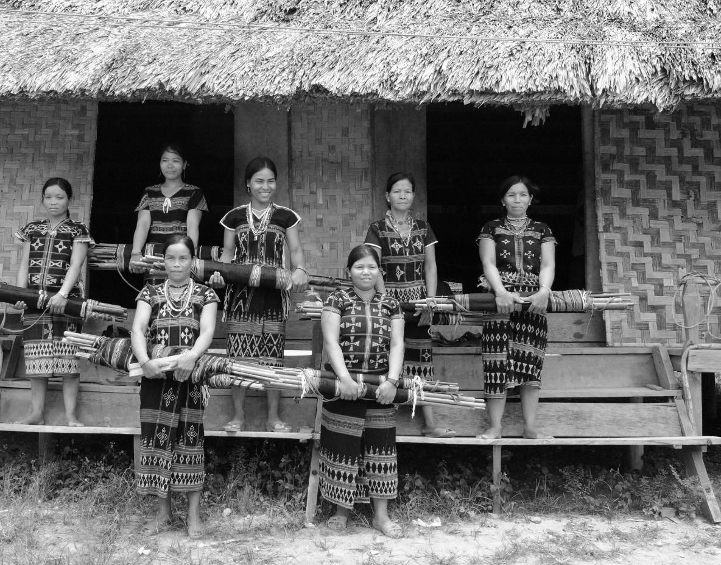

Session 6: Improving Production and Quality Control

# Session 6: Improving Production and Quality Control



**50 Mins**

**7 & 8**



**Session overview:**

The purpose of this session is to learn about systems that help improve production, and the importance of quality control. You will complete 6 activities. The objectives of the session are as follows:

**Objectives: By the end of this session trainees will be able to:**

* Understand that safety comes first, no matter what
* Understand to work backwards to schedule production
* Have some ideas for how to handle disasters and bottlenecks
* Understand the systems and tools to control quality
* Always make and keep a duplicate sample.

While you discuss improving production and quality in this session. Always remember that safety should come first.

All manufacturing businesses, including small handcrafts enterprises, need to deliver high quality products, bring their products to market in a timely manner, reduce costs, manage change emergencies, and be profitable. “Production” refers to all the steps involved in making a product, from the first contact with the raw materials to the finished product ready for packing and shipping.

Efficient production will help you compete better. When your physical workspace and your work flow are organized for maximum efficiency, you: Produce the most amount of uniform, quality-controlled product, in the least amount of time, for the least cost; thereby increasing your profit.

## Activity 6A: Scheduling Production and Using Gantt charts

In this activity you will look at the concept of working backwards to schedule production and explore the use of Gantt charts to help you to schedule production.

Why work backwards? By starting with the customer’s delivery date and working backwards to the very first step in producing the order, you can map out all the steps that need to be completed, the order they need to be performed in, and how much time each takes.

A Gantt chart is a bar or line chart with time shown along the horizontal, and tasks along the vertical. Starting from the delivery date, and working backwards to when you need to order supplies and set up your workshop, it will help you plan and visualize the steps required to make the product, the order they need to be performed in, how long each takes, and most importantly, when you need to start in order to be finished on time.



**10 Mins**

1. Split into groups of 3 people
2. The group reader will read the scenario below and you will complete the Gantt chart for Nui.

It is now 15th of November, Nui would like to make her Gantt chart until the end of the year.

She is currently making printed bags for company A and she is currently in negotiation to secure deal with company B for their orders of 1000 Christmas-themed T-shirts by the end of December. For the order from company A, she is now finishing her design, and would then propose it to the customer and upon their approval starts the production process. For the production process, she will need have the blocks prepared (3 days), buy raw materials (1 day), print the design on the large textiles (3days), cut the textile according to the design and then to sew it (3 days). The whole production process may take about 10 working days and the products will be boxed and shipped to the customers. The delivery will be done with normal shipping (5 days) and Company is expecting the products to arrive by 15th of December. Company B, will need the T-shirts to be sent by 30th of December. The production process will take more or less the same, but each t-shirts will need to be tagged and wrapped in plastics, making it a bit longer to pack. And in order to buy raw material, she will need to wait for the first down payment to be paid. She takes also a mental note that there’d be a Thursday in the first week of December when it will be national holiday. She expects some of her worker to take leave on the Friday. Of course, there would be holidays around Christmas (25th-26th). She has some people that does the printing, some make patterns and cut, and another one to sew. When should they start producing the T-shirts?

1. Complete the Gantt Chart in Table 6A according to this information. Or use a blank piece of paper.
2. Once you are done, compare you chart to the others in your group
3. What are some of the key points Nui should give more attention to?

|  |  |  |  |  |  |  |  |  |  |  |
| --- | --- | --- | --- | --- | --- | --- | --- | --- | --- | --- |
| Table 6A: Gantt Chart | | | | | | | | | | |
| Number of days | Activity | Wk 1 | Wk 2 | Wk 3 | Wk 4 | Wk 5 | Wk 6 | Wk 7 | Wk 8 | Due date |
|  | 1 |  |  |  |  |  |  |  |  |  |
|  | 2. |  |  |  |  |  |  |  |  |  |
|  | 3. |  |  |  |  |  |  |  |  |  |
|  | 4. |  |  |  |  |  |  |  |  |  |
|  | 5. |  |  |  |  |  |  |  |  |  |
|  | 6. |  |  |  |  |  |  |  |  |  |
|  | 7. |  |  |  |  |  |  |  |  |  |
|  | 8. |  |  |  |  |  |  |  |  |  |
|  | 9. |  |  |  |  |  |  |  |  |  |



In this activity you looked at using a Gantt chart to schedule production.

## Activity 6B: Dealing with Bottlenecks



In this activity you will look at how to deal with production bottlenecks.

Production bottlenecks mostly come from the production process, people, and uncontrollable externals like weather or natural disasters.

Disaster affects both you and your customer. Whatever the problem, immediately notify your buyer. Remember how we emphasized how critical customer service is, meaning “reliability, consistent quality, and exceptional communications.” If you practice this, your buyer will respect your professionalism, honesty and promptness in communicating, and will save the order if possible. But even if this order can't be saved, you will maintain the relationship and probably get another in the future.



**10 Mins**

1. In your groups, brainstorm some causes of bottlenecks in production
2. Brainstorm some ways to solve the bottleneck or what to do. Record these in Table 6B.
3. Share any experiences you had with bottlenecks and discuss how you handled them
4. Share if you would have done anything differently based on what you have learned or now know

|  |
| --- |
| Table 6B: Production Bottlenecks |
| Common causes |
| Solutions or what to do: |

In this activity you learned about production bottlenecks and shared your experiences of bottlenecks with the group in order to learn from your peers and strive for better customer service.

## Activity 6C: Quality Control



In this activity you will review the concept of quality control and look over a checklist to help you to improve quality control.

Quality control is how you ensure that products are uniform and of consistent quality and meet or exceed the standards that have been set by your customers. If buyers can’t actually get what they ordered when they need it, the product’s design and price won’t matter! Efficient production and accurate quality control systems will enable you to meet buyers’ expectations and needs and increase your business.

Quality control should take place at every stage of production, starting with your raw materials, and not only at the end of the production line. The earlier you catch a problem, the sooner you can solve it and prevent it from becoming bigger or from ruining production. If you have a quality issue that can’t be fixed, catching it sooner enables you to stop production right away instead of continuing to invest in something that can’t be sold

One key aspect of quality control is making a duplicate sample. This way you can ensure that the customer gets exactly what they expect and save yourself time.

**10 Mins**



1. In your groups review the checklist in Table 6C.
2. Discuss anything you don’t understand and try to add some additional items to the table.

|  |  |  |
| --- | --- | --- |
| Table 6C: Sample Quality Control Checklist | | Y/N |
| Colours | Do the colorus match the colors requested in the order?  Do they match the sample?  Is the color consistent in all products? Do the dyes crack, rub off or fade? |  |
| Materials | Are the quality of the materials identicalto the sample?  Is the quality consistent in all the products produced for the purchase order? |  |
| Odours | Does your product smell of stain, paint, fumigants, textile ink, soil, repellents, mold or cigarette smoke? Chances are your buyers will notice these orders and complain. Be sure to air products adequately before packing for delivery. |  |
| Size and dimensions | Are the products the same size as the original sample or order request?  Are the dimensions accurately duplicated in production?  Is the weight of the finished product the same as the original sample? |  |
| Finishes | Have the requested finishes and embellishments been added?  Are they exactlylike those on the control sample and purchase order? |  |
| Construction | Are you using trained, skilled artisans and appropriate tools and technology to deliver a quality product? |  |
| Storage | Is the climate in the storage area controlled? Is there mold? Insects? Is the moisture level adequate? |  |
| Packaging | Is the quality of the label, tags, and wrapping or bag as requested? |  |
| Packing | Are the packing materials in good condition? Are the boxes strong enough to withstand rough handling? Are the contents safe from the effects of water? |  |
| Rush orders | If you are working against a deadline, has the rush compromised the quality of the quality of the product? |  |
| Other |  |  |
| Other |  |  |
| Other |  |  |



In this activity you reflected on the importance of quality control.

## Activity 6D: Personal Action Plans

In the final activity of this session we decide on some concrete actions to improve production and quality control. Keeping in mind all the things we’ve discussed so far, take a few minutes to record your thoughts.

**10 Mins**

1. Each of us uses Table 6D: Personal action plan to write 1-3 changes that you would make to your production process and quality control. Are there any improvements you would like to make based on what we have learned in the previous activities? If so, decide what you will implement or improve.
2. Record how you will make these changes
3. Record by when will you make these changes?
4. Finally, state who will be responsible for this change?

|  |  |  |  |
| --- | --- | --- | --- |
| Table 6D: Priority Action Plan | | | |
| My changes | How will I make the changes? | When? | Who is responsible? |
|  |  |  |  |
|  |  |  |  |
|  |  |  |  |

In this session you reflected on production and quality control. Taking into account that safety should always come first you looked at planning production and ensuring quality through out the whole process. For more information, please refer to your GPG Section 7 and 8.

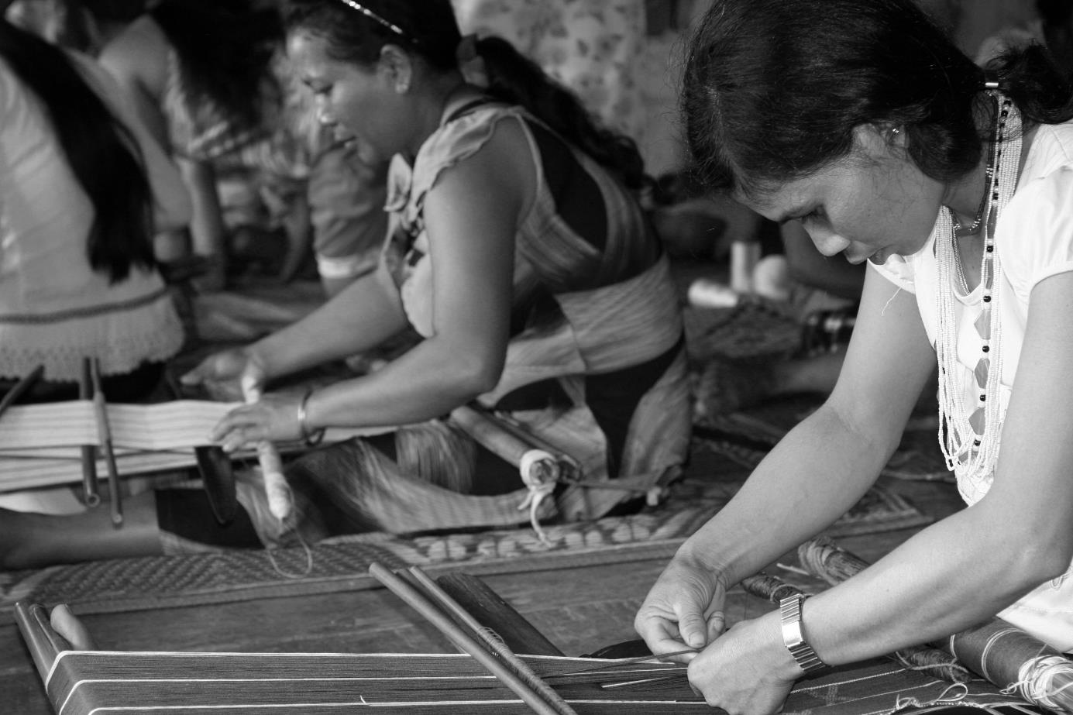

Session 7:

Costing

and Price

# Session 7: Costing and Pricing



**9**

**60 mins**



**Session overview:**

The purpose of this session is to understand how to accurately cost and successfully price your products. You will complete 6 activities. The objectives for this session are as follows:

* Know the difference between costing and pricing
* Understand the importance of good record keeping
* Understand ways to reduce costs and increase prices.

## Activity 7A: Difference Between Cost and Price

**[5mins]**



Before you sell your products to the market, you need to know what it costs you to make them so you can know the price you need to sell them for to make money.

If you don’t know the true cost of making your product, how can you know how much profit you make when you sell it or if you are making a profit at all, or if you are even losing money? If you underestimate your costs, you may think you are getting a good price for your product but you may actually be losing money. Do you find you are selling well but never have any money in your pocket? Your costs may be higher than you think.

Costing is the process of adding up all of the expenses involved in producing and selling a product. Your costs are everything that goes into making your product and running your business.

## Activity 7B: Costs

**[10 Mins]**

Indirect costs are all the expenses you have to operate your business that you wouldn’t have if you were working for someone else or not working at all. Most, but not all of your indirect costs are overhead. For example, some of your water and electricity is used to produce your products, and some to run your business.

What are other indirect costs might you have? Do you make phone calls for your business, do you mail letters (don’t forget paper), do you take the bus to town or drive your vehicle to sell your products? These are expenses you want to get back when you sell.

* Overhead: rent, utilities, taxes and fees, licenses, insurance, etc.
* Machinery maintenance and repairs
* Administrative expenses, like bookkeeping, shipping and postage
* Office supplies: paper, pens, computers, fax machines
* Transportation and fuel used to pick up materials and deliver your products
* New product development expenses (raw materials, labour, overhead)
* Selling and distribution costs: marketing and promotion costs, including attending fairs and shows shipping or delivery costs to get your product to the market or buyer
* Housekeeping costs
* Social security costs
* If you cover your workers’ transportation costs to your workshop
* Costs associated with attending crafts fairs and other sales and promotional events.

**Fixed costs** are things that are the same each time regardless of changes to production, like rent, fixed salaries, and insurance premiums. The same fixed amount will be entered each time into your records.

**Variable costs** are costs that change with changes to production: your raw materials, hourly or daily wages paid only for the amount of time worked, and utilities like electricity that may go up or down. These need to be calculated each time you do your recordkeeping.



**5 Mins**

1. In your groups, discuss why you think it is important to understand the differences in types of cost
2. How will this help you to contribute to a successful business?

## Activity 7C: Importance of Recordkeeping

**[10mins]**



Is it really necessary to separate costs into different types, and to maintain accurate records? Wouldn’t you rather spend your time designing and producing moneymaking products?

Well, without proper records, how do you even know if you’re recovering all your costs when you sell your products, much less making money?

You can only recover ALL of your business expenses by accounting for them in the prices you sell your products for. If for example, you don’t factor in the cost of electricity into your selling price, you may not have the money to pay the bill. How will you operate your workshop without lights and machinery?

So how do you know how much of the monthly electric bill to allocate to each product? There are two basic methods:

* Adding a set amount to the sales price of each item, or
* Adding a percentage of indirect costs to each item.

The point is you must account for all your costs, and a consistent and accurate recordkeeping system will enable you and your accountant or bookkeeper to do that.

## Activity 7D: Pricing

Pricing is the process of figuring out how much you can sell your product for, how much money you can get for it. It is an art. To pick your selling price, you take all the costs of producing and marketing your product, add in your profit margin, and try to find a middle ground between what you want to charge, what the market will typically pay, and what your competitors charge for comparable things.

Remember, perceived value may have no relation to the real cost. You may find that for you to make money, you need to get a higher price than the market is willing to pay you. This means the market does not value your product enough to pay you what you need. This is very common, and you should not take this personally, it happens all the time, to artisans and to all businesses. Everyone wants a bargain, to pay as little as possible and to get as much as possible, and of course you want the opposite - to get as much money for as little work as possible. So how can you increase the price the market will pay for your products? First try to reduce costs, without compromising quality or safety.



**10 Mins**

1. Gather around the table of products again.
2. In your groups, brainstorm some ways to lower costs and increase the prices of the products on the table

## Activity 7E: Personal action plans

In the final activity of this session you decide on some concrete actions to improve costing and pricing of your products. Keeping in mind all the things we’ve discussed so far, take a few minutes to record your thoughts.



**10 Mins**

1. Each of us uses Table 7E: Personal action plan to write 1-3 changes that you would make to your costing and pricing. Are there any improvements you would like to make based on what we have learned in the previous activities? If so, decide what you will implement or improve.
2. Record how you will make these changes
3. Record by when will you make these changes?
4. Finally, state who will be responsible for this change?

|  |  |  |  |
| --- | --- | --- | --- |
| Table 7E: Priority Action Plan | | | |
| My changes | How will I make the changes? | When? | Who is responsible? |
|  |  |  |  |
|  |  |  |  |
|  |  |  |  |



In this session you reflected on costing and pricing. For more information, please refer to your GPG Section 9.

Session 8:

Reasons to Turn Down an Order

# Session 8: Reasons to turn Down an Order



**10 Mins**

**10**



**Session overview:**

The purpose of this session is to understand that there might be times when it is better to turn down and order. This may seem counterintuitive but is can be the best thing for your business.

## Activity 8A: Turning Down and Order

Here are some good reasons to turn down an order:

* There is no profit. An exception might be to keep your factory producing and not shut down and keep your trained staff when a new, profitable order is soon coming. It would cost more to find and train new people, and start up again.
* The buyer owes you money. It’s not your job to finance your customer’s cash flow, just as your suppliers will not continue to supply you with more and more raw materials if you haven’t paid for the ones before. All past due payments for previous orders must be paid in full before you deliver anything else.
* It’s too big for you to handle: It’s too big and complicated for your expertise and there’s a good chance you’ll get it wrong.
* It’s a one-time huge order: You’ll have to hire people and invest in training and equipment that you won’t need again.
* It’s the wrong buyer/market segment for you.
* The payment terms are not good for you.
* The terms and price are too good to be true: could this be a warning?
* You don’t have the ability to finance production and will have to go into debt.
* You don’t have time in the production schedule to deliver it on time.
* It conflicts with other orders you already have.
* It violates an exclusive agreement you have with another buyer.
* It’s not what you make. You don’t have the expertise.
* You are discontinuing the item.
* The customer will be impossible to satisfy.

|  |
| --- |
| Table 8A: Turning down an order |
| Discussion |
| Draft response to a customer whose order you need to turn down: |



**10 mins**

1. In your groups, share any experiences that you have with turning down an order
2. Are there times when you accepted and order that you should have turned down?
3. Draft a response to a customer whose order you need to turn down
4. Record your thoughts and answers in Table 8A

## Activity 8B: Personal Action Plans

In the final activity of this session you decide on some concrete actions on when to turn down orders. Keeping in mind all the things we’ve discussed so far, take a few minutes to record your thoughts.



**10 Mins**

1. Each of us uses Table 8B: Personal action plan to write 1-3 changes that you would make about when not to accept orders. Are there any improvements you would like to make based on what we have learned in the previous activities? If so, decide what you will implement or improve.
2. Record how you will make these changes
3. Record by when will you make these changes?
4. Finally, state who will be responsible for this change?

|  |  |  |  |
| --- | --- | --- | --- |
| Table 8B: Priority Action Plan | | | |
| My changes | How will I make the changes? | When? | Who is responsible? |
|  |  |  |  |
|  |  |  |  |
|  |  |  |  |



In this session you reflected on when it would be in the best interests of your business to turn down and order. You can find more information about this in your GPG in section 10.

Session 9:

Priority Action Plans

# Session 9: Priority Action Plans



**40 mins**



**Session overview:**

With the workload that comes with running a small business, it’s not always easy to actually implement the changes you would like. In this session you look at the work you completed during this training and create a simple action plan to improve your businesses. You complete a single activity

## Activity 9A: Prioritized Actions



You will work step-by-step, session-by-session to prioritize the actions you have listed in the previous sessions.



**40 Mins**

1. You talk in a group. Everyone says what he or she found in each of the activities. You start from the first activity.
2. For the next step you use Table 9A: Priority action plan. Individually you look at the action plans you completed for each session and choose which of the changes you will introduce first and when, in a week, in a month, in two months? List at least 3 actions [15mins]
3. Each of us present their Priority Action Plan and the group shares their ideas of whether the priority of actions should be changed or if they are good the way they have been set. Each participant has 5 minutes. [25mins]
4. As a group, you can use additional time to decide whether you will meet again, after the training to practice some of the activities, such as costing. You can also plan to meet on a regular basis and talk about how are you doing with the changes you are introducing

|  |  |  |  |
| --- | --- | --- | --- |
| Table 9A: Priority action plan | | | |
| My priority changes | How will I make the changes? | When? | Who is responsible? |
|  |  |  |  |
|  |  |  |  |
|  |  |  |  |
|  |  |  |  |
|  |  |  |  |
|  |  |  |  |

Prioritizing actions, the activity you completed at the end of the training, is a very important step. It pushes you to decide how to apply what you have learned in this training into your work and lives. You can use it together with the Training Guide and GPG to do revisions and motivate yourselves to take actions. There has not been time to cover all the sections contained in the GPG today. You will find additional Sections on purchase orders, and competitive advantage that you can cover in your own time.

This is the end of the training. You can now complete the evaluation. In few months there will be some follow up too.

# Flipcharts:

## Activity 2C

**Flipchart 1**

What is Nui doing right, Dara doing wrong?

|  |  |
| --- | --- |
| Nui  1.  2.  3.  4.  5.  6.  7. | Dara  1.  2.  3.  4.  5.  6.  7. |

**Flipchart 2**

Nui’s Systems

|  |
| --- |
| 1.  2.  3.  4.  5.  6.  7. |

**Flipchart 3**

What can Dara do:

|  |  |
| --- | --- |
| Now  1.  2.  3.  4.  5.  6.  7. | Over time  1.  2.  3.  4.  5.  6.  7. |

Activity 2D

**Flipchart 4**

|  |
| --- |
| Use Systems to:  Assess who you are and what you can make  Determine the best market and customer match for you  Learn about and understand your market and customer  Do market-led product development  Improve production and quality control  Record keeping  Calculate your costs and set your prices  Efficient and reliable Customer Service  Decide whether to accept or turn down an order |



www.sme-tools.org