

****z

RESTAURANTS AND FOOD VENDORS

TRAINING GUIDE

*ILO - ASEAN Small Business Competitiveness*

A product of ­



Small Business Competitiveness by International Labour Organization (ILO – SBC) is licensed under a Creative Commons Attribution-Non Creative Commons Attribution‐NonCommercial‐ShareAlike 3.0 Unported License.



**Attribution** — You must give [appropriate credit](https://creativecommons.org/licenses/by-nc-sa/3.0/), provide a link to the license, and [indicate if changes were made](https://creativecommons.org/licenses/by-nc-sa/3.0/). You may do so in any reasonable manner, but not in any way that suggests the licensor endorses you or your use.



**NonCommercial** — You may not use the material for [commercial purposes](https://creativecommons.org/licenses/by-nc-sa/3.0/).



**ShareAlike** — If you remix, transform, or build upon the material, you must distribute your contributions under the [same license](https://creativecommons.org/licenses/by-nc-sa/3.0/) as the original.

****[*https://creativecommons.org/licenses/by-nc-sa/3.0/legalcode*](https://creativecommons.org/licenses/by-nc-sa/3.0/legalcode)

brought to you by:



Table of Contents

About C-BED vi

About the Restaurant Package: vi

Message to the Group vii

Session 1: Introductions 1

Activity 1A: Getting to Know Each Other 1

Session 2: Pricing and Budgeting 5

Activity 2A: Budgeting 5

Activity 2B: Salaries and Wages 10

Activity 2C: Pricing 14

Activity 2D: Stock Control 18

Activity 2E: Personal Action Plans 23

Session 3: Kitchen Management 27

Activity 3A: Food storage 27

Activity 3B: Waste 28

Activity 3C: Cleaning 29

Activity 3D: Personal Action Plans 31

Session 4: Safety and Health in The Restaurant 33

Activity 4A: Workplace Accidents 33

Activity 4B: Personal Action Plans 35

Session 5: Positive and Gender-Friendly Work Places 39

Activity 5A: Labour Conditions 39

Activity 5B: Gender Equality 41

Activity 5C: Personal Action Plans 43

Session 6: Reward Systems 45

Activity 6A: Positive Employee Behaviour and Performance 45

Activity 6B: Star Rewards System 46

Activity 6C: Personal Action Plans 48

Session 7: Developing Routines 51

Activity 7A: Recording Employee Hours 51

Activity 7B: Personal Action Plans 58

Session 8: Customer Service 61

Activity 8A: Customer Service Skills 61

Activity 8B: Serving Persons with Disabilities 64

Activity 8C: Personal Action Plans 65

Session 9: Priority Action Plans 69

Activity 9A: Prioritized Actions 69

Annex 1: Flipcharts 73

Flipchart for Activity 2C 73

# About C-BED

Community-Based Enterprise Development (C-BED) is a low cost, innovative training programme designed by the International Labour Organization (ILO) to support skills development and empowerment in local communities for improvements in livelihoods, productivity and working conditions.

As an approach to training, C-BED is unique in that the programme is built around peer-to-peer, activity based learning methods with no role for teachers, experts, or external consultants specialised in the skill area. Instead, C-BED participants work together through a series of activities and discussions guided only by simple step-by-step instructions in the training manual. New knowledge, skills and competencies are developed through the interactions between participants and sharing of existing local knowledge and experience. In this way the programme is a low cost, sustainable option for any organization or community.

The C-BED programme is structured around two core training packages designed to develop competencies for business start-up and operation through a focus on marketing, financial management, and action planning. These are the C-BED for Aspiring Entrepreneurs and C-BED for Small Business Operators. Additionally, a growing suite of tools to strengthen business competencies and enhance skills for specific sectors is in continual development. These packages can be implemented as either stand-alone trainings or integrated in modular format into existing programmes.

## About the Restaurant Package:

**The training package:**

The restaurant package should be used to help aspiring and current restaurant owners start and improve their businesses. It focuses on key business principles to build on from what participants already know from managing their restaurants and helps them to learn more. It can also build on from the learning in other C-BED tools namely SBO or AE. Participants bring experience to share and leave with a priority action plan (at least 3 actions to introduce improvements to their business). At the end of the training participants will have:

* Enhanced and advanced existing knowledge on restaurant development
* Strengthened critical competences to analyse job prospects or current conditions of work
* Affirmed the potential of enterprise development
* Identified steps and actions to improve a business or launch a business idea
* Decided on actions for the future
* Started planning effective collaborations and associations

**The Good Practice Guide:**

During the training day participants will be introduced to and become familiar with the Good Practice Guide (GPG), which they will then be able to use to further their learning and to support them in setting up or improving their businesses. The GPG contains best practices, tools and extra activities that supplement those covered in the training to further support the participants in setting up or improving their businesses. The exercises may depend on the GPG but if the participants do not have this guide this should not prevent them from moving forward, if necessary skip that activity. Look out for this icon:



Here you should refer to the Good Practice Guide for more information.

## Message to the Group

At the end of this C-BED training you will have a clear plan for the practical steps you can take to start or improve your business. Your understanding of the basic principles of doing business will be much stronger and you will have begun relationships with others in your community that can potentially support or cooperate with you to achieve mutual success in the future.

The style of this training is different to traditional education approaches. There will be no teacher, trainer or expert to assist you. Instead, you will work together as a team to follow the simple step-by-step instructions for discussions and activities in your training guide. Because there is no group leader, all group members should take a turn reading the information and instructions out loud to the group, and all group members share responsibility for monitoring time. In this new style of training, we will learn from each other by sharing ideas and opinions, skills, knowledge and experience. For this to work, all group members must participate in discussions.

Before and after the training you will be asked to complete a survey to understand the impact of the training. This information will be kept confidential and is used to improve the training materials and organization of future programs. Some trainees may also be contacted in the future after 3, 6 or 12 months for another survey to learn about your business plans.

The instructions in the training guide are easy to follow and suggested timing for each step is provided. Look out for these signs:



When you see this sign, read aloud



When you see this sign, you are reading instructions and doing activities



When you see this sign, share with the group



This sign gives you the estimated time for the session



Use the flipchart as outlined in Appendix 1, if you don’t have a flipchart use extra paper or the Training Guide

Before you begin the training, follow the simple steps below to get organized.

* Fill out the pre-training survey. Ask the organizers if you don’t have a copy or have not already filled it in.
* Organize into small groups of 5-7. The organizers will guide you in how best to do this.
* Identify one group member to volunteer to start the training as ‘Group ‘Reader’. The ‘Group Reader’s’ role is to read the information and activity instructions out loud to the group. Any group member with basic literacy can be the ‘Group Reader’ and you should aim to share this role among group members throughout the training.

All group members are responsible for monitoring time but one group member should be nominated for each session to remind the group when the suggested time for a step has been reached. You do not strictly need to follow the suggested timing but you will need to manage your time for the total training. If one activity lasts longer than the suggested timing, try to save time in other activities to keep the balance.

All group members will receive the same training guide. Individual work can be completed in these guides as well as group work. Groups may also like to complete activities together on flipchart paper if available.

Enjoy the training!

Session 1:

Introductions

# Session 1: Introductions



**20 Mins**



**Session Overview**

In this session you will get to know one another and the style of learning in this training. We learn without teachers. You help each other by sharing your different experiences and ask questions if you don’t understand an activity. You will complete a single activity. The objectives of this session are to:

* List the names of some of the trainees
* Understand the style of learning for this course, including activities and group work
* Understand the importance of contributing ideas and suggestions

## Activity 1A: Getting to Know Each Other



In Activity 1A, you will do some brief introductions so you can get to know one another.



**20 Mins**

1. Each person introduces themselves by providing:

* Full name and any nickname you prefer to use during the session
* Restaurant address
* How long your restaurant has existed (if applicable)
* Your purpose for attending this session and how you expect it to help your business

1. Each person shares a photo, business card or drawing of their restaurant for others to see. Place this on the wall or in the middle of the table, or allow others to see it on your mobile phone.
2. Fill in this sheet below (if not now, then during tea breaks and lunch time)

|  |  |  |
| --- | --- | --- |
| Table 1A: Participant Information | | |
| Participant Name | Restaurant Address | Phone number /  Email address |
|  |  |  |
|  |  |  |
|  |  |  |
|  |  |  |
|  |  |  |
|  |  |  |
|  |  |  |
|  |  |  |



In this activity you have gotten to know who your peers are and a little about their businesses.

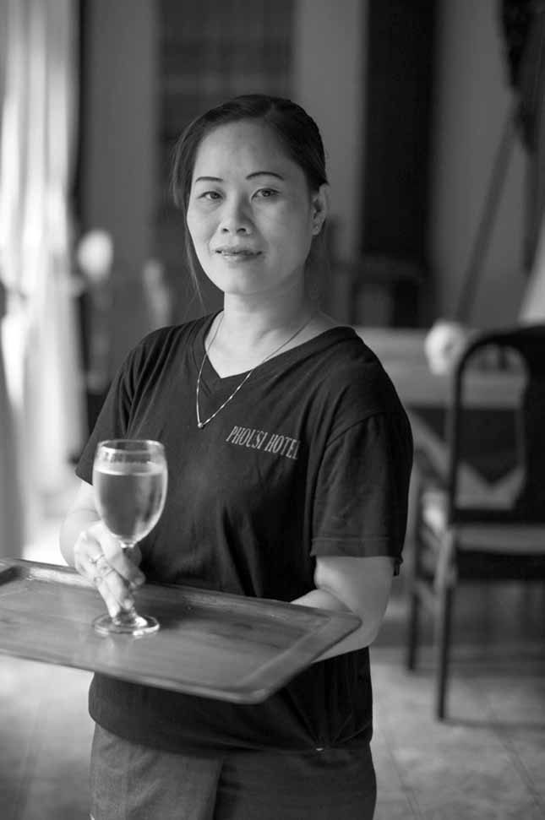

Session 2:

Pricing and Budgeting

# Session 2: Pricing and Budgeting





**1**

**2**

**45 Mins**



**Session Overview**

This session will introduce you to basic techniques of accounting, budgeting and stocktaking for products and services offered by your restaurant. You will complete 5 activities. The objectives of the session are as follows:

* Understand basic definitions of financial management for a small restaurant
* Create an operating budget
* Manage salaries and wages of staff
* Use basic technique for stock control
* Utilize a systematic approach towards setting the price of meals and identify the best technique of pricing.

Section 1 of the GPG deals with legalities and licensing. We won’t cover this today but you are encouraged to review this in your own time.

## Activity 2A: Budgeting



In Activity 2A you will take a look at a number of definitions and also complete a simple bookkeeping entry based on a scenario. This will help you to complete the same with your business.



Together we will read through the following definitions:

* **Balance sheet**: A final output from the accounting cycle that reports the assets, liabilities, and net worth of the restaurant at a single point in time (generally the month-end). This is also known as the statement of financial position.
* **Fixed assets:** Resources of the restaurant that are tangible, material in amount, used in the operation to generate revenue, and will benefit the restaurant for more than one year into the future.
* **Liquidity:** A measure of the restaurant’s ability to convert assets to cash.
* **Asset**: Something of value that is owned by the restaurant (e.g. cash, product inventories, equipment, land, and buildings).
* **Liabilities**: Money owed to outside entities (e.g. amount owed to suppliers, mortgages) and to employees (i.e. payroll that has been earned by but not paid to the restaurant’s staff).
* **Owner’s equity**: The claims of owners (individual or partnership) to assets of the restaurant.
* **Operating budget**: A detailed plan developed by restaurant managers that indicates estimated revenues and expenses for each department within the restaurant.
* **Direct operating costs**: involves items that is directly used in the production and serving of the food, i.e. salary of cook or waitresses, food materials, spices, etc.
* **Utility costs or indirect costs:** includes electricity, water, gas bills, etc.



**30 Mins**

1. We will work in our groups to complete Table 2A by creating a mock operating budget. Read through the situation analysis:

Jiraporn meets with his financial advisor (FA) to discuss his restaurant in Chumphon. Here is their dialogue:

**FA**: So we made your cash budget for January when we met at the beginning of the month. Let’s put together your operational budget now that it’s the end of the month. How big was your actual food revenue?

**J**: For the month, and thus the year so far, we made $160,100. We estimated only $153,950 before, but we’re anticipating making $1,947,240 this year.

**FA**: Great! What were the budget percentages?

**J**: Food costs should be 35%, salaries 24%, direct operating expenses and utility costs should be both 5%. Repairs we allocated just 1%, insurance 2%, and rent is 7%.

**FA**: Were the monthly percentage calculations the same?

**J**: Almost. Food costs were actually 36%, salaries were 23%, general and administrative fees came to 3%. Everything else was the same.

1. In a group of two, complete Table 2A using the following steps and the information above:

* **Step 1**: Insert value under food revenue (Column 2)
* **Step** **2**: Insert percentage value under food costs (Column 1)
* **Step** **3**: Insert percentage value under each item of operating expenses (Column 1)
* **Step** **4**: Calculate budget for month and year by following the formula in the table e.g. food revenue multiplied by percentage food costs = budget for month (A X B = M)
* **Step** **5**: Insert percentage figure in column 1 under operating expenses and follow step 4.

1. Once you have completed the table share Table 2A with your group and explain how you identified each item.
2. After you have discussed as a group look at GPG section 2 to compare your calculations. Please take note of any differences and discuss what you should have done.

|  |  |  |  |  |  |  |
| --- | --- | --- | --- | --- | --- | --- |
| Table 2A: Operating Budget | | | | | | |
| Month | | January | | | | |
|  | Budget % | Budget | | Actual | | Monthly percentage calculation |
|  |  | Month | Year | Month | Year | % |
|  | 1 | 2 | 3 | 4 | 5 | 6 |
| Food revenue | 100 | A | A1 | a | a1 | 100 |
| Cost of goods sold: |  |  |  |  |  |  |
| Food costs | B | A*B=M | A1*B=N | a*b=m | a1*b=n | b |
|  |  |  |  |  |  |  |
| Operating expenses: |  |  |  |  |  |  |
| Salaries and wages | C | A*C | A1*C | a*c | a1*c | c |
| Direct operating expenses | D | A*D | A1*D | a*d | a1*d | d |
| Utility costs | E | A*E | A1*E | a*e | a1*e | e |
| Repairs and maintenance | F | A*F | A1*F | a*f | a1*f | f |
| General and administrative | G | A*G | A1*G | a*g | a1*g | g |
| Insurance | H | A*H | A1*H | a*h | a1*h | h |
| Rent | J | A*J | A1*J | a*j | a1*j | j |
| Total operating expenses | C+D+E+F+G+H+J=I | A*I=X | A1*I=W | a*i=x | a1*i=w | c+d+e+f+g+h+j=II |
| Total expenses | Z/A or U/A1 | X+M=Z | W+N=U | x+m=z | w+n=u | z/a or u/a1 |
| Profit (before tax) | T/A or S/A | A-Z=T | A1-U=S | a-z=t | a1-u=s | t/a or s/a |

|  |  |  |  |  |  |  |
| --- | --- | --- | --- | --- | --- | --- |
| Table 2A: Operating Budget | | | | | | |
| Month | | January | | | | |
|  | Budget % | Budget | | Actual | | Monthly percentage calculation |
|  |  | Month | Year | Month | Year | % |
|  | 1 | 2 | 3 | 4 | 5 | 6 |
| Food revenue |  |  |  |  |  |  |
| Cost of goods sold: |  |  |  |  |  |  |
| Food costs |  |  |  |  |  |  |
|  |  |  |  |  |  |  |
| Operating expenses: |  |  |  |  |  |  |
| Salaries and wages |  |  |  |  |  |  |
| Direct operating expenses |  |  |  |  |  |  |
| Utility costs |  |  |  |  |  |  |
| Repairs and maintenance |  |  |  |  |  |  |
| General and administrative |  |  |  |  |  |  |
| Insurance |  |  |  |  |  |  |
| Rent |  |  |  |  |  |  |
| Total operating expenses |  |  |  |  |  |  |
| Total expenses |  |  |  |  |  |  |
| Profit (before tax) |  |  |  |  |  |  |



In this activity you looked at various definitions for budgeting and completed an operating budget. You will be able to use this to keep track of the money in your business.

## Activity 2B: Salaries and Wages

In Activity 2B, you will look at some basic concepts and go through some definitions. These definitions focus on salaries and wages as most restaurants need to employ people. This exercise will help you to use a simple and systematic approach towards managing your finances.



Together we will read through the following definitions:



* **Payroll:** The term generally used to refer to salaries and wages paid to restaurant employees
* **Fixed payroll:** The amount the restaurant pays in salaries. This normally remains unchanged from one pay period to the next
* **Variable Payroll:** The compensation paid to hourly employees. The amount varies with change in volume
* **Regular Hourly Rate:** The wage rate per hour used to compute regular pay
* **Overtime Hourly Rate:** The wage rate per hour used to compute overtime pay



**30 Mins**

1. Read through the situation analysis:

Jiraporn continues to discuss his new restaurant in Chumphon with his financial advisor. They have this additional dialogue:

**FA:** Let’s go into some detail about your payroll. How much do you pay your staff?

**J:** Well, that depends on the position. I pay the wait staff $6.80 per hour, and the cleaner gets $6 per hour. In the kitchen, the chef earns $15 per hour, his assistant earns $10 per hour, and the kitchen assistant earns $13.50 per hour.

**FA:** Is that their regular wage?

**J:** Yes. If they work overtime, they earn 1.5 times the regular wage for each hour they work.

**FA:** How long did your staff work this month?

**J:** Depends. The kitchen staff worked 140 hours, but the waiter worked 120 hours and the cleaner worked 64 hours.

**FA:** Were those regular hours or overtime?

**J:** Regular. The waiter and kitchen assistant worked 10 hours overtime, the chef worked 15 hours overtime, the chef’s assistant only worked 5 hours overtime, and the cleaner had no overtime this month.

**FA:** Great. Let’s figure out all of their salaries, plus tips and service charges, to see how much you owe them this month.

1. In a group of two, complete Table 2B using the following steps:

* **Step 1**: Insert regular wage rate per hour under Column 4
* **Step 2**: Set overtime value, which is more than regular wage rate. Insert overtime value in Column 5
* **Step 3**: Insert value of regular hours worked by employees over the month in Column 6 (4 weeks)
* **Step 4**: Insert value of overtime hours worked by employees over the month in Column 7 (4 weeks)
* **Step 5**: Calculate salaries and wage based on the formula in Column 8
* **Step 6**: Calculate tips and service charges based on the formula in Column 9
* **Step 7**: Calculate total amount paid by employer based on the formula in Column 10

1. Once you have completed Table 2B, share the document with your group and explain how you have identified each item.

|  |  |  |  |  |  |  |  |  |  |
| --- | --- | --- | --- | --- | --- | --- | --- | --- | --- |
| Table 2B: Example salaries and Wages | | | | | | | | | |
| Check No. or ID No. | Name of employee | Position | Wage rate (per hr.) | | Hours worked | | Salaries and wages | Tips and service charges (proportionate to position)+ | Total amount paid by employer |
| Regular | Over rime (1.5 of base) | Regular* | Overtime |
| *C1* | *C2* | *C3* | *C4* | *C5* | *C6* | *C7* | *C8* | *C9* | *C10* |
| 2014004 | Pachaporn Sirisom | Waiter | D | D*1.5=IV | d | iv | D*d+(IV*iv) | 1000*0.05 | C8+C9 |
| 2014005 | Vu Thi Quynh Hoa | Cleaner | E | E*1.5=V | e | v | E*e+(V*v) | 1000*0.03 | C8+C9 |
| 2014006 | Harron Khan | Chef | F | F*1.5=VI | f | vi | F*f+(VI*vi) | 1000*0.25 | C8+C9 |
| 2014007 | Sashikala | Chef's assistant | G | G*1.5=VII | g | vii | G*g+(VII*vii) | 1000*0.20 | C8+C9 |
| 2014008 | Dollaporn Intra | Kitchen Assistant | H | H*1.5=VIII | h | viii | H*h+(VIII*viii) | 1000*0.16 | C8+C9 |

* Standard working period is 40 hours per week (8 hours per day) with 1 hour for lunch, calculated over 4 weeks

e.g. 8-1= 7; 5*7 = 35 hours; 35*4 = 140 + Identify total tips & service and divide accordingly. This can be based on an equal division, length of employment, rank within your organization.

|  |  |  |  |  |  |  |  |  |  |
| --- | --- | --- | --- | --- | --- | --- | --- | --- | --- |
| Table 2B: Salaries and Wages | | | | | | | | | |
| Check no. or ID no. | Name of employee | Position | Wage rate (per hr.) | | Hours worked | | Salaries and wages | Tips and service charges (proportionate to position)+ | Total amount paid by employer |
| Regular | Over time (1.5 of base) | Regular* | Overtime |
| C1 | C2 | C3 | C4 | C5 | C6 | C7 | C8 | C9 | C10 |
|  |  |  |  |  |  |  |  |  |  |
|  |  |  |  |  |  |  |  |  |  |
|  |  |  |  |  |  |  |  |  |  |
|  |  |  |  |  |  |  |  |  |  |
|  |  |  |  |  |  |  |  |  |  |



In this activity you explored some concepts related to wages and salaries and recorded these in a table that you can use within your business to keep track of how many hours your staff work and what they are being paid.

## Activity 2C: Pricing



In this activity you will look at pricing. In order to introduce you to the basic concepts, you will go through some definitions followed by a short exercise to identify each item within the context of your business. This exercise will help you to use a simple and systematic approach towards pricing.



There are a number of different pricing methods that you could adopt. These are the approach you could take:

* **The reasonable price method:** Prices are set based on what you believe the value of the goof or service is to your customers. This may not be a true reflection of guests concerns and interests and may lead to restaurant charging too much or too little.
* **The highest price method:** Managers guess what the highest price the customers would be willing to pay, then reduce it a little to allow for error and set it at that. This relies on the managers’ ability to accurately guess what the customers would and are able to pay.
* **The loss-leader pricing method:** Using this method, menu prices are set as low as possible (even below cost price) in order to attract guests who purchase other products that make up for the shortfall. For instance, beverages.
* **The intuitive pricing method:** This method involves simple guess and adjustment if it does not work.
* **The no pricing method:** Staff and cooks set the prices in this method and are simply quoted to the guests. This is often used when menu items are substituted or for special orders. This is not considered to be a good pricing method.



**25 Mins**

1. Read through the situation below to help you complete the worksheet.
2. Jiraporn will open a restaurant in downtown Surat Thani. His initial investment in the business in $500,000 with a Return on Investment (ROI) of 12%. He has borrowed from Bangkok Bank at an interest rate of 12%. His annual tax rate and operating expense is 25% and $800,000 respectively. The cost of food sold is 40%, while the seat turnover (the number of sittings in the restaurant) is twice per day and it is open 365 days per year. The restaurant has 100 seats.
3. Complete the first section of Table 2C based on the information you have been given.
4. Using the following steps, complete the second section of Table 2C:

* **Step1:** Determine desired net income by multiplying the owner's investment by the desired return on owner's investment (ROI)
* **Step 2:** Determine the pre-tax profit by dividing the desired net income by 1 – the tax rate
* **Step 3:** Determine interest expenses
* **Step 4:** Determine operating expenses
* **Step 5:** Determine required food revenue by adding figures from steps 2-4 and then dividing this sum by 1 – the desired food cost percentage.
* **Step 6:** Determine meals to be served by multiplying days open by number of seats by seat turnover for the day
* **Step 7:** Determine the required price of the average meal by dividing the total food revenue by the estimated number of meals to be served.

1. Once you have completed Table 2C, take a look at Flipchart 1 for the answers to the calculations.

|  |  |  |
| --- | --- | --- |
| Table 2C: Pricing | | |
| First complete this section of the table based on the information you have: | | |
| Item | Amount | Other |
| Owner’s investment | $ |  |
| Funds borrowed | $ |  |
| Tax rate |  | (%) |
| Operating expenses | $ |  |
| Cost of food sold percentage |  | (%) |
| Seat turnover |  | Per day |
| Days open |  | Per year |
| Number of seats |  | Seats |
| Follow the steps outlines above to complete this section of the table | | |
| Step 1 | Net income |  |
| Step 2 | Pre-tax profit |  |
| Step 3 | Interest expense (funds borrowed) |  |
| Step 4 | Operating expenses |  |
| Step 5 | Total food revenue |  |
| Step 6 | Meals to be served |  |
| Step 7 | Price of average meal |  |

The average calculation indicates that an average per meal selling price of [Step 7] will generate the level of revenue needed to meet the owner’s investment requirement (profits) first and then to meet the costs required for interest and operating expenses (including cost of sales: food). Few restaurants establish one price for all meals, and many restaurants offer meals for more than one meal period. For example, if the restaurant serves lunch and dinner, the average meal price for both meal periods can be calculated as follows:



* Calculate the revenue per meal period by multiplying the total food revenue by the estimated percentage of the total earned during that meal period.
* Divide the revenue per meal period by the meals sold per meal period. The number of meals so ld per meal period is calculated by multiplying the days the restaurant is open by the seat turnover by the number of seats.

|  |  |  |
| --- | --- | --- |
| Example: Calculating Average Meal Price | | |
| Revenue per meal period: | | |
| Lunch: | 40% x = |  |
| Dinner: | 60% x = |  |
| Total |  |  |
| Meals sold per meal period: |  |  |
| Lunch: | = |  |
| Dinner: | = |  |
| Average meal prices by meal period |  |  |
| Lunch: | = |  |
| Dinner: | = |  |

In this activity you looked at pricing. You covered various methods of pricing before doing an exercise to determine to cost of meals and how much should be charged in order to cover restaurant expenses.



## Activity 2D: Stock Control

In this activity you will look at stock control. In order to introduce you to the basic concepts, you will go through some definitions followed by a short exercise to identify each item within the context of your business. You may be doing some or parts of this already, but this exercise will help you to use a standardized practice to ensure a systematic approach towards the financial management for your business.





Implementing stock control in your kitchen is a step-by-step process. It is an important process, which some businesses take more seriously than others. Every business should make an effort to control the stock in their kitchens.

**25 Mins**



Read the situation analysis below to help you complete the exercise:

Jiraporn continues his meeting with his financial advisor. They have the following dialogue:

**J:** I was recently introduced a new dish to the restaurant – fried chicken Do you think it will do well?

**FA:** Maybe – it depends on how you do the stock control.

**J:** Well, it’s a chicken dish, so a lot of the sales will be related to the meat stock items. I serve a salad along with the chicken so that the dish isn’t all meat but is a small meal instead. The whole meal is a 250-gram chicken with a simple lettuce and tomato salad about half the size of the chicken.

**FA:** How much is chicken these days?

**J:** It’s about $10 per kilo in the markets. Lettuce is $1 per kilo, and tomatoes are $2 per kilo.

**FA:** Did you take a stock interval this week?

**J:** Yeah, it looks a little something like this:

|  |  |  |  |  |  |  |  |  |  |  |
| --- | --- | --- | --- | --- | --- | --- | --- | --- | --- | --- |
| Example: Jiraporn’s Stock Take | | | | | | | | | | |
| Item | Opening stock | Purchases | | | Closing stock | | Actual Weekly Sales | Actual Cost percentage | Stock counted | Variance |
| Chicken (kg) | 15.50 | 10.00 | 8.30 | 17.20 | 58% | | | | 4.00 | 4.30 |
| Formulae | A | B | | C | D=A+B-C | B/D | | | E | F=D-E |

1. Complete Table 2D according to the following steps. Refer to the instructions in the table to see where to fill in the answers

* Step 1: Work out the cost of each item in the recipe. Adding up the cost of each ingredient (taking into account of each ingredient) will give you the total cost of the meal. Once this is completed for all menu items you can work out the cost percentage of your menu. [Cost of each meal ÷ total selling price = actual cost percentage].
* Step 2: Take stock (see the example above). If the overall goal is to know the cost percentage of your menu, you need to measure it by taking monthly stock of the items in your kitchen. The following four figures are necessary:

1. Value of the stock at the start of the month (or the value from the end of last month): **A**
2. Total purchases of food items your kitchen has purchased: **B**
3. Value of the stock at the end of the month: **C**
4. Total sales (less tax) of food sold during the month: **D**
5. From these figures, you can work out the actual cost percentage using the following calculation:

**A + B – C = E** (total stock value used in the kitchen), **E / D** = actual cost percentage. If this figure is greater than your goal from step 1, then the kitchen is using more than the menu was designed to cost.

|  |  |  |  |  |
| --- | --- | --- | --- | --- |
| Example: Menu Costing | | | | |
| 1. Example of menu cost percentage (Step 1 of the example) | | | | |
| Menu | Ingredients | Unit | $/unit | Sum ($) per portion |
| Fried Rice | Rice | 0.1 | 2 | 0.2 |
| Tomato | 1 | 0.1 | 0.1 |
| Chicken meat | 0.25 | 10 | 2.5 |
| 5 | 🡸 Selling price | Total cost of each meal 🡺 | | 2.8 |
| Conclusion: as step 2 calculation shows that the actual cost percentage (for chicken) is more than the menu cost percentage, 58% > 56 % then we can conclude that the kitchen is using slightly more than the menu was designed to cost. Hence, Jiraporn need to reduce the amount of chicken per menu, or she needs to increase the selling price of the menu. | | | | |

|  |  |  |  |  |  |  |  |  |  |
| --- | --- | --- | --- | --- | --- | --- | --- | --- | --- |
| Table 2D (Step 1) | | | | | | | | | |
| 2. Complete your own | | | | | | | | | |
| Menu | Ingredients | | | | Unit | | $/unit* | | Sum ($) per portion |
|  |  | | | |  | |  | |  |
|  | | | |  | |  | |  |
|  | | | |  | |  | |  |
|  | | | |  | |  | |  |
|  | 🡸 Selling price | | | | Total cost of each meal 🡺 | | | |  |
| Cost percentage | | | | | | | | |  |
| Table 2D (Step 2) | | | | | | | | | |
| 3. Complete stock take | | | | | | | | | |
| Item | | Opening stock | Purchases | Sales | | Closing stock | | Stock counted | Variance |
|  | |  |  |  | |  | |  |  |
|  | |  |  |  | |  | |  |  |
|  | |  |  |  | |  | |  |  |
|  | |  |  |  | |  | |  |  |
| Conclusion: | | | | | | | | | |

*Note: one Unit can be in kg, grams, and pieces, according to the items.



In this activity you looked at stocktaking and control of stock. This is something that should be done carefully by restaurants and on a monthly/weekly basis.

## Activity 2E: Personal Action Plans



In the final activity of this session you will decide on some concrete actions to improve or create systems in your restaurants. Keeping in mind all the things you’ve discussed so far about budgeting and pricing, take a few minutes to record your thoughts.

**10 Mins**



1. Each of you uses Table 2E: Personal action plan to write 1-3 changes that you would make to improve budgeting and pricing in your businesses. Are there any improvements you would like to make based on what you have learned in the previous activities? If so, decide what systems you will implement or improve.
2. Record how you will make these changes.
3. Record by when will you make these changes.
4. Finally, state who will be responsible for this change.

|  |  |  |  |
| --- | --- | --- | --- |
| Table 2E: Personal Action Plan | | | |
| My changes | How will I make the changes? | When? | Who is responsible? |
|  |  |  |  |
|  |  |  |  |
|  |  |  |  |



You have completed the final activity of session 2. In this session you looked at budgeting and pricing in your restaurant and the important role that it plays. Remember you can refer to Section 2 of you GPG for more information.

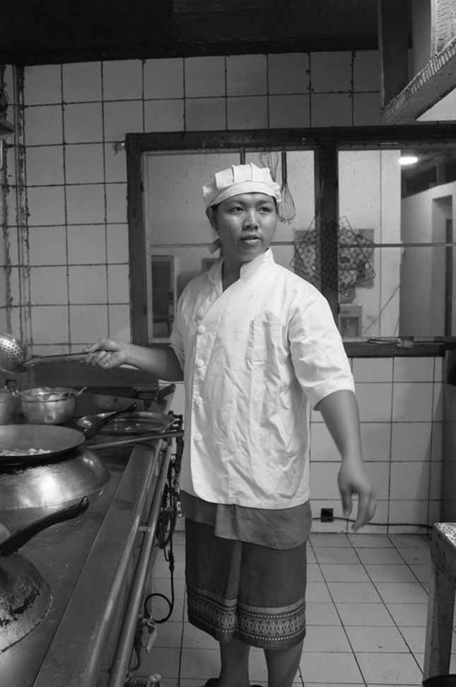

Session 3:

Kitchen Management

# Session 3: Kitchen Management



**3**

**55 Mins**



**Sessions Overview**

In this session you will be introduced to basic techniques for storing all types of food items safely. You will complete 4 activities. The objectives of this session are to:

* Understand the tools behind safe storage of food
* Distinguish between different food types
* Look at safe refrigeration of food
* Identifying and managing different forms of waste
* Understand the benefits of a routinized kitchen-cleaning schedule

## 

## Activity 3A: Food storage



In this activity you will brainstorm how food items are currently stored and how they should be stored.

**15 Mins**



1. In your groups, brainstorm how the food items in Table 3A are stored and then note down how you think they should ideally be stored. You can record your ideas here or write them on the Flipchart (if available)
2. Once you have completed this, you will review some extra information in the GPG Section 3.1 and make any adjustments to answers here, as necessary.

|  |  |  |
| --- | --- | --- |
| Table 3A: Food storage | | |
| Food item | How it is currently stored in your business | Ideal methods to store these items |
| Meat (beef, pork) |  |  |
| Poultry |  |  |
| Fish |  |  |
| Seafood |  |  |
| Crabmeat |  |  |
| Leafy vegetables |  |  |
| Root vegetables |  |  |



You have looked at how food is stored in your restaurant as well as brainstormed ideas about it should best be stored.

## Activity 3B: Waste



In this activity you will focus on waste and how waste is currently managed in your restaurant.



**15 Mins**

1. In your groups, brainstorm how the different types of waste in Table 3B are managed and then write down how you think they should be managed. You can record your ideas here or write them on the Flipchart (if available)
2. Once you have completed this, review some extra information in the GPG section 3.2 and make any adjustments to your answers here, as necessary.

|  |  |  |
| --- | --- | --- |
| Table 3B: Managing Waste | | |
|  | How it is currently managed in your business | Ideal methods to store/separate these items |
| Raw vegetable |  |  |
| Raw meat |  |  |
| Cooked meat and vegetables |  |  |
| Cooking oils |  |  |
| Alcohol |  |  |
| Gasoline |  |  |



In this activity you looked at how your restaurant currently manages waste and how it could improve its waste management.

## Activity 3C: Cleaning

In this activity you will look at cleaning routines and how they can be used. There is more information in Section 3.3 of your GPG. It provides a checklist that covers the following:

* Restaurant kitchen items to clean throughout every cooking shift
* Daily restaurant kitchen cleaning list
* Weekly restaurant kitchen cleaning list
* Restaurant kitchen items to clean after each cooking shift (Breakfast, lunch, dinner)
* Monthly restaurant kitchen cleaning list
* Yearly restaurant kitchen cleaning/safety list



**15 Mins**

1. Brainstorm about the routines that you currently use to keep your kitchen clean and hygienic
2. Discuss according to these categories:

* Daily
* Weekly
* Monthly
* Yearly

1. Record your ideas in the Table 3C

|  |
| --- |
| Table 3C: Brainstorming About Cleaning Routines |
| Daily |
| Weekly |
| Monthly |
| Yearly |

## Activity 3D: Personal Action Plans

In the final activity of this session you will decide on some concrete actions to improve or food safety and cleanliness systems in your restaurants. Keeping in mind all the things you’ve discussed so far, take a few minutes to record your thoughts.



**10 Mins**

1. Each of you uses Table 3D: Personal action plan to write 1-3 changes that you would make to improve your businesses. Are there any improvements you would like to make based on what you have learned in the previous activities? If so, decide what you will implement or improve.
2. Record how you will make these changes.
3. Record by when will you make these changes.
4. Finally, state who will be responsible for this change.

|  |  |  |  |
| --- | --- | --- | --- |
| Table 3D: Personal Action Plan | | | |
| My changes | How will I make the changes? | When? | Who is responsible? |
|  |  |  |  |
|  |  |  |  |
|  |  |  |  |



You have completed the final activity of session 3. In this session you looked at food safety including food storage and waste as well as hygiene and cleanliness systems in your restaurant and the important role these play. Kitchen management is covered in Section 3 of your GPG if you want to look for more information later.

Session 4:

Safety and Health in The Restaurant

# Session 4: Safety and Health in The Restaurant



**4**

**40 Mins**



**Session Overview**

The purpose of this session is to introduce techniques for first aid in the kitchen, personal protective equipment (PPE), and safety tips for employees. You will complete 2 activities. The objectives of this session are as follows:

* Know the contents of a first aid kit
* Understand the use of PPE
* Understand how to apply first aid.

## Activity 4A: Workplace Accidents



In Activity 4A you will look at how to deal with workplace accidents.



**30 Mins**

1. In groups, brainstorm some ideas on how to handle workplace accidents. What prevention measures do you already have in place?
2. Use this list of incidents to help you brainstorm:

* Burns in the restaurant kitchen
* Cuts from sharp knives and other kitchen equipment
* Slips on spilt liquids left on the kitchen or dining room floor
* Falls and trips over boxes or other items that should have been stored away
* Food poisoning
* Falls from height when a ladder hasn’t been supplied
* Trips on worn or uneven flooring (carpet and tiles)
* Electric shock injuries and burns from faulty electrical equipment

1. Record your ideas in Table 4A

|  |
| --- |
| Table 4A: Workplace accidents |
|  |



In this activity you looked at some potential accidents and how you could handle them. Accidents in the workplace can be managed to prevent permanent damage to the person injured.

## Activity 4B: Personal Action Plans



In the final activity of this session you will decide on some concrete actions to improve or workplace safety in your restaurants. Keeping in mind all the things you’ve discussed so far, take a few minutes to record your thoughts.



**10 Mins**

1. Each of you uses Table 4B: Personal action plan to write 1-3 changes that you would make to improve your businesses. Are there any improvements you would like to make based on what you have learned in the previous activities? If so, decide what you will implement or improve.
2. Record how you will make these changes.
3. Record by when will you make these changes.
4. Finally, state who will be responsible for this change.

|  |  |  |  |
| --- | --- | --- | --- |
| Table 4B: Personal Action Plan | | | |
| My changes | How will I make the changes? | When? | Who is responsible? |
|  |  |  |  |
|  |  |  |  |
|  |  |  |  |



You have completed the final activity of session 4. In this session you looked at workplace safety and discussed with your peers how to handle various workplace accidents. Please refer to your GPG section 4 for more information about workplace safety.

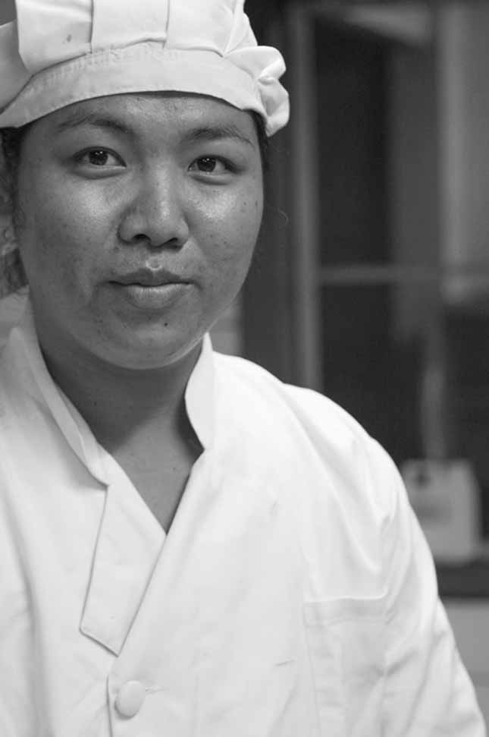

Session 5:

Positive and Gender-Friendly Work Places

# Session 5: Positive and Gender-Friendly Work Places



**35 Mins**

**5**



**Session Overview**

The purpose of the session is to introduce the foundations, ideas, and practices of creating a respectful and gender-friendly work environment. You will complete 3 activities. The objectives are as follows:

* To identify and address common problems in a disrespectful workplace
* Understand the basic needs of their employees
* Recognise the benefits of a gender-friendly work environment
* Develop a strategy to create a more gender-equal workplace

## Activity 5A: Labour Conditions



In Activity 5A you will review the provision of facilities and labour conditions for staff



**15 Mins**

1. Below is a letter of compliant from one of your employees. The group reader will read this letter.

I have worked in your restaurant for six months and am thankful to have acquired the valuable skills that can only be learned from experience. However, the indignity I’ve faced has been intolerable, and unless the conditions of the workplace and my employment improve, consider this a letter of resignation.

There is a cockroach infestation in the staff room that won’t go away no matter how thoroughly we clean the space, and the cleaning fluid we use is toxic and requires gloves, which you do not provide. The two lockers for the entire staff to store our clothing and personal belongings are not sufficient, and not having water supplied regularly for drinking is exhausting.

I have worked overtime for several weeks, sometimes with only the promise that I’ll receive due compensation later – I have not been paid for overtime work. During our 15-minute breaks, we don’t have enough time to finish a meal and are then expected to work hard for a whole 8-hour day. Despite all of the hard work I put in throughout these months, when I requested a weekend off to attend a cousin’s wedding two months in advance, you turned me down by saying it would be ‘a busy time’ at the restaurant.

I apologize for being so frank with my discontents, but I cannot tolerate these problems any longer. I hope you can address some of these issues.

1. Discuss in your group what general problems the employee has written about
2. Share with the group how you improve your workplace and treat your employees with respect
3. Explain what you could do better
4. Record your discussion in Table 5A

|  |
| --- |
| Table 5A: Positive Workplaces |
| General problems |
| Improvements |

In this activity you reviewed a complaint letter from a restaurant staff member. You then looked at some of the problems faced by the staff member before discussing what you do in your workplace and how you could improve.



In Activity 5B you will review some aspects related to gender and discrimination in the workplace. It is proven that creating a fair and respectful workplace for both men and women means that businesses have better access to talented and motivated staff.

## Activity 5B: Gender Equality



**10 Mins**

1. For this exercise, you will review the employment details of two employees. One female and one male employee.
2. Look at the list below that summarises their working hours, leave, training and personal status.

|  |  |
| --- | --- |
| Male Employee | Female Employee |
| Wage: $8/hour  Weekly Hours: 40  Training: wait staff, food prep, bartending, cashier, stock  Paternity Leave: 0 days  Supervisor: Male management  Marital Status: Married  Children: 2 | Wage: $6.5/hour  Weekly Hours: 40  Training: wait staff, food prep, cleaning  Maternity Leave: 0 days  Supervisor: Male management  Marital Status: Married  Children: 2 |

1. Based on what is described above, discuss in groups how to create a more gender-friendly environment. Keep in mind that gender dynamics are different in different societies. Try to think about your context.
2. Record your discussion in Table 5B

|  |
| --- |
| Table 5B: Gender-friendly Workplaces |
|  |

In this activity you looked at creating a gender-friendly environment in your restaurant.



## Activity 5C: Personal Action Plans



In the final activity of this session you will decide on some concrete actions to improve or gender equality in your restaurants. Keeping in mind all the things you’ve discussed so far, take a few minutes to record your thoughts.



**10 Mins**

1. Each of you uses Table 5C: Personal action plan to write 1-3 changes that you would make to improve your businesses. Are there any improvements you would like to make based on what you have learned in the previous activities? If so, decide what you will implement or improve.
2. Record how you will make these changes.
3. Record by when will you make these changes.
4. Finally, state who will be responsible for this change.

|  |  |  |  |
| --- | --- | --- | --- |
| Table 5C: Personal Action Plan | | | |
| My changes | How will I make the changes? | When? | Who is responsible? |
|  |  |  |  |
|  |  |  |  |
|  |  |  |  |



You have completed the final activity of session 5. In this session you looked at gender equality and discussed with your peers how to create gender-friendly workplaces. This is covered in Section 5.2 of your GPG.

Session 6:

Reward

Systems

# Session 6: Reward Systems



**5**

**35 Mins**



**Session Overview**

The purpose of this session is to introduce the idea of recognition and appreciation in the workplace in order to encourage good behaviour and practices among employees. You will complete 3 activities. The objectives of the session are as follows:

* To understand the value of recognising and appreciating good behaviour and practices
* Identify the behaviours and practices you want from your employees
* Use methods of recognition and appreciation with your employees
* Understand and utilise the star reward system

## Activity 6A: Positive Employee Behaviour and Performance



In this activity, you will look at examples of employee behaviour and performance that positively impact the workplace.



**15 Mins**

1. In your groups discuss what some actions and attitudes you want to see in the workplace and encourage among your staff
2. Record these using a Flipchart (if available) or write them down in the space below (Table 6A).
3. Once you have listed the behaviours, briefly brainstorm how to recognise and show appreciation for these behaviours.

|  |
| --- |
| Table 6A: Employee Behaviour and Performance |
|  |

## Activity 6B: Star Rewards System



How does it work? The manager provides a star to an employee when a positive activity is achieved. This could then count towards a bonuses or time-off. The attitudes and behaviours could be determined by the manager or jointly with staff members. A maximum of five stars can be awarded every week. The manager will decide in the case of a tie between employees. At the end of the month, each employee’s Star Rewards will be totaled and the employee with the most stars earns the Employee of the Month award.

In Activity 6B you will look at the Star Rewards system as a method of recognising and appreciating staff behaviours that contribute to a positive workplace.





**10 Mins**

1. Below is a list of the performance and attitudes of three employees over the course of a week.
2. Read through this list:
3. Discuss how you would allocate the weekly five stars to these three employees.
4. Record your answers in Table 6B

|  |  |  |
| --- | --- | --- |
| Mohammed | Pachaporn | Dominic |
| Arrived on time every day  Took extra 10 minutes on break Monday  Customer complimented service on Tuesday | Arrived 10 min. late on Wednesday  Customer complimented service Thursday  Assisted unloading stock trucks during break Tuesday | Arrived on time every day  Gave constructive input at weekly team meeting  Forgot to clean uniform on Thursday |

|  |
| --- |
| Table 6B: Star Reward System |
| Mohammed |
| Pachaporn |
| Dominic |



In this activity you reviewed the star rewards system and looked at how to allocate stars to employees to reward positive behaviour and performance.

## Activity 6C: Personal Action Plans

In the final activity of this session you will decide on some concrete actions for rewarding staff performance and behaviour that positively impacts your restaurants. Keeping in mind all the things you’ve discussed so far, take a few minutes to record your thoughts.



**10 Mins**

1. Each of you uses Table 6C: Personal action plan to write 1-3 changes that you would make to improve your businesses. Are there any improvements you would like to make based on what you have learned in the previous activities? If so, decide what you will implement or improve.
2. Record how you will make these changes.
3. Record by when will you make these changes.
4. Finally, state who will be responsible for this change.

|  |  |  |  |
| --- | --- | --- | --- |
| Table 6C: Personal Action Plan | | | |
| My changes | How will I make the changes? | When? | Who is responsible? |
|  |  |  |  |
|  |  |  |  |
|  |  |  |  |

You have completed the final activity of session 6. In this session you looked at positive staff behaviour and performance and discussed with your peers how to reward staff. Look at GPG section 5.3 for more information.

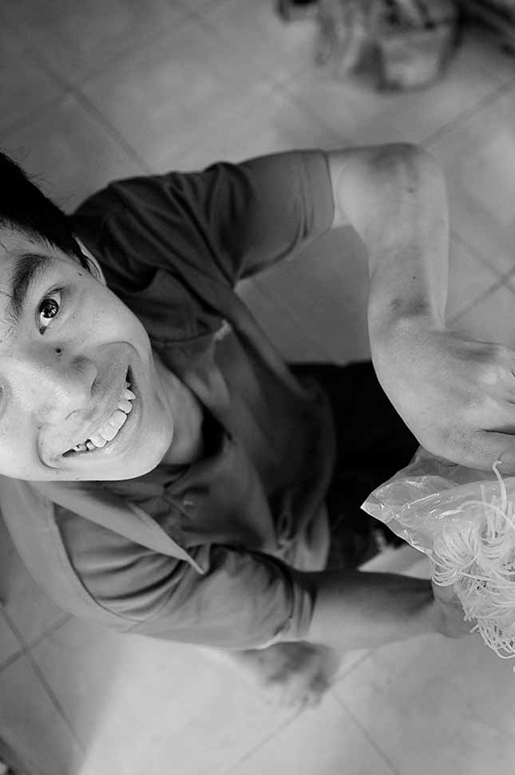

Session 7: Developing Routines

# Session 7: Developing Routines



**6**

**30 Mins**



**Session overview:**

The purpose of this session is to provide you with some useful tools for doing administrative tasks. More specifically it looks at, tools for managing your staff. By regularly keeping records it will make things much easier for you and improve the efficiency and organization of your business. You will complete 2 activities. The objectives of the session are to:

* Complete an employee timecard, a weekly work schedule, and an employee timesheet.
* Understand the components of each tool (e.g. total overtime wage, total regular hours) and how to use each tool
* Develop a systematic routine to manage labour costs on a weekly and monthly basis

## Activity 7A: Recording Employee Hours



In this activity you will look at employee hours and how to record employee hours in order to work out total pay and ensure



**10 Mins**

1. Use the hours and wage rates to calculate total hours worked and total pay for each empty section. Complete the timecard in Table 7A (1).
2. Once you have completed the individual time cards, move on to complete the weekly work schedule and the employer copy of employee timesheet in Table 7A (2) – (6)

|  |  |  |  |  |  |  |
| --- | --- | --- | --- | --- | --- | --- |
| Table 7A (1): Employee Timecard | | | | | | |
| Your Company name | Time Card | | | | | |
| Employee | Mohammed Bin Rahim | |  | Manager: | Group 1 | |
| [Street Address] | 123 Main Street | |  | Employee phone: | +12 3 456 7890 | |
| [Address 2] | Bangkok, Thailand | |  | Employee e-mail: | mbrahim@hotmail.com | |
| Week ending: | 31/12/2015 | |  |  |  |  |
| Day | Date | Regular Hours | Overtime | Sick | Vacation | Total |
| Monday | 25/12/2015 | 0 | 0 | 0 | 0 |  |
| Tuesday | 26/12/2015 | 7 | 0 | 0 | 0 |  |
| Wednesday | 27/12/2015 | 7 | 0 | 0 | 0 |  |
| Thursday | 28/12/2015 | 7 | 0 | 0 | 0 |  |
| Friday | 29/12/2015 | 7 | 1 | 0 | 0 |  |
| Saturday | 30/12/2015 | 7 | 1 | 0 | 0 |  |
| Sunday | 31/12/2015 | 0 | 0 | 0 | 0 |  |
| Total hours |  |  |  |  |  |  |
| Rate per hour |  | $6.50 | $9.75 | $0.00 | $0.00 |  |
| Total pay |  | $- | $- | $- | $- | $- |
|  |  | Employee signature |  |  |  | Date |
|  |  | Manager signature |  |  |  | Date |

|  |  |  |  |  |  |  |
| --- | --- | --- | --- | --- | --- | --- |
| Table 7A (2): Employee Timecard | | | | | | |
| Your Company name | Time Card | | | | | |
| Employee | Pachaporn Sirisom | |  | Manager: | Group 2 | |
| [Street Address] | 123 Main Street | |  | Employee phone: | +12 3 456 7890 | |
| [Address 2] | Bangkok, Thailand | |  | Employee e-mail: | psirisom@hotmail.com | |
| Week ending: | 31/12/2015 | |  |  |  |  |
| Day | Date | Regular Hours | Overtime | Sick | Vacation | Total |
| Monday | 25/12/2015 | 6 | 0 | 0 | 0 |  |
| Tuesday | 26/12/2015 | 6 | 0 | 0 | 0 |  |
| Wednesday | 27/12/2015 | 0 | 0 | 0 | 0 |  |
| Thursday | 28/12/2015 | 0 | 0 | 0 | 0 |  |
| Friday | 29/12/2015 | 6 | 0 | 0 | 0 |  |
| Saturday | 30/12/2015 | 6 | 1 | 0 | 0 |  |
| Sunday | 31/12/2015 | 6 | 1 | 0 | 0 |  |
| Total hours |  |  |  |  |  |  |
| Rate per hour |  | $6.80 | $10.20 | $0.00 | $0.00 |  |
| Total pay |  | $- | $- | $- | $- | $- |
|  |  | Employee signature |  |  |  | Date |
|  |  | Manager signature |  |  |  | Date |

|  |  |  |  |  |  |  |
| --- | --- | --- | --- | --- | --- | --- |
| Table 7A (3): Employee Timecard | | | | | | |
| Your Company name | Time Card | | | | | |
| Employee | Dominic Mercado | |  | Manager: | Group 3 | |
| [Street Address] | 123 Main Street | |  | Employee phone: | +12 3 456 7890 | |
| [Address 2] | Bangkok, Thailand | |  | Employee e-mail: | dmercado@hotmail.com | |
| Week ending: | 31/12/2015 | |  |  |  |  |
| Day | Date | Regular Hours | Overtime | Sick | Vacation | Total |
| Monday | 25/12/2015 | 0 | 0 | 0 | 0 |  |
| Tuesday | 26/12/2015 | 0 | 0 | 7 | 0 |  |
| Wednesday | 27/12/2015 | 0 | 0 | 7 | 0 |  |
| Thursday | 28/12/2015 | 7 | 0 | 0 | 0 |  |
| Friday | 29/12/2015 | 7 | 0 | 0 | 0 |  |
| Saturday | 30/12/2015 | 7 | 0 | 0 | 0 |  |
| Sunday | 31/12/2015 | 7 | 1 | 0 | 0 |  |
| Total hours |  |  |  |  |  |  |
| Rate per hour |  | $6.50 | $9.75 | $0.00 | $0.00 |  |
| Total pay |  | $- | $- | $- | $- | $- |
|  |  | Employee signature |  |  |  | Date |
|  |  | Manager signature |  |  |  | Date |

|  |  |  |  |  |  |  |
| --- | --- | --- | --- | --- | --- | --- |
| Table 7A (4): Employee Timecard | | | | | | |
| Your Company name | Time Card | | | | | |
| Employee | David Lin | |  | Manager: | Group 4 | |
| [Street Address] | 123 Main Street | |  | Employee phone: | +12 3 456 7890 | |
| [Address 2] | Bangkok, Thailand | |  | Employee e-mail: | dlin@hotmail.com | |
| Week ending: | 31/12/2015 | |  |  |  |  |
| Day | Date | Regular Hours | Overtime | Sick | Vacation | Total |
| Monday | 25/12/2015 | 0 | 0 | 0 | 0 |  |
| Tuesday | 26/12/2015 | 0 | 0 | 0 | 0 |  |
| Wednesday | 27/12/2015 | 0 | 0 | 0 | 0 |  |
| Thursday | 28/12/2015 | 5 | 0 | 0 | 0 |  |
| Friday | 29/12/2015 | 5 | 0 | 0 | 0 |  |
| Saturday | 30/12/2015 | 5 | 0 | 0 | 0 |  |
| Sunday | 31/12/2015 | 5 | 0 | 0 | 0 |  |
| Total hours |  |  |  |  |  |  |
| Rate per hour |  | $7.50 | $11.25 | $0.00 | $0.00 |  |
| Total pay |  | $- | $- | $- | $- | $- |
|  |  | Employee signature |  |  |  | Date |
|  |  | Manager signature |  |  |  | Date |

|  |  |  |  |  |  |  |
| --- | --- | --- | --- | --- | --- | --- |
| Table 7A (5): Employee Timecard | | | | | | |
| Your Company name | Time Card | | | | | |
| Employee | Vu Thi Quynh Hoa | |  | Manager: | Group 5 | |
| [Street Address] | 123 Main Street | |  | Employee phone: | +12 3 456 7890 | |
| [Address 2] | Bangkok, Thailand | |  | Employee e-mail: | vtqhoa@hotmail.com | |
| Week ending: | 31/12/2015 | |  |  |  |  |
| Day | Date | Regular Hours | Overtime | Sick | Vacation | Total |
| Monday | 25/12/2015 | 1 | 0 | 0 | 0 |  |
| Tuesday | 26/12/2015 | 1 | 0 | 0 | 0 |  |
| Wednesday | 27/12/2015 | 1 | 0 | 0 | 0 |  |
| Thursday | 28/12/2015 | 1 | 0 | 0 | 0 |  |
| Friday | 29/12/2015 | 2 | 0 | 0 | 0 |  |
| Saturday | 30/12/2015 | 2 | 0 | 0 | 0 |  |
| Sunday | 31/12/2015 | 2 | 0 | 0 | 0 |  |
| Total hours |  |  |  |  |  |  |
| Rate per hour |  | $6.00 | $9.00 | $0.00 | $0.00 |  |
| Total pay |  | $- | $- | $- | $- | $- |
|  |  | Employee signature |  |  |  | Date |
|  |  | Manager signature |  |  |  | Date |

|  |  |  |  |  |  |  |
| --- | --- | --- | --- | --- | --- | --- |
| Table 7A (6): Employee Timecard | | | | | | |
| Your Company name | Time Card | | | | | |
| Employee | Harron Khan | |  | Manager: | Group 6 | |
| [Street Address] | 123 Main Street | |  | Employee phone: | +12 3 456 7890 | |
| [Address 2] | Bangkok, Thailand | |  | Employee e-mail: | hkhan@hotmail.com | |
| Week ending: | 31/12/2015 | |  |  |  |  |
| Day | Date | Regular Hours | Overtime | Sick | Vacation | Total |
| Monday | 25/12/2015 | 0 | 0 | 0 | 0 |  |
| Tuesday | 26/12/2015 | 8 | 0 | 0 | 0 |  |
| Wednesday | 27/12/2015 | 8 | 0 | 0 | 0 |  |
| Thursday | 28/12/2015 | 8 | 0 | 0 | 0 |  |
| Friday | 29/12/2015 | 8 | 2 | 0 | 0 |  |
| Saturday | 30/12/2015 | 8 | 2 | 0 | 0 |  |
| Sunday | 31/12/2015 | 8 | 2 | 0 | 0 |  |
| Total hours |  |  |  |  |  |  |
| Rate per hour |  | $15.00 | $22.50 | $0.00 | $0.00 |  |
| Total pay |  | $- | $- | $- | $- | $- |
|  |  | Employee signature |  |  |  | Date |
|  |  | Manager signature |  |  |  | Date |

## Activity 7B: Personal Action Plans

In the final activity of this session you will decide on some concrete actions for developing routines that positively impact your restaurants. Keeping in mind all the things you’ve discussed so far, take a few minutes to record your thoughts.



**10 Mins**

1. Each of you uses Table 7B: Personal action plan to write 1-3 changes that you would make to improve your businesses. Are there any improvements you would like to make based on what you have learned in the previous activities? If so, decide what you will implement or improve.
2. Record how you will make these changes.
3. Record by when will you make these changes.
4. Finally, state who will be responsible for this change.

|  |  |  |  |
| --- | --- | --- | --- |
| Table 7B: Personal Action Plan | | | |
| My changes | How will I make the changes? | When? | Who is responsible? |
|  |  |  |  |
|  |  |  |  |
|  |  |  |  |

You have completed the final activity of session 7. In this session you looked at routines that improve the management of your restaurant, more specifically you focused on the use of time cards. You can find more information on developing routines in Section 6 of your GPG.

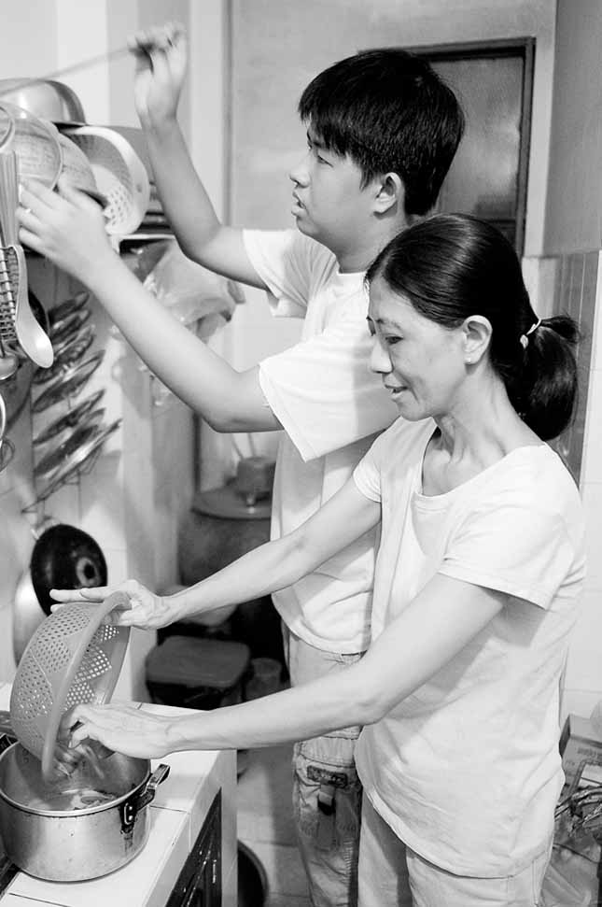

Session 8: Customer

Service

# Session 8: Customer Service



**7**

**45 Mins**



**Session overview:**

The purpose of the session is to get an understanding of good customer service. This includes providing service to all customers including people with disabilities. You will go through some skills that every employee needs to remember when serving customers. Remember the customer is always right and good service is very important. You will complete 3 activities. The objectives of this session are as follows:

* To learn to deal with customers in a variety of settings
* To learn to remain calm in difficult and challenging situations
* To serve customers with disabilities

## Activity 8A: Customer Service Skills

In session 8A you will get an overview of essential customer service skills and you will look at how to handle a situation where a customer is not satisfied.



**[5mins]** The following skills are important for good customer service:

1. **Patience**

If you deal with customers on a daily basis, be sure to stay patient when they come to you with a problem. Take the time to understand what they want – customers would rather have good service than be hurried away.

1. **Attentiveness**

The ability to really listen to customers is very important for providing good service. It is important to pay attention to each individual customer and also to pay attention to the feedback that you receive.

1. **Clear communication skills**

When it comes to important things, it is important to be very clear with your customer. This prevents confusion or misunderstanding. It is better to be overly cautious than overly confident when addressing customers to ensure that you can be certain about what you are saying.

1. **Knowledge of the menu and services**

In order to help customers you need to know your menu and services very well. Not everyone needs to know every detail but they should know something about how each dish is prepared.

1. **Ability to use positive language**

Remember to use this when interacting with customers. For example, without positive language: "I can't get you that item right now; it is unavailable at this time" and with positive language: "I’m sorry but we don’t have the ingredients for this item, but I can recommend an alternative."

1. **Acting skills**

Basic acting skills help you to remain positive and pleasant when interacting with difficult customers. Often the person may be upset due to situation beyond your control and it is important to maintain a happy and service minded outlook when interacting with them.

1. **Time management skills**

You need to realise where you cannot help a customer; otherwise you will end up wasting your time and the customer’s time. If you don't know the solution to a problem, the best support is sending a customer over to someone who does.

1. **Ability to read customers**

Look and listen for subtle clues about their current mood, patience level, personality, etc. This will improve your interactions with customers.

1. **A calming presence**

Those who are best at customer service know how to stay calm in all situations. They need to remain calm in order to be able to solve the problem for the customer who might be overwhelmed by the current situation.

1. **Ability to handle surprises**

* **Who? You need to have people you can ask when you are uncertain. While the manager can help, there should be other people you can ask for help.** Know this before the surprises happen, this will help you deal with the situation.
* **What? Knowing what important pieces of information to pass on when you need help with a problem is a good way to inform those who are helping you about the situation.**
* **How?** When it comes time to get someone else involved, how are you going to contact him or her?

1. **Closing ability**

**This refers to your ability to solve the problem. Your willingness to do this shows the customer 3 very important things:**

* That you care about getting it right
* That you're willing to keep going until you get it right
* That the customer is the one who determines what is best

1. **Willingness to learn**

Being willing to improve and learn from mistakes is very important for becoming better at service customers.



1. The group reader will read the following scenario:

It is 15 minutes before you close for the night, and a man walks in, soaking wet from the rain. When you greet him and seat him, he does not smile or respond. He gives his order and stares at his phone the rest of the night. His order is ready after 15 minutes, and the chef starts to clean up the kitchen. When you deliver his plate, he takes a bite and then tells you this is not what he ordered, though you are sure it was the right plate.

1. Discuss how to handle this situation with the customer service skills outlined above
2. Write your ideas in the space provided in Table 8A or on a Flipchart.

|  |
| --- |
| Table 8A: Customer Service Skills |
|  |



In this activity you have discussed how to handle a difficult situation with a difficult customer while ensuring that you use the skills important to providing good customer service.

## Activity 8B: Serving Persons with Disabilities



In this activity you will look at how to make sure that your restaurant is accessible for people with disabilities. It is important that you are able to serve all customers and to ensure customer satisfaction.



Here are some important points about providing good service to persons with disabilities.

* Provide facilities to accommodate physical disabilities in your restaurant (e.g. access ramps, handicapped accessible bathrooms).
* Don’t make assumptions about what type of disability or disabilities the customer has.
* Some disabilities are not visible. Take the time to get to know your customers’ needs.
* f you’re not sure what to do, ask your customer, “How may I help you?”
* If you can’t understand what someone is saying, just politely ask again.
* Ask before you offer to help, don’t just jump in. Your customers with disabilities know if they need help and how you can provide it.
* Look at your customer, but don’t stare. Speak directly to a person with a disability, not to their interpreter or someone who is with them.
* Don’t touch or address service animals, they are working and have to pay attention at all times.
* Ask permission before touching a wheelchair or a piece of equipment.



**15 Mins**

1. Read the following scenario:

Your restaurant is starting to get full when an old woman in a wheelchair arrives to your restaurant with her son. She wears a hearing aid and speaks very slowly. There is a table free towards the back of your restaurant and a table closer to the door with a single diner seated there.

1. Discuss how you could seat and serve these customers.
2. Record your ideas in Table 8B or record them on a Flipchart

|  |
| --- |
| Table 8B: Persons with Disabilities |
|  |

## Activity 8C: Personal Action Plans

In the final activity of this session you will decide on some concrete actions for improving customer service that positively impacts your restaurants. Keeping in mind all the things you’ve discussed so far, take a few minutes to record your thoughts.



**10 Mins**

1. Each of you uses Table 8C: Personal action plan to write 1-3 changes that you would make to improve your businesses. Are there any improvements you would like to make based on what you have learned in the previous activities? If so, decide what you will implement or improve.
2. Record how you will make these changes.
3. Record by when will you make these changes.
4. Finally, state who will be responsible for this change.

|  |  |  |  |
| --- | --- | --- | --- |
| Table 8C: Personal Action Plan | | | |
| My changes | How will I make the changes? | When? | Who is responsible? |
|  |  |  |  |
|  |  |  |  |
|  |  |  |  |

You have completed the final activity of session 8. In this session you looked at customer service and discussed with your peers how to improve customer service as well as how to serve people with disabilities. There is more information in Section 7 of your GPG.

You will have noticed that you have not covered everything in the GPG today. There is more material in the GPG, which you can cover at home that we have not discussed today. This includes: Section 1 that looks at licensing; Section 7.2 and 7.3 on adding value and additional safety and health information in Section 4 on fire and infection control. These are also important topics to help you in running a successful restaurant.

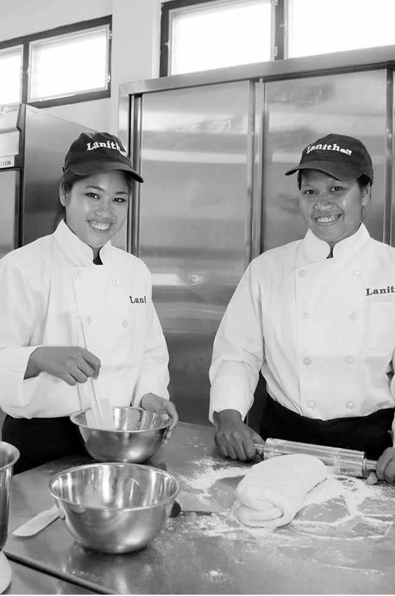

Session 9:

Priority Action Plans

# Session 9: Priority Action Plans



**20 Mins**



**Session overview:**

With the workload that comes with running a small business, it’s not always easy to actually implement the changes you would like. In this session you look at the work you completed during this training and create a simple action plan to improve your businesses. You complete a single activity

## Activity 9A: Prioritized Actions



You will work step-by-step, session-by-session to prioritize the actions you have listed in the previous sessions.



**40 Mins**

1. You talk in a group. Everyone says what he or she found in each of the activities. You start from the first activity.
2. For the next step you use Table 9A: Priority action plan. Individually you look at the action plans you completed for each session and choose which of the changes you will introduce first and when, in a week, in a month, in two months? List at least 3 actions [15mins]
3. Each of us present their Priority Action Plan and the group shares their ideas of whether the priority of actions should be changed or if they are good the way they have been set. Each participant has 5 minutes. [25mins]
4. As a group, you can use additional time to decide whether you will meet again, after the training to practice some of the activities, such as costing. You can also plan to meet on a regular basis and talk about how are you doing with the changes you are introducing

|  |  |  |  |
| --- | --- | --- | --- |
| Table 9A: Priority Action Plan | | | |
| My priority changes | How will I make the changes? | When? | Who is responsible? |
|  |  |  |  |
|  |  |  |  |
|  |  |  |  |
|  |  |  |  |
|  |  |  |  |
|  |  |  |  |

Prioritizing actions, the activity you completed at the end of the training, is a very important step. It pushes you to decide how to apply what you have learned in this training into your work and lives. You can use it together with the Training Guide and GPG to do revisions and motivate yourselves to take actions.

This is the end of the training. You can now complete the evaluation. In few months there will be some follow up too.

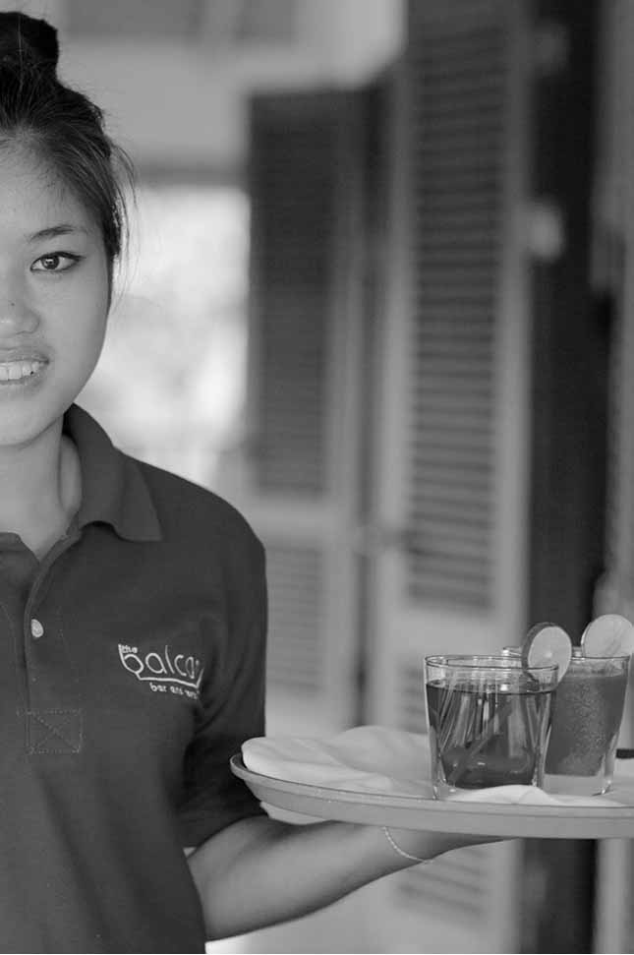

Annex 1:

Flipcharts

# Annex 1: Flipcharts

Write this information on the Flipchart before the training begins.

## Flipchart for Activity 2C

1

In step 6, this is the maximum number of meals that can be served. For the purposes of efficacy, it is advisable to use an average figure for the number of seats based on the following: weekend (Friday-Sunday), weekday (Monday-Thursday), month/season.



www.sme-tools.org