Smallholder Farmers Supplying Tourism Sector

ILO - ASEAN Small Business Competitiveness
A product of
Small Business Competitiveness by International Labour Organization (ILO – SBC) is licensed under a Creative Commons Attribution-Non Creative Commons Attribution‐NonCommercial‐ShareAlike 3.0 Unported License.

Attribution — You must give appropriate credit, provide a link to the license, and indicate if changes were made. You may do so in any reasonable manner, but not in any way that suggests the licensor endorses you or your use.

NonCommercial — You may not use the material for commercial purposes.

ShareAlike — If you remix, transform, or build upon the material, you must distribute your contributions under the same license as the original.

https://creativecommons.org/licenses/by-nc-sa/3.0/legalcode
brought to you by:
Table of Contents
About C-BED v
About the Smallholder Farmer Package v
Message to the Group vi
Session 1: Introductions 1
Activity 1A: Getting to Know Each Other 1
Activity 1B: What Makes a Successful Business? 2
Session 2: Better Marketing 7
Activity 2A: The 5P’s 7
Activity 2B: Improving Your Marketing Strategy 10
Session 3: Improving Quality 13
Activity 3A: Exceeding Customer Expectations 14
Session 4: Improving Productivity 19
Activity 4A: Farming Productivity 20
Activity 4B: Productivity Recordkeeping 22
Activity 4C: Planning for Change 28
Session 5: Farm Costs 31
Activity 5A: Variable and Fixed Costs 32
Activity 5B: Variable Sosts 34
Activity 5C: Fixed Costs 38
Activity 5D: Planning for Change 40
Session 6: Cash Management 43
Activity 6A: Cash Flow Planning 46
Activity 6B: Planning for Change 48
Session 7: Action Planning 51
Activity 7A: Prioritized Actions 51

About C-BED

Community-Based Enterprise Development (C-BED) is a low cost, innovative training programme designed by the International Labour Organization (ILO) to support skills development and empowerment in local communities for improvements in livelihoods, productivity and working conditions.

As an approach to training, C-BED is unique in that the programme is built around peer-to-peer, activity based learning methods with no role for teachers, experts, or external consultants specialised in the skill area. Instead, C-BED participants work together through a series of activities and discussions guided only by simple step-by-step instructions in the training manual. New knowledge, skills and competencies are developed through the interactions between participants and sharing of existing local knowledge and experience. In this way the programme is a low cost, sustainable option for any organization or community.

The C-BED programme is structured around two core training packages designed to develop competencies for business start-up and operation through a focus on marketing, financial management, and action planning. These are the C-BED for Aspiring Entrepreneurs and C-BED for Small Business Operators. Additionally, a growing suite of tools to strengthen business competencies and enhance skills for specific sectors is in continual development. These packages can be implemented as either stand-alone trainings or integrated in modular format into existing programmes.

About the Smallholder Farmer Package

C-BED for Smallholder farmer package is an introductory training that is suitable also for audiences with very limited literacy and useful to everyone who wants to gain basic familiarity with business development and operation. Participants arrive seeking opportunities to make change in their lives, wanting to find or change a vocation or improve their working conditions. They leave with basic competencies in business operation and critical learning. For criteria to select the participants refer to the C-BED curriculum Outline. At the end of the training participants will have:
- Gained new knowledge on enterprise development
- Acquired critical competences to weigh job prospective or current conditions for work
- Raised awareness about enterprise development
- Learned about different steps to start-up or improve a business
- Strengthened confidence to make decisions, plan and take action for the future
- Recognized the potential of association and collaborations

Message to the Group

At the end of this C-BED training you will have a clear plan for the practical steps you can take to start or improve your business. Your understanding of the basic principles of doing business will be much stronger and you will have begun relationships with others in your community that can potentially support or cooperate with you to achieve mutual success in the future.

The style of this training is different to traditional education approaches. There will be no teacher, trainer or expert to assist you. Instead, you will work together as a team to follow the simple step-by-step instructions for discussions and activities in your training guide. Because there is no group leader, all group members should take a turn reading the information and instructions out loud to the group, and all group members share responsibility for monitoring time. In this new style of training, we will learn from each other by sharing ideas and opinions, skills, knowledge and experience. For this to work, all group members must participate in discussions.

Before and after the training you will be asked to complete a survey to understand the impact of the training. This information will be kept confidential and is used to improve the training materials and organization of future programs. Some trainees may also be contacted in the future after 3, 6 or 12 months for another survey to learn about your business plans.

The instructions in the training guide are easy to follow and suggested timing for each step is provided. Look out for these signs:

Use the flipchart as outlined in Appendix 1, if you don’t have a flipchart use extra paper or the Training Guide
When you see this sign, read aloud
When you see this sign, share with the group

When you see this sign, you are reading instructions and doing activities

This sign gives you the estimated time for the session

Before you begin the training, follow the simple steps below to get organized.
- Fill out the pre-training survey. Ask the organizers if you don’t have a copy or have not already filled it in.
- Organize into small groups of 5-7. The organizers will guide you in how best to do this.
- Identify one group member to volunteer to start the training as ‘Group ‘Reader’. The ‘Group Reader’s’ role is to read the information and activity instructions out loud to the group. Any group member with basic literacy can be the ‘Group Reader’ and you should aim to share this role among group members throughout the training.

All group members are responsible for monitoring time but one group member should be nominated for each session to remind the group when the suggested time for a step has been reached. You do not strictly need to follow the suggested timing but you will need to manage your time for the total training. If one activity lasts longer than the suggested timing, try to save time in other activities to keep the balance.

All group members will receive the same training guide. Individual work can be completed in these guides as well as group work. Groups may also like to complete activities together on flipchart paper if available.

Enjoy the Training!
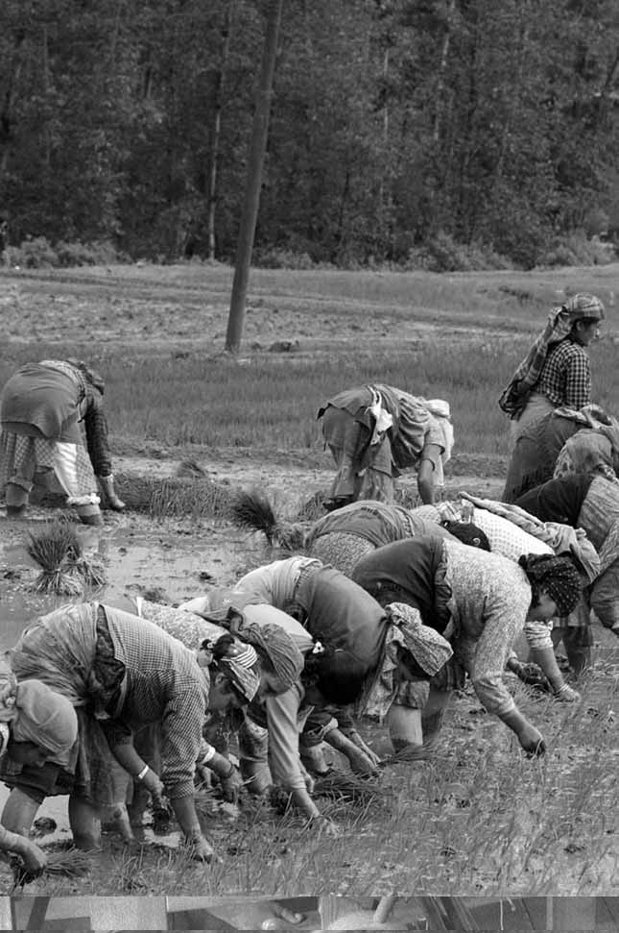

Session 1:
Introductions

Session 1: Introductions

50 Mins

Session Overview

In this session you will complete two activities to get to know one another and become familiar with the style of C-BED training. In C-BED our goal is to learn from each other as we complete the activities in each of the seven sessions. There will be no teacher so you should help each other by sharing our different ideas and experiences, and ask questions to the group if you don’t understand a concept or activity.

Activity 1A: Getting to Know Each Other

In Activity 1A you will get to know each other as a group and learn about each others farming businesses.

This is a programme designed to ‘teach without teachers’ and allow people to learn through their own experience and from each other. You will be challenged to assess your existing farming practices and become more entrepreneurial in considering your farm as a business that needs to generate sufficient income as well as food for your family.

Each participant needs to be open-minded, and try to think outside the limitations of your current farming practices and beliefs to explore new areas. Don't be afraid to suggest new innovations to your business, no matter how crazy these may seem, as this is the type of thinking of successful entrepreneurs. But also learn from each other, and what your neighbours are doing on their farms, which may or may not be successful. Upon completion of the training you should be able to better understand your farm as a business made up of individual enterprises (cropping, livestock, etc.) and be more confident to make strategic decisions about your business' future directions.

15 Mins

Each of you draws a map of your farm business and labels it clearly. The map could include the location of farmhouse, vegetable gardens, fields, stock pens, farm boundary, roads, etc. [5 minutes]
- Each of you introduces yourself to the other members of the group by displaying your map, and explaining your farm business. [2 minutes each]
- Everyone hangs his or her farm business map on the wall.

In this first activity we got to know more about one another and shared our drawings of our farms. Now we can move to the next activity. You should remember that farming businesses are just like any other businesses that have products or services. A successful farming business sells to market what customers need or want, at the price that they are willing to pay. The farming business should also give you sufficient income and happiness.

Activity 1B: What Makes a Successful Business?

The goal of this activity is to highlight good farming business practices and to assist you in prioritizing different strategies.

35 Mins

- If you are not already in small groups, form into groups of 5 – 7 people. Groups can be formed among people with the same farming business.
- Work in pairs to discuss the business traits in the word cloud in Table 1B(1) before individually completing Table 1B(2). [8 minutes]
- Share your choices with the rest of the group and explain your selection. [10 minutes]
- As a group discuss the different choices and agree on the 3-6 traits most important traits for successful farming businesses. [15 minutes]

Table 1B(1): Word Cloud
Location of farming business Good sales techniques Cost of raw materials

Set good price Know the costs of doing business Know how much people owe you

Good quality products Know how much money you earn Ability to attract new customers

Seasonal fluctuations Availability of raw materials Relationship with local traders

Good storage No waste of materials Productive workers

Know your daily tasks Access to water Availability of equipment and spare parts

Direct sales to markets Good planning Tracking your money

Good book-keeping Satisfied with your farming business Equipment in good condition

Know the tasks of your workers Know customer’s needs Strong demand from customers

Loyal buyers Know your potential problems
Table 1B(2): Important Business Traits
 | Most important traits  (from the Word Cloud) | Reason for choosing this one | Is your farming business doing this well?
1
2
3
4

In this activity you looked at some characteristics of a successful farming business.
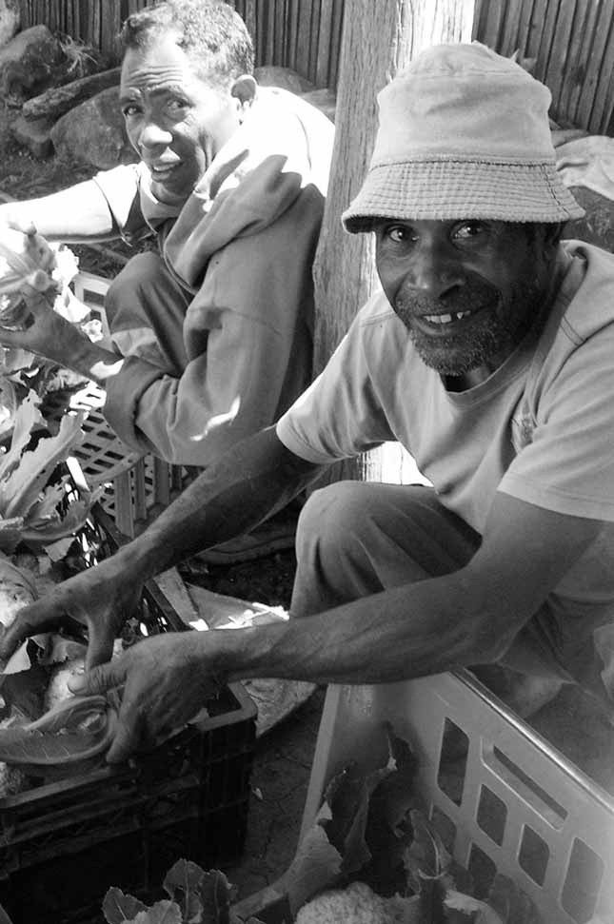
Session 2:
Better Marketing

Session 2: Better Marketing

55 Mins

Session Overview

In this session you will look at some good and bad marketing practices in order to help you understand how to market your farm produce better. You will also look at some issues related to budgeting, pricing and expenses. You will complete 2 activities.

In order to supply to businesses in the tourism industry it will be important to market your business so that the buyers know about your farm. Often hotels and restaurants want to source their produce locally but they are not aware of farmers in the area. You need to be able to make your business known.

Activity 2A: The 5P’s

In Activity 2A you will consider some marketing practices for farming businesses as well as issues relating to budgeting, pricing, and expenses.

35 Mins

- The Group Reader will read aloud the story of Family Tem. As the story is being read, others should listen for the 5 P’s (Product, Place, Price, Promotion, People). [5 minutes]
- As a group, work together to identify the 5P’s for the Family Tem farming enterprise and complete Table 2A(Part 1) [10 minutes].
- As a group, discuss the following questions about the family Tem's chicken enterprise experience [10 minutes]:
- Did Family Tem understand the seasonal supply and meet the demand for chickens in their local market/ should they have sold later?
- Were there opportunities to sell to other markets that they should have considered?
- Did they produce what local customers wanted?
- As a group, discuss how you would have managed the chicken raising enterprise differently to the Tem family. Complete Table 2A(Part B) to show how your group would do things differently to be more successful [10 minutes].

The Story of Family Tem:
The Tem Family goes to town to visit an uncle. This uncle tells the Tem family about his small profitable business raising and selling chickens in the local market. The family Tem returns to their village and calls some of their friends. They tell the friends about the need for more chickens in the area and propose to do the same business together. Everybody agrees and they all contribute enough money to buy 25 one-day old chicks. The following day, two people from the group go to town to make the purchase. By the time they arrive in town, there are no more chickens left because the demand is high. So they must spend the night to get the young chickens the next day. Since they had to spend some money on food and lodging, they can only afford to buy 15 baby chickens.

When they get back to the village, they realize that they also need chicken feed. One cousin of the family starts to build a shed for the chickens, while a close family friend goes to buy chicken mash from the village shop. This is expensive and the quality is low because the shop cannot afford to buy fresh stock every week. The next day, three chickens are found dead in the shed due to the hot weather and because the cousin did not finish building the protective roof. During the next few weeks, the friend and the family Tem take turns looking after the chickens. Illness killed more chicks and only seven out of the 15 chickens remained. Eventually the chickens are old enough to be sold. However, in their own village, nobody wants chickens because everybody has their own. Due to this lack of demand, the friend and the family Tem decide to sell the chickens in the town market.

At the market, it appears that everybody is selling chickens that look healthier and bigger than theirs. In fact, the Tem Family starts to see that there is a lot of variety in the market. When they finally manage to sell their smaller chickens, they realize that they did not make any money on their initial investment. Back home in the village, they discussed what went wrong.

Table 2A: The Story of Family Tem
Part (A) | Product | 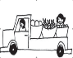  Place/Distribution | Price | Promotion | People
Family Tem
marketing strategy

How would you improve the Family Tem marketing strategy?
Part (B) | Product | Place/Distribution | Price | Promotion | People
Your groups improvements to the Family Tem
marketing strategy

In this activity you reflected on what went wrong in the Family Tem’s business. This includes looking at what you would have done better and taking a look at the role of the 5P’s.

Activity 2B: Improving Your Marketing Strategy

In Activity 2B you will look at how to improve your own marketing strategies. While you complete this activity try to think about the needs of the tourism industry. Keeping this in mind will help your business to become a better supplier to the industry.
20 Mins

- As individuals, reflect on what we have learned about marketing strategies and complete Table 2B showing what your current marketing strategy is and how you aim to improve. [10 minutes]
- Present your proposed changes to the group and discuss the results together. Determine together which business changes among the 5P’s would provide best results for your business [10 minutes].

Table 2B: Your marketing strategy and improvements
 | Product |  | Place/Distribution | Price |  | Promotion |  | People
My current
marketing strategy

My changes |  | How will I make the change? |  |  | When? |  | Who is responsible

In this session, you reflected on your marketing strategy before making plans to improve your current strategy.

Session 3: Improving
Quality

Session 3: Improving Quality

45 Mins

Session Overview

In this session you will look at how to meet and satisfy the needs of your customers. You will complete a single activity.

[5mins] In order to meet and satisfy your customers’ (and potential customers’) needs, you need to fully understand what those needs are, building on the marketing skills you gained in Session 2. After understanding what your customer’s needs and expectations are, it is important to aim to exceed your customer’s expectations. If a customer’s expectations are consistently exceeded, this will result in the customer repeatedly returning to your business and recommending your farming business to their friends.

Productivity means working smarter, not harder. Making sure that your products meet the customer’s needs and expectations is important to the success of your farming business. However, the most successful businesses exceed customer expectations. Implementing a quality tracking system will ultimately improve the quality of the products and services you provide to your customers.

This may be even more important when supplying to the tourism industry. Those in the tourism industry may have higher demands for good quality and need to guarantee the freshness and quality of the food that they serve their customers.

Activity 3A: Exceeding Customer Expectations

In Activity 3A you will gather feedback from the group on how you can improve your business and exceed customer expectations.

40 Mins

- In Table 3A, draw a picture of two things that you do to make your business different to others [5 minutes]
- Then draw two things that your buyers ask you to improve. [5 minutes]
- Share your drawings with the group [5 minutes]
- As a group discuss general options for improving the quality of the products and services that farming businesses provide. Record the suggested improvements in Table 3A (2). [15 minutes]
- Share ideas on ways other group members could make improvements to exceed buyer's expectations [10 minutes]

Table 3A (1): Customer Expectations
Things that you do to make your farming business different to others.
Improvements that buyers ask me to make.

Table 3A(2): Proposed improvements
Proposed business improvement | How this applies to my farming business | What changes do I need to make to my farming operations

In this activity you looked at how to exceed your customers expectations and planned some business improvements to help you to improve you quality.

.

Session 4: Improving Productivity

Session 4: Improving Productivity

60 Mins

Session Overview

This session will help you to think about the productivity of your farming business, which is how you can make your products or services better, faster and cheaper. You will complete 3 activities.

Productivity is the efficiency and quality with which a business produces goods or services.
The benefits of improving your productivity include:

- Producing more, faster, better and cheaper products and services
- Delivering faster
- Competing more with other businesses
- Making more profits
- Improving working conditions
- Generating more business
- Contributing more to the community

As farmers adopt new techniques and differences in productivity arise, the more productive farmers will benefit from an increase in their welfare while those farmers who are not productive enough will have to make improvements or be forced into other business activities.

When you are supplying the tourism industry you need to take into account that the industry is seasonal. You will have to prepare yourself for higher demands in peak season and to keep your business operating in the low season.

The Group reader will now read the following story about Somchai's story and compare his experiences with your own.

Somchai’s story
Somchai grew rice, mainly to feed his family of six, and soybean to sell to traders who visited his farm at the end of the harvest season. Somchai had about 1.5 ha of land. His wife also had some pigs and chickens that roamed free across his land and into the nearby forest. The chickens were mainly for his family to eat, but sometimes his wife sold chickens when they had too many. All the pigs and the extra chickens were sold at the local market when the family needed extra cash. They also grew vegetables and fruit for their home consumption and sometimes would sell their surplus fruit to sellers at the local market.

However, Somchai could not grow enough food nor sell enough produce from his farm to feed his family. Therefore, he regularly needed to work as a farm labourer on his neighbours' properties. He also worked on large sugarcane and rubber plantations, many kilometres away from his farm.

Somchai was a typical farmer for his district; most smallholder farmers grew the same crops and animals the same way. In fact, Somchai's father had grown the same crops and he had followed the same production methodologies as his father and his neighbours. Somchai noticed during the past couple of seasons that his crops did not yield as much as before and he had to spend increasing amounts of time working as a labourer off his farm in order to earn enough money to buy food for his family.

In order to improve productivity or make goods and services better, faster and cheaper, it is important to be able to identify all the components of production before one can identify areas for improvement. Also, knowing all the components of production will allow for better costing, buying, and financial management.

Activity 4A: Farming Productivity

In Activity 4A you will look at how to improve the productivity of your farming business. The goal of this activity is for all group members to consider the various components of productivity for their own farming business.

20 Mins

As a group, review the productivity chart in Table 4A for Somchai’s farming enterprise and complete any missing items. [2 minutes]
- Individually complete Table 4A with the productivity chart for at least one product or service produced by your own farming business. [8 minutes]
- One by one share your productivity chart with the group and discuss together the similarities and differences to Somchai’s experience. [10 minutes]

Table 4A: Somchai’s Productivity Chart
MATERIALS |  | LABOUR |  | TOOLS, EQUIPMENT, FACILITY
Farming land
Grazing land
Animal feed
Water
Motorbike
Feeding animals
Picking fruit and vegetables
Transporting to market
Rice Soybean
Pigs Chickens
Vegetables Fruit
My productivity chart
MATERIALS |  | LABOUR |  | TOOLS, EQUIPMENT, FACILITY

In Activity 4A you looked at your productivity chart, including the different materials, labour and tools, equipment and facility needed to keep your farm running.

Activity 4B: Productivity Recordkeeping

In Activity 4B you will look at ways to keep records of your productivity. A record is written proof of what happened, what is happening, or what is anticipated to happen in a business. As part of improving production, this activity will teach you how to track your product supply and basic finances. The goal of this activity is for group members to learn how to keep records of their farming productivity and recognize the impact family consumption can have.

A successful business needs to be able to have a record of its stock, or the supply of all the materials needed for it to make products or provide services. Similarly, they need to be able to track the amount of money entering or leaving their business, which is basic finance.

Many farming businesses do not write down how much they have produced or how much money comes in or goes out of their business because they do not know how to do it, or else they do not know how it can help their business.

Recordkeeping is the quickest and easiest way to improve your farming business because you can see from season to season how much you are growing, selling, consuming etc.

- Recordkeeping shows how much produce and money the business should have at any point-in-time, and makes sure money does not disappear or is unaccounted
- Records help the owner to find problems before it is too late such as, costs are too high, falling sales, or if money is leaking from the business etc.
- Records are needed when the business owner applies for a bank loan and pays taxes
- Financial records indicate the state of the business and the capacity of the owner to manage her business
- Records show how well a business did in the past and how well it is doing now. When the owner knows her business strengths and weaknesses, she can properly plan for the future.
- Records help the owner to monitor the total amount of money they should receive from customers (and their names) and the amount of money owed to others (e.g. suppliers).

50 Mins

- As a group, discuss the advantages to keeping records of production and family consumption. Agree on the two greatest benefits that come from keeping these records, and the two greatest problems that can arise from not keeping records. Record the results of your discussion in Table 4B(1). [15 minutes]
- As a group, read the example productivity record for Somchai’s farming enterprise over 1 year and the record of his family’s consumption for the first 6 months of the year. [10 minutes]
- You should each now complete the same records for your own farm business production and family consumption using Table 4B(2) and Table 4B(3). [10 minutes]
- As a group, compare your results with each other. Discuss the effect of your family's consumption on your farming business' total production and profitability [15 minutes]

Table 4B(1): Productivity Recordkeeping
List two good things about keeping records:
1.
2.
List two bad things about not keeping records:
1.
2.

Example: Somchai’s Annual Productivity Record Keeping
Crop | Size of area farmed | Amount produced per unit of land | Total Amount | Unit value  (PHP) | Total value (PHP)
Soybean | 0.8 ha | 2 tonne/ha | 1600 kg | 30 PHP/kg | 48 000
Rice | 0.6 ha | 2.5 tonne/ha | 1500 kg | 15 PHP/kg | 22 500
Vegetables/fruit | 0.1 ha | 3 tonne/ha | 300 kg | 7 PHP/kg | 2 100
Animal | Number of animals | Amount produced | Total amount | Unit value  (PHP) | Total value  (PHP)
Pigs | 5 sows  1 boar | 0 | 5 sows  1 boar | 900 | 5 400
Chickens | 10 hens  1 rooster | 60 hens | 70 hens  1 rooster | 700 | 4 970
Annual total of production |  |  |  |  | 82, 970 PHP

Table 4B (2): Your Annual Productivity Record Keeping
Crop | Size of area farmed | Amount produced per unit of land | Total amount | Unit value  (PHP) | Total value (PHP)
Animal | Number of animals | Amount produced | Total amount | Unit value  (PHP) | Total value  (PHP)
Annual total of production

Example: Somchai’s Family Consumption
Date | Food item | Quantity | Unit price | Total value (PHP)
January | Rice | 65 kg | 15 PHP/kg | 975
 | Vegetable/fruit | 18 kg | 7 PHP/kg | 126
 | Chickens | 4 | 70 PHP | 280
February | Rice | 70 kg | 15 PHP/kg | 1 050
 | Vegetable/fruit | 20 kg | 7 PHP/kg | 140
 | Chickens | 3 | 70 PHP | 210
March | Rice | 68 kg | 15 PHP/kg | 1 020
 | Vegetable/fruit | 22 kg | 7 PHP/kg | 154
 | Chickens | 3 | 70 PHP | 210
April | Rice | 65 kg | 15 PHP/kg | 975
 | Vegetable/fruit | 18 kg | 7 PHP/kg | 126
 | Chickens | 4 | 70 PHP | 280
May | Rice | 66 kg | 15 PHP/kg | 990
 | Vegetable/fruit | 19 kg | 7 PHP/kg | 133
 | Chickens | 4 | 70 PHP | 280
June | Rice | 70 kg | 15 PHP/kg | 1 050
 | Vegetable/fruit | 18 kg | 7 PHP/kg | 126
 | Chickens | 3 | 70 PHP | 210
Total |  |  |  | 8 335 PHP

Table 4B(3): Your Family Consumption
Date | Food item | Quantity | Unit price | Total value (PHP)
Total

Activity 4C: Planning for Change

In the final activity of this session you will decide on some concrete actions to improve your business. Keeping in mind all the things you’ve discussed so far about recordkeeping and productivity, take a few minutes to record your thoughts.
10 Mins

- Each of you uses Table 4C: Personal action plan to write 1-3 changes that you would make. Are there any improvements you would like to make based on what you have learned in the previous activities? If so, decide what you will implement or improve.
- Record how you will make these changes.
- Record by when will you make these changes.
- Finally, state who will be responsible for this change.

Table 4C: Personal Action Plan
My changes | How will I make the changes? | When? | Who is responsible?

You have completed the final activity of session 5. In this session you looked at productivity and recordkeeping in your business and how this can help you.
Session 5:
Farm Costs

Session 5: Farm Costs

110 Mins

Session Overview

In this session you will get an overview of farm costs. Understanding your costs also has important implications on your prices. The Group reader will begin by reading some information about costs to the group, before you complete 3 activities.

[5mins] Farm costs can be divided into variable and fixed costs:

Variable costs: Variable costs change with the amount of production. Usually these types of costs include raw materials and labour. Examples of variable costs for farming businesses include: raw materials, fuel, hired labour, animal feed, electricity, packaging materials, labels, boxes, transport costs, etc. Variable costs increase when you produce more, and decrease when you produce less.

Example:
If you need 10 pineapples and 10 bottles to produce 10 litres of pineapple juice for sale, you will need 1,000 pineapples and 1000 bottles to produce 1000 litres of pineapple juice for sale. This example shows how variable costs go up as you produce more.

Fixed costs: Fixed costs are the same regardless of the amount you produce. These types of costs are usually the longer-term assets of the business. Examples of fixed costs for farming businesses include: farming equipment and machinery, storage sheds, rental of land, fences, depreciation costs of equipment, etc.

Example
Whether your production is 10 kg of cotton or 100 kg of cotton, the rent for the building will be the same. In the case of pineapple juice, the machinery producing the juice will cost the same in depreciation whether you produce 100 litres or 10 000 litres.

Understanding your costs is important because if you don’t know your costs you appropriately set your prices. Price means how much you will charge your customers for your products or services. In order to make a profit, the price customers will pay must be higher than your costs to provide the product or service.

So, to set your prices you have to:
- Know how much your potential customers are willing to pay.
- Know your competitors’ prices and identify the highest and the lowest prices in the market for products and services offered to your potential customers
- Know your costs

Activity 5A: Variable and Fixed Costs

In Activity 5A, you will consider the various costs for your farming business in the categories of variable costs (those that change depending on production output) and fixed costs (those that are constant regardless of production output).
15 Mins

- As a group, complete a list of variable and fixed costs in your farming businesses using Table 5A. [10 minutes].
- As a group, rank each variable cost and fixed cost from most important to least important costs for farmers in your group. [5 minutes]

Table 5A: Types of Costs
Variable costs | Rank | Fixed costs | Rank
Raw materials:

Labour

In this activity you looked at fixed and variable costs as well as ranked them according to importance for the farmers in your group.

Activity 5B: Variable Sosts

In Activity 5B you will first learn about Somchai’s example before calculating the variable costs for your own farm.

[10mins] One of Somchai's main variable costs was labour. Somchai did not work on his farm every day of the year and he hired additional workers for those times when he needed extra support to crop his rice and soybean fields.

He recorded his extra labour costs as follows:

Example: Somchai’s Extra Labour Costs
Activity | Month | Number of workers | Number of days | Cost per day (PHP)) | Total cost (PHP)
Land preparation | May | 2 | 2 | 450 | 900
Planting | May | 4 | 4 | 450 | 1 800
Weeding | June/July | 6 | 3 | 450 | 1 350
Harvesting | September | 4 | 3 | 450 | 1 350
Total per year |  | 16 | 12 |  | 5 400

Somchai then calculated his own labour expenses to be:

Example: Somchai’s Labour Costs
Activity | Month | Number of workers | Number of days | Cost per day (PHP) | Total cost (PHP)
Farm management | Jan-Dec | 1 | 50 | 450 | 22 500
Total per year |  | 1 | 1 |  | 22 500
Total labour costs per year |  |  |  | 27 900

Although Somchai decided to hire extra workers only to help out when things were busy during certain times of the year, other farmers may choose to hire workers to do menial tasks around the farm so that they can devote their own time to higher value tasks.

Higher value task are the activities that either generate business income directly, or that indirectly help the business to generate revenue. These activities may include marketing, quality control of produce, packaging, delivering produce to market etc. These tasks have more of a direct impact on business income that menial tasks such as weeding, feeding livestock, or milking cows.

Next Somchai identified the other variable costs for his farming business:

Example: Somchai’s Variable Costs
Item | Quantity | Unit price (PHP) | Total cost (PHP)
Rice seed | 50kg | 15 | 750
Soybean seed | 100kg | 20 | 2 000
Fertiliser (Urea) | 3 bags | 700 | 2 100
Fertiliser (DAP) | 3 bags | 3 500 | 10 500
Water | 10 hours | 40 | 400
Fuel | 120 litres | 55 | 6 600
Total per year |  |  | 22 350

Somchai believed he had no costs for his livestock because they roamed free around his land and adjacent forests and he did not feed, house or vaccinate them. He did lose many of his animals because they were not well looked after.

Similarly, Somchai had no costs associated with his fruit and vegetable growing enterprises. He kept seed from year to year, and utilised materials he gathered from the forest for fencing and other purposes. He did not produce large amounts of vegetables or fruit, but just enough for his family's consumption.

5 Mins

- As a group, study how Somchai calculated the variable costs for his farming business and discuss if there are any you feel he missed [5 minutes]
- As a group, discuss which business tasks should be considered higher value and which could be done by hired workers. [10 minutes].
- Working together, support each other to complete Table 5B(1) and Table 5B(2) for variable costs of your own farming business. When calculating your personal labour costs, try to breakdown these costs by task [15 minutes].

Table 5B(1): Your Labour Costs
Labour costs of my farming business
Activity | Month |  | Number of workers | Number of days | Cost per day |  | Total cost
My personal labour costs
Activity | Month |  | Number of workers | Number of days | Cost per day |  | Total cost
Total per year
Total labour costs per year
Table 5B(2): Your Raw Material Costs
Raw materials and other variable costs of my farming business
Item |  | Quantity |  | Unit price (PHP) |  | Total cost (PHP)
Total raw materials and other costs per year

In Activity 5B you looked at Somchai’s raw material and labour costs before calculating your own costs.

Activity 5C: Fixed Costs

In Activity 5C you will take a look at fixed costs. The Group reader will read Somchai’s example aloud before you work out your own fixed costs.

After Somchai calculated his variable costs, he then calculated the fixed costs of his farming business in the table below.

Example: Somchai’s Fixed Costs
Fixed costs | Purchase price  (If relevant) | Number of months can be used | Cost per month (PHP)  (Purchasing price/number of months) | Total cost
Farming tools and equipment
Farm land
Shed for processing produce
Motorbike (purchase)
Total fixed costs per year

20 Mins

- As a group, study how Somchai calculated the fixed costs for his farming business and discuss if there are any you feel he missed. [5 minutes]
- Working together, support each other to complete Table 5C for the fixed costs of your own farming business. When identifying these costs, try to be more specific than Somchai. For example, list the 4 specific pieces of equipment needed. [15 minutes]

Table 5C: Your Fixed Costs
Fixed costs | Purchase price  (If relevant) | Number of months can be used | Cost per month (PHP)  (Purchasing price/number of months) | Total cost
Total fixed costs per year

In this activity you calculated the fixed costs for your own farming business.

Activity 5D: Planning for Change

In the final activity of this session you will decide on some concrete actions to improve costing in your business. Keeping in mind all the things you’ve discussed so far about costs, take a few minutes to record your thoughts.
10 Mins

- Each of you uses Table 5D: Personal action plan to write 1-3 changes that you would make. Are there any improvements you would like to make based on what you have learned in the previous activities? If so, decide what you will implement or improve.
- Record how you will make these changes.
- Record by when will you make these changes.
- Finally, state who will be responsible for this change.

Table 5D: Personal Action Plan
My changes | How will I make the changes? | When? | Who is responsible?

You have completed the final activity of session 5. In this session you looked costing in your business

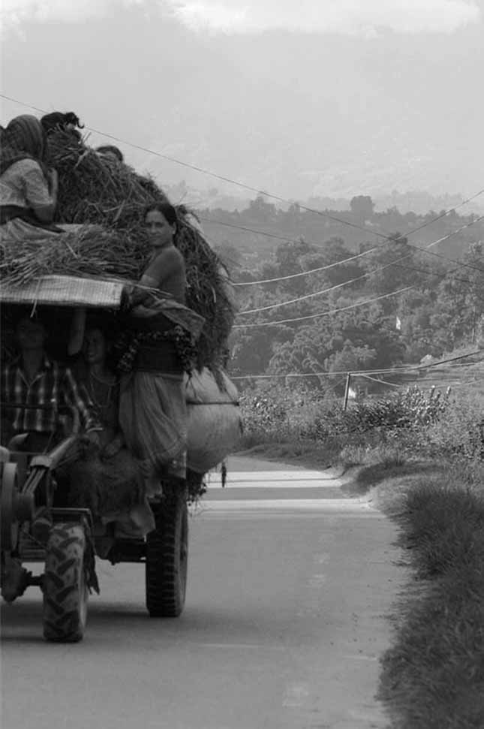
Session 6:
Cash Management

Session 6: Cash Management

45 Mins

Session Overview

In this session you will look at cash flow planning. Cash flow management is an important part of successful business management. The Group reader will first read aloud some information on cash flow planning and also take a look at Somchai’s example. Then you will complete two activities.

[5mins] Cash flow planners are used to record all expenses and incomes generated by the farming business but do not capture family consumption. They are useful because most farming businesses produce more than one income generating product. For example, Somchai produces rice, soya bean, chicken and pigs and these involve different cash in and cash out activities.

Although the cash flow planner is used only for the farming business, some costs may overlap with household expenses such as electricity, water, and land rental. When completing the cash flow planner, entrepreneurs must determine what percentages of these costs are for your farm and what percentage are for your household use. Only the proportion of the cost for your farming business is used in the cash flow planner.

The advantage of keeping your cash flow planner up to date is that it is a useful tool for planning ahead. They help farming businesses to predict the if there will be a profit at the end of the month/year and create the opportunity for business owners to assess how business costs could be reduced or sales increased to ensure a profit is made.

Business owners should only record sales figures after the cash has been received. Even though traders may promise a purchase price at the start of the season, it is not safe to plan your business on this information. The same is true for sales on credit where payment is not received at the point of sale but after several days, weeks or months. These sales should not be recorded as cash in until the cash has been received.

The time you invest in your business has a value so you should be planning to pay yourself a salary each month from the cash flow of your farming business.

Poor cash flow management is one of the main reasons for business failure. A Cash Flow Planner helps you record sales, costs and profit of your business each month and helps manage fluctuations in the cash flow of your business. See the example below:

Example: Somchai’s Farming Business Cash Flow Planner
 | Month | 1 | 2 | 3 | 4 | 5 | 6 | 7 | 8 | 9 | 10 | 11 | 12
Cash in | Start of Month |  | 20,000 | 4,650 | 850 | 6,850 | 5,250 | 5,250 | 4,650
 | Crop Sales |  |  |  |  | 2,500 |  | 1,200 | 62,600
 | Livestock Sales |  |  | 8,200 | 10,000 |  |  | 7,200
 | Other Cash
 | Total |  | 20,000 | 12,850 | 10,850 | 9,350 | 5,250 | 13,650 | 67,250
Cash out | Seed |  | 2,750
 | Labour |  |  | 9,000 | 4,000 | 4,100 |  | 5,400
 | Equipment Hire
 | Fuel |  |  | 3,000 |  |  |  | 3,600
 | Fertilizer |  | 12,600
 | Animal Feed
 | Loan Repayment |  |  |  |  |  |  |  | 56,970
 | Other Costs
 | Total |  | 15,350 | 12,000 | 4,000 | 4,100 | 0 | 9,000 | 56,970
 | Net Cash Flow |  | 4,650 | 850 | 6,850 | 5,250 | 5,250 | 4,650 | 10,280

Activity 6A: Cash Flow Planning

In Activity 6A you will support each other in cash flow planning for your farming business.

30 Mins

- As a group, study Somchai's annual cash flow from his farming business. The difference between cash-in and cash-out for the month is the amount of profit or loss for that month. Compare the costs with those Somchai listed in the previous activities to make sure he did not forget anything. [10 minutes]
- Working together, help each other to complete a cash flow planner for your own farming businesses using Table 6A. [20 minutes]
- Take note of the following:
- Net cash flow is calculated by finding the difference between cash in and cash out. If you have more cash in, your business has made a profit for the month. If you have more cash out, you have made a loss for the month.
- At the start of each month you should record this difference in cash in and cash out from the previous month. In Somchai’s example, his cash in and cash out difference was 4 650 PHP at the end of the first month. This was his profit. In his cash flow planner he starts month his second month by recording this result from the first month.

Table 6A: Your Cash Flow Planner
 | Month | 1 | 2 | 3 | 4 | 5 | 6 | 7 | 8 | 9 | 10 | 11 | 12
Cash in | Start of Month
 | Total
Cash out
 | Total
 | Net Cash Flow

In this session you looked at managing cash flow in your business and completed a cash flow planner for your business.

Activity 6B: Planning for Change

In the final activity of this session you will decide on some concrete actions to improve cash management in your business. Keeping in mind all the things you’ve discussed so far about managing cash, take a few minutes to record your thoughts.

10 Mins

- Each of you uses Table 6B: Personal action plan to write 1-3 changes that you would make. Are there any improvements you would like to make based on what you have learned in the previous activities? If so, decide what you will implement or improve.
- Record how you will make these changes.
- Record by when will you make these changes.
- Finally, state who will be responsible for this change.

Table 6B: Personal Action Plan
My changes | How will I make the changes? | When? | Who is responsible?

You have completed the final activity of session 6. In this session you looked costing in your business.

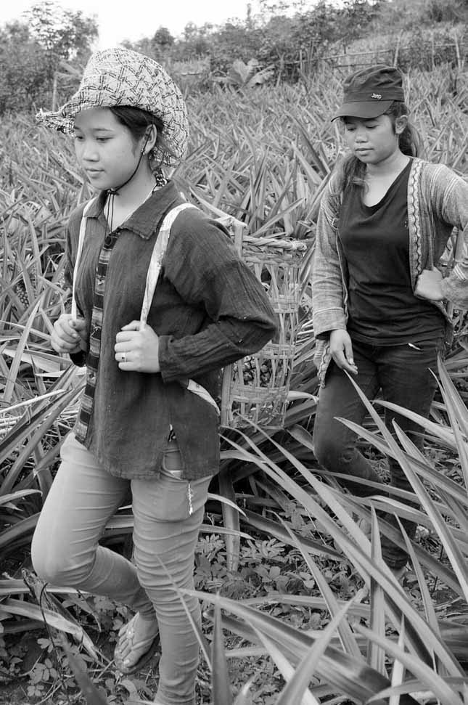
Session 7:
Action
Planning

Session 7: Action Planning
40 Mins

Session Overview

With the workload that comes with running a small business, it’s not always easy to actually implement the changes you would like. In this session you look at the work you completed during this training and create a simple action plan to improve your businesses. You complete a single activity

Activity 7A: Prioritized Actions

You will work step-by-step, session-by-session to prioritize the actions you have listed in the previous sessions.
40 Mins

- You talk in a group. Everyone says what he or she found in each of the activities. You start from the first activity.
- For the next step you use Table 7A: Priority action plan. Individually you look at the action plans you completed for each session and choose which of the changes you will introduce first and when, in a week, in a month, in two months? List at least 3 actions [15mins]
- Each of us present their Priority Action Plan and the group shares their ideas of whether the priority of actions should be changed or if they are good the way they have been set. Each participant has 5 minutes. [25mins]
- As a group, you can use additional time to decide whether you will meet again, after the training to practice some of the activities, such as costing. You can also plan to meet on a regular basis and talk about how are you doing with the changes you are introducing

Table 7A: Priority Action Plan
My priority changes | How will I make the changes? | When? | Who is responsible?

Prioritizing actions, the activity you completed at the end of the training, is a very important step. It pushes you to decide how to apply what you have learned in this training into your work and lives.

This is the end of the training. You can now complete the evaluation. In few months there will be some follow up too.

www.sme-tools.org

