GUESTHOUSE AND SMALL HOTEL TRAINING GUIDE

*ILO - ASEAN Small Business Competitiveness*

A product of ­







Small Business Competitiveness by International Labour Organization (ILO – SBC) is licensed under a Creative Commons Attribution-Non Creative Commons Attribution‐NonCommercial‐ShareAlike 3.0 Unported License.



**Attribution** — You must give [appropriate credit](https://creativecommons.org/licenses/by-nc-sa/3.0/), provide a link to the license, and [indicate if changes were made](https://creativecommons.org/licenses/by-nc-sa/3.0/). You may do so in any reasonable manner, but not in any way that suggests the licensor endorses you or your use.



**NonCommercial** — You may not use the material for [commercial purposes](https://creativecommons.org/licenses/by-nc-sa/3.0/).



**ShareAlike** — If you remix, transform, or build upon the material, you must distribute your contributions under the [same license](https://creativecommons.org/licenses/by-nc-sa/3.0/) as the original.

****[*https://creativecommons.org/licenses/by-nc-sa/3.0/legalcode*](https://creativecommons.org/licenses/by-nc-sa/3.0/legalcode)

brought to you by:



Table of Contents

About C-BED vi

About The Guesthouse Package: vi

Message to the Group vii

Session 1: Introductions 1

Activity 1A: Getting to Know Each Other 1

Session 2: Creating Systems 5

Activity 2A: Examples 5

Activity 2B: Group Discussion 7

Activity 2C: Personal Action Plans 10

Session 3: Marketing 13

Activity 3A: Surveys 13

Activity 3B: Personal Action Plans 17

Session 4: Pricing and Budgeting 19

Activity 4A: Budgeting 19

Activity 4B: Personal Action Plans 23

Session 5: Joint Problem-Solving and Developing Loyal Employees 27

Activity 5A: Brainstorming From Problem-Solving 27

Activity 5B: Brainstorming Solutions 28

Activity 5C: Solutions 30

Activity 5D: A Positive Work Environment 31

Activity 5E: Personal Action Plans 33

Session 6: Improving Service 37

Activity 6A: Staff Meetings 38

Activity 6B: Steps to Good Service 39

Activity 6C: Personal Action Plans 46

Session 7: Safety and Health 49

Activity 7A: Identify Risks and Threats 49

Activity 7B: Personal Action Plans 51

Session 8: Priority Action Plans 55

Activity 8A: Prioritized Actions 55

Annex 1: Flipcharts 59

Flipchart for Activity 2B 59

Flipchart for Activity 6A 59

# About C-BED

Community-Based Enterprise Development (C-BED) is a low cost, innovative training programme designed by the International Labour Organization (ILO) to support skills development and empowerment in local communities for improvements in livelihoods, productivity and working conditions.

As an approach to training, C-BED is unique in that the programme is built around peer-to-peer, activity based learning methods with no role for teachers, experts, or external consultants specialised in the skill area. Instead, C-BED participants work together through a series of activities and discussions guided only by simple step-by-step instructions in the training manual. New knowledge, skills and competencies are developed through the interactions between participants and sharing of existing local knowledge and experience. In this way the programme is a low cost, sustainable option for any organization or community.

The C-BED programme is structured around two core training packages designed to develop competencies for business start-up and operation through a focus on marketing, financial management, and action planning. These are the C-BED for Aspiring Entrepreneurs and C-BED for Small Business Operators. Additionally, a growing suite of tools to strengthen business competencies and enhance skills for specific sectors is in continual development. These packages can be implemented as either stand-alone trainings or integrated in modular format into existing programmes.

## About The Guesthouse Package:

**The Training Package:**

The guesthouse package should be used to help aspiring and current guesthouse managers and owners start and improve their businesses. It focuses on key business principles to build on from what participants already know from managing their guesthouses and helps them to learn more. It can also build on from the learning in other C-BED tools namely SBO or AE. Participants bring experience to share and leave with a priority action plan (at least 3 actions to introduce improvements to their business). At the end of the training participants will have:

* Enhanced and advanced existing knowledge on guesthouse development
* Strengthened critical competences to analyse job prospects or current conditions of work
* Affirmed the potential of enterprise development
* Identified steps and actions to improve a business or launch a business idea
* Decided on actions for the future
* Started planning effective collaborations and associations

**The Good Practice Guide:**

During the training day participants will be introduced to and become familiar with the Good Practice Guide (GPG), which they will then be able to use to further their learning and to support them in setting up or improving their businesses. The GPG contains best practices, tools and extra activities that supplement those covered in the training to further support the participants in setting up or improving their businesses. The exercises may depend on the GPG but if the participants do not have this guide this should not prevent them from moving forward, if necessary skip that activity. Look out for this icon:



Here you should refer to the Good Practice Guide for more information.

## Message to the Group

At the end of this C-BED training you will have a clear plan for the practical steps you can take to start or improve your business. Your understanding of the basic principles of doing business will be much stronger and you will have begun relationships with others in your community that can potentially support or cooperate with you to achieve mutual success in the future.

The style of this training is different to traditional education approaches. There will be no teacher, trainer or expert to assist you. Instead, you will work together as a team to follow the simple step-by-step instructions for discussions and activities in your training guide. Because there is no group leader, all group members should take a turn reading the information and instructions out loud to the group, and all group members share responsibility for monitoring time. In this new style of training, we will learn from each other by sharing ideas and opinions, skills, knowledge and experience. For this to work, all group members must participate in discussions.

Before and after the training you will be asked to complete a survey to understand the impact of the training. This information will be kept confidential and is used to improve the training materials and organization of future programs. Some trainees may also be contacted in the future after 3, 6 or 12 months for another survey to learn about your business plans.

The instructions in the training guide are easy to follow and suggested timing for each step is provided. Look out for these signs:



When you see this sign, read aloud



When you see this sign, you are reading instructions and doing activities



When you see this sign, share with the group



This sign gives you the estimated time for the session



Use the flipchart as outlined in Appendix 1, if you don’t have a flipchart use extra paper or the Training Guide

Before you begin the training, follow the simple steps below to get organized.

Fill out the pre-training survey. Ask the organizers if you don’t have a copy or have not already filled it in.

Organize into small groups of 5-7. The organizers will guide you in how best to do this.

Identify one group member to volunteer to start the training as ‘Group ‘Reader’. The ‘Group Reader’s’ role is to read the information and activity instructions out loud to the group. Any group member with basic literacy can be the ‘Group Reader’ and you should aim to share this role among group members throughout the training.

All group members are responsible for monitoring time but one group member should be nominated for each session to remind the group when the suggested time for a step has been reached. You do not strictly need to follow the suggested timing but you will need to manage your time for the total training. If one activity lasts longer than the suggested timing, try to save time in other activities to keep the balance.

All group members will receive the same training guide. Individual work can be completed in these guides as well as group work. Groups may also like to complete activities together on flipchart paper if available.

Enjoy The Training!

Session 1:

Introductions

# Session 1: Introductions



**20 Mins**



**Session overview:**

In this session you will get to know one another and the style of learning in this training. We learn without teachers. You help each other by sharing your different experiences and ask questions if you don’t understand an activity. The objectives of this session are to:

* Know the names of some of the trainees
* Understand the style of learning for this course, including activities and group work
* Understand the importance of contributing ideas and suggestions

## Activity 1A: Getting to Know Each Other



In Activity 1A, you will do some brief introductions so you can get to know one another.



**20 Mins**

1. Each person introduces themselves by providing:

* Full name and any nickname you prefer to use during the session
* Guesthouse address
* How long your guesthouse has existed (if applicable)
* Your purpose for attending this session and how you expect it to help your business

1. Each person shares a photo, business card or drawing of their guesthouse for others to see. Place this on the wall or in the middle of the table, or allow others to see it on your mobile phone.
2. Fill in this sheet below (if not now, then during tea breaks and lunch time

|  |  |  |
| --- | --- | --- |
| Table 1A: Participant Information | | |
| Participant name | Guesthouse address | Phone number /  Email address |
|  |  |  |
|  |  |  |
|  |  |  |
|  |  |  |
|  |  |  |
|  |  |  |
|  |  |  |
|  |  |  |



In this activity you have gotten to know who your peers are and a little about their businesses

.

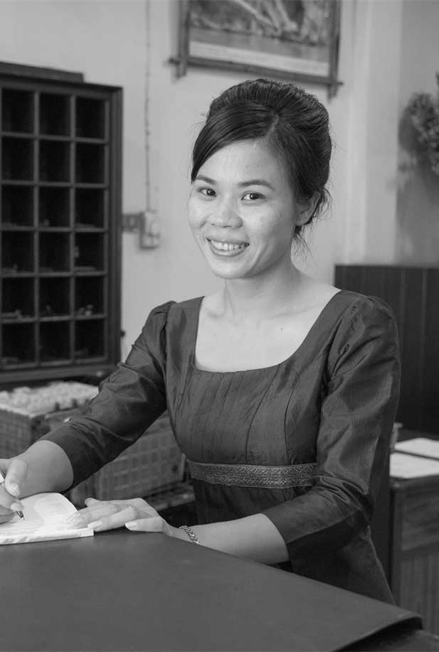

Session 2:

Creating

System

# Session 2: Creating Systems



**80 Mins**

1

**1 & 2**



**Session overview**

In this session you will look at the value of using systems to ensure smooth operation of your guesthouse or hotel. You complete 3 activities. The objectives of this session are as follows:

* Identify the benefit of a systems-based approach to management
* Identify businesses failing to adhere to a systems-based approach
* Become familiar with the GPG
* Learn that the GPG will help them create systems to improve your businesses.

## Activity 2A: Examples



In Activity 2A you will hear the stories of two guesthouses as told by some recent guests to help you to understand the value of systems in guesthouse and hotels. You should listen carefully to their experience to help you complete the next activities. Is there someone who would like to read us the first story? We have 10mins for this activity.



**[5mins] The Story of the Blue Guesthouse**

Two years ago, Ms Kim became the manager of the Blue Guesthouse, a beautiful old house with 10 guestrooms near the centre of town. Ms Kim was very happy. She had always enjoyed walking by the Blue Guesthouse, and she was looking forward to working there. But during her first week, Ms Kim was sad to hear so many complaints from customers. Here are some of the comments she heard from them:

* “Why was there no hot coffee this morning? Doesn’t breakfast include coffee?”
* “Why are there spider webs on the ceiling in my room? I’m afraid of spiders!”
* “Why couldn’t someone help me find my sunglasses?”

When Ms Kim asked her staff why was there no hot coffee this morning, they did not know why. There was no one assigned to making the coffee and while anyone could make it, no one did. She then asked her staff why are there spider webs on the ceilings of the guestrooms? The Housekeepers did not know why but explained that because of the climate there were always spiders. When Ms Kim asked about the sunglasses the employees reported having seen some in the breakfast room but not knowing what happened to them.

Ms Kim was curious that the guests were complaining but the staff did not seem bothered. The Receptionists and Housekeepers simply said that customers always complained.

Now, two years after she became the manager of the Blue Guesthouse, Ms Kim is not so happy about her job. She hears the same complaints all the time and now she also says also adopted the attitude that customers simply complain and that there is nothing to be done.

Is there someone who would like to read us the second story?

**[5mins] The Story of the Yellow Guesthouse**



Mr Lee is the manager of the Yellow Guesthouse. It is a 10-room guesthouse in a quiet neighbourhood, a few blocks from the centre of town. The Yellow Guesthouse is small, and the rooms are small, and it has a lovely flower garden. Everyday, Mr Lee puts fresh flowers in all the rooms. As he walks through the guesthouse, he smiles. He enjoys listening to the comments from his guests.

* “I don’t want to leave. I’ve enjoyed staying here so much.”
* “The staff are incredible! The housekeeper even took my shoes to be repaired.”
* “Our room is small, but it’s so clean and comfortable, I don’t mind.”
* “I’m going to recommend the Yellow Guesthouse on the Internet.”

After he distributes fresh flowers throughout the guesthouse, Mr Lee walks to the kitchen. It’s time for breakfast, and many guests are dining, but the kitchen is clean and neat. Mr Lee looks at the checklist posted on the back of the kitchen door. He looks around and notices that every task on the list has been done.

The senior Housekeeper is the cook, and he watches with pride as she quickly and efficiently prepares the food. Before the breakfast service started, she arranged everything she needed. Now she can concentrate on cooking, and she doesn’t have to look for anything as it is all there.

In the dining area, before he starts to chat with the guests, he takes a quick look around and sees that everything is in order. There is plenty of coffee and hot water for tea. The condiments and napkin holders are clean and on every table. The floor and tablecloths are clean and everything has been done.

Mr Lee has managed the Yellow Guesthouse for ten years. He still loves his job. He treats his employees very well, and they are very loyal to him. He knows he can count on each one of them to do exactly what they need to do. In fact, Mr Lee knows that they will do even more than that. For instance, they have taken a guest’s shoes to be repaired, helped a guest mail a package and found soymilk at the market when a guest requested it.

The guests are happy meaning that the employees are happy and Mr Lee is happy. Mr Lee is convinced that the secret and root of his success is the systems he has in place.

In Activity 2A you have heard stories from two different guesthouses and the perception of the guests. You heard how systems helped to improve guest, employee and manger experience.

## Activity 2B: Group Discussion



In Activity 2B you will review the term system, and discuss the value of systems in guesthouse and hotels.

What is meant by “systems?” Let’s look at Flipchart 2. A system: A set of detailed procedures created to:

* Do a specific activity
* Perform a duty
* Solve a problem efficiently and with consistent quality



If you want your guesthouses to run efficiently and with consistent quality, one of the best things you can do is create systems. The Good Practice Guide (GPG) will help you do this. The GPG has many suggestions for creating systems for guesthouses and hotels. They will help you create systems to improve your managerial skills, help you train your staff, and to help you impress your guests. Let’s take a brief look at section 1.

Do systems have to be complicated? Let’s look at Flipchart 2. No. A good system often starts with a clear, easy-to-follow written checklist. It does not have to be complicated. A simple checklist will clearly let employees know exactly what is expected of them and that is the sign of effective management.



**25 Mins**

1. In your groups discuss the value and importance of systems in guesthouses and hotels
2. Discuss and answer the questions in Table 2A together. Record your thoughts and the discussion in the spaces provided

|  |  |
| --- | --- |
| Table 2B: Value of Systems | |
| 1. Give some examples of established systems (if you have them) in your guesthouse or hotel. |  |
| 2. How do employees feel about having systems in place? |  |
| 3. How could you improve your business by creating more systems (for pricing, budgeting, sales and marketing, emergencies, greening your guesthouse, etc.)? |  |

In Activity 2B you reviewed the term system, and discussed how systems can help you. You also looked the GPG where you found some tools that could help you implement systems in your own businesses.

## Activity 2C: Personal Action Plans

In the final activity of this session you will decide on some concrete actions to improve or create systems in your guesthouses. Keeping in mind all the things you’ve discussed so far about creating systems, take a few minutes to record your thoughts.



**10 Mins**

1. Each of you uses Table 2C: Personal action plan to write 1-3 changes that you would make to improve systems in your businesses. Are there any improvements you would like to make based on what you have learned in the previous activities? If so, decide what systems you will implement or improve.
2. Record how you will make these changes.
3. Record by when will you make these changes.
4. Finally, state who will be responsible for this change.

|  |  |  |  |
| --- | --- | --- | --- |
| Table 2C: Personal Action Plan | | | |
| My changes | How will I make the changes? | When? | Who is responsible? |
|  |  |  |  |
|  |  |  |  |
|  |  |  |  |

You have completed the final activity of session 2. In this session you looked at what systems you need in a guesthouse and the important role that they play in guest experience. You can refer to Section 1 of your GPG for more about systems.

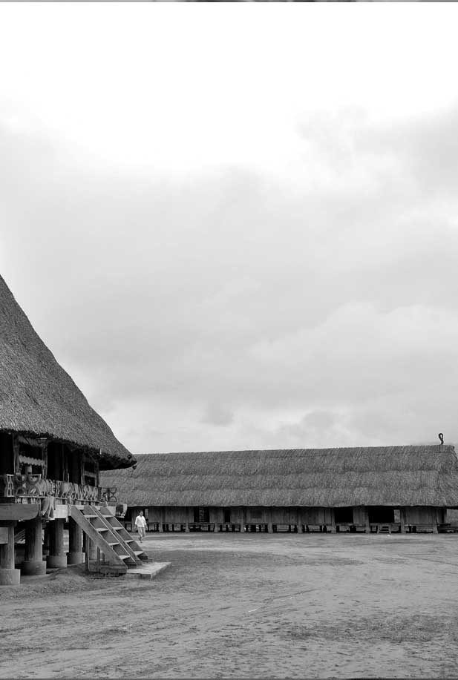

Session 3:

Marketing

# Session 3: Marketing



**2**

**40 Mins**

**Session overview**

In this session you will get an overview of a critical aspect of marketing, determining price. You complete 2 activities. The objectives of this session are as follows:

* Understand the importance of pricing
* Become familiar with tools for determining price such as analysis of current customers and competitors

Determine questions to cover in surveys



## Activity 3A: Surveys



A detailed analysis of current guests or customers is key for your business. In this activity you will look at how to conduct a survey before planning one of your own.



**[10mins]**

In order to ensure you provide the right options to your customers, it is crucial to undertake a survey of existing guests in your working area. The data from the survey should also help challenge your assumptions, adjust your ideas and support the development of the business. Ask yourself the following questions:

* Do you know how much do other guesthouses charge for their rooms, in different seasons? What does that cover? □ Yes □ No
* Do you know what makes customers choose your guesthouse over the other guesthouses? What would make them willing to pay more to your guesthouse?
  + Yes □ No

Refer to Section 2 of the GPG and to marketing tool 3 for guided survey questions. This can be used to capture crucial information, which will provide data for your business plan. The survey should be taken at 3-4 different locations in your locality, preferably capturing information from existing customers as well as your target customer base. Make sure you seek permission from the relevant authorities if you are collecting data within a public space. Follow these pointers:

* Introduce yourself to the participant
* Inform the participant that the data is anonymous
* Describe the reason behind the data collection
* At the end of the survey, always thank the participant for their time

Selecting participants:

* Identify 3-4 locations in your working area
* Select 1 period of the day and collect the data at the same time (e.g. midday)
* Ensure there is an equal representation of men and women
* Ensure that the participant has not undertaken the survey once before
* Select an equal number of participants from each location
* Select locals and visitors and weight the sample size according to your target group. So if you want to target visitors as your customer base then select 2 persons visiting from 3 surveyed
* Total survey participants should not exceed 60 persons



**20 Mins**

1. In Table 3A design a survey for your guesthouse. Select 3-4 locations to survey
2. Record some key questions you would like to ask. Look at the tables below and in the GPG section 2 for some ideas
3. Record when would be best to do this survey

|  |  |
| --- | --- |
| Table 3A: Pricing Surveys | |
| Locations | 1.  2.  3. |
| Key questions |  |
| When? |  |

|  |  |  |  |
| --- | --- | --- | --- |
| Competitor Survey | | | |
|  | Price | | |
| Single room | Twin room | Extra bed |
| Similar accommodation <1km from your business |  |  |  |
| Similar accommodation <5km from your business |  |  |  |
| Similar accommodation close to rail/bus/air ports |  |  |  |
| Smaller accommodation <5km from your business |  |  |  |
| Average price from customer survey |  |  |  |

|  |  |  |  |  |  |  |  |  |  |  |  |  |  |  |  |  |  |  |  |  |  |  |  |  |  |
| --- | --- | --- | --- | --- | --- | --- | --- | --- | --- | --- | --- | --- | --- | --- | --- | --- | --- | --- | --- | --- | --- | --- | --- | --- | --- |
| Customer Survey | | | | | | | | | | | | | | | | | | | | | | | | | |
| 1 | What is the nature of your visit? (Please select one) | | | Business | | | | | | | | | Holiday | | | | | | | | Other | | | | |
| 2 | What is your length of stay? (Days) | | | 1-2 | | | | | | | | | 2-5 | | | | | | | | >5 | | | | |
| 3 | What type of accommodation do you seek? (Please select one) | | | | | | | Budget | | | | | | | | Comfortable | | | | | | Luxury | | | |
| During a typical stay: | | | | | | | | | | | | | | | | | | | | | | | | | |
| 4 | What is your room occupation? (Please select one) | | | Single | | | | | | | | | Double | | | | | | | | Triple | | | | |
| 5 | Would like breakfast included in the room price? | | | Yes | | | | | | | | | | | | | No | | | | | | | | |
| 6 | Do you order meals from the hotel? | | | Yes | | | | | | | | | | | | | No | | | | | | | | |
| 7 | Do you order alcoholic beverages? | | | Yes | | | | | | | | | | | | | No | | | | | | | | |
| Activities during a typical stay: | | | | | | | | | | | | | | | | | | | | | | | | | |
| 8 | How do you spend your time on a visit? (Please select one or more) | Adventure tourism | | | | Attending business functions | | | | | Relax near beach or swimming pool | | | | | | | | Visit sites of culture and history | | | | Other | | |
| 9 | Do you organize your own activities? | Yes | | | | | | | | | | | | No | | | | | | | | | | | |
| 10 | Do you purchase package tours? | Yes | | | | | | | | | | | | No | | | | | | | | | | | |
| Payment | | | | | | | | | | | | | | | | | | | | | | | | | |
| 11 | Do you book hotels in advance of travel? | | | Yes | | | | | | | | | | | | | No | | | | | | | | |
| 12 | If you book in advance, which website do you use? (Please select more than one) | | Hotel website | | Hotel.com | | | | Booking.com | | | | | | Agoda.com | | | | | Travel agent | | | | | Other |
| 13 | How do you make your payment if booking in advance? | | Credit card | | | | Debit card | | | | | PayPal | | | | | | Bank transfer | | | | | | Cash | |
| 14 | What is preferred method of payment? (Please select one) | | Cash | | | | | | | Bank Card | | | | | | | | | Other | | | | | | |
| Price | | | | | | | | | | | | | | | | | | | | | | | | | |
| 15 | How much are you willing to pay or the following room types? (Insert price range as shown in example) | | Single room (Please select one) | | | | | | | 10-15 | | | | | | | | | 16-25 | | | | | | >25 |
| Twin room (Please select one) | | | | | | | 15-20 | | | | | | | | | 21-30 | | | | | | >30 |
| Extra bed (Please select one) | | | | | | | 5-10 | | | | | | | | | 11-15 | | | | | | >15 |
| 16 | What determines your choice of selecting accommodation? | | Price | | Customer rating/review | | | | | Expert rating/ review | | | | | | | | | Accuracy of advertised information | | | | | | Photos of the accommodation |



In Activity 3A you reviewed how to gather data to help you to determine price. The GPG has more valuable tools and information about setting your price.

## Activity 3B: Personal Action Plans



In the final activity of this session you will decide on some concrete actions to improve pricing in your guesthouses. Keeping in mind all the things you’ve discussed so far, take a few minutes to record your thoughts.

**10 Mins**



1. Each of you uses Table 3B: Personal action plan to write 1-3 changes that you would make to improve pricing in your businesses. Are there any improvements you would like to make based on what you have learned in the previous activities? If so, decide what systems you will implement or improve.
2. Record how you will make these changes.
3. Record by when will you make these changes.
4. Finally, state who will be responsible for this change.

|  |  |  |  |
| --- | --- | --- | --- |
| Table 3B: Personal Action Plan | | | |
| My changes | How will I make the changes? | When? | Who is responsible? |
|  |  |  |  |
|  |  |  |  |
|  |  |  |  |

You have completed the final activity of session 3. In this session you looked at determining price and the role it plays in marketing. It is important to gather data to get an idea of how much customers would pay and what your competitors are currently charging. Look at Section 2 of your GPG for more about marketing and pricing.



Session 4:

Pricing and

Budgeting

# Session 4: Pricing and Budgeting



**3**

**70 Mins**



**Session overview**

The purpose of this session is to introduce basic techniques of accounting, budgeting and stocktaking for products and services offered by your guesthouse. You will complete 2 activities. The objectives of this session are as follows:

* Understand the definitions of variable, direct, fixed and labour costs, and raw materials
* Calculate total costs
* Use a customer survey tool to determine average market price by competitors, taste, choice determination, and payment preference
* Develop value added services based on current market trends

## Activity 4A: Budgeting

In Activity 4A you will look at budgeting or how to keep track of how much money your guesthouse is making and spending. Budgeting is a tool to keep track of your spending (costs) and income. In order to maximize profits, maximize investments and lower costs it is important set the appropriate price. In order to do that you must have an accurate knowledge of your costs and how much your guests are willing to pay





**These are some key definitions.**

**Variable Costs:** Variable costs change with the amount of goods/services produced and usually fall under the raw materials or labour column. Using the haircutting example, variable costs would be shampoo or hair gel and labour costs are cutting and washing hair.

**Direct Costs:** A price that can be completely attributed to the production of specific goods or services. Direct costs refer to materials, labour and expenses related to the production of a product. Other costs, such as depreciation or administrative expenses, are more difficult to assign to a specific product, and are therefore considered indirect costs.

**Fixed Costs:** Fixed costs are the same regardless of the amount of goods and services produced. For the hairdressing example, the cost of rent, scissors and chairs are all fixed costs.

**Raw Materials:** The basic materials used to make the final product or service. For hairdressing, it is the shampoo or conditioner needed to wash hair. This is a variable cost because it changes based on the amount of goods/services produced.

**Labour Costs**: These costs are the amount of wages you pay your employees, as well as the amount of money you earn from your business. These are variable costs because the amount of money you pay your employees and yourself changes with the amount of goods/services produced.



**60 Mins**

1. Review section 3 of your GPG (tool 1 to 4)
2. Complete Table 4A (1-4) below (you will need a calculator) with some example costs from your own business
3. Use the space provided below for working out, if necessary

|  |  |
| --- | --- |
| Table 4A (1): Raw Material Costs | |
| Raw materials | Cost of materials |
|  |  |
|  |  |
|  |  |
|  |  |
|  |  |
|  |  |
|  |  |
|  |  |
|  |  |
|  |  |
|  |  |
|  |  |
|  |  |
|  |  |
|  |  |
|  |  |
|  |  |
|  |  |
|  |  |
| Total |  |

|  |  |  |  |  |  |
| --- | --- | --- | --- | --- | --- |
| Table 4A(2): Labour Costs | | | | | |
| Labour Cost per day | Number of employees |  | Time |  | Cost per day |
|  |  |  |  |
|  |  |  |  |
|  |  |  |  |
|  |  |  |  |
|  |  |  |  |
| Sub-total | | A |  | B |  |
| Total variable labour costs per hour (Insert figure B/A) | | |  | | |

|  |  |  |  |  |
| --- | --- | --- | --- | --- |
| Table 4A (3): Fixed Costs | | | | |
| Fixed Costs per day |  | Price per month ($) |  | Working days |
|  |  |  |
|  |  |
|  |  |
|  |  |
| Sub-total | A |  |
| Average number of days worked per month | | | B |  |
| Total (Insert figure B/A) |  | | | |

|  |  |
| --- | --- |
| Table 4A (4) Total Cost | |
| Step 1 Variable Costs |  |
| Step 2 Labor Costs |  |
| Step 3 Fixed Costs |  |
| Total Cost = Step 1 + Step 2+ Step 3 |  |
| Your Total Cost for one unit is _________ |  |

|  |
| --- |
| Working out space: |

In Activity 4A you determined some key costs to help you with budgeting.



## Activity 4B: Personal Action Plans

10 Mins

In the final activity of this session you will decide on some concrete actions to improve budgeting and pricing in your guesthouses. Keeping in mind all the things you’ve discussed so far, take a few minutes to record your thoughts.



1. Each of you uses Table 4B: Personal action plan to write 1-3 changes that you would make to improve budgeting in your business. Are there any improvements you would like to make based on what you have learned in the previous activities? If so, decide what systems you will implement or improve.
2. Record how you will make these changes.
3. Record by when will you make these changes.
4. Finally, state who will be responsible for this change.

|  |  |  |  |
| --- | --- | --- | --- |
| Table 4B: Personal Action Plan | | | |
| My changes | How will I make the changes? | When? | Who is responsible? |
|  |  |  |  |
|  |  |  |  |
|  |  |  |  |



You have completed the final activity of session 4. In this session you looked at what budgeting for a guesthouse and the important role that it plays in managing financial or money flows. Section 3 of your GPG has more information for you.

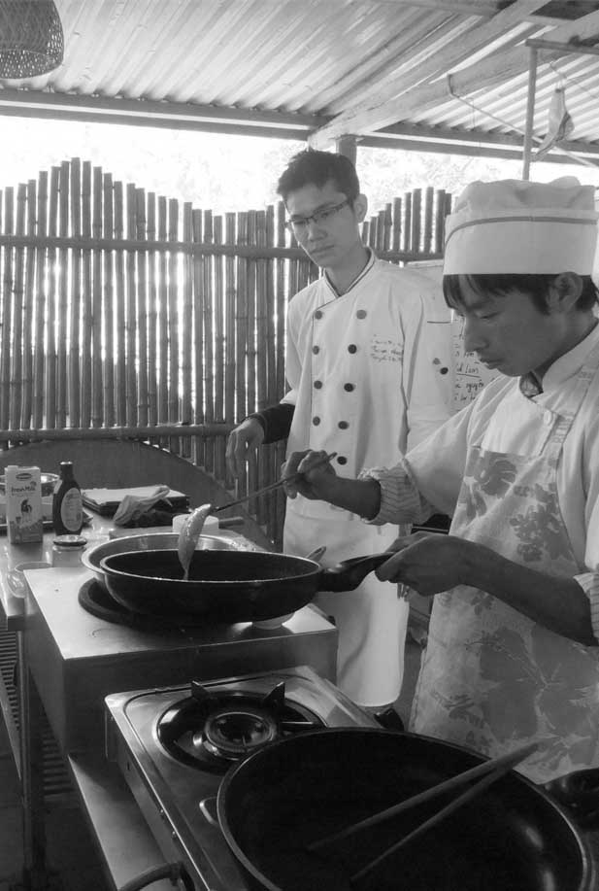

Session 5: Joint Problem-Solving and Developing Loyal Employees

# Session 5: Joint Problem-Solving and Developing Loyal Employees



**4**

**90 Mins**



**Session overview**

The purpose of this session is to practice brainstorming and problem-solving with a group, with the aim of highlighting the importance of involving employees in problem solving. You will complete 5 activities. The objectives of this session are as follows:

* To list the principles of effective brainstorming
* Conduct brainstorming session
* Understand the value in involving staff in solving work-related problems
* Assess how well you currently treat your employees
* Understand the value in developing staff loyalty
* Identify specific actions to take to treat your employees well and to build loyalty

If they are available, try to flipcharts to record your group work for the activities in this session.

## Activity 5A: Brainstorming From Problem-Solving

In Activity 5A you will look at brainstorming and get some practice using the technique





An important part of joint problem solving is brainstorming as a group. When trying to solve a problem, it helps to have everyone in the group brainstorm and contribute ideas for possible solutions. The guidelines for effective brainstorming are as follows:

* Encourage everyone to contribute suggestions for solving the problem
* Seek as many ideas as possible, even unusual ones
* Make everyone feel safe and comfortable contributing ideas

**10 Mins**



1. Create a list of as many work related problems as possible. Try to think of some unusual problems if you can.
2. Record these in the space below

|  |
| --- |
| Table 5A: Work Related Problems |
|  |

## Activity 5B: Brainstorming Solutions

In this activity you used brainstorming to come up with work related problems.

In Activity 5B you will follow on from the previous activity and look at how to solve the problems that you came up with



**20 Mins**



1. Imagine that you are co-workers at a guesthouse and the guesthouse has a problem that you want to solve together.
2. Look at the list of problems you created in Activity 5A. Choose one problem to work on
3. Try to choose a problem that would benefit from input from the entire staff, because the entire staff will work on this problem
4. Each group member should choose one of the following roles to fill:

* Housekeepers
* Breakfast Servers
* Receptionists
* Managers

1. You can also have more than one of each role in the group
2. Brainstorm solutions for the problem you have chosen. Try to think about the problem from the perspective of the role that you have chosen. Act how that person would in the situation. Do not think about the best solution just come up with as many as possible.
3. Record all your potential solutions in the space below

|  |
| --- |
| Table 5B: Brainstorming Solutions |
|  |



In this activity you brainstormed solutions for a guesthouse problem. This showed you that all staff members have something to contribute to the understanding and solving of a problem.

## Activity 5C: Solutions

In this activity you will focus on selecting a solution through looking at the pros and cons of the proposed solutions.



**10 Mins**



1. Based on the solutions you came up with in Activity 5B, identify 3 options that your group would like to try
2. Identify some Pros and Cons for each.
3. Record these in Table 5C

|  |  |  |
| --- | --- | --- |
| Table 5C: Pros and Cons | | |
| Solutions | Pros | Cons |
| Solution 1 |  |  |
| Solution 2 |  |  |
| Solution 3 |  |  |

In this activity you looked at pros and cons to different solutions. The GPG takes this one step further and asks you to look at what is necessary to implement the solution and to make some action plans.



## Activity 5D: A Positive Work Environment

In Activity 5D you will look at how to retain employees. One issue that many guesthouses and hotels face is high turnover. This is a problem because the longer you keep your employees, the better they will be at their jobs, the less time you have to spend training new people, and the more motivated your employees will be to help your business succeed. Having loyal employees is one of the keys to your success.





Let’s review this checklist

|  |  |  |
| --- | --- | --- |
| Table 5D (1): How Positive is My Workplace? | | |
| Self-evaluation | Yes | No |
| Do all my staff members clearly understand what I expect them to do? |  |  |
| If they do not understand, do I explain it to them in a friendly way? |  |  |
| Do I compliment each of them every day? |  |  |
| Do I get angry with them if they make a mistake? |  |  |
| Do I turn mistakes into opportunities for learning in a positive way? |  |  |
| Do I treat everyone fairly? |  |  |
| Do I treat everyone with respect? |  |  |
| Do I invite their ideas and suggestions and really listen to them? |  |  |
| Do we take enough time to relax and enjoy each other’s company? |  |  |
| Is there any reason one of them is unhappy? |  |  |
| If so, can I do something to help? |  |  |
| Am I ever cruel or unfair to them? |  |  |
| Do I yell at them or make fun of them? |  |  |
| Do I know, understand, and respect national labor standards, including: |  |  |
| Employee working hour limitations? |  |  |
| Minimum wage requirements? |  |  |
| Avoiding split shifts? |  |  |
| Is my guesthouse (or hotel) a clean, safe, and pleasant place to work? |  |  |
| Do I arrange fun, informal events so my employees can socialize? |  |  |
| Do we have breakfast or lunch together? |  |  |
| Do we celebrate employee birthdays or holidays together? |  |  |
| Other questions |  |  |

If you could not answer yes, to some of these questions ask yourself if you think you could develop loyal employees by making your workplace a positive place for them to work.





**10 Mins**

1. Brainstorm at least 3 other things that you could do to create a positive workplace
2. If you can think of more than 3, that is even better.
3. Record you ideas in the space below

|  |
| --- |
| Table 5D (2) |
|  |



In Activity 5D you looked at what factors contribute to creating a happy and positive workplace. The more positive the workplace the more likely that your employees will want to give of their best and stay working for you

## Activity 5E: Personal Action Plans



In the final activity of this session you will decide on some concrete actions for improvement in your guesthouses. Keeping in mind all the things you’ve discussed so far, take a few minutes to record your thoughts.



**10 Mins**

1. Each of you uses Table 5E: Personal action plan to write 1-3 changes that you would make to improve employee relations and problem solving in your businesses. Are there any improvements you would like to make based on what you have learned in the previous activities? If so, decide what you will implement or improve.
2. Record how you will make these changes.
3. Record by when will you make these changes.
4. Finally, state who will be responsible for this change.

|  |  |  |  |
| --- | --- | --- | --- |
| Table 5E: Personal Action Plan | | | |
| My changes | How will I make the changes? | When? | Who is responsible? |
|  |  |  |  |
|  |  |  |  |
|  |  |  |  |

You have completed the final activity of session 5. In this session you looked at creating a positive workplace and joint problem solving for a guesthouse and the important role that they play in managing a guesthouse successfully. Look at Section 4 of your GPG for more information.



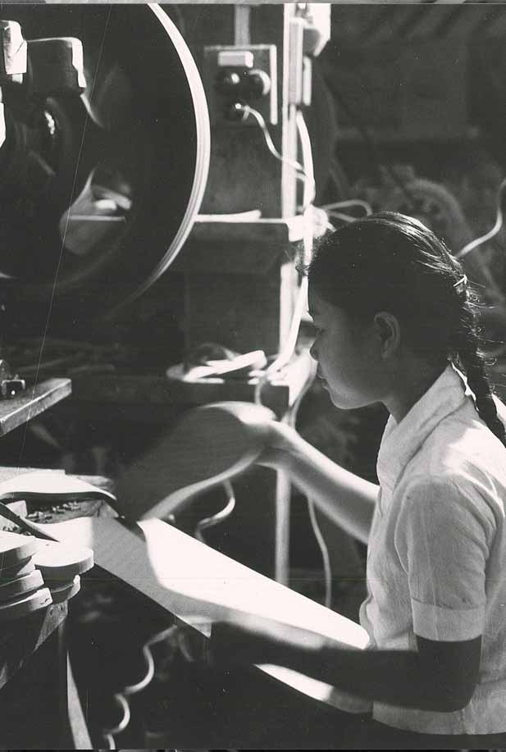

Session 6: Improving

Service

# Session 6: Improving Service



**60 Mins**

**3**

**4**



**Session overview**

The purpose of this session is to show why and how to hold effective staff meetings. Regular staff meetings are important to running a successful guesthouse. You will complete 3 activities. The objectives of the session are as follows:

* Understand the value in staff meetings
* Hold effective staff meetings
* Understand the value of using Guest Comment Forms to improve service
* Understand that you can customize the checklists and forms in the GPG to meet your needs.

Continually thinking of ways to improve your service will make your business more successful and keep it competitive. In today’s business world, customers expect good service, and if they feel that they don’t receive it, they might post a negative comment about your business through various forums.



It is important to always know what your guests like and dislike. If a few guests dislike something that could simply be because their preferences are different. If there is an on-going pattern of guests disliking something about your guesthouse, it is important for you to know, so you can make changes.

How do you find out what your guests like and dislike? You can talk to them yourself, of course. But that would take a lot of time. There are two other important ways to find out what your guests like and dislike.

Flipchart 3 shows you that you can speak to your staff and your guests about improving service. Guests often like to speak with staff. They tell your staff what they like and what they don’t like. Getting that information from your staff will help you improve your service because it will tell you exactly what your guests like and dislike. The other source of information is the guests themselves. First, let’s talk about getting this valuable information from your staff.

## Activity 6A: Staff Meetings

In this activity you will explore how to hold effective staff meetings. Meetings are a valuable opportunity for you to get feedback from your staff members.



**15 Mins**



1. Read over the guidelines for holding staff meetings in Table 6A
2. Discuss the three questions outlined in Table 6A and record your thoughts in space provided

|  |
| --- |
| Table 6A: Successful Staff Meetings |
| Guidelines for holding daily or weekly staff meetings:   * Meet when people can relax and focus (maybe in the afternoon when it is quiet). * Keep the meetings short (about 10 - 15 minutes). They can be more productive. * Keep the meetings fun and informal * Set a friendly, positive tone * Agree that this is a way for everyone to suggest ways to improve. * Agree to show respect for each other’s ideas and opinions. * Make it safe for employees to offer their ideas, opinions, and suggestions. * Encourage everyone to contribute to the discussion. |
| Do you think it is a good idea to hold daily or weekly staff meetings (why or why not)? |
| How could staff meetings help you improve your service? |
| How could staff meetings help you improve your service? |

Staff and guests are two important sources of information for helping you to improve your service. In this activity, you looked at holding successful staff meetings and discussed how staff could help you improve your service. There are some other tools in the GPG to help you to get more information such as Guest Comment Cards.



## Activity 6B: Steps to Good Service



In this activity you will review some important service aspects of running a guesthouse. This includes running a good reception, good housekeeping and a good breakfast service. There is more information on this topic provided in your GPG, including a number of good practice tools and checklists. For now we will just get an overview of the steps.



**20 Mins**

1. Read through the steps below
2. If you have any questions or comments please raise them for discussion in the group

In Activity 6B you looked at steps to ensuring a good reception, breakfast and housekeeping service. Your GPG has a number of different tools for you to use to help you to follow these steps.

|  |
| --- |
| Table 6B: Ten Key Steps |
| Ten steps for running a good reception service:  Using a good reception system will help you keep your guesthouse friendly and well organized. This section explains how to use a 10-step system for running a good reception service in your guesthouse.   1. Be friendly and confident when speaking with guests  * Smile when you talk. * Speak loudly enough for guests to hear you comfortably. * Look at the guest when you speak. * Stand up straight with shoulders back in a confident posture.  1. Be clean and neat  * Receptionists spend more time with guests, so they always need to be clean and neat. * Pay close attention to hair, fingernails, clothes and shoes.  1. Keep your front desk and reception clean and well organized  * This is the first thing guests see when they arrive and you should make a good impression. * Keep important supplies and telephone numbers at hand  1. Answer the phone politely  * Being polite, clear and efficient on the telephone will give your guests confidence in your guesthouse. * Some tips for good telephone etiquette: * Answer the phone within 3 - 5 rings. * Don’t leave guests on hold for more than 30 seconds; if necessary take their number to call them back. * Keep a pen and paper by the phone to take messages. * Start the call politely: “Hello, this is the ___ Guesthouse, how can I help you?” * End the call politely: “Thank you for your call, we’re looking forward to your stay with us”. If you don’t understand the caller say: “I’m sorry, could you please speak more slowly?”  1. Make advance reservations by telephone  * Collect basic information (arrival and departure dates, number of rooms and people, type of bed). * Check room availability. * If rooms are available and the rate is accepted, continue the booking. * Collect further information (full name, contact details, arrival time). * Update room availability calendar. * Send an email to guests to confirm booking.  1. Make advance reservations by email  * Taking reservations by email or by SMS is increasingly popular. * Use the sample email reply and the sample booking confirmation included in this GPG to help you create your own customized email responses.  1. Take walk-in reservations  * Be friendly and confident when tourists walk in to ask about a room. * Describe the guesthouse features, e.g., * Room facilities * Meal service * Included meals * Included beverages * Location of dining area * Meal times * Other services and activities, e.g., * Snacks, bottled water * Laundry service * Bicycle rentals * Cultural activities * Cooking demonstrations * Fishing * Guided hiking or trekking * Transportation  1. Help guests with problems   If a problem occurs, guests will probably want to discuss it with the Receptionist. If so, stay calm and follow these steps:   * Listen to the guest’s problem without interrupting. * Apologise. * Discuss a possible solution. * Tell the guest exactly what you will do. * Don’t promise the impossible, but try to make the guest happy. * Ask your manager if you need help * Follow up with guests to make sure they were satisfied.  1. Give good customer service   Giving good customer service is key to running a successful guesthouse. The Receptionist should give information in a friendly way. Here are things your Receptionist should be able to explain well:   * Details of meal services i.e. breakfast times * Snacks and beverages (tea, water, etc.) * Other places to dine in the area * Internet / wifi use * Location of nearest ATM * Lost and found items * Maintenance problems * Additional services and activities * Local transport (buses, tuk-tuks, etc.) * Regional and local tourist attractions  1. Check guests in and out  * Use a daily arrivals and departure list to help you manage check-ins and check-outs smoothly and professionally. * Have guests pay for their room and tax when they check-in and issue a receipt. * Have them pay for additional services and activities at check-out. * Give guests a room key, if applicable. * Check-in: The Receptionist should explain the following: * Meal service * Housekeeping service (for guests staying more than one night) * Other services and activities * The Receptionist should walk with guests to their room as a sign of good customer service. While walking, invite guests to ask questions. * Check-out: * Have someone check the room to see if anything is damaged or missing. If so, add the charge for repair or replacement to the guest’s bill. * Take payment for any outstanding charges (laundry, activities, etc.). * Collect the guest’s room key. * Assist with guest’s transportation and luggage (if applicable). |
| Running a good housekeeping service:  Step 1: Entering a guest room  Use a standard system each time you enter a guest rooms. This will help you:   * Increase guests’ comfort. * Increase your efficiency.   Step 2: Using good cleaning procedures  Use a standard cleaning system to save time. To do this you should:   * Have all the cleaning products with you before you start cleaning. * Follow safety guidelines when using cleaning products.   Step 3: Cleaning guest rooms  Always clean guest rooms from top (ceiling, lights, walls, windows) to bottom (furniture, floor, trash cans). Using this cleaning system will help you:   * Work quickly * Avoid missing something * Avoid having to clean something twice   Step 4: Cleaning public areas  Again, use the system and clean from *top* (ceiling, lights, walls, windows) to *bottom* (furniture, floor, trash cans). When cleaning in public areas:   * Do not allow guests to walk on wet floors (use a sign and chairs to block off wet areas). * Greet guests in a friendly way. Smile and say “Good morning/afternoon/ evening Madame/Sir!”   Step 5: Cleaning bathrooms  Remember: Guests can be very sensitive about bathroom cleanliness!  Some common complaints include:   * Dirty mirrors * Dirty toilets * Hair in the bathroom (bathtub, floor, shower, sink) * Not enough toilet paper (*always* leave two rolls in the bathroom)   Step 6: Cleaning stay-over rooms  A stay-over room is a guest room where a guest stays for more than one night. It is important that these rooms look fresh and clean each day, but you do not have to change the linens and towels each day. For long-term guests, offer to change the linens and towels every third or fourth day.  Step 7: How to manage room keys:  Housekeepers are responsible for the keys they need to clean guest rooms as well as guests’ belongings in their rooms. It is important to use a system to safeguard those keys. |
| Three steps for running a good meal service:  Using a meal service system will help you keep your dining area clean and attractive. And it will help you serve meals in a friendly, efficient way.  Step 1: Preparing the dining area   * Prepare the dining area before your guests arrive. * Make sure any staff in contact with food maintain high personal hygiene standards.   Step 2: Serving meals   * Smile and be friendly while serving meals * Be attentive to guests' needs. * Explain what is included. * Try to accommodate simple requests if possible.   Step 3: Cleaning up after meals - when the meal service is finished:   * Clean the dining area. * Prepare whatever you can for the next meal service. |

## Activity 6C: Personal Action Plans

In the final activity of this session you will decide on some concrete actions for improvement in your guesthouses. Keeping in mind all the things you’ve discussed so far, take a fBw minutes to record your thoughts.





**10 Mins**

1. Each of you uses Table 6C: Personal action plan to write 1-3 changes that you would make to improve service in your businesses. Are there any improvements you would like to make based on what you have learned in the previous activities? If so, decide what service improvements you will implement.
2. Record how you will make these changes.
3. Record by when will you make these changes.
4. Finally, state who will be responsible for this change.

|  |  |  |  |
| --- | --- | --- | --- |
| Table 6C: Personal Action Plan | | | |
| My changes | How will I make the changes? | When? | Who is responsible? |
|  |  |  |  |
|  |  |  |  |
|  |  |  |  |



You have completed the final activity of session 6. In this session you looked at getting information to ensure that you provide good service and how to provide good housekeeping, reception and breakfast services. Section 5 of your GPG has more information about improving service in your guesthouse.

Session 7:

Safety and

Health

# Session 7: Safety and Health



**6**

**60 Mins**



**Session overview**

The purpose of this session is to introduce how to create a safe working environment based on accident prevention, appropriate response during accidents and creating confidence amongst guests in the systems in place. You will complete two activities. The objectives of the session are as follows:

* Maintain good safety and health standards in your guesthouse
* Identify systemic failures that lead to accidents
* Promote basic hygiene amongst staff, fire safety, and pest control
* Administer first aid and ensure staff are aware and able to undertake basic techniques to dispense first aid
* Respond to fire and train staff to ensure safety of all patrons during an emergency

## Activity 7A: Identify Risks and Threats

It is important for managers and staff to be able to identify risks and threats in the workplace. In Activity 7A you will look at how to do this.





**45 Mins**

1. In your groups discuss the items in the below in Table 7A
2. The occupational safety and health (OSH) tools highlighted refer to the GPG that outlines some ways to overcome these risks and threats
3. Identify a few of the issues discussed and individually brainstorm what measures that could be taken to prevent them. Use the table below to take notes.
4. Share with your group the various solutions and discuss possible solutions from the brainstorming.

|  |
| --- |
| Table 7A: Risks and Threats |
| Accident prevention:  Many accidents can be prevented with careful planning. Using a system of regular maintenance of your buildings, tidying and cleaning common areas and keeping guest rooms secure can prevent injuries or damage to personal items. Making sure your staff members wear clothing that is safe, and that they all know how to use equipment safely can reduce accidents at work and improve your standards (see OSH tools 1 and 2).  Good Hygiene:  It is important that you and your staff follow a system of good hygiene for the workplace, such as regularly washing your hands and keeping hair tied back when cooking (see OSH tool 3).  Fire safety:  You can reduce the risk of fire by following an accident prevention system that includes maintaining equipment, frequently checking gas and electric circuits, regularly tidying corridors and keeping corridors and doors unobstructed. Fires often take people by surprise. Creating a fire safety checklist can limit damage (see OSH tool 4).  Pest control:  Following a basic hygiene and cleanliness system in your guesthouse can help keep pests away (see OSH tool 5)  Accident response:  Having accident response systems in place can help limit damages if accidents occur.  First Aid:  Do you have a First Aid kit to treat small injuries and illnesses? Is it easy to access, and do all your staff members know where it is? Does it have all the items you need and are they within their expiry date? (see OSH tool 6)  Fire response:  What plan do you have in case of fire? Would you and your staff know what to do? Maintaining a fire response checklist and running regular fire drills can help you save lives and limit damage to your property (see OSH tool 7). |
| Brainstorming |

## Activity 7B: Personal Action Plans

In the final activity of this session you will decide on some concrete actions for improvement in your guesthouses. Keeping in mind all the things you’ve discussed so far, take a few minutes to record your thoughts



.

**10 Mins**

1. Each of you uses Table 7B: Personal action plan to write 1-3 changes that you would make to safety and health. Are there any improvements you would like to make based on what you have learned in the previous activities? If so, decide what service improvements you will implement.
2. Record how you will make these changes.
3. Record by when will you make these changes.
4. Finally, state who will be responsible for this change.

|  |  |  |  |
| --- | --- | --- | --- |
| Table 7B: Personal Action Plan | | | |
| My changes | How will I make the changes? | When? | Who is responsible? |
|  |  |  |  |
|  |  |  |  |
|  |  |  |  |



You have completed the final activity of session 7. In this session you looked at safety and health in the workplace. Remember safety and health is covered in more detail in Section 6 of your GPG.



Session 8:

Priority Action Plans

# Session 8: Priority Action Plans



**40 Mins**



**Session overview:**

With the workload that comes with running a small business, it’s not always easy to actually implement the changes you would like. In this session you look at the work you completed during this training and create a simple action plan to improve your businesses. You complete a single activity.

## Activity 8A: Prioritized Actions



You will work step-by-step, session-by-session to prioritize the actions you have listed in the previous sessions.



**40 Mins**

1. You talk in a group. Everyone says what he or she found in each of the activities. You start from the first activity.
2. For the next step you use Table 8A: Priority action plan. Individually you look at the action plans you completed for each session and choose which of the changes you will introduce first and when, in a week, in a month, in two months? List at least 3 actions [15mins]
3. Each of us present their Priority Action Plan and the group shares their ideas of whether the priority of actions should be changed or if they are good the way they have been set. Each participant has 5 minutes. [25mins]
4. As a group, you can use additional time to decide whether you will meet again, after the training to practice some of the activities, such as costing. You can also plan to meet on a regular basis and talk about how are you doing with the changes you are introducing

|  |  |  |  |
| --- | --- | --- | --- |
| Table 8A: Priority Action Plan | | | |
| My priority changes | How will I make the changes? | When? | Who is responsible? |
|  |  |  |  |
|  |  |  |  |
|  |  |  |  |
|  |  |  |  |
|  |  |  |  |
|  |  |  |  |



Prioritizing actions, the activity you completed at the end of the training, is a very important step. It pushes you to decide how to apply what you have learned in this training into your work and lives. You can use it together with the training guide and GPG to do revisions and motivate yourselves to take actions.

This is the end of the training. You can now complete the evaluation. In few months there will be some follow up too.

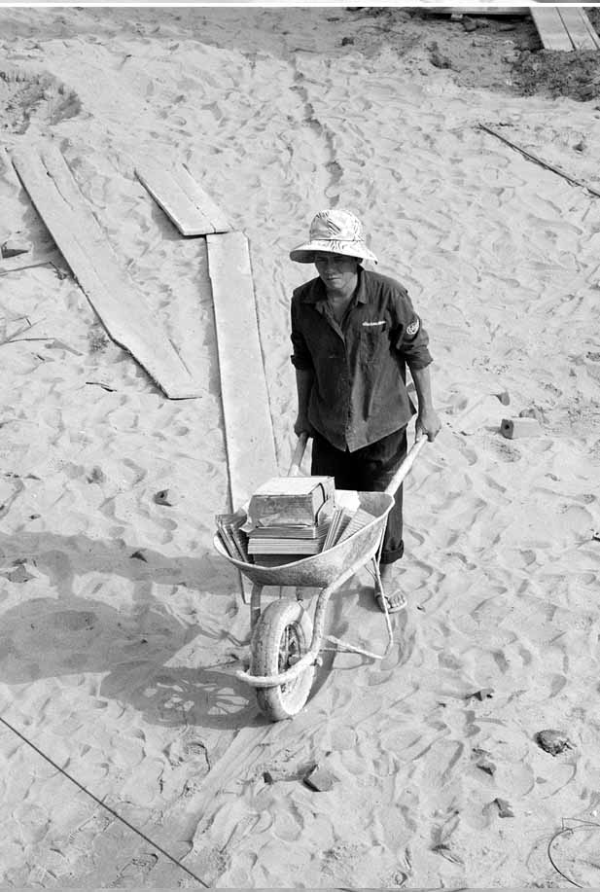

Annex 1: Flipcharts

# Annex 1: Flipcharts

Write the following on Flipcharts before the training begins and refer to them as necessary:

## Flipchart for Activity 2B



**Flipchart 1: Staff and systems**

System = A set of detailed procedures created to:

* Do a specific activity
* Perform a duty
* Solve a problem efficiently and with consistent quality



**Flipchart 2: Systems and checklists**

A good system often starts with a checklist that is:

* Clear
* Easy-to-follow
* Written

## Flipchart for Activity 6A



**Flipchart 3: Feedback**

Ask:

* Your staff; and
* Your guests



www.sme-tools.org